A FAMILY STUDY IN THE CHARLOTTE MASON TRADITION
THE WIND IN THE WILLOWS
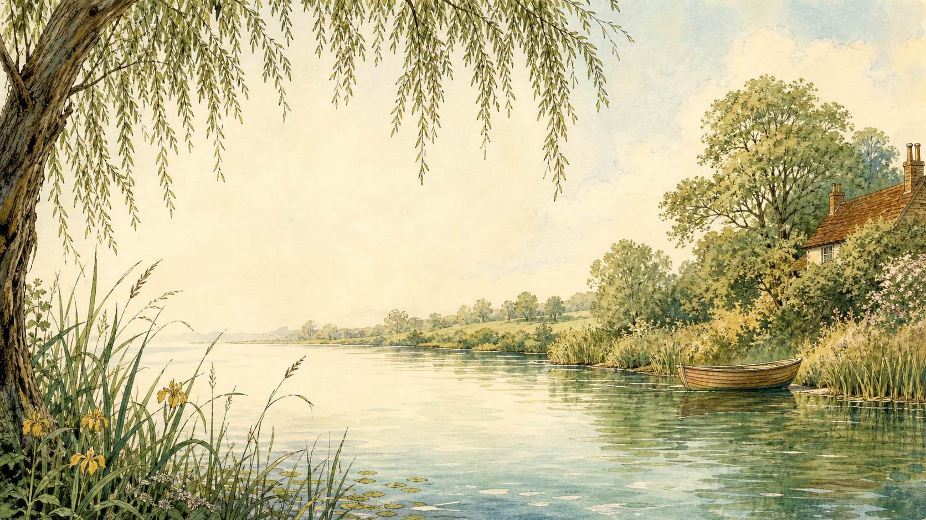
by Kenneth Grahame

A Living Book Study for mixed-age learning

Welcome. This Living Book Study of The Wind in the Willows is written for parents teaching children of different ages side by side. Read together, talk together, and let the story do its quiet work.
In the Charlotte Mason tradition, we keep the feast wide: literature, nature, history, art, and thoughtful conversation. Choose what fits your family, do a little at a time, and let each child respond in their own way - by telling back, drawing, building, writing, or acting.
Alongside our shared reading, a few steady habits will support progress:
- For KS2: keep grammar, punctuation and spelling ticking along - little and often (for example, CGP workbook practice).
- For KS1: follow a systematic phonics programme with daily practice, and let early reading be cheerful and successful.

How to use this plan
- Follow the suggested medium-term plan, or use the activity map to build your own route.
- Choose play stations for KS1 children from the list below (1-2 a week).
- Print the accompanying Learning Booklet for chapter-by-chapter reading and response tasks.
- Use the Independent Study slides if older children are working through the plan on their own.

About the Text
First published in 1908, The Wind in the Willows follows Mole, Rat, Badger and the irrepressible Toad through the English countryside - messing about in boats, exploring the Wild Wood, and rescuing Toad Hall from invaders. Grahame's gentle, richly descriptive nature writing sits alongside real comedy and adventure, and the book's warmth around friendship and home has kept it a favourite for well over a century.
Text used: the 1908 first edition is out of copyright and freely available from Project Gutenberg and Standard Ebooks (see Helpful Websites, below). Editions illustrated by E.H. Shepard (from 1931) are widely available and well worth seeking out for the art activities in this pack.
Topics included: Nature/Science (riverbank habitats, seasons, hibernation), History (Edwardian England, the arrival of the motor car), Geography (rivers, the Wild Wood, England's waterways), Art (illustration, seasonal scenes), and Drama (Toad's speeches, the battle for Toad Hall).

KS1 Play-Based Learning Stations

It is important for KS1 children to continue to learn through play where possible. They can still enjoy the story with their siblings, but also continue to explore the world around them. It is also recommended that they follow a phonics scheme as they learn to read and write.
Activity | Learning Areas | Description | Resources
Messing about in boats | UW + Fine Motor | Water play with toy boats in a tray, sink, or paddling pool; talk about floating, sinking, and 'messing about'. | Water tray, toy boats, small world figures
Animal homes small world | Storytelling + Fine Motor | Build burrows and riverbank dens from boxes, sand or mud; retell who lives where (Mole's hole, Rat's riverbank, Badger's set). | Boxes, sand/mud tray, small animal figures
Toad's motor car | PE + Imaginative Play | Ride-on toys or a cardboard box car; race around a track making engine noises, then talk about being safe on the 'open road'. | Ride-on toy or box, chalk track, cones
Wild Wood spooky trail | PE + Listening | Set up a torch-lit trail indoors or in a dark garden with hidden toy animals to find, echoing Mole's frightening journey. | Torches, hidden toys, string/tape for a path
Seasons scavenger hunt | UW + Science | Go outside and collect signs of the current season (leaves, blossom, frost, conkers); sort and talk about what changes through the year. | Basket, outdoor space, sorting trays
Riverbank picnic | PSED + UW | Have a simple picnic outside or on a rug; talk about why 'there is nothing - absolutely nothing - half so much worth doing as simply messing about'. | Picnic blanket, simple food, cups

The Wind in the Willows Activity Map KS2

Literacy:
- Keep a nature journal as you read the book - note new words, and any passage of description you especially like.
- Rewrite the opening paragraph of Chapter 1 in modern-day language.
- Find and collect examples of personification - where do the animals feel most human, and where do they still feel like animals?
- Write a diary entry as Mole, Rat, Badger or Toad for one day in the story.
- After reading the book, watch a film or TV adaptation and compare it to the book.

Nature / Science:
- Research real riverbank wildlife: water voles, otters, kingfishers. Which animal is Ratty most likely based on?
- Track the seasons through the book - it opens in spring and moves through summer, autumn and winter. Find a description of each season and compare them.
- Research hibernation - why might Badger's underground home suit an animal that sleeps through winter?
- Draw a food web or habitat map for the riverbank.

History:
- Research Edwardian England (1901-1910) - what was daily life like when this book was written?
- Find out about the arrival of the motor car. Why might it have seemed so thrilling and dangerous to people used to horses and boats?
- Research Kenneth Grahame's life - the book began as letters and bedtime stories he told his son, Alastair.
- Record key dates into your Book of Centuries.

Geography:
- Plot the story's setting: Grahame is thought to have been inspired by the River Thames near Cookham. Find the River Thames on a map.
- Map the different locations in the book: the River Bank, the Wild Wood, Toad Hall, and the Wide World beyond.
- Trace the Sea Rat's imagined travels around the Mediterranean in 'Wayfarers All'.

Art:
- Look at E.H. Shepard's original illustrations for the book, then draw your own scene from a chapter.
- Draw a cross-section of Badger's underground home, showing all its rooms.
- Illustrate the same riverbank scene in two different seasons.

Drama:
- Perform one of Toad's boastful speeches ('there's real life for you...').
- Act out Toad's escape from prison disguised as a washerwoman.
- Stage the final battle to reclaim Toad Hall from the weasels and stoats.

Year 6 and KS3 Extension:
- The Wind in the Willows is often read as a pastoral, nostalgic picture of England before industrialisation. Discuss what the book seems to be nostalgic for, and why.
- Explore social class through the animal characters - Toad, Badger and Rat live as landed gentry, while the weasels and stoats are treated as outsiders. What might Grahame be suggesting?
- Compare the episodic chapters (like 'The Piper at the Gates of Dawn') with the continuous plot chapters about Toad. Why might Grahame have structured the book this way?
- Research Kenneth Grahame's career at the Bank of England, and how it contrasts with the book's themes of escape and adventure.

Possible Medium-Term Plan (4 Weeks)

Chapters: 1 The River Bank | 2 The Open Road | 3 The Wild Wood | 4 Mr Badger | 5 Dulce Domum | 6 Mr Toad | 7 The Piper at the Gates of Dawn | 8 Toad's Adventures | 9 Wayfarers All | 10 The Further Adventures of Toad | 11 'Like Summer Tempests Came His Tears' | 12 The Return of Ulysses

Week 1 - Chapters 1-3
Day | Read | Core Task | Extension / Cross-curricular
Day 1 | Ch 1: The River Bank. Mole meets Rat and discovers the river. | Narration: what makes the riverbank so appealing to Mole? Find the line about 'simply messing about in boats'. | Nature: research riverbank wildlife - voles, otters, kingfishers.
Day 2 | Ch 2: The Open Road. Meeting Toad, and the motor-car smashes his caravan. | Narration: what does Grahame show us about Toad's personality through his changing enthusiasms? | History: research the arrival of motor cars in Edwardian England.
Day 3 | Ch 3: The Wild Wood. Mole's dangerous solo trip, and Badger's home. | Writing: describe a frightening place using the five senses, as Grahame does with the Wild Wood. | Discuss: how does Grahame build fear and atmosphere in this chapter?

Week 2 - Chapters 4-6
Day | Read | Core Task | Extension / Cross-curricular
Day 4 | Ch 4: Mr Badger. Meeting Badger properly, and his underground home. | Discuss: compare Badger's home to Mole's and Rat's homes. What does each say about its owner? | Art: draw a cross-section of Badger's underground home.
Day 5 | Ch 5: Dulce Domum. Mole revisits his old home at Christmas time. | Narration: why does Mole feel so emotional returning home? ('Dulce Domum' means 'sweet home' in Latin.) | Discuss: what makes somewhere feel like home?
Day 6 | Ch 6: Mr Toad. Toad's car obsession worsens; his friends intervene. | Discuss: how does Grahame use humour in Toad's boastful speeches? | Drama: perform one of Toad's speeches aloud.

Week 3 - Chapters 7-9
Day | Read | Core Task | Extension / Cross-curricular
Day 7 | Ch 7: The Piper at the Gates of Dawn. Rat and Mole's mystical encounter. | Discuss: this chapter feels different from the rest of the book. What changes in tone and style? | Art: respond to the imagery of dawn on the river.
Day 8 | Ch 8: Toad's Adventures. Toad escapes prison disguised as a washerwoman. | Narration: retell Toad's escape in your own words. | Drama: act out the disguise scene.
Day 9 | Ch 9: Wayfarers All. Rat meets the Sea Rat and feels the pull of travel. | Discuss: the tension between adventure and home - which does Rat choose, and why? | Geography: map the Sea Rat's imagined Mediterranean travels.

Week 4 - Chapters 10-12 and wrap-up
Day | Read | Core Task | Extension / Cross-curricular
Day 10 | Ch 10: The Further Adventures of Toad. Escapades on the road and canal. | Discuss: what keeps going wrong for Toad, and why? | Narration: retell Toad's journey as a newspaper report.
Day 11 | Ch 11: 'Like Summer Tempests Came His Tears'. Toad Hall has been taken over. | Narration: what has happened to Toad Hall while Toad has been away? | Discuss: is this fair? What might Grahame want us to feel about Toad at this point?
Day 12 | Ch 12: The Return of Ulysses. The battle to reclaim Toad Hall. | Discuss: how has Toad changed by the end of the book? Has he really changed for good? | Extension: compare Toad's change of heart to another character who reforms, such as Scrooge in A Christmas Carol.
Day 13 | Response day. | Character profiles: draw or write about Mole, Rat, Badger and Toad - what does each one represent? | Discuss: which character are you most like, and why?
Day 14 | Wrap-up. | Watch a film or TV adaptation and discuss the similarities and differences. | Art: explore E.H. Shepard's illustrations for the whole book.
Day 15 | Wrap-up. | Writing: plan and write a new, short adventure for Mole, Rat, Badger and Toad. | Share your new chapter aloud with your family.

Helpful Websites

- Full text (free, out of copyright): Project Gutenberg - www.gutenberg.org/ebooks/289 and Standard Ebooks - standardebooks.org
- E.H. Shepard's original illustrations: search the V&A collections - www.vam.ac.uk
- Kenneth Grahame's life: The Bodleian Libraries, Oxford - www.bodleian.ox.ac.uk (holds Grahame's papers)
- Edwardian England and the arrival of the motor car: Historic UK - www.historic-uk.com
- River Thames wildlife: The Wildlife Trusts - www.wildlifetrusts.org

Glossary

- English Journal: a notebook where thoughts and images are kept while reading a novel. You can also use the printable booklet.
- Book of Centuries: a timeline in a book, taken from the Charlotte Mason tradition, where children add historical figures and important dates as they meet them.
- Personification: giving human qualities to something that isn't human - as Grahame does throughout with Mole, Rat, Badger and Toad.
- Pastoral: writing that idealises rural, countryside life - a key feature of this book's style.

Other Living Book Studies in the Series

- Alice's Adventures in Wonderland by Lewis Carroll (Year 5-7)
- A Christmas Carol by Charles Dickens (Year 7-9, GCSE extension)
- The Strange Case of Dr Jekyll and Mr Hyde by Robert Louis Stevenson (GCSE)
- Treasure Island by Robert Louis Stevenson
- The Jungle Book by Rudyard Kipling

