INDEPENDENT STUDY COMPANION
THE WIND IN THE WILLOWS
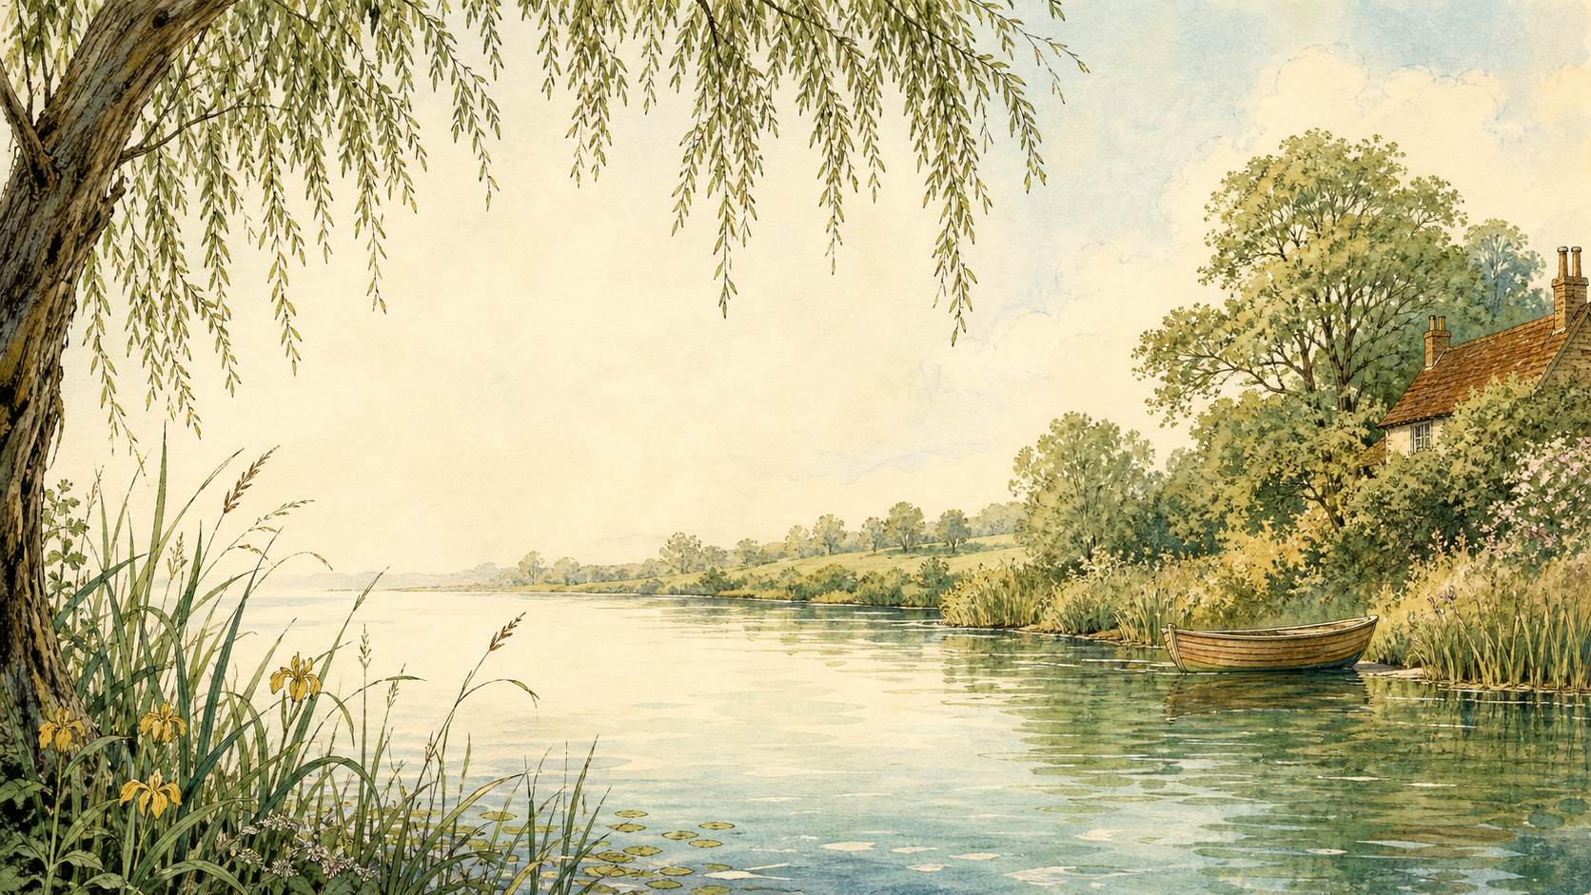
A LIVING BOOK STUDY - LEARNING BOOKLET
Name: _______________________

TASKS: DAY 1
Week 1 - Chapter 1: The River Bank
READ:
Chapter 1: Mole meets Rat and discovers the river and boating.
NARRATION:
What makes the riverbank so appealing to Mole? Find the line about 'simply messing about in boats' and explain it in your own words.
EXTENSION:
Nature: research riverbank wildlife - water voles, otters and kingfishers. Which animal is Ratty most likely based on?
Your response:

TASKS: DAY 2
Week 1 - Chapter 2: The Open Road
READ:
Chapter 2: meeting Toad, and the motor-car that smashes his caravan.
NARRATION:
What does Grahame show us about Toad's personality through his changing enthusiasms - first the caravan, then the motor car?
EXTENSION:
History: research the arrival of motor cars in Edwardian England. Why might they have seemed so exciting and dangerous?
Your response:

TASKS: DAY 3
Week 1 - Chapter 3: The Wild Wood
READ:
Chapter 3: Mole's dangerous solo trip, and finding Badger's home.
WRITING OPPORTUNITY:
Describe a frightening place using your five senses, as Grahame does with the Wild Wood.
EXTENSION:
Discuss: how does Grahame build fear and atmosphere in this chapter?
Your response:

TASKS: DAY 4
Week 2 - Chapter 4: Mr Badger
READ:
Chapter 4: meeting Badger properly, and seeing his underground home.
DISCUSS:
Compare Badger's home to Mole's and Rat's homes. What does each home say about its owner?
EXTENSION:
Art: draw a cross-section of Badger's underground home.
Your response:

TASKS: DAY 5
Week 2 - Chapter 5: Dulce Domum
READ:
Chapter 5: Mole revisits his old home at Christmas time.
NARRATION:
Why does Mole feel so emotional returning home? ('Dulce Domum' means 'sweet home' in Latin.)
EXTENSION:
Discuss: what makes somewhere feel like home to you?
Your response:

TASKS: DAY 6
Week 2 - Chapter 6: Mr Toad
READ:
Chapter 6: Toad's car obsession worsens, and his friends stage an intervention.
DISCUSS:
How does Grahame use humour in Toad's boastful speeches?
EXTENSION:
Drama: perform one of Toad's speeches aloud, as boastfully as you can.
Your response:

TASKS: DAY 7
Week 3 - Chapter 7: The Piper at the Gates of Dawn
READ:
Chapter 7: Rat and Mole's mystical encounter by the river at dawn.
DISCUSS:
This chapter feels different from the rest of the book. What changes in tone and style?
EXTENSION:
Art: respond to the imagery of dawn on the river with a drawing or painting.
Your response:

TASKS: DAY 8
Week 3 - Chapter 8: Toad's Adventures
READ:
Chapter 8: Toad escapes from prison disguised as a washerwoman.
NARRATION:
Retell Toad's escape in your own words.
EXTENSION:
Drama: act out the disguise scene with a friend or family member.
Your response:

TASKS: DAY 9
Week 3 - Chapter 9: Wayfarers All
READ:
Chapter 9: Rat meets the Sea Rat and feels the pull of travel.
DISCUSS:
This chapter is about the tension between adventure and home. Which does Rat choose in the end, and why?
EXTENSION:
Geography: map the Sea Rat's imagined Mediterranean travels.
Your response:

TASKS: DAY 10
Week 4 - Chapter 10: The Further Adventures of Toad
READ:
Chapter 10: Toad's escapades on the road and canal.
DISCUSS:
What keeps going wrong for Toad, and why?
EXTENSION:
Narration: retell Toad's journey as a newspaper report.
Your response:

TASKS: DAY 11
Week 4 - Chapter 11: 'Like Summer Tempests Came His Tears'
READ:
Chapter 11: Toad Hall has been taken over by weasels and stoats.
NARRATION:
What has happened to Toad Hall while Toad has been away?
EXTENSION:
Discuss: is this fair? What might Grahame want us to feel about Toad at this point in the story?
Your response:

TASKS: DAY 12
Week 4 - Chapter 12: The Return of Ulysses
READ:
Chapter 12: the battle to reclaim Toad Hall, and the celebratory banquet.
DISCUSS:
How has Toad changed by the end of the book? Has he really changed for good?
EXTENSION:
Compare Toad's change of heart to another character who reforms, such as Scrooge in A Christmas Carol.
Your response:

TASKS: DAY 13
Week 4 - Response Day
READ:
No new reading - review the whole book.
CHARACTER PROFILES:
Draw or write about Mole, Rat, Badger and Toad - what does each one represent?
EXTENSION:
Discuss: which character are you most like, and why?
Your response:

TASKS: DAY 14
Week 4 - Wrap-up
READ:
No new reading - watch a film or TV adaptation instead, if you can.
DISCUSS:
Compare the adaptation to the book. What is similar? What is different, and why might a filmmaker make those changes?
EXTENSION:
Art: explore E.H. Shepard's original illustrations for the whole book.
Your response:

TASKS: DAY 15
Week 4 - Wrap-up
READ:
No new reading - it's your turn to write.
WRITING OPPORTUNITY:
Plan and write a new, short adventure for Mole, Rat, Badger and Toad.
EXTENSION:
Share your new chapter aloud with your family.
Your response:

SEASONS THROUGH THE BOOK
The story moves through the seasons. As you read, note where each season appears and how Grahame describes it.
Season | Chapter | How Grahame describes it
Spring
Summer
Autumn
Winter

RIVERBANK FACT FILE

Water vole

Otter

Kingfisher

Badger

Fun facts

