A FAMILY STUDY IN THE CHARLOTTE MASON TRADITION
TREASURE ISLAND
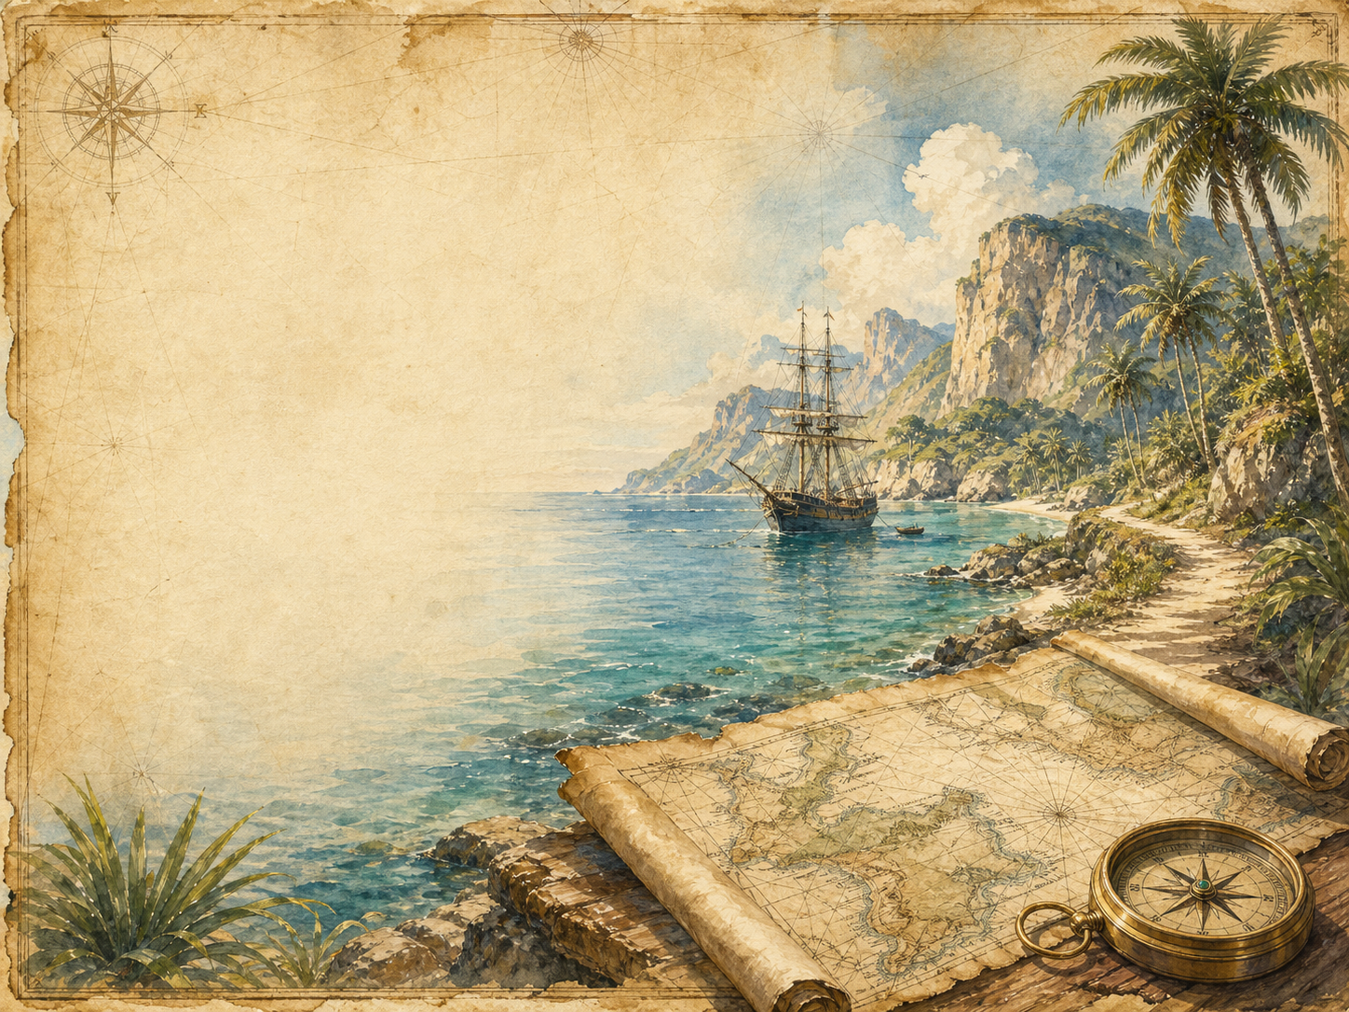
by Robert Louis Stevenson

A Living Book Study for KS3, with a Years 5-6 Support Tier

Welcome. This Living Book Study of Treasure Island is written for families teaching children of different ages side by side, with a core plan for Years 7-9 and a lighter-touch tier for Years 5-6.
In the Charlotte Mason tradition, we keep the feast wide alongside the adventure: history, geography, science and thoughtful conversation sit next to maps, drama and character study. Choose what fits your family, do a little at a time, and let each child respond in their own way.
A few steady habits will support progress:
- For Years 5-6: focus on adventure, map-reading and vocabulary - build familiarity with the story before deeper analysis.
- For Years 7-9: keep a running character study of Long John Silver - one of literature's great morally ambiguous figures - adding evidence as you read.
- For Years 9-11: use the extension tasks to practise close analysis of narrative voice and character, skills that carry directly into GCSE English Literature.

How to use this plan
- Follow the suggested 4-week medium-term plan, or use the subject activity map to build your own route.
- Print the accompanying Learning Booklet for chapter-by-chapter reading and response tasks.
- Use the Independent Study slides if a student is working through the plan on their own.
- The book includes pirate violence and several deaths, handled without graphic detail - typical of a Victorian adventure story, and generally suitable from Year 5 up with adult guidance.

About the Text
First published in 1883, Treasure Island follows young Jim Hawkins from a quiet coastal inn to a hunt for buried pirate gold, after a treasure map falls into his hands. Alongside honest men like Captain Smollett and Dr Livesey sails Long John Silver - the ship's cook, and secretly the leader of a mutinous crew of pirates. Stevenson's novel effectively invented the modern pirate story, giving the genre its treasure maps, parrots, 'X marks the spot', and its first great morally ambiguous villain.
Text used: the 1883 first edition is out of copyright and freely available from Project Gutenberg and Standard Ebooks (see Helpful Websites, below).
Topics included: History (the Golden Age of Piracy, 18th-century sailing ships), Geography (map-reading, a fictional island), Science (tides, navigation, sailors' health), Art (maps, ships, character portraits), Drama (confrontation and mutiny scenes), and Literacy (narrative voice, character study, adventure genre conventions).
Years 5-6 Support Tier

Younger children can enjoy the adventure and build familiarity with the story through play and simpler tasks, without needing to engage with the character analysis aimed at older students.
Activity | Learning Areas | Description | Resources
Treasure hunt trail | PE + Map Skills | Hide small 'treasure' outdoors and draw a simple map with a compass rose and an X, then follow it to find the prize. | Small treats/coins, paper, pens
Build a pirate ship | DT + Art | Build a model ship from a box or recycled materials, complete with a Jolly Roger flag. | Box, craft materials, black paper for the flag
Pirate vocabulary bingo | Literacy | Play bingo with pirate words from the book - ahoy, matey, plank, treasure, mutiny - and their meanings. | Bingo cards, counters
Knot-tying station | PE + Fine Motor | Learn two or three simple knots a sailor might use, such as a reef knot. | Rope or thick string
Compass points practice | Geography | Practise North, South, East and West with a simple direction game, ready for reading the treasure map. | Floor space, direction cards

KS3 Subject Activity Map

Literacy:
- Keep a pirate vocabulary glossary as you read - collect nautical and pirate slang and their meanings.
- Build a running character study of Long John Silver: add evidence from every part of the book about whether he is good, bad, or something more complicated.
- Discuss: the narrator switches from Jim Hawkins to Dr Livesey for three chapters (16-18). Why might Stevenson have done this?
- Write a 'wanted' poster for Long John Silver, describing his appearance and crimes as the authorities might.
- Compare Treasure Island to a more modern pirate story or film - which classic pirate tropes (maps, parrots, peg legs) come from this book?

History:
- Research the Golden Age of Piracy (roughly 1650s-1730s) and compare real pirates such as Blackbeard or Bartholomew Roberts to Long John Silver.
- Research 18th-century sailing ships - how they were rigged, sailed and provisioned for a long voyage.
- Discuss why real sailors sometimes turned to piracy - poor pay, harsh discipline, and the promise of a share in stolen treasure.
- Research the history and meaning of the Jolly Roger flag.
- Record key dates into your Book of Centuries.

Geography:
- Study the treasure map in the book closely - what features does it show, and how does it help (or mislead) the characters?
- Draw your own map of a fictional island, including a compass rose, key landmarks, and a hidden treasure.
- Research 18th-century British trade routes and the parts of the world where piracy was most common.
Science:
- Research how sailing ships were navigated before satellite technology - the compass, dead reckoning, and the stars.
- Research tides and how they might affect a small boat, like Jim's coracle in Part Five.
- Research scurvy and other health risks faced by 18th-century sailors on long voyages.

Art:
- Draw your own version of the treasure map, following the details given in the book.
- Design and illustrate a pirate ship, labelling its parts.
- Illustrate Long John Silver, capturing both his charm and his menace.

Drama:
- Act out the Black Dog confrontation at the Admiral Benbow inn.
- Perform Silver's negotiation with Captain Smollett at the stockade.
- Perform Jim's fight with Israel Hands in the rigging.
Years 9-11 Extension:
- Long John Silver is often described as one of literature's first great 'anti-heroes'. Plan a response to: 'How does Stevenson use Silver to blur the line between hero and villain?'
- Discuss narrative reliability: Jim clearly admires Silver despite his crimes. Does this affect how much we should trust Jim's account of him?
- Research how Treasure Island shaped almost every pirate story that followed it, and discuss why its version of piracy - romantic, adventurous - differs so much from the historical reality.
- Compare Silver's fate at the end of the book to Israel Hands' and George Merry's. What might Stevenson be suggesting about who is punished and who escapes justice, and whether this feels fair?

Possible Medium-Term Plan (4 Weeks)

The novel has 34 chapters across six parts. This plan reads two chapters a day.

Week 1 - Part One: The Old Buccaneer (Ch 1-8)
Day | Read | Core Task | Extension / Cross-curricular
Day 1 | Ch 1-2: The Old Sea-dog at the 'Admiral Benbow' / Black Dog Appears and Disappears. | Narration: what makes Billy Bones such a menacing, mysterious character? | History: research 18th-century English coastal inns and smuggling.
Day 2 | Ch 3-4: The Black Spot / The Sea-chest. | Discuss: what is 'the black spot', and why is it so frightening to Billy Bones? | Literacy: start your pirate vocabulary glossary.
Day 3 | Ch 5-6: The Last of the Blind Man / The Captain's Papers. | Narration: describe the death of Pew and its impact on Jim. | Geography: begin studying the treasure map - what details does it include?
Day 4 | Ch 7-8: I Go to Bristol / At the Sign of the Spy-glass. | Discuss: this is our introduction to Long John Silver. Why does everyone seem to trust him? | Begin your Silver character study - first impressions.

Week 2 - Part Two and start of Part Three (Ch 9-15)
Day | Read | Core Task | Extension / Cross-curricular
Day 5 | Ch 9-10: Powder and Arms / The Voyage. | Science: research 18th-century sailing ships - how they were rigged, sailed, and provisioned. | Narration: describe daily life aboard the Hispaniola.
Day 6 | Ch 11-12: What I Heard in the Apple-Barrel / Council of War. | Discuss: how does Stevenson build tension as Jim overhears the mutiny plot? | Writing: write Jim's inner thoughts as he hides in the barrel.
Day 7 | Ch 13-14: How I Began My Shore Adventure / The First Blow. | Narration: describe the island as Jim first sees it. | Discuss: this is the first violence in the book. How does Stevenson handle it?
Day 8 | Ch 15: The Man of the Island. | Discuss: what does Ben Gunn's story tell us about the dangers of the treasure and of being marooned? | Art: draw Ben Gunn as Stevenson describes him.

Week 3 - Parts Four and Five (Ch 16-27)
Day | Read | Core Task | Extension / Cross-curricular
Day 9 | Ch 16-17: Narrative Continued by the Doctor - How the Ship Was Abandoned / The Jolly-boat's Last Trip. | Discuss: why might Stevenson switch narrators here? What does Dr Livesey's account add that Jim's couldn't? | Compare Dr Livesey's calm, factual voice to Jim's more excitable one.
Day 10 | Ch 18-19: End of the First Day's Fighting / The Garrison in the Stockade. | Narration: summarise the fighting so far, from both narrators' accounts. | Discuss: what makes Captain Smollett a good leader under pressure?
Day 11 | Ch 20-21: Silver's Embassy / The Attack. | Drama: perform the negotiation between Silver and Captain Smollett. | Discuss: what does this scene reveal about Silver's character?
Day 12 | Ch 22-23: How I Began My Sea Adventure / The Ebb-tide Runs. | Science: research tides, and how they might affect a small boat like Jim's coracle. | Narration: describe Jim's coracle and his plan.
Day 13 | Ch 24-25: The Cruise of the Coracle / I Strike the Jolly Roger. | Narration: retell Jim's daring solo adventure in your own words. | Discuss: why does Jim take such risks throughout the book?
Day 14 | Ch 26-27: Israel Hands / 'Pieces of Eight'. | Discuss: how does Stevenson build suspense in the fight with Israel Hands? | Extension: plan a response to how Stevenson creates tension using short sentences and pace in this chapter.

Week 4 - Part Six: Captain Silver (Ch 28-34)
Day | Read | Core Task | Extension / Cross-curricular
Day 15 | Ch 28-29: In the Enemy's Camp / The Black Spot Again. | Discuss: why does Jim choose to return to the stockade, even though it's now full of pirates? | Update your Silver character study with new evidence.
Day 16 | Ch 30-31: On Parole / The Treasure-hunt - Flint's Pointer. | Geography: follow the treasure hunt using the map - can you track their route? | Discuss: why does Silver seem to switch sides again here?
Day 17 | Ch 32-34: The Treasure-hunt - The Voice Among the Trees / The Fall of a Chieftain / And Last. | Discuss: what happens to Silver at the end? Do you think he deserves his fate? | Wrap-up: compare the endings for different characters - who is punished, who is rewarded, and is this fair?

Helpful Websites

- Full text (free, out of copyright): Project Gutenberg - www.gutenberg.org/ebooks/120 and Standard Ebooks - standardebooks.org
- The Golden Age of Piracy: National Maritime Museum - www.rmg.co.uk
- 18th-century sailing ships: Royal Museums Greenwich - www.rmg.co.uk/stories
- Map-reading and compass skills: Ordnance Survey - www.ordnancesurvey.co.uk/education
- Real pirates in history: search 'Golden Age of Piracy' via your library or a trusted encyclopedia

Glossary

- English Journal: a notebook where thoughts and images are kept while reading a novel. You can also use the printable booklet.
- Book of Centuries: a timeline in a book, taken from the Charlotte Mason tradition, where children add historical figures and important dates as they meet them.
- Anti-hero: a main character who lacks conventional heroic qualities, such as Long John Silver - charming, clever, but also dishonest and dangerous.
- Coracle: a small, round boat, traditionally made of a wicker frame covered in animal hide - the type of boat Jim uses in Part Five.

Other Living Book Studies in the Series

- Alice's Adventures in Wonderland by Lewis Carroll (Year 5-7)
- The Wind in the Willows by Kenneth Grahame
- Peter Pan by J.M. Barrie
- A Christmas Carol by Charles Dickens (Year 7-9, GCSE extension)
- The Strange Case of Dr Jekyll and Mr Hyde by Robert Louis Stevenson (GCSE)

