INDEPENDENT STUDY COMPANION
TREASURE ISLAND
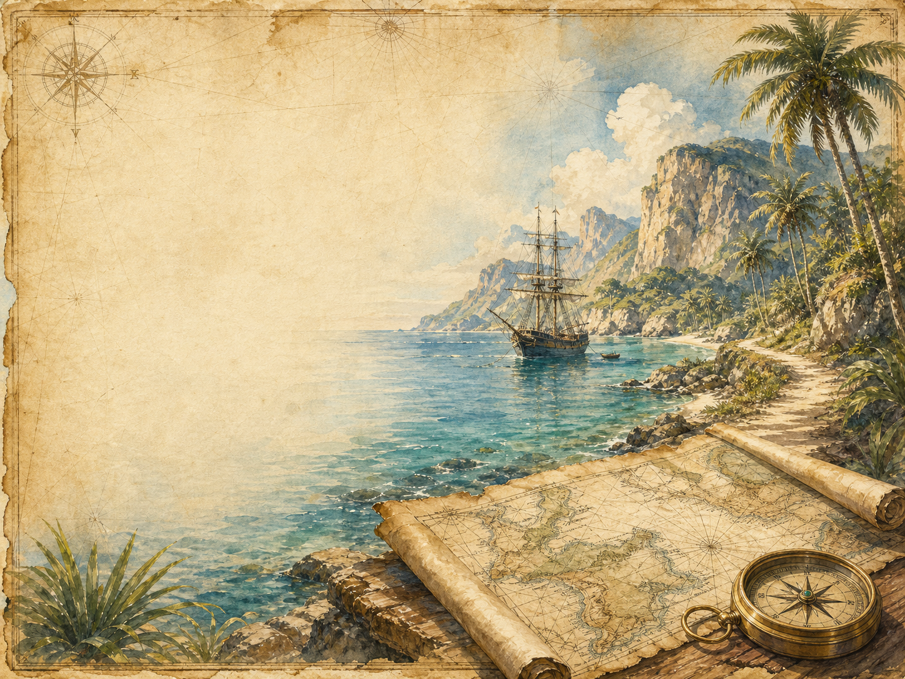
A LIVING BOOK STUDY - LEARNING BOOKLET
Name: _______________________

TASKS: DAY 1
Week 1 - Chapters 1-2
READ:
Chapter 1: The Old Sea-dog at the 'Admiral Benbow', and Chapter 2: Black Dog Appears and Disappears.
NARRATION:
What makes Billy Bones such a menacing, mysterious character?
EXTENSION:
History: research 18th-century English coastal inns and smuggling.
Your response:

TASKS: DAY 2
Week 1 - Chapters 3-4
READ:
Chapter 3: The Black Spot, and Chapter 4: The Sea-chest.
DISCUSS:
What is 'the black spot', and why is it so frightening to Billy Bones?
EXTENSION:
Literacy: start your pirate vocabulary glossary.
Your response:

TASKS: DAY 3
Week 1 - Chapters 5-6
READ:
Chapter 5: The Last of the Blind Man, and Chapter 6: The Captain's Papers.
NARRATION:
Describe the death of Pew and its impact on Jim.
EXTENSION:
Geography: begin studying the treasure map - what details does it include?
Your response:

TASKS: DAY 4
Week 1 - Chapters 7-8
READ:
Chapter 7: I Go to Bristol, and Chapter 8: At the Sign of the Spy-glass.
DISCUSS:
This is our introduction to Long John Silver. Why does everyone seem to trust him?
EXTENSION:
Begin your Silver character study - note your first impressions.
Your response:

TASKS: DAY 5
Week 2 - Chapters 9-10
READ:
Chapter 9: Powder and Arms, and Chapter 10: The Voyage.
SCIENCE:
Research 18th-century sailing ships - how they were rigged, sailed and provisioned.
EXTENSION:
Narration: describe daily life aboard the Hispaniola.
Your response:

TASKS: DAY 6
Week 2 - Chapters 11-12
READ:
Chapter 11: What I Heard in the Apple-Barrel, and Chapter 12: Council of War.
DISCUSS:
How does Stevenson build tension as Jim overhears the mutiny plot?
EXTENSION:
Writing: write Jim's inner thoughts as he hides in the barrel.
Your response:

TASKS: DAY 7
Week 2 - Chapters 13-14
READ:
Chapter 13: How I Began My Shore Adventure, and Chapter 14: The First Blow.
NARRATION:
Describe the island as Jim first sees it.
EXTENSION:
Discuss: this is the first violence in the book. How does Stevenson handle it?
Your response:

TASKS: DAY 8
Week 2 - Chapter 15
READ:
Chapter 15: The Man of the Island.
DISCUSS:
What does Ben Gunn's story tell us about the dangers of the treasure and of being marooned?
EXTENSION:
Art: draw Ben Gunn as Stevenson describes him.
Your response:

TASKS: DAY 9
Week 3 - Chapters 16-17
READ:
Chapter 16: Narrative Continued by the Doctor - How the Ship Was Abandoned, and Chapter 17: The Jolly-boat's Last Trip.
DISCUSS:
Why might Stevenson switch narrators here? What does Dr Livesey's account add that Jim's couldn't?
EXTENSION:
Compare Dr Livesey's calm, factual voice to Jim's more excitable one.
Your response:

TASKS: DAY 10
Week 3 - Chapters 18-19
READ:
Chapter 18: End of the First Day's Fighting, and Chapter 19: The Garrison in the Stockade.
NARRATION:
Summarise the fighting so far, from both narrators' accounts.
EXTENSION:
Discuss: what makes Captain Smollett a good leader under pressure?
Your response:

TASKS: DAY 11
Week 3 - Chapters 20-21
READ:
Chapter 20: Silver's Embassy, and Chapter 21: The Attack.
DRAMA:
Perform the negotiation between Silver and Captain Smollett.
EXTENSION:
Discuss: what does this scene reveal about Silver's character?
Your response:

TASKS: DAY 12
Week 3 - Chapters 22-23
READ:
Chapter 22: How I Began My Sea Adventure, and Chapter 23: The Ebb-tide Runs.
SCIENCE:
Research tides, and how they might affect a small boat like Jim's coracle.
EXTENSION:
Narration: describe Jim's coracle and his plan.
Your response:

TASKS: DAY 13
Week 3 - Chapters 24-25
READ:
Chapter 24: The Cruise of the Coracle, and Chapter 25: I Strike the Jolly Roger.
NARRATION:
Retell Jim's daring solo adventure in your own words.
EXTENSION:
Discuss: why does Jim take such risks throughout the book?
Your response:

TASKS: DAY 14
Week 3 - Chapters 26-27
READ:
Chapter 26: Israel Hands, and Chapter 27: 'Pieces of Eight'.
DISCUSS:
How does Stevenson build suspense in the fight with Israel Hands?
EXTENSION:
Extension: how does Stevenson use short sentences and pace to build tension in this chapter?
Your response:

TASKS: DAY 15
Week 4 - Chapters 28-29
READ:
Chapter 28: In the Enemy's Camp, and Chapter 29: The Black Spot Again.
DISCUSS:
Why does Jim choose to return to the stockade, even though it's now full of pirates?
EXTENSION:
Update your Silver character study with new evidence.
Your response:

TASKS: DAY 16
Week 4 - Chapters 30-31
READ:
Chapter 30: On Parole, and Chapter 31: The Treasure-hunt - Flint's Pointer.
GEOGRAPHY:
Follow the treasure hunt using the map - can you track their route?
EXTENSION:
Discuss: why does Silver seem to switch sides again here?
Your response:

TASKS: DAY 17
Week 4 - Chapters 32-34
READ:
Chapter 32: The Treasure-hunt - The Voice Among the Trees, Chapter 33: The Fall of a Chieftain, and Chapter 34: And Last.
DISCUSS:
What happens to Silver at the end? Do you think he deserves his fate?
EXTENSION:
Wrap-up: compare the endings for different characters - who is punished, who is rewarded, and is this fair?
Your response:

LONG JOHN SILVER: CHARACTER STUDY
Add evidence as you read. Is Silver good, bad, or something in between?
What Silver does or says | Chapter | What it suggests about him

PIRATE VOCABULARY GLOSSARY
Word or phrase | What it means

