A FAMILY STUDY IN THE CHARLOTTE MASON TRADITION
THE WAR OF THE WORLDS
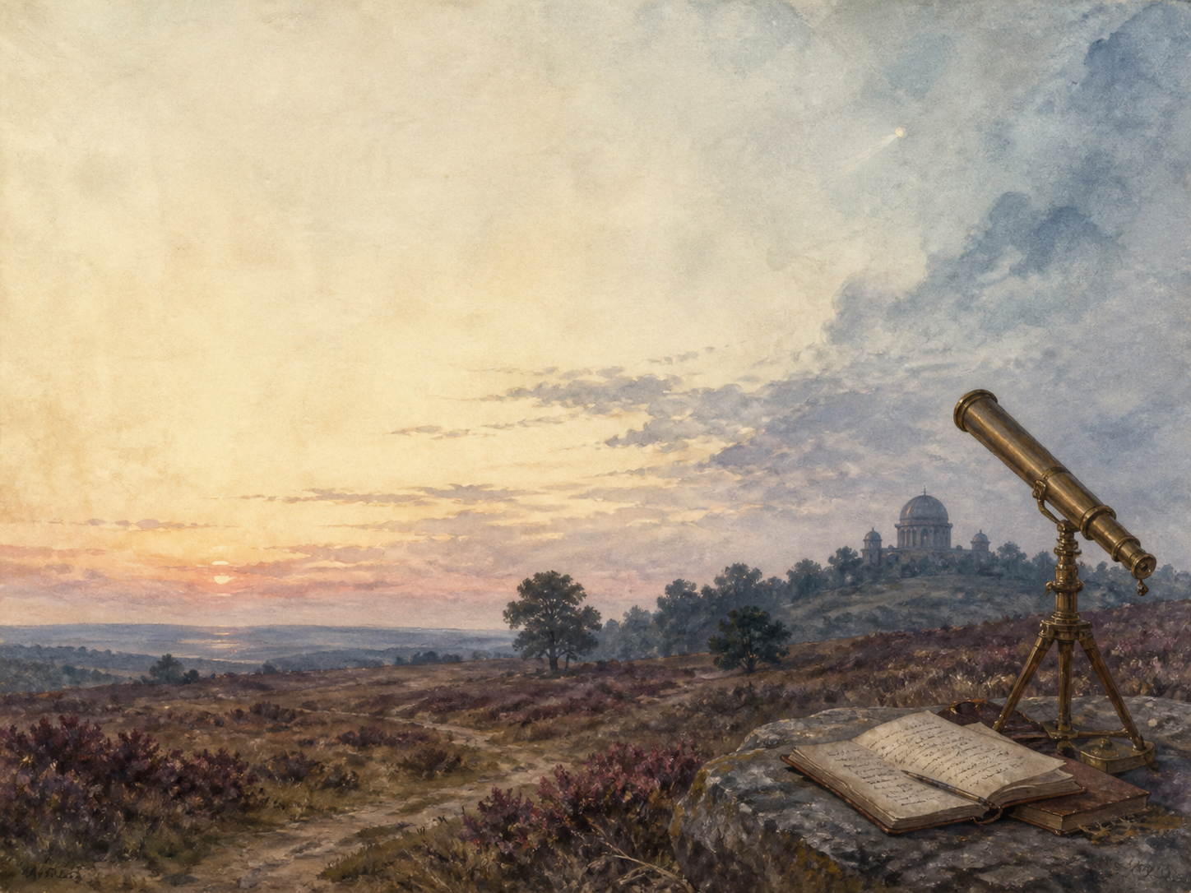
by H.G. Wells

A Living Book Study for Year 8, with a Year 7 Support Tier

Welcome. This Living Book Study of The War of the Worlds is written for families teaching children of different ages side by side, with a core plan pitched at Year 8 and a lighter-touch tier for Year 7.
In the Charlotte Mason tradition, we keep the feast wide alongside the invasion: science, history, geography and searching conversation sit next to writing, drama and discussion. Choose what fits your family, do a little at a time, and let each child respond in their own way.
A few steady habits will support progress:
- For Year 7: enjoy the thrill of the invasion - the cylinders, the Heat-Ray, the towering machines - and follow the narrator's escape across the country.
- For Year 8: keep a reading journal, and start noticing how Wells makes something impossible feel real, and what he is really writing ABOUT.
- For GCSE (Years 10-11): use the extension tasks to analyse Wells's craft, his hidden argument about empire, and the birth of science fiction.

How to use this plan
- Follow the suggested 4-week medium-term plan, or use the subject activity map to build your own route.
- Print the accompanying Learning Booklet for reading and response tasks.
- Use the Independent Study slides if a student is working through the plan on their own.
- A note for parents: The War of the Worlds pictures a violent invasion, with mass death, destruction and scenes of panic and despair, especially in the second half. One character, a curate, suffers a mental breakdown and dies. Nothing is gory, but the mood turns bleak. The famous opening also refers to the near-destruction of the Tasmanian people by British colonists - a heavy but important true reference that Wells uses deliberately. A read-ahead will help you frame these moments for your child.

About the Text
Published in 1898, The War of the Worlds tells, in the plain voice of an ordinary eyewitness, how Martians land in the quiet English county of Surrey and set about conquering the Earth with towering fighting-machines and a deadly Heat-Ray. As humanity's armies crumble, the narrator struggles simply to survive - until the invaders meet an enemy they never expected.
Wells was one of the founders of science fiction, and this is perhaps his most famous book - later turned into a notorious 1938 American radio broadcast that convinced some listeners a real invasion was underway. But Wells had a serious point beneath the spectacle: he wanted proud imperial Britain to feel, for once, what it is like to be on the receiving end of a ruthless, more powerful invader.
Text used: the 1898 text is out of copyright and freely available from Project Gutenberg and Standard Ebooks (see Helpful Websites, below).
Topics included: Science (Mars and astronomy, the Heat-Ray, ecology and the red weed, germs and immunity), History (the British Empire, invasion-scare fears, Darwin), Geography (the real Surrey-to-London invasion route), RE/PSHE (human behaviour under catastrophe, humility), Art, and Drama.
Year 7 Support Tier

A younger or less confident reader can enjoy the invasion as a thrilling adventure and a science puzzle, without the closer literary analysis aimed at older students. These activities lean into design, science and imagination.
Activity | Learning Areas | Description | Resources
Design a fighting-machine | Art | Draw a Martian tripod from Wells's description, with its Heat-Ray and metal tentacles. | Paper, pens
Map the invasion | Geography | Trace the Martians' route from Horsell Common across Surrey to London on a real map. | Paper, map or atlas
Mars facts | Science | Research the real planet Mars: why people once imagined life there, and what our probes have found. | Books or internet access
Breaking news broadcast | Literacy + Drama | Write and perform a radio news bulletin reporting the first cylinder landing, like the famous 1938 broadcast. | Paper; a device to record, optional
Why did the Martians die? | Science | Find out about germs and immune systems, and work out why Earth's tiniest life defeats the invaders. | Books or internet access

Year 8 Subject Activity Map

Literacy:
- Notice how Wells makes an impossible invasion feel real - naming true places, using an ordinary eyewitness, and reporting like a journalist.
- Explore the science-fiction genre Wells helped found, and list later stories and films that owe it a debt.
- Research the 1938 Orson Welles radio version, and discuss why it frightened its listeners so badly.
- Write a survivor's diary entry, or a newspaper front page, from the height of the invasion.
Science:
- Research the planet Mars: why Victorians imagined 'canals' and life there, and what modern missions have actually found.
- The Heat-Ray works much like a laser, decades before lasers existed. Research how a laser works.
- The 'red weed' is an alien invasive species. Research real invasive species and the damage they do to ecosystems.
- The Martians are killed by Earth's bacteria. Research germs, disease and the immune system.

History:
- Research the British Empire at its height in the 1890s, and read the book's opening as a warning to it.
- Research the 'invasion scare' stories popular in Britain before the First World War, which Wells was answering.
- Research Charles Darwin and the idea of 'survival of the fittest', which shadows the whole novel.
- Record key dates into your Book of Centuries.

Geography:
- Map the real invasion route: Horsell Common near Woking, across Surrey, along the Thames, into London.
- Compare Wells's map of destruction with a modern map of the same area.

RE / PSHE:
- Discuss how people behave under catastrophe: panic, looting, courage and kindness all appear. Which characters cope well, and which badly?
- Compare the curate, who breaks down, with the artilleryman, who talks grandly but does little. What is Wells saying about people?
- Discuss the book's lesson in humility: how does it feel to have humanity treated as we treat animals?

Art / Drama:
- Illustrate a fighting-machine, the ironclad Thunder Child's charge, or the silence of 'Dead London'.
- Perform the artilleryman's speech about the future of humankind - and let the audience judge whether to believe him.
- Design a film poster for a modern retelling of the story.
GCSE (Years 10-11) Extension:
- The War of the Worlds appears on some 19th-century GCSE courses. Plan a response to: 'How does Wells build tension and realism?'
- Analyse the imperial allegory: how does Wells use the Martians to criticise the British Empire?
- Explore how the novel presents human nature when order breaks down.
- Write about the novel's place at the birth of science fiction, and why its ideas still recur today.

Possible Medium-Term Plan (4 Weeks)

The novel is in two Books, of seventeen and ten chapters. This plan groups the titled chapters by the stages of the invasion.

Week 1 - Book One: The Coming of the Martians (I-VI)
Day | Read | Core Task | Extension / Cross-curricular
Day 1 | I-II: The Eve of the War; The Falling Star. | Narration: how do the Martians first announce themselves, and how calmly does life carry on? | Science: research the planet Mars and why Victorians imagined life there.
Day 2 | III-IV: On Horsell Common; The Cylinder Opens. | Narration: describe the crowd around the pit, and the first sight of a Martian. | Discuss: why does no one seem to grasp the danger at first?
Day 3 | V-VI: The Heat-Ray; The Heat-Ray in the Chobham Road. | Narration: retell the fate of the men who approach with a white flag. | Science: research how a laser works, and compare it to the Heat-Ray.

Week 2 - Book One: Invasion (VII-XII)
Day | Read | Core Task | Extension / Cross-curricular
Day 4 | VII-VIII: How I Reached Home; Friday Night. | Discuss: an uneasy calm settles before the storm. How does Wells build dread in the quiet? | Geography: begin mapping the invasion across Surrey.
Day 5 | IX-X: The Fighting Begins; In the Storm. | Narration: the great fighting-machines rise and the army engages. Retell the narrator's flight. | Art: illustrate a Martian tripod striding through the storm.
Day 6 | XI-XII: At the Window; The Destruction of Weybridge and Shepperton. | Discuss: a Martian is brought down at last. What does this rare victory cost? | Science: the 'red weed' spreads. Research real invasive species and their effects.

Week 3 - Book One's End into Book Two (XIII-XVII, then II i-ii)
Day | Read | Core Task | Extension / Cross-curricular
Day 7 | XIII-XIV: How I Fell in with the Curate; In London. | Narration: the narrator meets the curate, while his brother sees London begin to panic. | PSHE: discuss how people first react when normal life is threatened.
Day 8 | XV-XVI: What Had Happened in Surrey; The Exodus from London. | Narration: retell the Black Smoke and the vast, desperate flight from London. | History: research real mass evacuations, and how societies cope under them.
Day 9 | XVII + Book Two I-II: The Thunder Child; Under Foot; What We Saw from the Ruined House. | Narration: describe the ironclad Thunder Child's charge to save the fleeing ships. | Discuss: the narrator is now trapped, watching the Martians. How does the mood change for Book Two?

Week 4 - Book Two: The Earth under the Martians (III-X)
Day | Read | Core Task | Extension / Cross-curricular
Day 10 | III-IV: The Days of Imprisonment; The Death of the Curate. | Discuss: trapped together, the narrator and the curate fall out badly. What does fear do to each of them? | PSHE: discuss how extreme stress can change how people behave.
Day 11 | V-VI: The Stillness; The Work of Fifteen Days. | Narration: the narrator emerges into a changed, silent, weed-covered land. Describe it. | Science: research how ecosystems recover after a disaster.
Day 12 | VII: The Man on Putney Hill. | Discuss: the artilleryman lays out a grand plan for humanity's future - then does nothing. What is Wells saying? | Drama: perform the artilleryman's speech, and let others judge it.
Day 13 | VIII: Dead London. | Narration: the narrator walks through a deserted London and makes an astonishing discovery. | Science: research germs and the immune system - why do the Martians die?
Day 14 | IX-X: Wreckage; The Epilogue. | Wrap-up: how does the world recover, and what lesson does the narrator draw? | Extension: 'The Martians treat us as we treat lesser creatures.' How does Wells use the invasion to hold up a mirror to empire?

Helpful Websites

- Full text (free, out of copyright): Project Gutenberg - www.gutenberg.org/ebooks/36 and Standard Ebooks - standardebooks.org
- The planet Mars and its exploration: NASA - www.nasa.gov and Royal Museums Greenwich - www.rmg.co.uk
- H.G. Wells and early science fiction: The British Library - www.bl.uk
- The British Empire in the 1890s: The National Archives - www.nationalarchives.gov.uk
- Germs and the immune system: search a trusted science site or encyclopedia

Glossary

- Reading Journal: a notebook where thoughts and images are kept while reading a novel. You can also use the printable booklet.
- Book of Centuries: a timeline in a book, taken from the Charlotte Mason tradition, where children add historical figures and important dates as they meet them.
- Science fiction: stories that imagine the effects of real or invented science and technology - a genre Wells helped create.
- Heat-Ray: the Martians' beam weapon, which burns everything in its path, much like a modern laser.
- Red weed: the fast-spreading Martian plant that overruns the English countryside - an alien invasive species.
- Allegory: a story with a hidden second meaning; here, an invasion story that is also about empire.

Other Living Book Studies in the Series

- Great Expectations by Charles Dickens
- The Adventures of Sherlock Holmes by Arthur Conan Doyle
- Frankenstein by Mary Shelley
- Dracula by Bram Stoker
- The Strange Case of Dr Jekyll and Mr Hyde by Robert Louis Stevenson (GCSE)

