INDEPENDENT STUDY COMPANION
THE WAR OF THE WORLDS
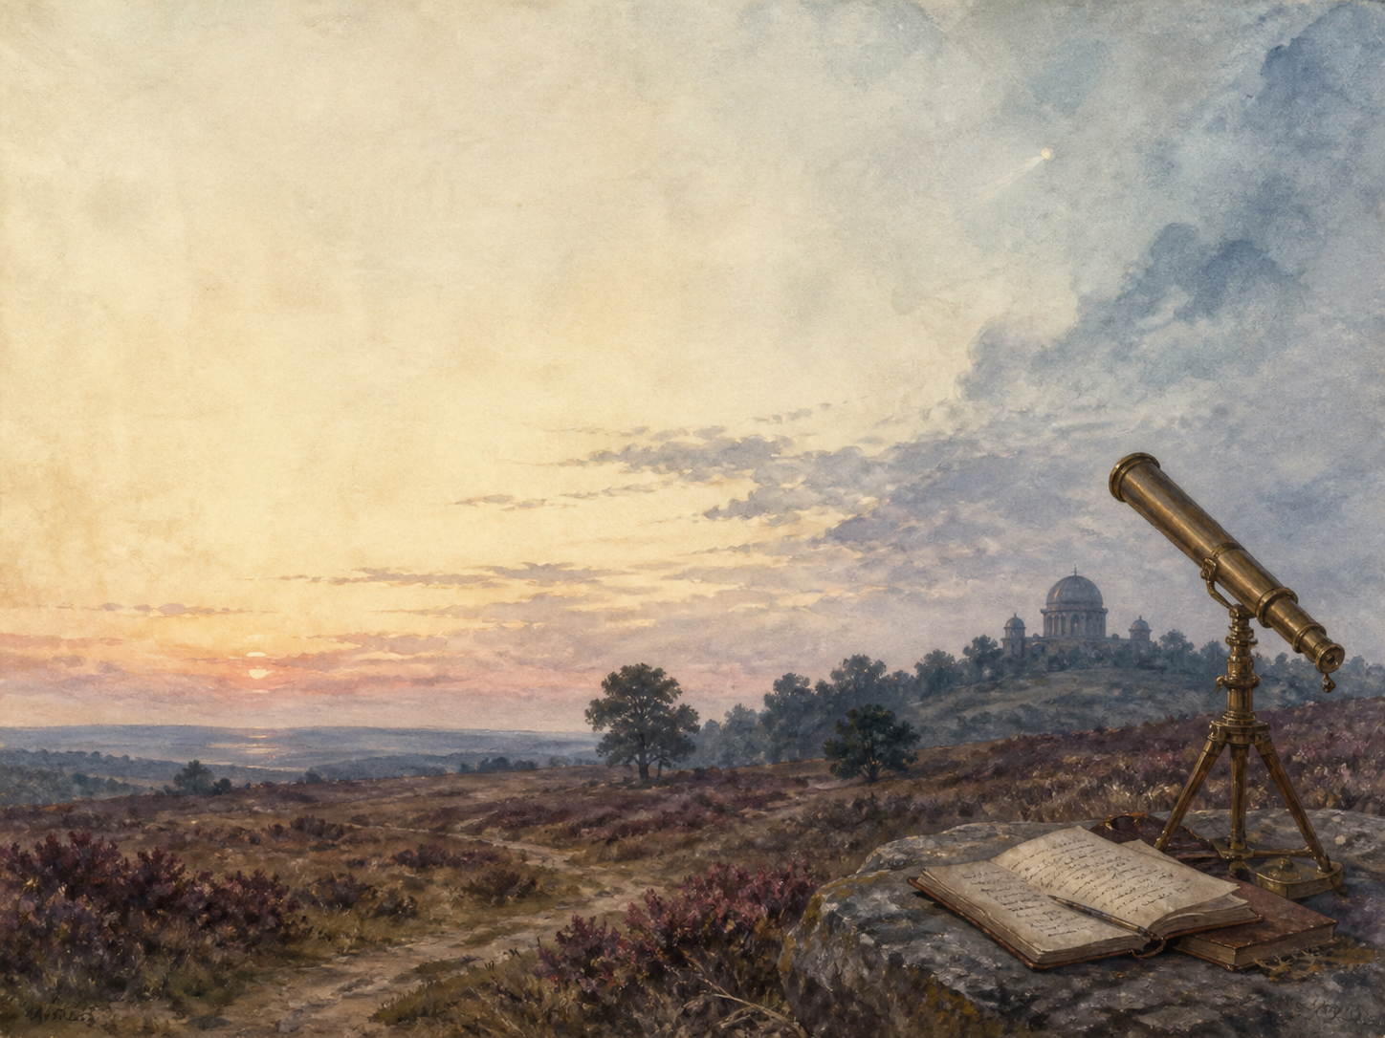
A LIVING BOOK STUDY - LEARNING BOOKLET
Name: _______________________

TASKS: DAY 1
Week 1 - Book One, I-II: The Eve of the War; The Falling Star
READ:
Astronomers see strange flashes on Mars. Soon a 'falling star' - really the first cylinder - lands on Horsell Common, and life carries calmly on.
NARRATION:
How do the Martians first announce themselves, and how calmly does ordinary life continue?
EXTENSION:
Science: research the planet Mars, and why Victorians imagined there was life on it.
Your response:

TASKS: DAY 2
Week 1 - Book One, III-IV: On Horsell Common; The Cylinder Opens
READ:
A curious crowd gathers around the pit. The great cylinder slowly unscrews, and the first Martian heaves itself into view.
NARRATION:
Describe the crowd at the pit and their first sight of a Martian.
EXTENSION:
Discuss: why does almost no one grasp the danger at first?
Your response:

TASKS: DAY 3
Week 1 - Book One, V-VI: The Heat-Ray
READ:
A party approaches the pit with a white flag of peace - and is destroyed by the Martians' invisible Heat-Ray.
NARRATION:
Retell the fate of the men who approach the Martians with a flag of truce.
EXTENSION:
Science: research how a laser works, and compare it to Wells's Heat-Ray.
Your response:

TASKS: DAY 4
Week 2 - Book One, VII-VIII: How I Reached Home; Friday Night
READ:
The narrator returns to his wife amid an uneasy calm, as more cylinders fall and the country slowly wakes to its danger.
DISCUSS:
How does Wells build a feeling of dread during this quiet pause before the storm?
EXTENSION:
Geography: begin mapping the invasion as it spreads across Surrey.
Your response:

TASKS: DAY 5
Week 2 - Book One, IX-X: The Fighting Begins; In the Storm
READ:
The towering fighting-machines rise up, the army opens fire, and the narrator is swept into a desperate flight through a thunderstorm.
NARRATION:
Retell how the fighting-machines appear and the narrator's escape through the storm.
EXTENSION:
Art: illustrate a Martian tripod striding through the rain and lightning.
Your response:

TASKS: DAY 6
Week 2 - Book One, XI-XII: At the Window; Destruction of Weybridge and Shepperton
READ:
The army manages to bring down a single Martian, but at a fearful cost, as whole towns are destroyed and the red weed begins to spread.
DISCUSS:
A Martian is destroyed at last. Why does this rare victory feel so small against the invasion?
EXTENSION:
Science: the 'red weed' spreads fast. Research real invasive species and the harm they do.
Your response:

TASKS: DAY 7
Week 3 - Book One, XIII-XIV: The Curate; In London
READ:
The narrator falls in with a frightened curate, while his brother, in London, watches the great city begin to panic.
NARRATION:
Introduce the curate, and describe how London first reacts to the news.
EXTENSION:
PSHE: discuss how people first react when normal life is suddenly threatened.
Your response:

TASKS: DAY 8
Week 3 - Book One, XV-XVI: What Had Happened in Surrey; The Exodus from London
READ:
The Martians unleash a suffocating Black Smoke, and millions flee the capital in a vast, chaotic exodus.
NARRATION:
Retell the horror of the Black Smoke and the desperate flight from London.
EXTENSION:
History: research real mass evacuations, and how societies cope under them.
Your response:

TASKS: DAY 9
Week 3 - Book One XVII + Book Two I-II: The Thunder Child; Under Foot; The Ruined House
READ:
The ironclad warship Thunder Child charges the machines to save fleeing ships. Then the narrator is trapped in a ruined house, watching the Martians at work.
NARRATION:
Describe the Thunder Child's heroic charge against the fighting-machines.
EXTENSION:
Discuss: the narrator is now trapped and helpless. How does the mood change as Book Two begins?
Your response:

TASKS: DAY 10
Week 4 - Book Two, III-IV: The Days of Imprisonment; The Death of the Curate
READ:
Trapped for days in the ruined house, the narrator and the curate turn on each other, with tragic results.
DISCUSS:
Fear affects the narrator and the curate very differently. What does it do to each of them?
EXTENSION:
PSHE: discuss how extreme stress and fear can change how people behave.
Your response:

TASKS: DAY 11
Week 4 - Book Two, V-VI: The Stillness; The Work of Fifteen Days
READ:
The narrator escapes into a strange, silent land smothered by red weed, and surveys the ruin the Martians have made.
NARRATION:
Describe the changed, silent, weed-covered world the narrator walks into.
EXTENSION:
Science: research how ecosystems recover after a major disaster.
Your response:

TASKS: DAY 12
Week 4 - Book Two, VII: The Man on Putney Hill
READ:
The narrator meets the artilleryman again, who lays out a grand plan for humanity to live underground and fight back - but does almost nothing.
DISCUSS:
The artilleryman talks boldly but acts idly. What is Wells saying about people through him?
EXTENSION:
Drama: perform the artilleryman's speech, and let your audience decide whether to believe him.
Your response:

TASKS: DAY 13
Week 4 - Book Two, VIII: Dead London
READ:
The narrator walks through an eerily deserted London - and finds the mighty Martians lying dead in their machines.
NARRATION:
Describe 'Dead London', and the narrator's astonishing discovery.
EXTENSION:
Science: research germs and the immune system - what really defeats the Martians?
Your response:

TASKS: DAY 14
Week 4 - Book Two, IX-X: Wreckage; The Epilogue
READ:
The world slowly recovers, the narrator is reunited with his wife, and he reflects on what the invasion has taught humankind.
WRAP-UP:
How does the world recover, and what lasting lesson does the narrator draw from it all?
EXTENSION:
'The Martians treat us as we treat lesser creatures.' How does Wells use the invasion to hold up a mirror to the British Empire?
Your response:

MY READING JOURNAL
Keep your own eyewitness journal of the invasion - note what happens, and how humanity's fortunes rise and fall.
Chapters | What happened | Who is winning now?

SCIENCE VS STORY
Wells mixes real science with invention. For each idea in the book, note the real science behind it - and how close Wells came.
Idea in the book | The real science
Life on Mars
The Heat-Ray
The red weed
Why the Martians die

