A FAMILY STUDY IN THE CHARLOTTE MASON TRADITION
THE SECRET GARDEN
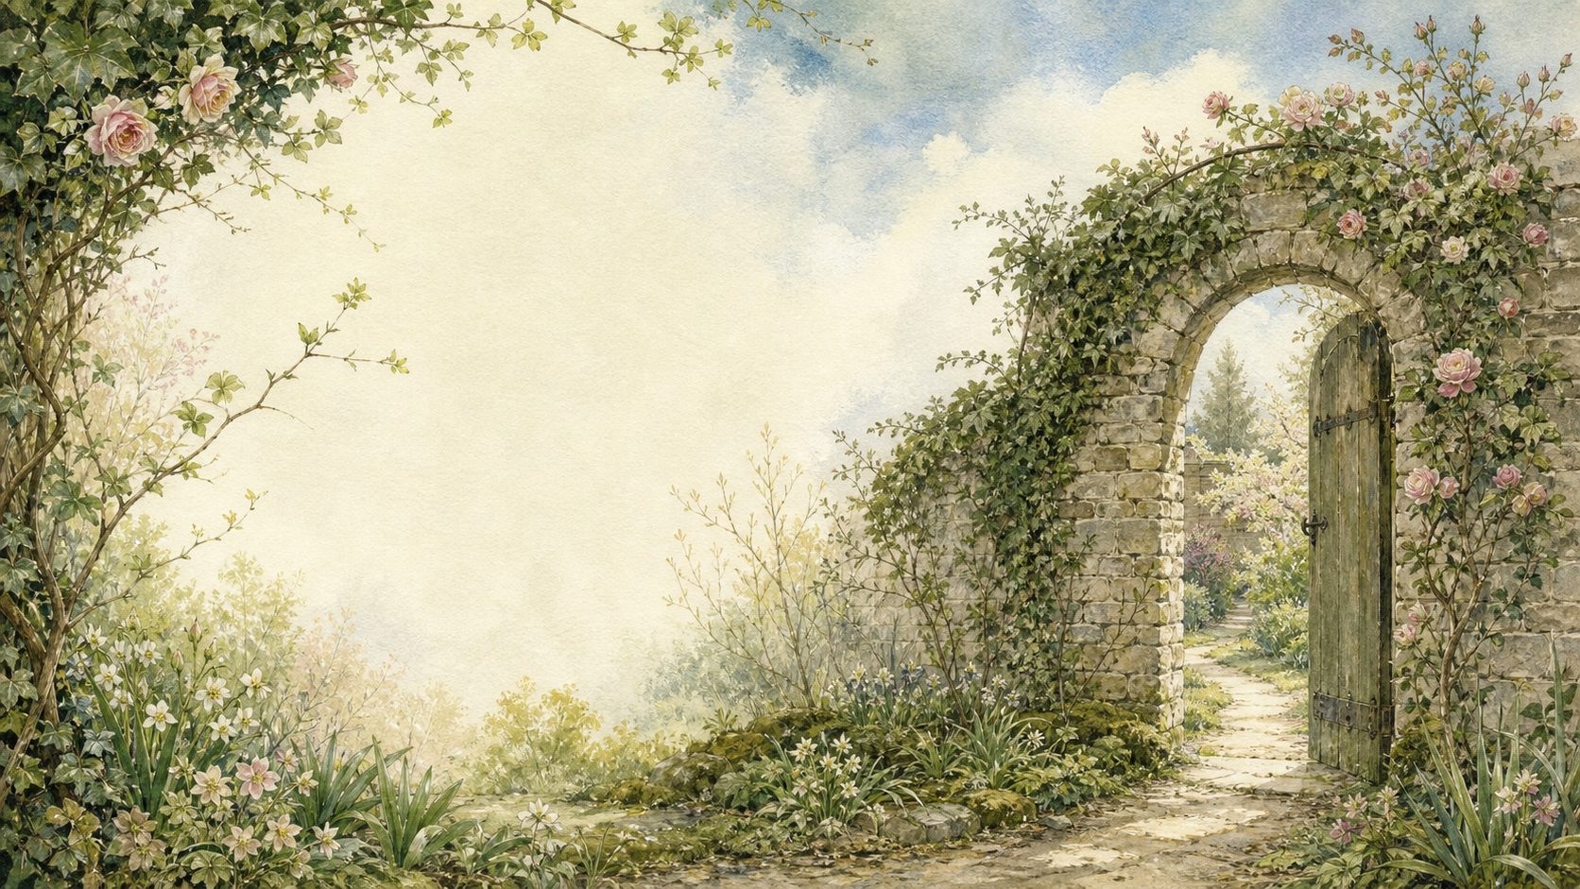
by Frances Hodgson Burnett

A Living Book Study for mixed-age learning

Welcome. This Living Book Study of The Secret Garden is written for parents teaching children of different ages side by side. Read together, talk together, and let the story do its quiet work.
In the Charlotte Mason tradition, we keep the feast wide: literature, nature, history, art, and thoughtful conversation. Choose what fits your family, do a little at a time, and let each child respond in their own way - by telling back, drawing, gardening, writing, or acting.
Alongside our shared reading, a few steady habits will support progress:
- For KS2: keep grammar, punctuation and spelling ticking along - little and often (for example, CGP workbook practice).
- For KS1: follow a systematic phonics programme with daily practice, and let early reading be cheerful and successful.

How to use this plan
- Follow the suggested medium-term plan, or use the activity map to build your own route.
- Choose play stations for KS1 children from the list below (1-2 a week).
- Print the accompanying Learning Booklet for chapter-by-chapter reading and response tasks.
- Use the Independent Study slides if older children are working through the plan on their own.
- A note for parents: the book is set partly in colonial India and reflects attitudes of its 1911 setting. See the Year 6/KS3 Extension section below for a gentle way to open that conversation with older children.

About the Text
First published in 1911, The Secret Garden follows Mary Lennox, a sickly and friendless child sent from India to live with her uncle on the Yorkshire moors after the death of her parents. There she discovers a locked, forgotten garden - and, slowly, a household full of secrets. As Mary tends the garden with the help of the servant boy Dickon, she and her sickly cousin Colin are both transformed by fresh air, friendship, and growing things.
Text used: the 1911 first edition is out of copyright and freely available from Project Gutenberg and Standard Ebooks (see Helpful Websites, below).
Topics included: History (Edwardian England, colonial India, Yorkshire life and dialect, Edwardian ideas about health), Science/Nature (gardening, plant life cycles, seasons, garden wildlife), Geography (India to Yorkshire), Art (garden illustration), and PSHE (grief, friendship, kindness, positive thinking).

KS1 Play-Based Learning Stations

It is important for KS1 children to continue to learn through play where possible. They can still enjoy the story with their siblings, but also continue to explore the world around them. It is also recommended that they follow a phonics scheme as they learn to read and write.
Activity | Learning Areas | Description | Resources
Hidden key and door hunt | PE + Problem Solving | Hide a key and a picture of a door somewhere in the garden or house; follow clues (like the robin) to find them. | Toy key, picture of a door, clue cards
Bulb and seed planting | UW + Fine Motor | Plant real bulbs or seeds in pots; check on them regularly and talk about what plants need to grow. | Pots, compost, bulbs/seeds, watering can
Robin bird feeder | DT + Nature | Make a simple bird feeder from a pine cone or recycled materials; hang it outside and watch for visitors. | Pine cones/yoghurt pots, bird seed, string
Yorkshire moor small world | Storytelling + Fine Motor | Build a small moor scene with heather, stones and toy sheep; retell Mary's journey across the moor. | Tuff tray, natural materials, small toy figures
Wheelchair garden walk | PE + PSED | Take turns pushing a toy pram or trolley around a 'garden route' outside, as Dickon does for Colin. | Toy pram/trolley, outdoor space
Magic thoughts jar | PSED + Literacy | Decorate a jar; each day, write or draw one good thing that happened, echoing Colin's 'Magic'. | Jam jar, paper slips, pens, decorating materials

The Secret Garden Activity Map KS2

Literacy:
- Keep a garden journal as you read the book - note new words, and how the garden changes each time it's described.
- Collect Yorkshire dialect words used by Martha, Dickon and Ben Weatherstaff, and write down what each one means.
- Write a diary entry as Mary on her first day at Misselthwaite Manor.
- Compare Mary at the start of the book with Mary by the end - what has changed in how she speaks and behaves?
- After reading the book, watch a film adaptation and compare it to the book.

History:
- Research Edwardian England (1901-1910) - what was life like in a great country house like Misselthwaite Manor?
- Research Yorkshire moor life and the people who worked on great estates.
- Find out about Edwardian ideas around health and 'fresh air cures' - why might doctors have recommended time outdoors for Colin?
- Record key dates into your Book of Centuries.

Geography:
- Trace Mary's journey from India to Yorkshire on a world map.
- Find Yorkshire and the North York Moors on a map of England, and research what the landscape looks like.
Science / Nature:
- Plant real bulbs or seeds and keep a growth diary alongside your reading, checking in as the secret garden itself comes to life.
- Research robins - their habits, and their place in British folklore and Christmas cards.
- Track the seasons through the book, from Mary's arrival in a bleak season to the garden bursting into life.

Art:
- Illustrate the secret garden as you imagine it before and after it is brought back to life.
- Design a garden of your own - draw a plan and label the plants you would grow.

Drama:
- Act out Colin's tantrum, and Mary's response to it.
- Perform the scene where Colin is taken outside to see the garden for the first time.

Year 6 and KS3 Extension:
- The book reflects British attitudes to colonial India in 1911, including how Mary is described and how she treats servants at the start of the story. Discuss: how does the book's view of India compare to how we would describe it today? Why is it important to notice this when reading older books?
- Discuss Mary and Colin as a matched pair - both begin the book unhappy, sickly and unpleasant to be around. What does Burnett suggest helps them both recover?
- 'Magic' is used throughout the book to describe growth, healing and positive thinking. Discuss what you think Burnett means by 'Magic' - is it supernatural, or something else?
- Research the history of tuberculosis and Edwardian fresh-air treatments, and consider how they might have shaped Colin's story.

Possible Medium-Term Plan (4 Weeks)

The novel has 27 short chapters. This plan groups them into fifteen reading days.

Week 1 - Chapters 1-8
Day | Read | Core Task | Extension / Cross-curricular
Day 1 | Ch 1-2: There Is No One Left / Mistress Mary Quite Contrary. | Narration: what kind of child is Mary at the start of the book? Why is she called 'quite contrary'? | History: research British colonial India in the early 1900s - what was Mary's life like there?
Day 2 | Ch 3-4: Across the Moor / Martha. | Literacy: collect a few Yorkshire dialect words Martha uses, and what they mean. | Geography: map the journey from India to Yorkshire.
Day 3 | Ch 5-6: The Cry in the Corridor / 'There Was Some One Crying'. | Discuss: how does Burnett build mystery and suspense in these chapters? | Predict: who do you think is crying, and why?
Day 4 | Ch 7-8: The Key of the Garden / The Robin Who Showed the Way. | Discuss: what might the key and the robin represent in the story? | Nature: research robins - their habits, and their place in British folklore.

Week 2 - Chapters 9-15
Day | Read | Core Task | Extension / Cross-curricular
Day 5 | Ch 9: The Strangest House Any One Ever Lived In. | Narration: how does Burnett describe Misselthwaite Manor? Find your favourite description. | Art: draw the house as you imagine it.
Day 6 | Ch 10-11: Dickon / The Nest of the Missel Thrush. | Discuss: what makes Dickon special? How is he different from Mary? | Art: draw Dickon with his animal friends.
Day 7 | Ch 12: 'Might I Have a Bit of Earth?' | Discuss: why is this such an important moment for Mary? | Nature: plant a real bulb or seed and start a growth diary.
Day 8 | Ch 13-14: 'I Am Colin' / A Young Rajah. | Discuss: compare Colin to Mary when we first met her. What is similar? | History: discuss why Colin might be nicknamed 'A Young Rajah' - link to the colonial context in the book.
Day 9 | Ch 15: Nest Building. | Narration: how does Mary begin to change Colin's outlook on life? | Writing: write a short conversation between Mary and Colin about the secret garden.

Week 3 - Chapters 16-22
Day | Read | Core Task | Extension / Cross-curricular
Day 10 | Ch 16-17: 'I Won't!' Said Mary / A Tantrum. | Discuss: why is Mary's reaction to Colin's tantrum important? | Drama: act out the tantrum scene.
Day 11 | Ch 18-19: 'Tha' Munnot Waste No Time' / 'It Has Come!' | Nature: research spring growth - what changes are happening in the garden? | Discuss: how does Dickon help Colin see things differently?
Day 12 | Ch 20: 'I Shall Live Forever - and Ever - and Ever!' | Narration: describe Colin's reaction to seeing the garden for the first time. | Art: illustrate this moment.
Day 13 | Ch 21-22: Ben Weatherstaff / When the Sun Went Down. | Discuss: why does Ben Weatherstaff care so much about the garden? | Narration: retell this section from Ben's point of view.

Week 4 - Chapters 23-27 and wrap-up
Day | Read | Core Task | Extension / Cross-curricular
Day 14 | Ch 23-24: Magic / 'Let Them Laugh'. | Discuss: what does 'Magic' mean in this book? Is it really magic, or something else - fresh air, exercise, friendship, positive thinking? | PSHE: try your own daily 'Magic' - a positive thought or piece of gratitude, each day for a week.
Day 15 | Ch 25-27: The Curtain / 'It's Mother!' / In the Garden. | Narration: how has the whole household changed by the end of the book? | Wrap-up: compare the beginning and end of the story - how have Mary, Colin, and Mr Craven all changed?

Helpful Websites

- Full text (free, out of copyright): Project Gutenberg - www.gutenberg.org/ebooks/113 and Standard Ebooks - standardebooks.org
- Edwardian country house life: National Trust - www.nationaltrust.org.uk
- Yorkshire dialect: Yorkshire Dialect Society - www.yorkshiredialectsociety.org.uk
- Gardening with children: RHS - www.rhs.org.uk/schools-gardening
- Robins and British garden birds: RSPB - www.rspb.org.uk

Glossary

- English Journal: a notebook where thoughts and images are kept while reading a novel. You can also use the printable booklet.
- Book of Centuries: a timeline in a book, taken from the Charlotte Mason tradition, where children add historical figures and important dates as they meet them.
- Dialect: a way of speaking particular to a region - Yorkshire dialect appears throughout this book in Martha, Dickon and Ben Weatherstaff's speech.
- Colonial India: the period when India was under British rule, which forms the backdrop to Mary's early childhood in this book.

Other Living Book Studies in the Series

- Alice's Adventures in Wonderland by Lewis Carroll (Year 5-7)
- The Wind in the Willows by Kenneth Grahame
- A Christmas Carol by Charles Dickens (Year 7-9, GCSE extension)
- The Strange Case of Dr Jekyll and Mr Hyde by Robert Louis Stevenson (GCSE)
- The Jungle Book by Rudyard Kipling

