INDEPENDENT STUDY COMPANION
THE SECRET GARDEN
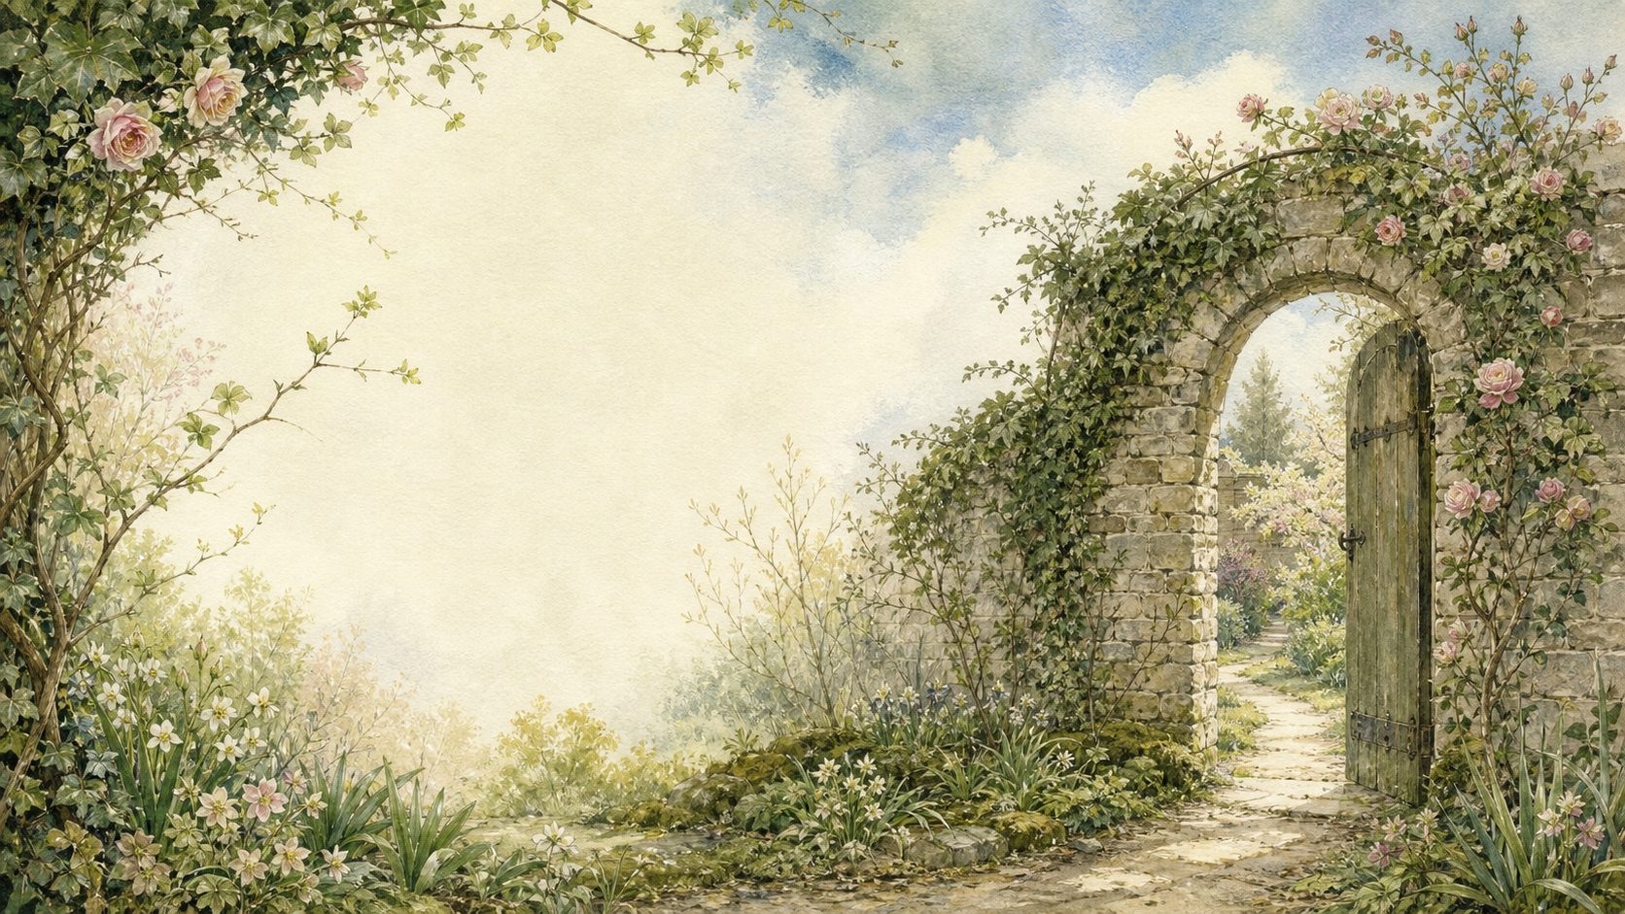
A LIVING BOOK STUDY - LEARNING BOOKLET
Name: _______________________

TASKS: DAY 1
Week 1 - Chapters 1-2
READ:
Chapter 1: There Is No One Left, and Chapter 2: Mistress Mary Quite Contrary.
NARRATION:
What kind of child is Mary at the start of the book? Why is she called 'quite contrary'?
EXTENSION:
History: research British colonial India in the early 1900s. What was Mary's life like there?
Your response:

TASKS: DAY 2
Week 1 - Chapters 3-4
READ:
Chapter 3: Across the Moor, and Chapter 4: Martha.
LITERACY:
Collect a few Yorkshire dialect words Martha uses, and write down what each one means.
EXTENSION:
Geography: trace the journey from India to Yorkshire on a map.
Your response:

TASKS: DAY 3
Week 1 - Chapters 5-6
READ:
Chapter 5: The Cry in the Corridor, and Chapter 6: 'There Was Some One Crying - There Was!'
DISCUSS:
How does Burnett build mystery and suspense in these chapters?
EXTENSION:
Predict: who do you think is crying, and why?
Your response:

TASKS: DAY 4
Week 1 - Chapters 7-8
READ:
Chapter 7: The Key of the Garden, and Chapter 8: The Robin Who Showed the Way.
DISCUSS:
What might the key and the robin represent in the story?
EXTENSION:
Nature: research robins - their habits, and their place in British folklore.
Your response:

TASKS: DAY 5
Week 2 - Chapter 9
READ:
Chapter 9: The Strangest House Any One Ever Lived In.
NARRATION:
How does Burnett describe Misselthwaite Manor? Find your favourite description.
EXTENSION:
Art: draw the house as you imagine it.
Your response:

TASKS: DAY 6
Week 2 - Chapters 10-11
READ:
Chapter 10: Dickon, and Chapter 11: The Nest of the Missel Thrush.
DISCUSS:
What makes Dickon special? How is he different from Mary?
EXTENSION:
Art: draw Dickon with his animal friends.
Your response:

TASKS: DAY 7
Week 2 - Chapter 12
READ:
Chapter 12: 'Might I Have a Bit of Earth?'
DISCUSS:
Why is this such an important moment for Mary?
EXTENSION:
Nature: plant a real bulb or seed and start a growth diary alongside your reading.
Your response:

TASKS: DAY 8
Week 2 - Chapters 13-14
READ:
Chapter 13: 'I Am Colin', and Chapter 14: A Young Rajah.
DISCUSS:
Compare Colin to Mary when we first met her. What is similar?
EXTENSION:
History: discuss why Colin might be nicknamed 'A Young Rajah' - link to the colonial context in the book.
Your response:

TASKS: DAY 9
Week 2 - Chapter 15
READ:
Chapter 15: Nest Building.
NARRATION:
How does Mary begin to change Colin's outlook on life?
EXTENSION:
Writing: write a short conversation between Mary and Colin about the secret garden.
Your response:

TASKS: DAY 10
Week 3 - Chapters 16-17
READ:
Chapter 16: 'I Won't!' Said Mary, and Chapter 17: A Tantrum.
DISCUSS:
Why is Mary's reaction to Colin's tantrum important?
EXTENSION:
Drama: act out the tantrum scene with a friend or family member.
Your response:

TASKS: DAY 11
Week 3 - Chapters 18-19
READ:
Chapter 18: 'Tha' Munnot Waste No Time', and Chapter 19: 'It Has Come!'
NATURE:
Research spring growth - what changes are happening in the garden at this point in the story?
EXTENSION:
Discuss: how does Dickon help Colin see things differently?
Your response:

TASKS: DAY 12
Week 3 - Chapter 20
READ:
Chapter 20: 'I Shall Live Forever - and Ever - and Ever!'
NARRATION:
Describe Colin's reaction to seeing the garden for the first time.
EXTENSION:
Art: illustrate this moment.
Your response:

TASKS: DAY 13
Week 3 - Chapters 21-22
READ:
Chapter 21: Ben Weatherstaff, and Chapter 22: When the Sun Went Down.
DISCUSS:
Why does Ben Weatherstaff care so much about the garden?
EXTENSION:
Narration: retell this section from Ben's point of view.
Your response:

TASKS: DAY 14
Week 4 - Chapters 23-24
READ:
Chapter 23: Magic, and Chapter 24: 'Let Them Laugh'.
DISCUSS:
What does 'Magic' mean in this book? Is it really magic, or something else - fresh air, exercise, friendship, positive thinking?
EXTENSION:
PSHE: try your own daily 'Magic' - write one positive thought or piece of gratitude, each day for a week.
Your response:

TASKS: DAY 15
Week 4 - Chapters 25-27
READ:
Chapter 25: The Curtain, Chapter 26: 'It's Mother!', and Chapter 27: In the Garden.
NARRATION:
How has the whole household changed by the end of the book?
EXTENSION:
Wrap-up: compare the beginning and end of the story - how have Mary, Colin, and Mr Craven all changed?
Your response:

GROWTH DIARY
If you are growing a real bulb or seed alongside the story, use this page to record what you see each week.
Week | What I see | Drawing

YORKSHIRE DIALECT WORD BANK
Collect dialect words used by Martha, Dickon and Ben Weatherstaff as you read, and write down what each one means.
Word | Who says it | What it means

