A FAMILY STUDY IN THE CHARLOTTE MASON TRADITION
THE PICTURE OF DORIAN GRAY
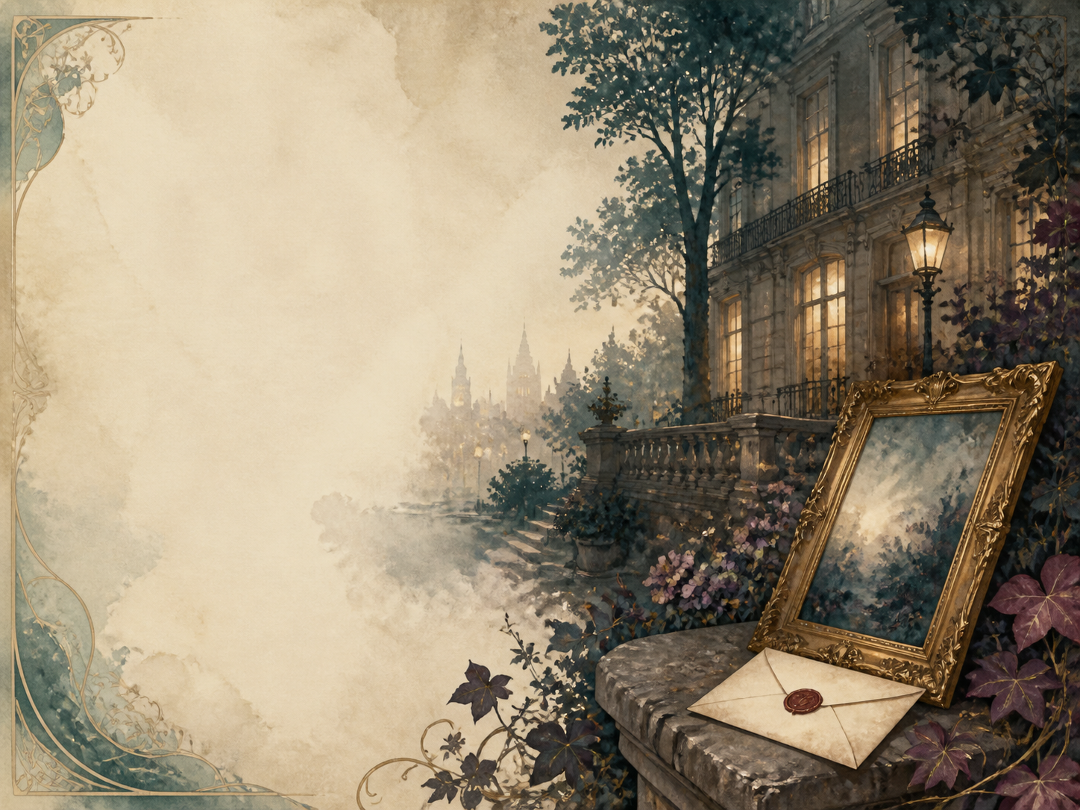
by Oscar Wilde

A Living Book Study for Year 9 (GCSE lead-in), with a Year 8 Support Tier

Welcome. This Living Book Study of The Picture of Dorian Gray is written for families teaching children of different ages side by side, with a core plan pitched at Year 9 as a lead-in to GCSE, and a lighter-touch tier for Year 8.
In the Charlotte Mason tradition, we keep the feast wide alongside the story: history, art and searching conversation sit next to writing, drama and discussion. Choose what fits your family, do a little at a time, and let each child respond in their own way.
A few steady habits will support progress:
- For Year 8: follow the eerie story of the man whose portrait ages while he does not, and enjoy Wilde's dazzling wit.
- For Year 9: keep a reading journal, and start analysing how Wilde uses the portrait as a symbol, and how one person can corrupt another.
- For GCSE (Years 10-11): use the extension tasks to write analytically about the Gothic, influence and the double life, with an eye on context.

How to use this plan
- Follow the suggested 4-week medium-term plan, or use the subject activity map to build your own route.
- Print the accompanying Learning Booklet for reading and response tasks.
- Use the Independent Study slides if a student is working through the plan on their own.
- A note for parents: this is the most grown-up book in the Year 9 set, and better suited to the older end of the age range. It follows a young man's slide into a life of selfish pleasure, and includes the ruin and suicide of a young actress, a murder and the disposal of the body, scenes in an opium den, and Dorian's own violent death. There is also a strong (though unstated) hint of romantic feeling between two men, reflecting Wilde's world - and the book was later used against Wilde at his trial, which is important context. Nothing is graphic, but please read ahead and decide if it suits your child now.

About the Text
Published in 1890 and expanded in 1891, The Picture of Dorian Gray is Oscar Wilde's only novel. A beautiful young man, Dorian, wishes that a portrait of himself would grow old and bear the marks of his sins, while he stays forever young and unblemished. His wish is granted - and, freed from any visible consequence, Dorian sinks into a secret life of cruelty and vice, as the hidden portrait grows more hideous with every wrong.
Witty, glittering and darkly Gothic, the novel is a fable about beauty, influence and conscience. Wilde was a leader of the 'Aesthetic Movement', which prized beauty and art above all - and this book both celebrates and warns against that idea.
Text used: the 1891 text is out of copyright and freely available from Project Gutenberg and Standard Ebooks (see Helpful Websites, below).
Topics included: History (Oscar Wilde, the Aesthetic Movement, Victorian hypocrisy), Art (portraiture and what art can capture), Science/Ethics (pleasure, influence and addiction), RE/PSHE (conscience, guilt and the cost of a limitless life), and Drama.
Year 8 Support Tier

A younger or less confident reader can enjoy the ghostly central idea and Wilde's sparkling talk without the closer analysis aimed at older students. These activities keep the focus on the story's imagination and its wit.
Activity | Learning Areas | Description | Resources
Design the changing portrait | Art | Draw the portrait twice - young and beautiful at the start, then aged and corrupted at the end. | Paper, pens
Write your own epigrams | Literacy | Wilde fills the book with witty one-liners. Write three clever sayings of your own. | Paper, pens
Aesthetic Movement | History + Art | Research 'art for art's sake' and the Aesthetic Movement Wilde belonged to. | Books or internet access
If the mirror told the truth | Literacy | Write a short story in which someone's reflection shows their real self, good or bad. | Paper, pens
Can a book change a person? | Drama + PSHE | A mysterious 'yellow book' helps corrupt Dorian. Debate whether a book can really make someone worse. | Nothing needed

Year 9 Subject Activity Map

Literacy:
- Track the portrait as a symbol: it changes with every one of Dorian's sins, standing in for his conscience or soul.
- Collect Wilde's epigrams (witty, upside-down sayings) and discuss what makes them so quotable.
- The 'yellow book' Lord Henry gives Dorian seems to corrupt him. Explore the idea of art or ideas 'infecting' a person.
- Compare Dorian Gray with other 'double life' stories, especially Jekyll and Hyde and Frankenstein.
- Write a diary entry as Dorian on the night he first notices the portrait has changed.

History:
- Research Oscar Wilde and the Aesthetic Movement, and its motto 'art for art's sake'.
- Research Victorian hypocrisy - the gap between public respectability and private behaviour - which the novel exposes.
- Research Wilde's trial and imprisonment in 1895; this very book was quoted against him. Discuss why that matters.
- Record key dates into your Book of Centuries.
Art:
- Research portrait painting, and discuss what a great portrait can seem to 'capture' about a person.
- Design your own version of the portrait's transformation across the novel.
- Discuss the idea, raised in the Preface, that art should be beautiful rather than useful.
Science / Ethics:
- Discuss the idea of living purely for pleasure. What does the novel suggest it costs?
- Discuss influence: how does Lord Henry shape Dorian? How much are we shaped by the people around us?
- The novel features an opium den. Research how Victorians viewed such places, and what addiction really does.

RE / PSHE:
- Discuss conscience: the portrait is Dorian's conscience made visible. What happens when he tries to ignore it?
- Discuss what we owe other people, through Dorian's treatment of Sibyl Vane and of Basil.
- Discuss whether a person can truly escape the consequences of how they live.
Drama:
- Perform a scene of Lord Henry's tempting, paradoxical talk.
- Stage the moment Dorian first sees the change in the portrait.
- Design a stage or film set for Dorian's hidden, locked room.
GCSE (Years 10-11) Extension:
- The Picture of Dorian Gray is a rich Gothic text. Plan a response to: 'How does Wilde present the theme of influence and corruption?'
- Analyse the portrait as a symbol, and how Wilde uses the Gothic 'double'.
- Explore the novel's context: aestheticism, Victorian morality, and Wilde's own life.
- Compare Dorian Gray with another Gothic text you know (such as Jekyll and Hyde or Frankenstein).

Possible Medium-Term Plan (4 Weeks)

The novel has a Preface and twenty chapters. This plan groups them by the stages of Dorian's story.

Week 1 - The Portrait and the Bargain (Preface + Ch 1-5)
Day | Read | Core Task | Extension / Cross-curricular
Day 1 | Preface + Ch 1. | Discuss: read Wilde's Preface on art, then meet Basil, Lord Henry and the finished portrait. | Art: research portrait painting and what a portrait can seem to capture.
Day 2 | Ch 2. | Narration: Lord Henry fills Dorian's head with ideas about youth and pleasure, and Dorian makes his fateful wish. | Discuss: what exactly does Dorian wish for, and why is it so dangerous?
Day 3 | Ch 3-4. | Discuss: how does Lord Henry's influence over Dorian grow? Then Dorian falls in love with the actress Sibyl Vane. | PSHE: discuss how much we are shaped by the people we admire.
Day 4 | Ch 5. | Narration: meet Sibyl, her mother, and her fiercely protective brother James. | Literacy: how does Wilde make us care about Sibyl before what is to come?

Week 2 - The First Cruelty (Ch 6-10)
Day | Read | Core Task | Extension / Cross-curricular
Day 5 | Ch 6-7. | Narration: Sibyl acts badly the night Dorian brings friends, and he cruelly casts her off. Then the portrait first changes. | Discuss: why does Sibyl act 'badly', and is Dorian's cruelty forgivable?
Day 6 | Ch 8. | Narration: Dorian learns Sibyl has killed herself, and Lord Henry persuades him to feel almost nothing. | RE/PSHE: discuss conscience, and how Dorian begins to silence his.
Day 7 | Ch 9-10. | Narration: Dorian hides the portrait away, and is drawn deeper into corruption by a strange 'yellow book'. | Literacy: explore the idea of a book or set of ideas 'infecting' a person.

Week 3 - The Descent (Ch 11-14)
Day | Read | Core Task | Extension / Cross-curricular
Day 8 | Ch 11. | Narration: years pass in secret sin; Dorian's name grows dark while his face stays young and lovely. | History: research Victorian hypocrisy - the gap between public and private life.
Day 9 | Ch 12-13. | Narration: Basil confronts Dorian about the rumours, is shown the hideous portrait - and is murdered. | Discuss: this is the story's turning point. How does Wilde make it so shocking?
Day 10 | Ch 14. | Narration: Dorian blackmails the scientist Alan Campbell into destroying the body. | PSHE: discuss how one crime forces Dorian into more, dragging others down with him.

Week 4 - Reckoning (Ch 15-20)
Day | Read | Core Task | Extension / Cross-curricular
Day 11 | Ch 15-16. | Narration: Dorian moves from a glittering party to a squalid opium den, where Sibyl's brother James recognises him. | Science: research how Victorians viewed opium dens, and what addiction really does.
Day 12 | Ch 17-18. | Narration: James Vane stalks Dorian at his country house and is killed in a shooting accident. | Discuss: Dorian escapes yet again. Is he lucky, or is something catching up with him?
Day 13 | Ch 19. | Discuss: Dorian resolves to become good - but realises even this 'good deed' was really vanity. | RE/PSHE: can Dorian truly reform, or has he left it too late?
Day 14 | Ch 20. | Wrap-up: Dorian attacks the portrait to destroy his conscience once and for all - with a terrible result. | Extension: 'The portrait is Dorian's conscience.' How does Wilde use it across the whole novel?

Helpful Websites

- Full text (free, out of copyright): Project Gutenberg - www.gutenberg.org/ebooks/174 and Standard Ebooks - standardebooks.org
- Oscar Wilde's life and works: The British Library - www.bl.uk
- The Aesthetic Movement and 'art for art's sake': Victoria and Albert Museum - www.vam.ac.uk
- Victorian portrait painting: National Portrait Gallery - www.npg.org.uk
- Victorian London and its underworld: Museum of London - www.museumoflondon.org.uk

Glossary

- Reading Journal: a notebook where thoughts and images are kept while reading a novel. You can also use the printable booklet.
- Book of Centuries: a timeline in a book, taken from the Charlotte Mason tradition, where children add historical figures and important dates as they meet them.
- Aestheticism: the belief that beauty and art matter above all else - 'art for art's sake' - which Wilde championed.
- Epigram: a short, witty, surprising saying; Wilde was a master of them.
- Gothic: a style of writing full of dread, secrets, and the supernatural.
- Doppelganger / double: a second self or hidden version of a person - here, the portrait is Dorian's true self.

Other Living Book Studies in the Series

- Jane Eyre by Charlotte Bronte
- Wuthering Heights by Emily Bronte
- Pride and Prejudice by Jane Austen
- Romeo and Juliet by William Shakespeare
- The Strange Case of Dr Jekyll and Mr Hyde by Robert Louis Stevenson (GCSE)

