INDEPENDENT STUDY COMPANION
THE PICTURE OF DORIAN GRAY
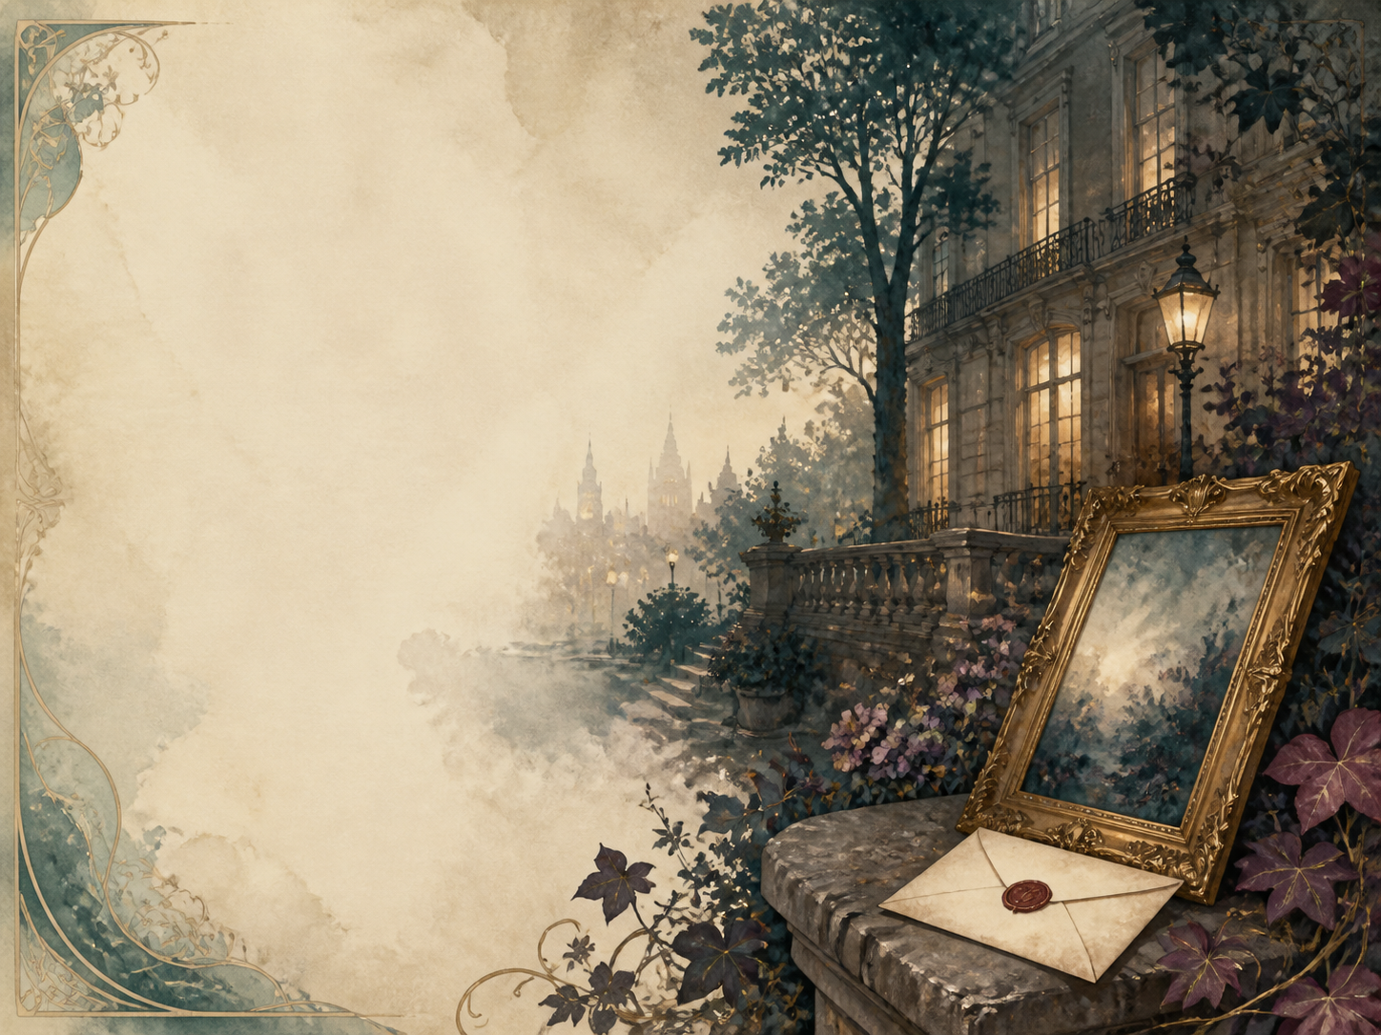
A LIVING BOOK STUDY - LEARNING BOOKLET
Name: _______________________

TASKS: DAY 1
Week 1 - Preface + Chapter 1
READ:
Wilde's short Preface sets out his ideas about art. Then the painter Basil Hallward finishes a portrait of the beautiful Dorian Gray, watched by the witty, cynical Lord Henry Wotton.
DISCUSS:
Read the Preface, then meet the three men. What does each seem to want?
EXTENSION:
Art: research portrait painting, and what a fine portrait can seem to 'capture' about a person.
Your response:

TASKS: DAY 2
Week 1 - Chapter 2: The Wish
READ:
Lord Henry dazzles Dorian with ideas about youth and pleasure. Fearing age, Dorian wishes the portrait would grow old in his place.
NARRATION:
Describe Dorian's fateful wish, and what leads him to make it.
EXTENSION:
Discuss: what exactly does Dorian wish for, and why is it so dangerous?
Your response:

TASKS: DAY 3
Week 1 - Chapters 3-4: Influence and Love
READ:
Lord Henry's grip on Dorian tightens; then Dorian falls headlong in love with a young actress, Sibyl Vane.
DISCUSS:
How does Lord Henry's influence over Dorian grow, day by day?
EXTENSION:
PSHE: discuss how much we are shaped by the people we admire.
Your response:

TASKS: DAY 4
Week 1 - Chapter 5: Sibyl's Family
READ:
We meet Sibyl at home with her anxious mother and her devoted brother James, who vows to protect her.
NARRATION:
Introduce Sibyl, her mother, and her protective brother James.
EXTENSION:
Literacy: how does Wilde make us care about Sibyl before what is to come?
Your response:

TASKS: DAY 5
Week 2 - Chapters 6-7: The First Cruelty
READ:
Sibyl acts badly the night Dorian brings friends to watch - real love has made pretending feel false - and he cruelly rejects her. That night the portrait first changes.
NARRATION:
Retell how Dorian rejects Sibyl, and what he then notices about the portrait.
EXTENSION:
Discuss: why does Sibyl act 'badly', and is Dorian's cruelty ever forgivable?
Your response:

TASKS: DAY 6
Week 2 - Chapter 8: A Hardened Heart
READ:
Dorian learns that Sibyl has killed herself. Lord Henry talks him out of his guilt, teaching him to treat it all as a kind of drama.
DISCUSS:
How does Dorian begin to silence his conscience after Sibyl's death?
EXTENSION:
RE/PSHE: discuss conscience, and what happens when we train ourselves not to feel guilt.
Your response:

TASKS: DAY 7
Week 2 - Chapters 9-10: The Portrait Hidden
READ:
Dorian locks the portrait away in an old schoolroom, and is drawn deeper into corruption by a mysterious 'yellow book' Lord Henry sends him.
NARRATION:
Describe how and why Dorian hides the portrait.
EXTENSION:
Literacy: explore the idea of a book, or a set of ideas, 'infecting' a person.
Your response:

TASKS: DAY 8
Week 3 - Chapter 11: Years of Sin
READ:
Years pass. Dorian's reputation grows darker with whispered scandals, yet his face stays young and unspoiled while the hidden portrait rots.
DISCUSS:
How does Wilde show Dorian's secret corruption without spelling out every detail?
EXTENSION:
History: research Victorian hypocrisy - the gap between public respectability and private life.
Your response:

TASKS: DAY 9
Week 3 - Chapters 12-13: Murder
READ:
Basil confronts Dorian about the terrible rumours. Dorian shows him the hideous portrait - and then murders him.
NARRATION:
Retell the confrontation with Basil and its shocking end.
EXTENSION:
Discuss: this is the story's turning point. How does Wilde make it so shocking?
Your response:

TASKS: DAY 10
Week 3 - Chapter 14: Covering the Crime
READ:
Dorian blackmails an old friend, the scientist Alan Campbell, into destroying Basil's body.
DISCUSS:
How does one crime force Dorian into more, dragging others down with him?
EXTENSION:
PSHE: discuss how wrongdoing can trap a person in a chain of further wrongs.
Your response:

TASKS: DAY 11
Week 4 - Chapters 15-16: The Opium Den
READ:
Dorian slips from a glittering party to a squalid opium den, where Sibyl's brother James suddenly recognises him.
NARRATION:
Describe Dorian's night, and the danger James Vane now poses.
EXTENSION:
Science: research how Victorians viewed opium dens, and what addiction really does to a person.
Your response:

TASKS: DAY 12
Week 4 - Chapters 17-18: The Hunter Killed
READ:
James Vane stalks Dorian at his country house, but is killed by accident during a shooting party.
DISCUSS:
Dorian escapes danger yet again. Is he simply lucky, or is something closing in on him?
EXTENSION:
Literacy: notice how Wilde keeps a sense of doom hanging over Dorian even in safety.
Your response:

TASKS: DAY 13
Week 4 - Chapter 19: A False Reform
READ:
Dorian resolves to change and be good - but comes to see that even his one 'good deed' was really done out of vanity.
DISCUSS:
Can Dorian truly reform, or has he left it too late?
EXTENSION:
RE/PSHE: discuss whether good actions still count if they are done for the wrong reasons.
Your response:

TASKS: DAY 14
Week 4 - Chapter 20: The Reckoning
READ:
Tormented by the portrait, Dorian stabs it to destroy his conscience for good - and is found dead and hideous, while the picture is beautiful once more.
WRAP-UP:
What finally happens, and why is the ending so fitting?
EXTENSION:
'The portrait is Dorian's conscience made visible.' How does Wilde use it across the whole novel?
Your response:

THE PORTRAIT AS A MIRROR OF THE SOUL
Each time Dorian does wrong, the portrait changes. Track the key changes and what causes each one.
What Dorian does | How the portrait changes

WILDE'S WIT - EPIGRAM COLLECTION
Wilde fills the book with sparkling, upside-down sayings. Collect your favourites here, then try writing three of your own.
Epigram from the book | What it really means

