A FAMILY STUDY IN THE CHARLOTTE MASON TRADITION
THE JUNGLE BOOK
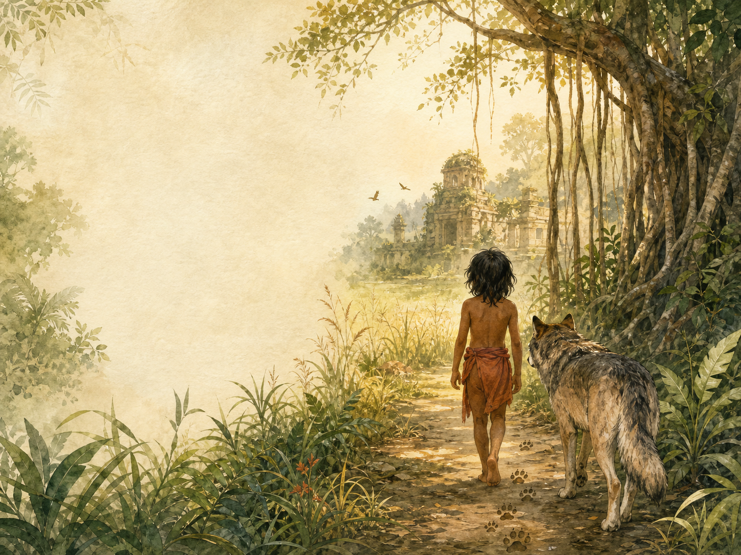
by Rudyard Kipling

A Living Book Study for KS3, with a Years 5-6 Support Tier

Welcome. This Living Book Study of The Jungle Book is written for families teaching children of different ages side by side, with a core plan for Years 7-9 and a lighter-touch tier for Years 5-6.
In the Charlotte Mason tradition, we keep the feast wide alongside the stories: history, geography, science and thoughtful conversation sit next to poetry, drama and discussion. Choose what fits your family, do a little at a time, and let each child respond in their own way.
A few steady habits will support progress:
- For Years 5-6: enjoy the stories and their poems, and start noticing the 'Law of the Jungle' as it appears.
- For Years 7-9: collect every 'Law of the Jungle' rule as you meet it, and start thinking about what it suggests about order, respect and belonging.
- For Years 9-11: use the extension tasks to think critically about the book's colonial setting and Kipling's own complicated legacy.

How to use this plan
- Follow the suggested 4-week medium-term plan, or use the subject activity map to build your own route.
- Print the accompanying Learning Booklet for story-by-story reading and response tasks.
- Use the Independent Study slides if a student is working through the plan on their own.
- A note for parents: this collection is set in colonial India and reflects attitudes of its 1894 setting, including the assumptions of the British Raj. See the Extension section below for a way to open that conversation with older children.

About the Text
First published in 1894, The Jungle Book is a collection of seven stories, each followed by a poem. Three tell the story of Mowgli, a boy raised by wolves in the Indian jungle and taught the 'Law of the Jungle' by Baloo the bear and Bagheera the panther. The other four stand alone: an Alaskan fur seal searching for a safe home, a brave mongoose defending a family from cobras, a boy who witnesses a secret elephant ceremony, and army camp animals speaking on the eve of battle. Kipling's stories helped shape how generations of readers imagined the jungle - and his 'Law of the Jungle' has entered everyday language.
Text used: the 1894 first edition is out of copyright and freely available from Project Gutenberg and Standard Ebooks (see Helpful Websites, below).
Topics included: History (British colonial India, Kipling's life), Science/Nature (wolf packs, fur seals, mongooses and cobras, elephants), Geography (India, the Bering Sea), Art (jungle animals, the elephant dance), Drama (the Law of the Jungle, Rikki-Tikki's fight with Nag), and Poetry (the seven poems that accompany the stories).
Years 5-6 Support Tier

Younger children can enjoy these vivid stories and their poems without needing to engage with the deeper historical and critical discussion aimed at older students.
Activity | Learning Areas | Description | Resources
Animal mask making | Art + Imaginative Play | Make simple masks for Mowgli's jungle friends - Baloo, Bagheera, Kaa - and act out a favourite scene. | Paper plates, elastic, craft materials
Law of the Jungle poster | Literacy + Art | Choose three simple rules from the Law of the Jungle and illustrate them as a poster for your room. | Paper/card, pens
Rikki-Tikki puppet show | Drama + Fine Motor | Make simple sock or paper-bag puppets for Rikki-Tikki, Nag and Nagaina, and act out the story. | Socks or paper bags, craft materials
Jungle small world | Storytelling + Fine Motor | Build a jungle scene in a tray with toy animals and plants; retell a story you've read. | Tuff tray, toy animals, greenery
Elephant footprint art | Art + Science | Research how big an elephant's footprint really is, then paint or draw one to scale. | Large paper, paint, measuring tape

KS3 Subject Activity Map

Literacy:
- Collect every 'Law of the Jungle' rule as you meet it across the three Mowgli stories, and discuss what each one teaches.
- Compare Kipling's narrative styles across the seven stories - some are told with a warm, storytelling voice, others more seriously.
- Choose a poem from the collection and discuss what it adds to the story it follows.
- Write your own short 'law' or rule in Kipling's style, for a group or place you know well.
- Track Mowgli's growth across his three stories - how does he change from 'Mowgli's Brothers' to 'Tiger! Tiger!'?

History:
- Research British colonial India (the Raj) in the late 19th century, when Kipling was writing.
- Research Rudyard Kipling's own life - born in Bombay, sent to school in England as a child, and later the youngest ever winner of the Nobel Prize in Literature (1907).
- Research the real use of elephants in Indian logging camps, as shown in 'Toomai of the Elephants'.
- Research the British Indian Army in the Victorian era, and the real role of animals in military logistics, linked to 'Her Majesty's Servants'.
- Record key dates into your Book of Centuries.
Science / Nature:
- Research real wolf pack behaviour and compare it to Kipling's version in the Mowgli stories.
- Research fur seals and the history of seal hunting in the Bering Sea and North Pacific, linked to 'The White Seal'.
- Research mongooses and their real relationship with cobras and other snakes, linked to 'Rikki-Tikki-Tavi'.
- Research elephant intelligence and behaviour.

Geography:
- Map the Indian jungle settings of the Mowgli stories, 'Rikki-Tikki-Tavi' and 'Toomai of the Elephants'.
- Map the Bering Sea and North Pacific for 'The White Seal', and trace Kotick's journey to find a safe island.

Art:
- Illustrate a scene from any of the seven stories.
- Draw the secret elephant dance that Toomai witnesses.
- Design a poster showing the animal cast of the Mowgli stories, in role (Baloo the teacher, Bagheera the protector, Kaa the hunter).

Drama:
- Perform the scene where Baloo and Bagheera rescue Mowgli from the Bandar-log.
- Act out Rikki-Tikki-Tavi's fight with Nag.
- Read the 'Law of the Jungle' aloud as a formal recitation.
Years 9-11 Extension:
- Kipling is a famously complicated figure - celebrated as a storyteller, but also the author of 'The White Man's Burden', a poem that helped justify empire. Discuss: does knowing this change how you read The Jungle Book?
- Some readers see the 'Law of the Jungle' as more than a story rule - as a reflection of ideas about hierarchy, order and 'civilising' rule that were common in the age of empire. Plan a response to: 'How does the Law of the Jungle reflect the ideas of the time it was written?'
- Compare the different narrative perspectives across the seven stories - what unifies the collection thematically, despite such different settings and characters?
- Research Kipling's own childhood, including being sent to England as a young child under the care of strangers - a common practice for colonial families - and discuss how this might have shaped his writing about belonging and displacement.

Possible Medium-Term Plan (4 Weeks)

The collection has seven stories, each followed by a poem: Mowgli's Brothers, Kaa's Hunting, and 'Tiger! Tiger!' (the Mowgli trilogy), then The White Seal, Rikki-Tikki-Tavi, Toomai of the Elephants, and Her Majesty's Servants.

Week 1 - The Mowgli Trilogy
Day | Read | Core Task | Extension / Cross-curricular
Day 1 | Mowgli's Brothers, and the poem Hunting-Song of the Seeonee Pack. | Narration: how is Mowgli adopted into the wolf pack? What is the Law of the Jungle, as introduced here? | Poetry: read the Hunting-Song aloud - what does it tell us about wolf pack life?
Day 2 | Kaa's Hunting, and the poem Road-Song of the Bandar-Log. | Discuss: why are the Bandar-log (monkeys) considered outcasts in the jungle? What does this story teach about showing off? | Poetry: compare the playful tone of the Bandar-Log song to the serious Law of the Jungle.
Day 3 | 'Tiger! Tiger!', and the poem Mowgli's Song. | Discuss: how does Mowgli's story end in this first trilogy? What does it mean for him to return to human society? | Writing: write Mowgli's feelings as he leaves the jungle for the village.
Day 4 | Response day - no new reading. | Collect every 'Law of the Jungle' rule mentioned across the three Mowgli stories in a list. | History: research real wolf pack behaviour and compare it to Kipling's version.

Week 2 - The White Seal and Rikki-Tikki-Tavi
Day | Read | Core Task | Extension / Cross-curricular
Day 5 | The White Seal (first half). | Narration: how is Kotick different from the other seal pups? | Geography: research the real geography of Bering Sea and North Pacific seal colonies.
Day 6 | The White Seal (second half), and the poem Lukannon. | Discuss: what makes Kotick a different kind of hero compared to Mowgli? | Science: research the real history of fur seal hunting and conservation.
Day 7 | Rikki-Tikki-Tavi (first half). | Narration: describe Rikki-Tikki's character and courage. | Science: research mongooses and their real relationship with snakes.
Day 8 | Rikki-Tikki-Tavi (second half), and the poem Darzee's Chant. | Discuss: how does Kipling build tension in the final confrontation with Nagaina? | Discuss: this story is set in a British colonial household in India - what does it show us about that setting?

Week 3 - Toomai of the Elephants and Her Majesty's Servants
Day | Read | Core Task | Extension / Cross-curricular
Day 9 | Toomai of the Elephants (first half). | History: research the use of elephants in the working life of colonial India, including logging camps. | Discuss: what is Toomai's dream, and why does everyone think it's impossible?
Day 10 | Toomai of the Elephants (second half), and the poem Shiv and the Grasshopper. | Narration: describe the elephant dance Toomai witnesses. Why is this such an extraordinary honour? | Art: illustrate the elephant dance scene.
Day 11 | Her Majesty's Servants. | Discuss: this story is told through the eyes of army camp animals on the eve of battle. What does each animal's attitude to their work reveal? | History: research the British Indian Army, and the real role of animals in military logistics.
Day 12 | The poem Parade Song of the Camp Animals. | Poetry: read the poem aloud, giving each animal its own voice. | Discuss: how does this final story and poem differ in tone from the Mowgli stories?

Week 4 - Response and Extension
Day | Read | Core Task | Extension / Cross-curricular
Day 13 | Response day - no new reading. | Compare all seven stories in a table: setting, main character, and theme. | Discuss: which story did you enjoy most, and why?
Day 14 | Extension day - no new reading. | Research Kipling's life and the colonial context of the book. Discuss what you find, using the Years 9-11 Extension tasks above. | Book of Centuries: record key dates.
Day 15 | Wrap-up - no new reading. | Writing: write your own short story or 'law' inspired by Kipling's style, set in a place of your choosing. | Share your writing aloud with your family.

Helpful Websites

- Full text (free, out of copyright): Project Gutenberg - www.gutenberg.org/ebooks/236 and Standard Ebooks - standardebooks.org
- British colonial India (the Raj): The British Library - www.bl.uk
- Rudyard Kipling's life: Kipling Society - www.kiplingsociety.co.uk
- Wolf pack behaviour: The Wildlife Trusts - www.wildlifetrusts.org
- Fur seal history and conservation: NOAA Fisheries - www.fisheries.noaa.gov

Glossary

- English Journal: a notebook where thoughts and images are kept while reading a novel. You can also use the printable booklet.
- Book of Centuries: a timeline in a book, taken from the Charlotte Mason tradition, where children add historical figures and important dates as they meet them.
- The Raj: the period of direct British rule in India, from 1858 to 1947 - the historical setting for most of these stories.
- Law of the Jungle: the code of rules governing the animals in the Mowgli stories, covering hunting, respect and behaviour.

Other Living Book Studies in the Series

- Alice's Adventures in Wonderland by Lewis Carroll (Year 5-7)
- The Secret Garden by Frances Hodgson Burnett
- Treasure Island by Robert Louis Stevenson
- A Christmas Carol by Charles Dickens (Year 7-9, GCSE extension)
- The Strange Case of Dr Jekyll and Mr Hyde by Robert Louis Stevenson (GCSE)

