INDEPENDENT STUDY COMPANION
THE JUNGLE BOOK
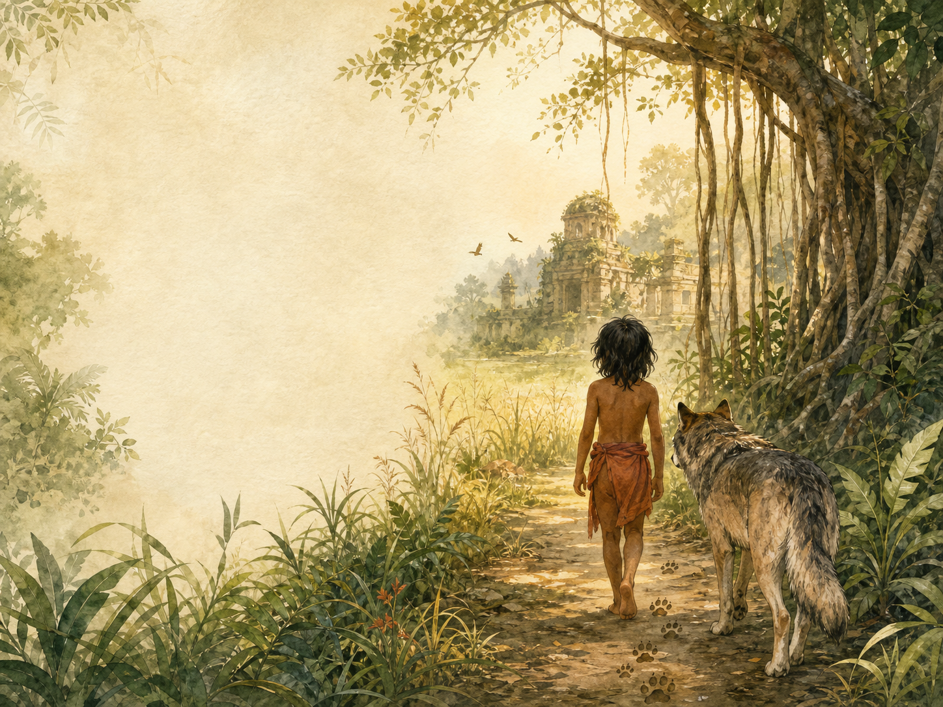
A LIVING BOOK STUDY - LEARNING BOOKLET
Name: _______________________

TASKS: DAY 1
Week 1 - Mowgli's Brothers
READ:
'Mowgli's Brothers', and the poem Hunting-Song of the Seeonee Pack.
NARRATION:
How is Mowgli adopted into the wolf pack? What is the Law of the Jungle, as introduced here?
EXTENSION:
Poetry: read the Hunting-Song aloud - what does it tell us about wolf pack life?
Your response:

TASKS: DAY 2
Week 1 - Kaa's Hunting
READ:
'Kaa's Hunting', and the poem Road-Song of the Bandar-Log.
DISCUSS:
Why are the Bandar-log (monkeys) considered outcasts in the jungle? What does this story teach about showing off?
EXTENSION:
Poetry: compare the playful tone of the Bandar-Log song to the serious Law of the Jungle.
Your response:

TASKS: DAY 3
Week 1 - 'Tiger! Tiger!'
READ:
'Tiger! Tiger!', and the poem Mowgli's Song.
DISCUSS:
How does Mowgli's story end in this first trilogy? What does it mean for him to return to human society?
EXTENSION:
Writing: write Mowgli's feelings as he leaves the jungle for the village.
Your response:

TASKS: DAY 4
Week 1 - Response Day
READ:
No new reading - review the three Mowgli stories.
LAW OF THE JUNGLE:
Collect every rule of the Law of the Jungle mentioned so far in a list.
EXTENSION:
History: research real wolf pack behaviour and compare it to Kipling's version.
Your response:

TASKS: DAY 5
Week 2 - The White Seal (first half)
READ:
The White Seal, up to Kotick's decision to search for a safe island.
NARRATION:
How is Kotick different from the other seal pups?
EXTENSION:
Geography: research the real geography of Bering Sea and North Pacific seal colonies.
Your response:

TASKS: DAY 6
Week 2 - The White Seal (second half)
READ:
The rest of The White Seal, and the poem Lukannon.
DISCUSS:
What makes Kotick a different kind of hero compared to Mowgli?
EXTENSION:
Science: research the real history of fur seal hunting and conservation.
Your response:

TASKS: DAY 7
Week 2 - Rikki-Tikki-Tavi (first half)
READ:
Rikki-Tikki-Tavi, up to his first encounter with Nag.
NARRATION:
Describe Rikki-Tikki's character and courage.
EXTENSION:
Science: research mongooses and their real relationship with snakes.
Your response:

TASKS: DAY 8
Week 2 - Rikki-Tikki-Tavi (second half)
READ:
The rest of Rikki-Tikki-Tavi, and the poem Darzee's Chant.
DISCUSS:
How does Kipling build tension in the final confrontation with Nagaina?
EXTENSION:
Discuss: this story is set in a British colonial household in India - what does it show us about that setting?
Your response:

TASKS: DAY 9
Week 3 - Toomai of the Elephants (first half)
READ:
Toomai of the Elephants, up to Toomai's night in the jungle.
HISTORY:
Research the use of elephants in the working life of colonial India, including logging camps.
EXTENSION:
Discuss: what is Toomai's dream, and why does everyone think it's impossible?
Your response:

TASKS: DAY 10
Week 3 - Toomai of the Elephants (second half)
READ:
The rest of Toomai of the Elephants, and the poem Shiv and the Grasshopper.
NARRATION:
Describe the elephant dance Toomai witnesses. Why is this such an extraordinary honour?
EXTENSION:
Art: illustrate the elephant dance scene.
Your response:

TASKS: DAY 11
Week 3 - Her Majesty's Servants
READ:
Her Majesty's Servants.
DISCUSS:
This story is told through the eyes of army camp animals on the eve of battle. What does each animal's attitude to their work reveal?
EXTENSION:
History: research the British Indian Army, and the real role of animals in military logistics.
Your response:

TASKS: DAY 12
Week 3 - Parade Song of the Camp Animals
READ:
The final poem, Parade Song of the Camp Animals.
POETRY:
Read the poem aloud, giving each animal its own voice.
EXTENSION:
Discuss: how does this final story and poem differ in tone from the Mowgli stories?
Your response:

TASKS: DAY 13
Week 4 - Response Day
READ:
No new reading - review all seven stories.
COMPARE:
Compare all seven stories in a table: setting, main character, and theme.
EXTENSION:
Discuss: which story did you enjoy most, and why?
Your response:

TASKS: DAY 14
Week 4 - Extension Day
READ:
No new reading - research day.
RESEARCH:
Research Rudyard Kipling's life and the colonial context of the book.
EXTENSION:
Book of Centuries: record key dates.
Your response:

TASKS: DAY 15
Week 4 - Wrap-up
READ:
No new reading - it's your turn to write.
WRITING OPPORTUNITY:
Write your own short story or 'law', inspired by Kipling's style, set in a place of your choosing.
EXTENSION:
Share your writing aloud with your family.
Your response:

LAW OF THE JUNGLE COLLECTION
Collect every rule of the Law of the Jungle as you meet it across the three Mowgli stories.
The rule | Which story | What it teaches

SEVEN STORIES COMPARISON
Story | Setting | Main character | Theme
Mowgli's Brothers
Kaa's Hunting
'Tiger! Tiger!'
The White Seal
Rikki-Tikki-Tavi
Toomai of the Elephants
Her Majesty's Servants

