A FAMILY STUDY IN THE CHARLOTTE MASON TRADITION
ROMEO AND JULIET
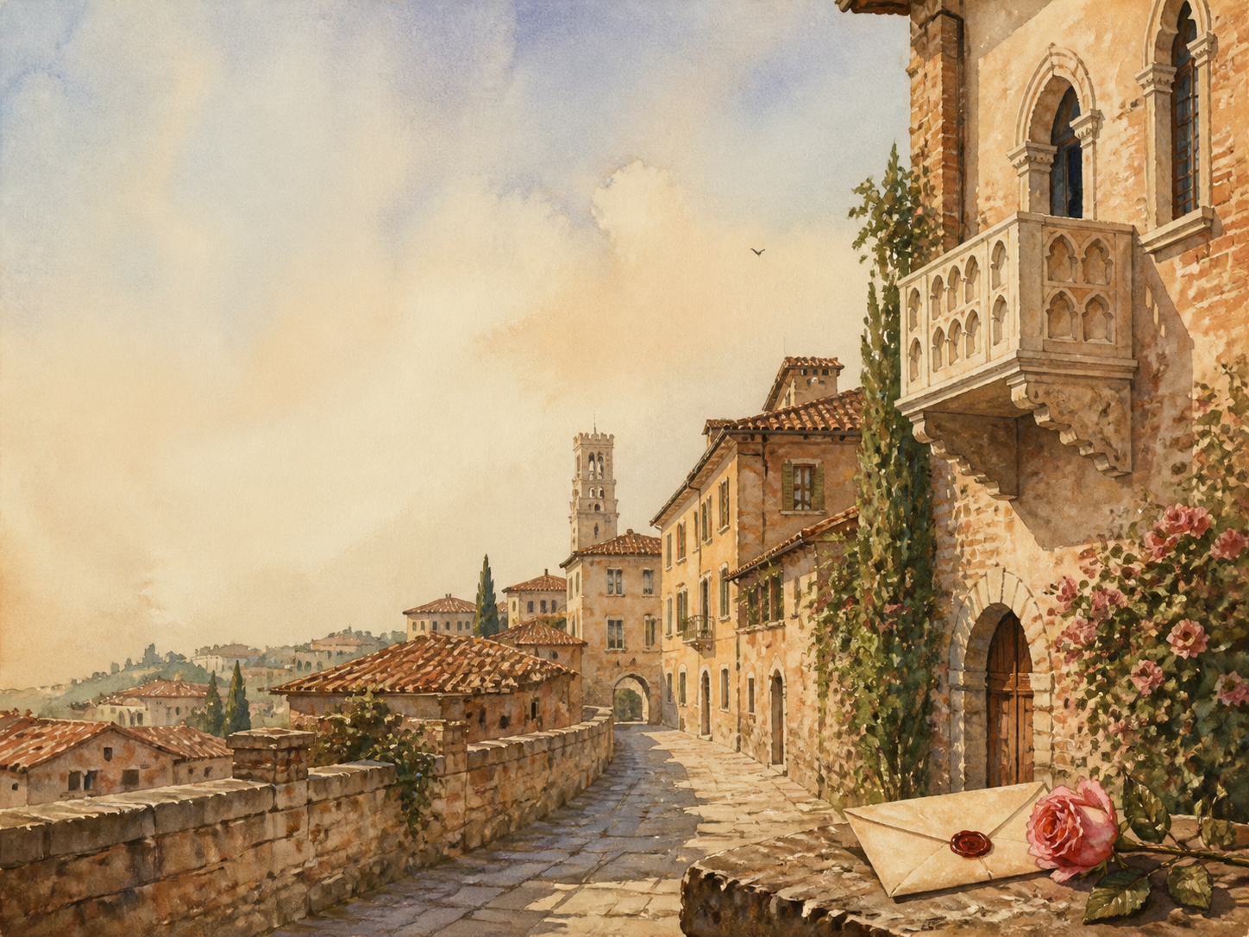
by William Shakespeare

A Living Book Study for Year 9 (GCSE lead-in), with a Year 8 Support Tier

Welcome. This Living Book Study of Romeo and Juliet is written for families teaching children of different ages side by side, with a core plan pitched at Year 9 as a lead-in to GCSE, and a lighter-touch tier for Year 8.
Romeo and Juliet is a play, meant to be heard and seen, not just read. This study keeps performance at its heart: alongside history, discussion and writing, it asks students to speak the lines aloud, act scenes, and watch a production or two. Choose what fits your family, and let each child respond in their own way.
A few steady habits will support progress:
- For Year 8: follow the story scene by scene, read the best speeches aloud, and enjoy watching a film version alongside the text.
- For Year 9: keep a quotation bank and a reading journal, and start analysing how Shakespeare presents love, conflict and fate.
- For GCSE (Years 10-11): use the extension tasks to analyse language and dramatic methods closely, as Romeo and Juliet is a set Shakespeare text on major GCSE courses.

How to use this plan
- Follow the suggested 4-week plan, which works scene by scene through the play.
- Read the great speeches aloud, and act scenes wherever you can - the play comes alive when spoken.
- Watch at least one film version (for example the 1968 Zeffirelli or 1996 Luhrmann films) and compare it with the text.
- A note for parents: Romeo and Juliet is a standard Year 9 text, but do note its content: it is a tragedy that ends in the suicides of both young lovers, includes three sword-fight deaths, features a teenage romance and secret marriage, and contains bawdy jokes and innuendo (especially from Mercutio and the Nurse). These are usually handled lightly in class; a quick look ahead will help you set the tone for your child.
About the Play
Written around 1595, Romeo and Juliet is Shakespeare's famous tragedy of 'a pair of star-crossed lovers'. In the Italian city of Verona, two great families - the Montagues and the Capulets - are locked in an old, bitter feud. When young Romeo Montague and Juliet Capulet meet and fall instantly in love, they marry in secret; but the feud, a fatal duel and a string of terrible mischances drive the story to its heartbreaking end.
It is one of the most performed plays ever written, and a favourite first Shakespeare for young people. Its Prologue tells us from the start that the lovers will die - so the play's power lies not in surprise, but in watching fate close in.
Text used: Shakespeare's text is out of copyright and freely available from Project Gutenberg, the Folger Shakespeare Library and Standard Ebooks (see Helpful Websites, below).
Topics included: History (Elizabethan theatre and the Globe, Shakespeare's life, honour and the feud, marriage and daughters), Drama (staging, soliloquy, performance), Literacy (Shakespeare's verse, imagery and dramatic irony), RE/PSHE (love, conflict, impulsive choices and blame), and Art.
Year 8 Support Tier

A younger or less confident student can enjoy the story, the characters and the drama without the closer language analysis aimed at older students. These activities keep the focus on performance and imagination.
Activity | Learning Areas | Description | Resources
Retell a scene | Literacy + Drama | Rewrite one scene in modern English, then perform your version. | Paper, pens
The two family crests | Art | Design coats of arms for the Montagues and the Capulets, showing what each family is like. | Paper, pens
The balcony scene | Drama | Learn and perform a short part of the famous balcony scene aloud. | The text, a open space
Inside the Globe | History + DT | Research Shakespeare's theatre, and build or draw a simple model of the Globe. | Books or internet access
Shakespearean insults | Literacy | Collect insults from the play and mix your own - a fun way into the language. | The text, paper

Year 9 Subject Activity Map

Literacy:
- Keep a quotation bank, sorted by theme (love, conflict, fate), ready for essays later.
- Study Shakespeare's verse: notice the shared sonnet the lovers speak when they first meet, and the play's rich imagery of light and dark.
- Explore dramatic irony: the Prologue tells us the ending, so we watch every hopeful moment knowing what is coming.
- Collect the play's oxymorons and paradoxes of love ('O brawling love, O loving hate'). What do they capture about young love?
- Write a diary entry as Romeo or Juliet on the night of the secret marriage.
Drama:
- Read the great speeches aloud, paying attention to rhythm and feeling.
- Stage a scene, making choices as a director: where do people stand, and how do they move?
- Watch two film versions and compare the choices each director makes.
- Debate how to play a key moment - is the Nurse funny, or is she letting Juliet down?

History:
- Research Elizabethan theatre and the Globe: the open-air stage, the groundlings, and the all-male casts.
- Research Shakespeare's life and times, and the Italian source-poem he reshaped.
- Research feuds and 'honour' culture, and why a Montague and a Capulet could not simply be friends.
- Research marriage in the period, and how little say a daughter like Juliet had in whom she married.
- Record key dates into your Book of Centuries.

RE / PSHE:
- Discuss love versus infatuation: Romeo and Juliet meet, marry and die within days. Is it true love, or something headier?
- Discuss impulsive decisions, and how nearly every character acts in haste.
- Discuss blame: is the tragedy caused by fate, by the feud, by the parents, by the young lovers, or by pure bad luck?
Science:
- Research the Friar's sleeping-potion and the poison Romeo buys. What might such 'draughts' really have been?
- The play is full of day-and-night imagery (the lark and the nightingale). Research why dawn matters so much to the lovers.
- 'Star-crossed': research what Elizabethans believed about the stars shaping human fate.
Art:
- Design a set for Verona, or costumes for the two feuding houses.
- Illustrate a key moment - the feast, the balcony, or the tomb.
- Design a film poster for your own modern version of the play.
GCSE (Years 10-11) Extension:
- Romeo and Juliet is a set Shakespeare text on major GCSE courses. Plan a response to: 'How does Shakespeare present love in the play?'
- Analyse a character in depth - Romeo, Juliet, Mercutio, the Nurse or Friar Laurence - across the whole play.
- Explore how Shakespeare presents the theme of conflict, from the opening brawl onward.
- Learn and use key quotations, and practise close analysis of a single short extract.

Possible Study Plan (4 Weeks)

The play has a Prologue and five acts. This plan works through it scene by scene. Read the great speeches aloud, and watch a film version alongside.

Week 1 - Act 1: The Feud and the Feast
Day | Read (Act & Scene) | Core Task | Extension / Cross-curricular
Day 1 | Prologue + Act 1 Sc 1. | Narration: the Chorus tells us the ending, then a street brawl breaks out. Describe the feud and the lovesick Romeo. | Literacy: why does Shakespeare give away the ending in the Prologue?
Day 2 | Act 1 Sc 2-3. | Discuss: Paris asks to marry Juliet, and her mother and the Nurse discuss it. How much say does Juliet have? | History: research marriage and the limited choices of daughters in this period.
Day 3 | Act 1 Sc 4-5. | Narration: Mercutio's Queen Mab speech, then the Capulet feast where Romeo and Juliet meet and fall in love. | Drama: read aloud the shared sonnet the lovers speak at their first meeting.

Week 2 - Act 2: Secret Vows
Day | Read (Act & Scene) | Core Task | Extension / Cross-curricular
Day 4 | Act 2 Chorus + Sc 1-2. | Narration: the famous balcony scene. Read the best lines aloud. | Literacy: collect the play's imagery of light and dark from this scene.
Day 5 | Act 2 Sc 3-4. | Discuss: Friar Laurence agrees to marry the lovers, hoping to end the feud. Is this wise or reckless? | Drama: perform some of Mercutio's quick, witty banter with Romeo.
Day 6 | Act 2 Sc 5-6. | Narration: the Nurse carries messages, and the lovers are secretly married. | PSHE: Romeo and Juliet marry within days of meeting. Discuss love versus infatuation.

Week 3 - Act 3: Death and Banishment
Day | Read (Act & Scene) | Core Task | Extension / Cross-curricular
Day 7 | Act 3 Sc 1. | Narration: Mercutio is killed by Tybalt, Romeo kills Tybalt in revenge, and is banished. Retell this turning point. | Discuss: this scene changes everything. Who, if anyone, is to blame?
Day 8 | Act 3 Sc 2-3. | Discuss: Juliet's anguish, and Romeo's despair at the Friar's cell. How do the two react differently? | Drama: perform part of Juliet's speech as she waits for news.
Day 9 | Act 3 Sc 4-5. | Narration: Capulet suddenly promises Juliet to Paris; at dawn the lovers part, and Juliet defies her father. | PSHE: discuss the clash between Juliet and her parents. Whose behaviour surprises you?

Week 4 - Acts 4-5: Star-Crossed
Day | Read (Act & Scene) | Core Task | Extension / Cross-curricular
Day 10 | Act 4 Sc 1-2. | Narration: the Friar's desperate sleeping-potion plan, and Juliet's pretended agreement to marry Paris. | Science: research what a 'sleeping draught' might really have been.
Day 11 | Act 4 Sc 3-5. | Narration: Juliet drinks the potion alone, and her family find her as if dead. | Drama: perform Juliet's frightened soliloquy before she drinks.
Day 12 | Act 5 Sc 1. | Discuss: in exile, Romeo hears that Juliet is dead and buys poison. How does bad news travel wrongly here? | Literacy: notice how the tragedy turns on a message that fails to arrive.
Day 13 | Act 5 Sc 2. | Narration: the Friar learns his warning letter never reached Romeo. Explain why the plan falls apart. | History: research the plague, which is why the letter is delayed.
Day 14 | Act 5 Sc 3. | Wrap-up: the tomb. Paris, Romeo and Juliet all die, and the grief-struck families finally make peace. | Extension: 'Fate, not human choice, destroys the lovers.' How far do you agree?

Helpful Websites

- Full text (free, out of copyright): Project Gutenberg - www.gutenberg.org/ebooks/1513 and the Folger Shakespeare Library - www.folger.edu
- Shakespeare's life and the Globe theatre: Shakespeare's Globe - www.shakespearesglobe.com
- Shakespeare's world: The Royal Shakespeare Company - www.rsc.org.uk
- Elizabethan England: The British Library - www.bl.uk
- Study support and scene summaries: search a trusted education site

Glossary

- Quotation Bank: a page where you collect key lines, sorted by theme, ready to use in discussion and essays.
- Book of Centuries: a timeline in a book, taken from the Charlotte Mason tradition, where children add historical figures and important dates as they meet them.
- Prologue / Chorus: an opening speech that sets the scene; here, it also reveals the ending in advance.
- Soliloquy: a speech in which a character, alone on stage, shares their thoughts aloud with the audience.
- Dramatic irony: when the audience knows something the characters do not - a key effect in this play.
- Blank verse: unrhymed lines of ten beats (iambic pentameter), the usual verse of Shakespeare's plays.
- Star-crossed: doomed by the stars; the Prologue's word for lovers fated to fail.

Other Living Book Studies in the Series

- Jane Eyre by Charlotte Bronte
- Wuthering Heights by Emily Bronte
- Pride and Prejudice by Jane Austen
- The Picture of Dorian Gray by Oscar Wilde
- Great Expectations by Charles Dickens

