INDEPENDENT STUDY COMPANION
ROMEO AND JULIET
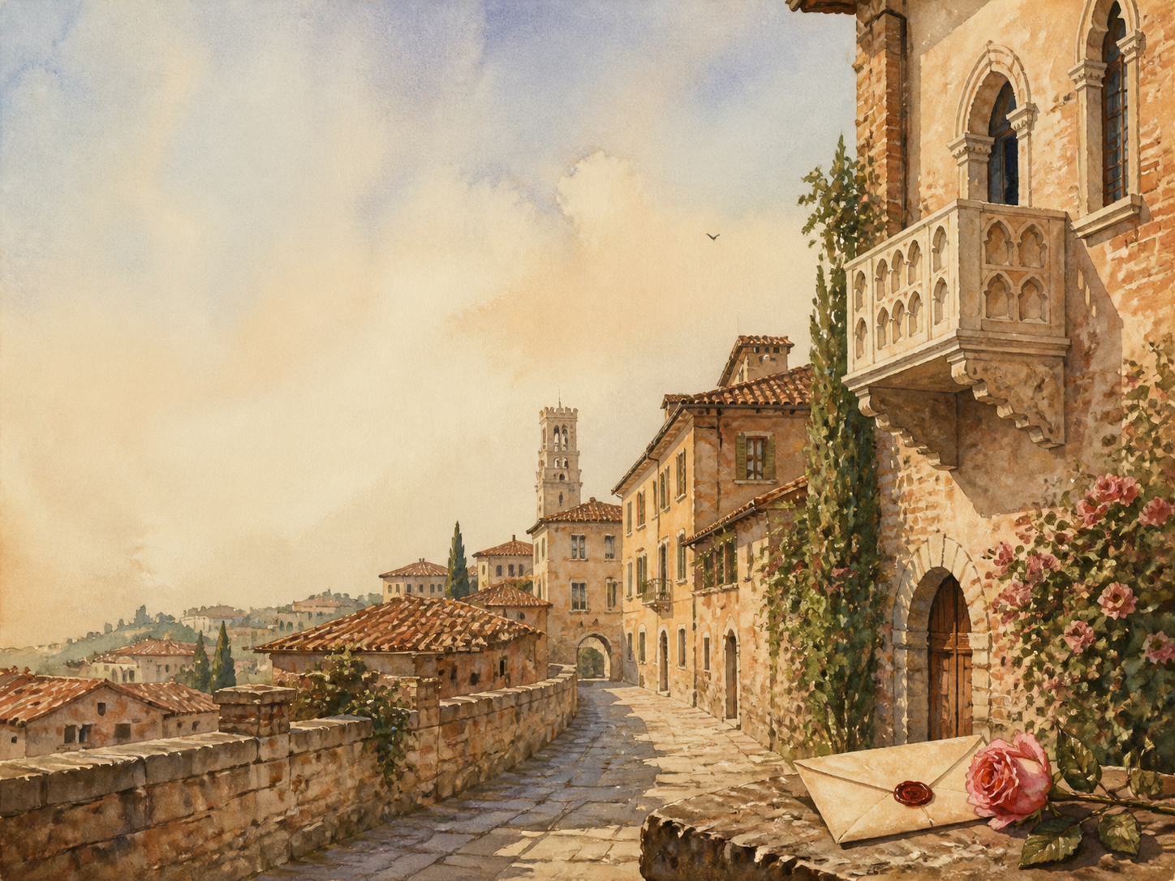
A LIVING BOOK STUDY - LEARNING BOOKLET
Name: _______________________

DAY 1: PROLOGUE + ACT 1 SCENE 1
READ / WATCH:
The Chorus tells us that two 'star-crossed lovers' will die. Then a street brawl between Montagues and Capulets breaks out, and we meet Romeo, moping over a girl called Rosaline.
NARRATION:
Describe the feud, the brawl, and the lovesick Romeo we first meet.
EXTENSION:
Literacy: why does Shakespeare give away the ending in the very first speech?
Your response:

DAY 2: ACT 1 SCENES 2-3
READ / WATCH:
Count Paris asks Lord Capulet for Juliet's hand, and Juliet's mother and Nurse raise the subject of marriage with her.
DISCUSS:
How much real say does Juliet have over who she marries?
EXTENSION:
History: research marriage and the limited choices of daughters in Shakespeare's day.
Your response:

DAY 3: ACT 1 SCENES 4-5
READ / WATCH:
On the way to the Capulet feast, Mercutio spins his 'Queen Mab' speech. At the feast, Romeo and Juliet meet and fall instantly in love - as Tybalt seethes.
DRAMA:
Read aloud the shared sonnet Romeo and Juliet speak when they first meet and touch hands.
EXTENSION:
Discuss: they fall in love at first sight. Is this romantic, or a warning sign?
Your response:

DAY 4: ACT 2 CHORUS + SCENES 1-2
READ / WATCH:
The famous balcony scene: Romeo overhears Juliet confess her love, and the two exchange vows in the moonlit garden.
DRAMA:
Learn and perform a short part of the balcony scene aloud.
EXTENSION:
Literacy: collect the imagery of light and dark that fills this scene.
Your response:

DAY 5: ACT 2 SCENES 3-4
READ / WATCH:
Friar Laurence agrees to marry the young couple, hoping their love will end the families' feud, while Mercutio and Romeo trade quick-fire jokes.
DISCUSS:
Is the Friar wise or reckless to marry Romeo and Juliet so quickly?
EXTENSION:
Drama: perform some of Mercutio's witty, teasing banter with Romeo.
Your response:

DAY 6: ACT 2 SCENES 5-6
READ / WATCH:
The Nurse brings Juliet word of the plan, and Friar Laurence marries the lovers in secret.
NARRATION:
Retell how the secret marriage is arranged and carried out.
EXTENSION:
PSHE: the couple marry within days of meeting. Discuss love versus infatuation.
Your response:

DAY 7: ACT 3 SCENE 1
READ / WATCH:
The play's turning point: Tybalt kills Mercutio, Romeo kills Tybalt in fury, and the Prince banishes Romeo from Verona.
NARRATION:
Retell the duel and its consequences, step by step.
EXTENSION:
Discuss: after this scene nothing can go back. Who, if anyone, is to blame?
Your response:

DAY 8: ACT 3 SCENES 2-3
READ / WATCH:
Juliet is torn between grief for Tybalt and love for Romeo, while Romeo despairs at the Friar's cell. A plan is made for one night together.
DISCUSS:
How do Romeo and Juliet each react to the banishment differently?
EXTENSION:
Drama: perform part of Juliet's speech as she waits, longing, for night.
Your response:

DAY 9: ACT 3 SCENES 4-5
READ / WATCH:
Capulet suddenly promises Juliet to Paris. At dawn the lovers part, and when Juliet refuses the match, her father turns on her furiously.
NARRATION:
Retell the dawn parting and Juliet's clash with her father.
EXTENSION:
PSHE: discuss the conflict between Juliet and her parents. Whose behaviour surprises you most?
Your response:

DAY 10: ACT 4 SCENES 1-2
READ / WATCH:
Desperate, Juliet turns to Friar Laurence, who gives her a potion to make her seem dead; she returns home and pretends to agree to marry Paris.
NARRATION:
Explain the Friar's risky plan, step by step.
EXTENSION:
Science: research what a 'sleeping draught' like this might really have been.
Your response:

DAY 11: ACT 4 SCENES 3-5
READ / WATCH:
Alone and afraid, Juliet drinks the potion. The next morning her family find her as if dead, and joy turns to mourning.
DRAMA:
Perform Juliet's frightened soliloquy just before she drinks the potion.
EXTENSION:
Discuss: how does Shakespeare make us feel Juliet's fear and loneliness here?
Your response:

DAY 12: ACT 5 SCENE 1
READ / WATCH:
In exile in Mantua, Romeo hears only that Juliet is dead - not of the plan - and buys poison from a poor apothecary, meaning to die beside her.
DISCUSS:
The whole tragedy now turns on news that arrives wrong. How does Shakespeare build the dread?
EXTENSION:
Literacy: notice how a single failed message drives the ending.
Your response:

DAY 13: ACT 5 SCENE 2
READ / WATCH:
Friar Laurence discovers that his letter explaining the plan never reached Romeo, delayed by an outbreak of plague.
NARRATION:
Explain exactly why the Friar's plan falls apart.
EXTENSION:
History: research the plague, and why it could halt travel and messages.
Your response:

DAY 14: ACT 5 SCENE 3
READ / WATCH:
At the tomb, Paris, Romeo and finally Juliet all die. Faced with their children's bodies, the two families at last make peace.
WRAP-UP:
How do the deaths finally end the feud - and was such a price necessary?
EXTENSION:
'Fate, not human choice, destroys the lovers.' How far do you agree?
Your response:

QUOTATION BANK
Collect the play's key lines here, sorted by theme, ready for discussion and essays. Note who says each line, and when.
Theme (love / conflict / fate) | Quotation | Who / when

WHO IS TO BLAME?
Many people and forces help cause the tragedy. Give each a share of the blame, with a reason, then decide who is MOST responsible.
Person or force | Their share of the blame - and why
The feud / the families
Romeo
Juliet
Friar Laurence
The Nurse
Fate / bad luck

