A FAMILY STUDY IN THE CHARLOTTE MASON TRADITION
ROBINSON CRUSOE
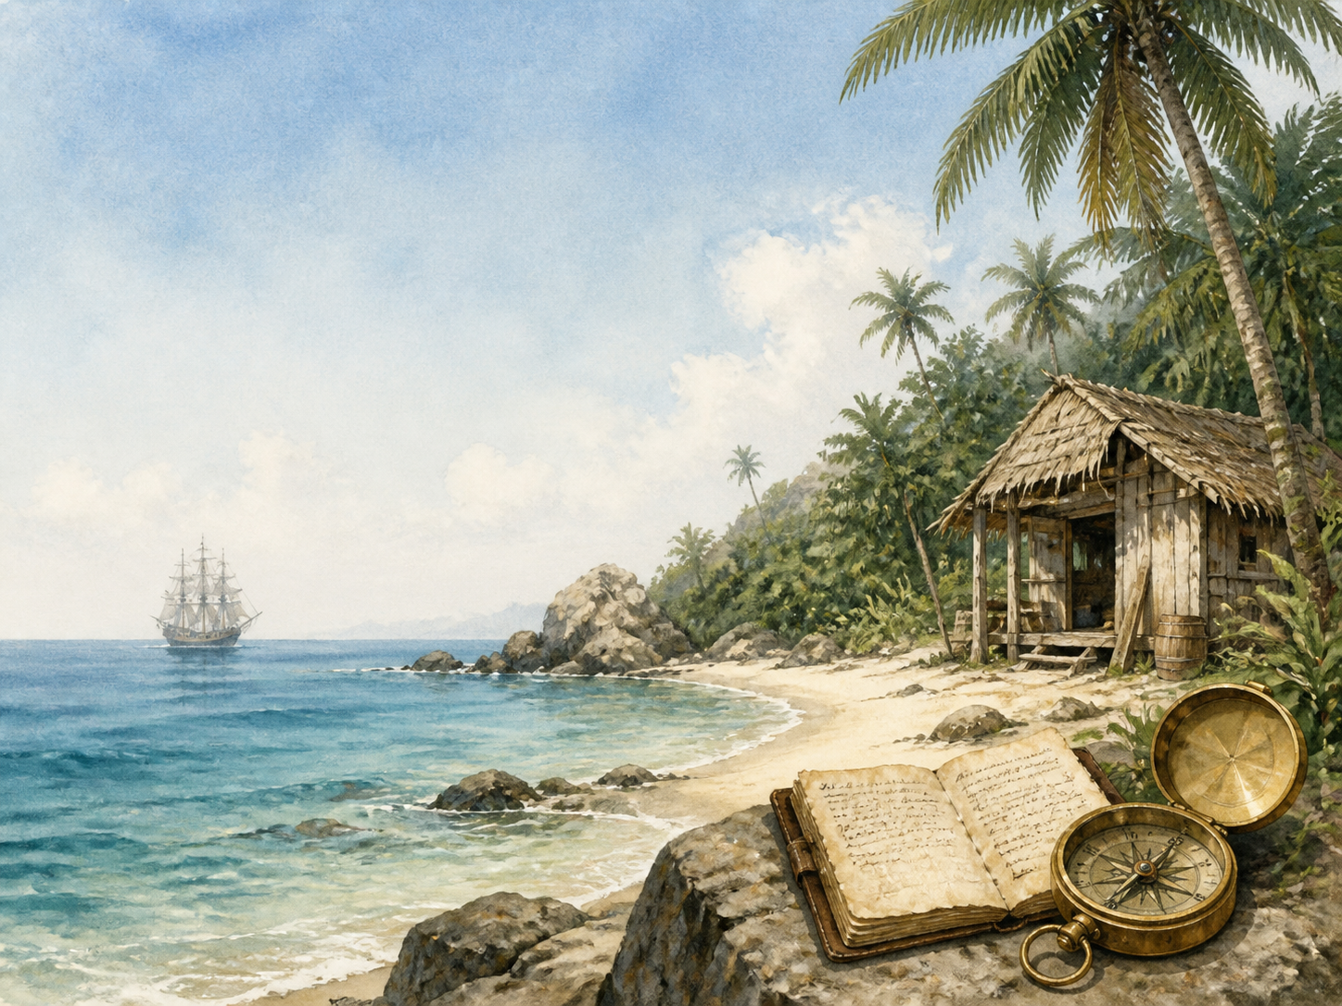
by Daniel Defoe

A Living Book Study for KS3, with a Years 5-6 Support Tier

Welcome. This Living Book Study of Robinson Crusoe is written for families teaching children of different ages side by side, with a core plan for Years 7-9 and a lighter-touch tier for Years 5-6.
In the Charlotte Mason tradition, we keep the feast wide alongside the adventure: history, geography, science and thoughtful conversation sit next to journalling, drama and discussion. Choose what fits your family, do a little at a time, and let each child respond in their own way.
A few steady habits will support progress:
- For Years 5-6: focus on survival, ingenuity and island life - build familiarity with the story before deeper discussion.
- For Years 7-9: keep a running 'castaway journal' alongside Crusoe's own, and start noticing how the book portrays Friday and the wider world beyond England.
- For Years 9-11: use the extension tasks to think critically about the book's treatment of slavery and colonialism, and its place at the start of the English novel.

How to use this plan
- Follow the suggested 4-week medium-term plan, or use the subject activity map to build your own route.
- Print the accompanying Learning Booklet for chapter-by-chapter reading and response tasks.
- Use the Independent Study slides if a student is working through the plan on their own.
- A note for parents: this book deals directly with slavery in several forms - Crusoe himself is enslaved by Barbary pirates, he sells a boy who helps him escape, and he is shipwrecked while on a voyage to buy enslaved people in Africa. It also depicts Friday, whom Crusoe rescues and treats as a servant, in ways that reflect the colonial attitudes of 1719. This pack addresses these themes directly rather than skipping them - see the Extension section below.

About the Text
First published in 1719, Robinson Crusoe tells the story of a young Englishman who, against his father's wishes, goes to sea, is enslaved, escapes, becomes a plantation owner in Brazil, and is shipwrecked alone on an island for twenty-eight years. Told as a journal-like first-person account, the novel is often considered one of the first English novels, and gave its name to an entire genre of castaway fiction - the 'Robinsonade' - that includes The Swiss Family Robinson and, much later, Lord of the Flies and Cast Away.
Text used: the 1719 first edition is out of copyright and freely available from Project Gutenberg and Standard Ebooks (see Helpful Websites, below).
Topics included: History (Barbary and transatlantic slavery, 18th-century sailing, Alexander Selkirk), Geography (mapping Crusoe's voyages and island), Science (survival skills, farming, animal domestication), RE/PSHE (providence, isolation, resilience), Art, and Drama.
Years 5-6 Support Tier

Younger children can enjoy the survival adventure and practical ingenuity of the story without needing to engage with the deeper historical and critical discussion aimed at older students.
Activity | Learning Areas | Description | Resources
Build a castaway den | DT + Construction | Build a den or shelter outside or indoors from whatever materials you can find, just as Crusoe does. | Blankets, cushions, boxes, garden materials
Castaway supply list | Literacy + Problem Solving | Imagine you were shipwrecked - list ten things you would want to salvage, and why. | Paper, pens
Simple castaway journal | Literacy | Keep a short daily journal for a week, just like Crusoe, noting the weather, what you did, and how you felt. | Notebook, pen
Goat and farm animal facts | Science | Research what goats eat and how they're cared for, and why Crusoe found them useful to tame. | Books or internet access, paper
Footprint mystery game | PE + Discussion | Make footprints in sand, flour or mud and see if others can guess whose foot made them - then discuss how Crusoe felt finding a footprint that wasn't his own. | Sand/flour tray, various shoes

KS3 Subject Activity Map

Literacy:
- Keep your own 'castaway journal' alongside Crusoe's, noting anything you find striking as you read.
- Discuss why Defoe chose to write the novel as a journal-like, first-person account - what does this add to how believable the story feels?
- Research the word 'Robinsonade' and the genre of castaway fiction this novel began.
- Write a newspaper report announcing Crusoe's rescue after 28 years away.
- Compare Robinson Crusoe to a later castaway or survival story you know.

History:
- Research the Barbary pirates and slavery in the Mediterranean and North Africa in the 17th-18th centuries - the fate Crusoe himself suffers in Chapter II.
- Research the transatlantic slave trade and Britain's role in it during the 18th century - Crusoe is shipwrecked while sailing to buy enslaved people in Africa.
- Research Alexander Selkirk, the real castaway sailor often said to have inspired the novel, and compare his real story to Crusoe's fictional one.
- Research 18th-century sailing ships and trade routes between England, Brazil and West Africa.
- Record key dates into your Book of Centuries.

Geography:
- Map Crusoe's voyages: England to Guinea, to Brazil, to Africa again, and finally to his island.
- Draw a map of Crusoe's island based on the details given in the book.
- Research the real island in the Pacific, now named Robinson Crusoe Island, associated with Alexander Selkirk.
Science:
- Research practical survival skills: shelter, fire, water and food.
- Research how to grow grain crops from seed, and compare this to Crusoe's trial-and-error farming.
- Research animal domestication - what makes goats a practical animal for Crusoe to tame?

RE / PSHE:
- Discuss how Crusoe interprets his ordeal as a religious test or punishment. How does his outlook change across the book?
- Discuss isolation and resilience - what helps Crusoe cope with 28 years largely alone?
- Discuss the relationship Crusoe builds with Friday. Is it a friendship, a master-and-servant relationship, or both?

Art / Drama:
- Illustrate Crusoe's shelter, based on his own descriptions.
- Act out the moment Crusoe discovers the footprint in the sand.
- Perform the confrontation where Crusoe and the captain retake the ship from the mutineers.
Years 9-11 Extension:
- Robinson Crusoe is often called one of the first English novels. Research what made it so different from earlier fiction, and why some historians credit it with helping start the novel as a form.
- Crusoe calls Friday 'my man Friday' and teaches him to call Crusoe 'Master'. Plan a response to: 'How does Defoe present the relationship between Crusoe and Friday, and what does this reveal about attitudes to empire in 1719?'
- Crusoe is enslaved himself in Chapter II, sells the boy Xury into servitude shortly after, and is later shipwrecked while on a slave-trading voyage. Discuss what this tells us about the novel's own moral blind spots, even as it shows sympathy for Crusoe's suffering as a captive.
- Research how Robinson Crusoe has been reinterpreted by later writers - for example, J.M. Coetzee's Foe, which retells the story from a different perspective. What does this suggest about how later generations have responded to the original novel?

Possible Medium-Term Plan (4 Weeks)

The novel is presented here in twenty chapters. This plan reads one chapter a day.

Week 1 - Chapters 1-5: Before the Island
Day | Read | Core Task | Extension / Cross-curricular
Day 1 | Ch 1: Start in Life. | Narration: what warning does Crusoe's father give him, and why does Crusoe ignore it? | Discuss: the theme of disobedience and consequence, set up from the very first chapter.
Day 2 | Ch 2: Slavery and Escape. | History: research the Barbary pirates and slavery in the Mediterranean in the 17th-18th centuries. | Discuss: Crusoe sells the boy Xury, who helped him escape, to the Portuguese captain. How do you feel about this?
Day 3 | Ch 3: Wrecked on a Desert Island. | Discuss: Crusoe was sailing to buy enslaved people in Africa when his ship wrecked. Why is this important context? | History: research the transatlantic slave trade and Britain's role in it during this period.
Day 4 | Ch 4: First Weeks on the Island. | Narration: what does Crusoe manage to save from the wreck, and why is each item important? | Science: what would you prioritise saving from a shipwreck, and why?
Day 5 | Ch 5: Builds a House - The Journal. | Literacy: why does Crusoe start keeping a journal? What does it reveal about him? | Writing: start your own castaway journal alongside your reading.

Week 2 - Chapters 6-10: Settling In
Day | Read | Core Task | Extension / Cross-curricular
Day 6 | Ch 6: Ill and Conscience-Stricken. | Discuss: how does Crusoe's illness change his outlook on his situation? | RE/PSHE: discuss the role of religious reflection in the book.
Day 7 | Ch 7: Agricultural Experience. | Science: research how grain crops grow from seed, and compare it to Crusoe's trial and error. | Discuss: what mistakes does Crusoe make, and what does he learn from them?
Day 8 | Ch 8: Surveys His Position. | Geography: map Crusoe's island based on the details given in this chapter. | Narration: describe the island as Crusoe now understands it.
Day 9 | Ch 9: A Boat. | Discuss: what mistake does Crusoe make when building his first boat? What does this teach about planning ahead? | Writing: design a boat you think would actually work for Crusoe's situation.
Day 10 | Ch 10: Tames Goats. | Science: research animal domestication - what makes an animal suitable for taming? | Discuss: how does taming goats change daily life on the island for Crusoe?

Week 3 - Chapters 11-15: Not Alone
Day | Read | Core Task | Extension / Cross-curricular
Day 11 | Ch 11: Finds Print of Man's Foot on the Sand. | Narration: describe Crusoe's reaction to finding the footprint. | Discuss: why does this discovery change everything for him, after years of solitude?
Day 12 | Ch 12: A Cave Retreat. | Discuss: how does Crusoe describe the people who visit the island? What assumptions does he make about them? | Art: illustrate Crusoe's fortified retreat.
Day 13 | Ch 13: Wreck of a Spanish Ship. | Narration: what does Crusoe find on the Spanish wreck, and how does it affect his hopes of rescue? | Discuss: how has Crusoe's attitude to rescue changed since the early chapters?
Day 14 | Ch 14: A Dream Realised. | Discuss: Crusoe interprets his dream as a sign. What does this suggest about how he understands his own story? | Predict: what do you think will happen next?
Day 15 | Ch 15: Friday's Education. | Discuss: Crusoe teaches Friday to call him 'Master'. What do you notice about the relationship Crusoe sets up between them? | History/PSHE: begin exploring the Years 9-11 Extension questions above about Friday and colonial attitudes.

Week 4 - Chapters 16-20: Leaving the Island
Day | Read | Core Task | Extension / Cross-curricular
Day 16 | Ch 16: Rescue of Prisoners from Cannibals. | Discuss: how does the island community grow in this chapter? What changes about Crusoe's situation? | Narration: describe the moment Friday finds his father.
Day 17 | Ch 17: Visit of Mutineers. | Narration: retell how Crusoe decides to help the imprisoned captain. | Discuss: why might Crusoe be so ready to trust and help a stranger, after everything he's been through?
Day 18 | Ch 18: The Ship Recovered. | Drama: act out the confrontation with the mutineers. | Discuss: what qualities does Crusoe show as a leader in this chapter?
Day 19 | Ch 19: Return to England. | Discuss: how does Crusoe feel returning to a world that has changed so much without him? | Writing: write a letter from Crusoe to a friend, describing his 28 years away.
Day 20 | Ch 20: Fight Between Friday and a Bear. | Wrap-up: discuss the whole book - what has Crusoe learned? Has he really changed? | Extension: revisit the Friday relationship one more time - by the end of the book, has anything changed about how Crusoe treats him?

Helpful Websites

- Full text (free, out of copyright): Project Gutenberg - www.gutenberg.org/ebooks/521 and Standard Ebooks - standardebooks.org
- Barbary slavery and the Mediterranean corsairs: The National Archives - www.nationalarchives.gov.uk
- The transatlantic slave trade: The British Library - www.bl.uk (search 'transatlantic slave trade')
- Alexander Selkirk: search 'Alexander Selkirk' via your library or a trusted encyclopedia
- 18th-century sailing and trade routes: Royal Museums Greenwich - www.rmg.co.uk

Glossary

- English Journal: a notebook where thoughts and images are kept while reading a novel. You can also use the printable booklet.
- Book of Centuries: a timeline in a book, taken from the Charlotte Mason tradition, where children add historical figures and important dates as they meet them.
- Robinsonade: a genre of fiction inspired by Robinson Crusoe, about characters stranded and surviving in isolation.
- Providence: the idea that events are guided by God - a recurring theme in how Crusoe interprets his own story.

Other Living Book Studies in the Series

- Treasure Island by Robert Louis Stevenson
- The Jungle Book by Rudyard Kipling
- A Christmas Carol by Charles Dickens (Year 7-9, GCSE extension)
- The Strange Case of Dr Jekyll and Mr Hyde by Robert Louis Stevenson (GCSE)
- Black Beauty by Anna Sewell

