INDEPENDENT STUDY COMPANION
ROBINSON CRUSOE
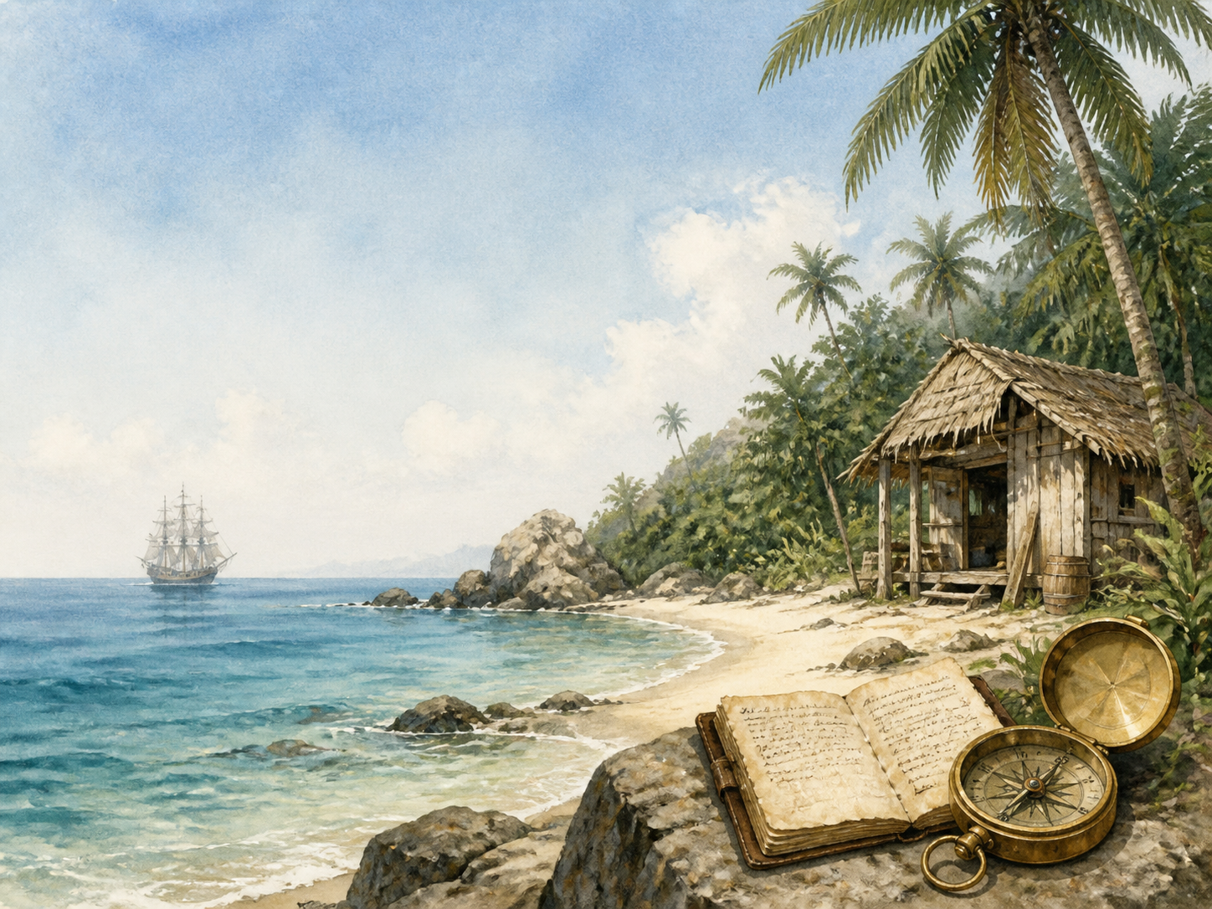
A LIVING BOOK STUDY - LEARNING BOOKLET
Name: _______________________

TASKS: DAY 1
Week 1 - Chapter 1: Start in Life
READ:
Chapter 1: Crusoe's family life, and his decision to go to sea against his father's wishes.
NARRATION:
What warning does Crusoe's father give him, and why does Crusoe ignore it?
EXTENSION:
Discuss: the theme of disobedience and consequence, set up from the very first chapter.
Your response:

TASKS: DAY 2
Week 1 - Chapter 2: Slavery and Escape
READ:
Chapter 2: Crusoe is captured by Barbary pirates, enslaved, and escapes with the boy Xury.
HISTORY:
Research the Barbary pirates and slavery in the Mediterranean in the 17th-18th centuries.
EXTENSION:
Discuss: Crusoe sells Xury, who helped him escape, to the Portuguese captain. How do you feel about this?
Your response:

TASKS: DAY 3
Week 1 - Chapter 3: Wrecked on a Desert Island
READ:
Chapter 3: Crusoe settles in Brazil, sets sail on a slave-trading voyage, and is shipwrecked.
DISCUSS:
Crusoe was sailing to buy enslaved people in Africa when his ship wrecked. Why is this important context for the book?
EXTENSION:
History: research the transatlantic slave trade and Britain's role in it during this period.
Your response:

TASKS: DAY 4
Week 1 - Chapter 4: First Weeks on the Island
READ:
Chapter 4: salvaging goods from the wreck, and building a first shelter.
NARRATION:
What does Crusoe manage to save from the wreck, and why is each item important?
EXTENSION:
Science: what would you prioritise saving from a shipwreck, and why?
Your response:

TASKS: DAY 5
Week 1 - Chapter 5: Builds a House - The Journal
READ:
Chapter 5: a proper shelter, and the start of Crusoe's journal.
LITERACY:
Why does Crusoe start keeping a journal? What does it reveal about him?
EXTENSION:
Writing: start your own castaway journal alongside your reading.
Your response:

TASKS: DAY 6
Week 2 - Chapter 6: Ill and Conscience-Stricken
READ:
Chapter 6: Crusoe falls ill and reflects deeply on his situation.
DISCUSS:
How does Crusoe's illness change his outlook on his situation?
EXTENSION:
RE/PSHE: discuss the role of religious reflection in the book.
Your response:

TASKS: DAY 7
Week 2 - Chapter 7: Agricultural Experience
READ:
Chapter 7: growing corn and rice through trial and error.
SCIENCE:
Research how grain crops grow from seed, and compare it to Crusoe's trial and error.
EXTENSION:
Discuss: what mistakes does Crusoe make, and what does he learn from them?
Your response:

TASKS: DAY 8
Week 2 - Chapter 8: Surveys His Position
READ:
Chapter 8: Crusoe explores the island more fully.
GEOGRAPHY:
Map Crusoe's island based on the details given in this chapter.
EXTENSION:
Narration: describe the island as Crusoe now understands it.
Your response:

TASKS: DAY 9
Week 2 - Chapter 9: A Boat
READ:
Chapter 9: Crusoe attempts to build a boat.
DISCUSS:
What mistake does Crusoe make when building his first boat? What does this teach about planning ahead?
EXTENSION:
Writing: design a boat you think would actually work for Crusoe's situation.
Your response:

TASKS: DAY 10
Week 2 - Chapter 10: Tames Goats
READ:
Chapter 10: Crusoe domesticates goats for food and milk.
SCIENCE:
Research animal domestication - what makes an animal suitable for taming?
EXTENSION:
Discuss: how does taming goats change daily life on the island for Crusoe?
Your response:

TASKS: DAY 11
Week 3 - Chapter 11: Finds Print of Man's Foot on the Sand
READ:
Chapter 11: the famous footprint scene.
NARRATION:
Describe Crusoe's reaction to finding the footprint.
EXTENSION:
Discuss: why does this discovery change everything for him, after years of solitude?
Your response:

TASKS: DAY 12
Week 3 - Chapter 12: A Cave Retreat
READ:
Chapter 12: Crusoe discovers evidence of cannibal feasts, and fortifies his home.
DISCUSS:
How does Crusoe describe the people who visit the island? What assumptions does he make about them?
EXTENSION:
Art: illustrate Crusoe's fortified retreat.
Your response:

TASKS: DAY 13
Week 3 - Chapter 13: Wreck of a Spanish Ship
READ:
Chapter 13: another shipwreck appears, and Crusoe explores it.
NARRATION:
What does Crusoe find on the Spanish wreck, and how does it affect his hopes of rescue?
EXTENSION:
Discuss: how has Crusoe's attitude to rescue changed since the early chapters?
Your response:

TASKS: DAY 14
Week 3 - Chapter 14: A Dream Realised
READ:
Chapter 14: Crusoe dreams of rescuing a captive, and the dream comes true.
DISCUSS:
Crusoe interprets his dream as a sign. What does this suggest about how he understands his own story?
EXTENSION:
Predict: what do you think will happen next?
Your response:

TASKS: DAY 15
Week 3 - Chapter 15: Friday's Education
READ:
Chapter 15: Crusoe rescues Friday, and teaches him English and Christianity.
DISCUSS:
Crusoe teaches Friday to call him 'Master'. What do you notice about the relationship Crusoe sets up between them?
EXTENSION:
History/PSHE: begin exploring Friday's treatment and colonial attitudes - see the Extension tasks in the main study plan.
Your response:

TASKS: DAY 16
Week 4 - Chapter 16: Rescue of Prisoners from Cannibals
READ:
Chapter 16: further rescues, including Friday's father.
DISCUSS:
How does the island community grow in this chapter? What changes about Crusoe's situation?
EXTENSION:
Narration: describe the moment Friday finds his father.
Your response:

TASKS: DAY 17
Week 4 - Chapter 17: Visit of Mutineers
READ:
Chapter 17: English mutineers arrive with a captive captain.
NARRATION:
Retell how Crusoe decides to help the imprisoned captain.
EXTENSION:
Discuss: why might Crusoe be so ready to trust and help a stranger, after everything he's been through?
Your response:

TASKS: DAY 18
Week 4 - Chapter 18: The Ship Recovered
READ:
Chapter 18: Crusoe and the captain retake the ship from the mutineers.
DRAMA:
Act out the confrontation with the mutineers.
EXTENSION:
Discuss: what qualities does Crusoe show as a leader in this chapter?
Your response:

TASKS: DAY 19
Week 4 - Chapter 19: Return to England
READ:
Chapter 19: Crusoe finally leaves the island after 28 years.
DISCUSS:
How does Crusoe feel returning to a world that has changed so much without him?
EXTENSION:
Writing: write a letter from Crusoe to a friend, describing his 28 years away.
Your response:

TASKS: DAY 20
Week 4 - Chapter 20: Fight Between Friday and a Bear
READ:
Chapter 20: a final adventure on the journey home through the Pyrenees.
WRAP-UP:
Discuss the whole book - what has Crusoe learned? Has he really changed?
EXTENSION:
Revisit the Friday relationship one more time - by the end of the book, has anything changed about how Crusoe treats him?
Your response:

MY CASTAWAY JOURNAL
Keep your own journal alongside Crusoe's, in his style - note the day, what happened, and how you felt about it.
Day | What happened | How I felt

VOYAGES MAP NOTES
Use this page to note the places Crusoe visits across the book: England, Guinea, Brazil, the island, and home again.
Place | Chapter | What happens there

