A FAMILY STUDY IN THE CHARLOTTE MASON TRADITION
PRIDE AND PREJUDICE
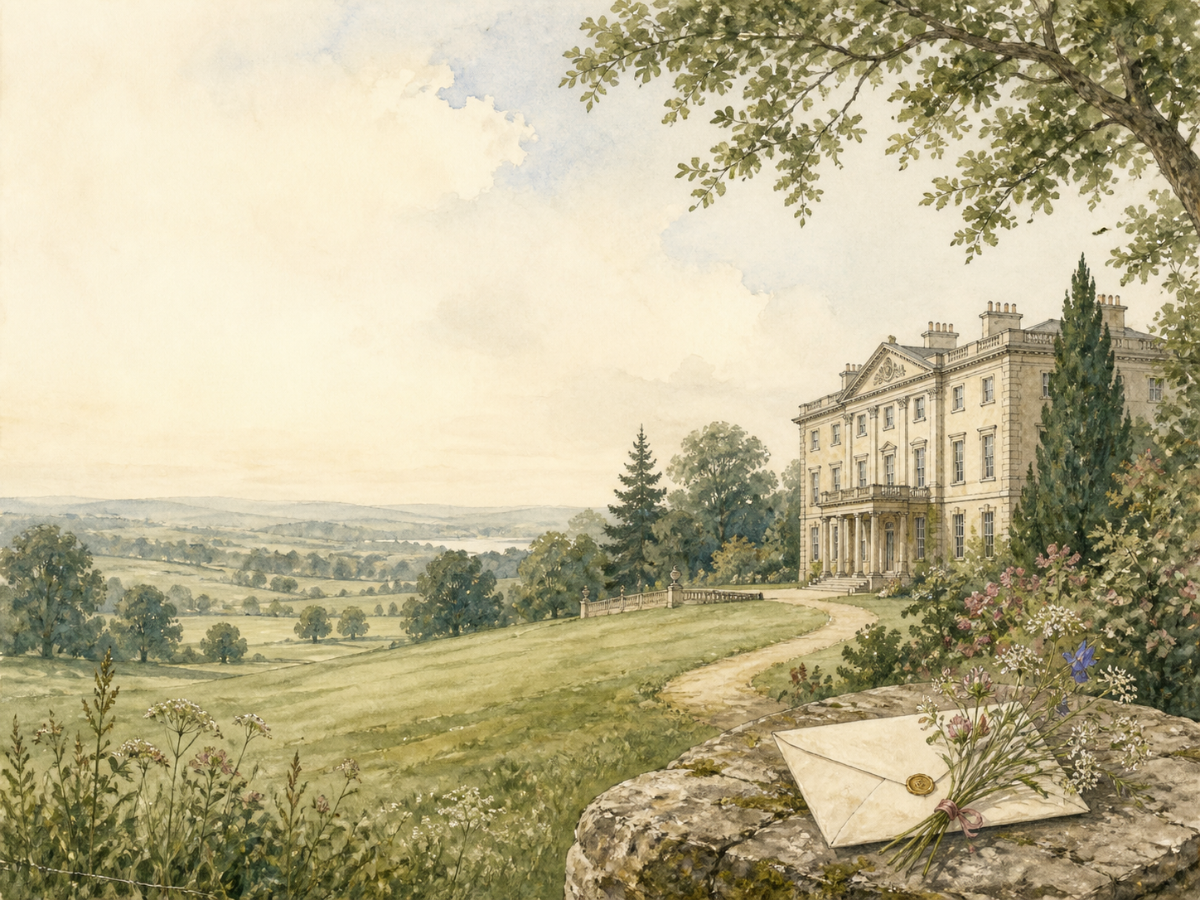
by Jane Austen

A Living Book Study for Year 9 (GCSE lead-in), with a Year 8 Support Tier

Welcome. This Living Book Study of Pride and Prejudice is written for families teaching children of different ages side by side, with a core plan pitched at Year 9 as a lead-in to GCSE, and a lighter-touch tier for Year 8.
In the Charlotte Mason tradition, we keep the feast wide alongside the story: history, a little economics and lively conversation sit next to writing, drama and discussion. Choose what fits your family, do a little at a time, and let each child respond in their own way.
A few steady habits will support progress:
- For Year 8: enjoy the wit and romance, and follow the misunderstandings between Elizabeth and Darcy that drive the whole story.
- For Year 9: keep a reading journal, and start analysing Austen's irony, and how first impressions mislead nearly everyone.
- For GCSE (Years 10-11): use the extension tasks to write analytically about Austen's narrative voice, her themes and her world.

How to use this plan
- Follow the suggested 4-week medium-term plan, or use the subject activity map to build your own route.
- Print the accompanying Learning Booklet for reading and response tasks.
- Use the Independent Study slides if a student is working through the plan on their own.
- A note for parents: Pride and Prejudice is the gentlest book in the Year 9 set - a witty comedy of manners with no violence. The only sensitive strand is the pressure on women to marry well, including a teenage sister who runs off with an unsuitable man, and a passing mention of his earlier attempt to elope with an even younger heiress. These make good, safe discussion points about reputation and choice.

About the Text
Published in 1813, Pride and Prejudice follows the clever, quick-witted Elizabeth Bennet, second of five sisters whose mother is desperate to see them married. When the proud, wealthy Mr Darcy comes into the neighbourhood, Elizabeth takes an instant dislike to him - but first impressions, on both sides, prove badly mistaken. It is one of the best-loved novels in the language: sparkling, funny and sharp about money, class and love.
Austen writes with famous irony, letting us laugh at her characters even as we come to care for them. Beneath the romance is a serious picture of a world where a woman's whole future could depend on making a good marriage.
Text used: the 1813 text is out of copyright and freely available from Project Gutenberg and Standard Ebooks (see Helpful Websites, below).
Topics included: History (Regency England, the position of women, class and 'connections'), Maths/Economics (incomes, dowries and the cost of living), Geography (Hertfordshire, London, Kent and Derbyshire), RE/PSHE (pride, prejudice and personal growth, marriage and choice), Art, and Drama.
Year 8 Support Tier

A younger or less confident reader can enjoy the humour and romance without the closer analysis aimed at older students. These activities keep the focus on character, setting and fun.
Activity | Learning Areas | Description | Resources
First impressions chart | Literacy | For each main character, note the first impression they give, and what they turn out to be really like. | Paper, pens
Design a Regency outfit | Art | Draw a gown or coat for a Regency ball, researching the fashions of Austen's day. | Paper, pens
At the ball | History + Dance | Research a Regency dance or ball, and how young people were allowed to meet and court. | Books or internet access
Marriage-market maths | Maths | Compare the characters' yearly incomes, and work out roughly what they would be worth today. | Paper, calculator
Perform a proposal | Drama | Act out Mr Collins's ridiculous proposal, or Darcy's disastrous first one. | A open space

Year 9 Subject Activity Map

Literacy:
- Study Austen's irony, starting with the famous opening line. Where does the narrator gently mock her characters?
- The book was first called 'First Impressions'. Track how first impressions of Darcy, Wickham and others prove wrong.
- Notice how we see mostly through Elizabeth's eyes, and how that leads us to share her mistakes.
- Explore the role of letters in the novel, especially Darcy's, in changing what Elizabeth (and we) believe.
- Write a diary entry as Elizabeth after Darcy's first proposal, or after reading his letter.

History:
- Research Regency England (roughly 1811-1820) - its manners, money and society.
- Research why the Bennet estate is 'entailed' away to Mr Collins, and what that meant for daughters who could not inherit.
- Research the very limited choices open to genteel women, for whom a good marriage was often the only security.
- Record key dates into your Book of Centuries.
Maths / Economics:
- List the characters' incomes (Darcy's famous 10,000 pounds a year, and so on) and rank them.
- Research what those sums were worth then, and estimate them in today's money.
- Discuss how money shapes almost every match considered in the novel.

Geography:
- Map the world of the novel: Longbourn and Meryton in Hertfordshire, London, Rosings in Kent, and Pemberley in Derbyshire.
- Research the great country estates of the period, and what Pemberley signals about Darcy.

RE / PSHE:
- Discuss pride and prejudice as faults: who is proud, who is prejudiced, and how do they grow?
- Compare the marriages and near-marriages (Charlotte's, Lydia's, Jane's, Elizabeth's). What is each one really based on?
- Discuss judging by first impressions, and what it takes to change your mind fairly.

Art / Drama:
- Illustrate a Regency ball, or the grand house and grounds of Pemberley.
- Perform a scene of sharp dialogue between Elizabeth and Darcy.
- Design a modern film poster for the story.
GCSE (Years 10-11) Extension:
- Pride and Prejudice is a much-studied novel. Plan a response to: 'How does Austen present the theme of marriage?'
- Analyse Austen's use of irony and her narrative voice.
- Explore how Elizabeth and Darcy each change, and what each must overcome.
- Write about the presentation of women and their limited choices in the novel.

Possible Medium-Term Plan (4 Weeks)

The novel has sixty-one chapters. This plan reads about three chapters per day.

Week 1 - Chapters 1-15: First Impressions
Day | Read | Core Task | Extension / Cross-curricular
Day 1 | Ch 1-3. | Narration: the Bennets, the arrival of Mr Bingley, and the ball where Darcy snubs Elizabeth. | Literacy: study the famous opening line. What is Austen quietly mocking?
Day 2 | Ch 4-6. | Discuss: first impressions form fast. What does each family make of the others? | Discuss: Darcy begins, against his will, to admire Elizabeth. What draws him?
Day 3 | Ch 7-9. | Narration: Jane falls ill at Netherfield and Elizabeth walks miles to nurse her. | History: research what was thought 'proper' for a young woman, and how Elizabeth bends the rules.
Day 4 | Ch 10-12. | Discuss: the sharp, teasing exchanges between Elizabeth and Darcy. Who is winning? | Literacy: note how Austen reveals character through dialogue.
Day 5 | Ch 13-15. | Narration: the pompous Mr Collins arrives, and the charming Mr Wickham is introduced. | Discuss: what first impressions do Collins and Wickham each create?

Week 2 - Chapters 16-30: Complications
Day | Read | Core Task | Extension / Cross-curricular
Day 6 | Ch 16-18. | Discuss: Wickham's story paints Darcy as a villain. Do you believe him? Why? | Narration: describe the Netherfield ball and the Bennets' embarrassments.
Day 7 | Ch 19-21. | Narration: Mr Collins proposes to Elizabeth, who refuses him flatly. | PSHE: discuss Elizabeth's choice to refuse a secure but loveless match.
Day 8 | Ch 22-24. | Discuss: Charlotte Lucas accepts Mr Collins. Is she wise, or settling? What are her reasons? | Maths: work out why marriage mattered so much to a woman's finances.
Day 9 | Ch 25-27. | Narration: the sensible Gardiners appear, and Elizabeth sets off to visit Charlotte in Kent. | Geography: map Elizabeth's journey from Hertfordshire to Kent.
Day 10 | Ch 28-30. | Narration: Rosings, the overbearing Lady Catherine de Bourgh, and the reappearance of Darcy. | Discuss: how does Lady Catherine show the pride of high rank?

Week 3 - Chapters 31-45: Truths Revealed
Day | Read | Core Task | Extension / Cross-curricular
Day 11 | Ch 31-33. | Discuss: Darcy keeps seeking Elizabeth out at Rosings. What is happening to him? | Literacy: note the gap between what Darcy feels and what Elizabeth notices.
Day 12 | Ch 34-36. | Narration: Darcy's proud first proposal, Elizabeth's furious refusal, and the letter that changes everything. | Discuss: Darcy's letter reveals the truth about Wickham and Jane. How should it change our view?
Day 13 | Ch 37-39. | Discuss: Elizabeth reflects on how wrong she has been. What is she learning about herself? | PSHE: discuss the courage it takes to admit you misjudged someone.
Day 14 | Ch 40-42. | Narration: Elizabeth confides in Jane, and travels with the Gardiners toward Derbyshire. | Geography: research the great estates of Derbyshire, the setting for Pemberley.
Day 15 | Ch 43-45. | Narration: at Pemberley, Elizabeth meets a warmer, more gracious Darcy on his own ground. | Discuss: how does seeing Pemberley change how Elizabeth understands Darcy?

Week 4 - Chapters 46-61: Pride and Prejudice Overcome
Day | Read | Core Task | Extension / Cross-curricular
Day 16 | Ch 46-48. | Narration: shocking news arrives - Lydia has run off with Wickham, threatening the family's good name. | PSHE: discuss reputation, and how one person's choices affected a whole family then.
Day 17 | Ch 49-51. | Narration: Lydia is found and hastily married. Retell how the crisis is patched up. | Discuss: someone has quietly paid to save the Bennets. Who might it be, and why?
Day 18 | Ch 52-54. | Discuss: Elizabeth learns Darcy secretly arranged Lydia's marriage. How does this complete her change of heart? | Literacy: track how far Elizabeth's feelings for Darcy have travelled.
Day 19 | Ch 55-57. | Narration: Bingley returns and proposes to Jane; Lady Catherine tries to forbid Elizabeth from marrying Darcy. | Discuss: why does Lady Catherine's bullying backfire?
Day 20 | Ch 58-61. | Wrap-up: Darcy proposes again, and is accepted. How have both hero and heroine grown by the end? | Extension: who had to overcome pride, and who prejudice? Trace both across the whole novel.

Helpful Websites

- Full text (free, out of copyright): Project Gutenberg - www.gutenberg.org/ebooks/1342 and Standard Ebooks - standardebooks.org
- Jane Austen's life and world: Jane Austen's House - janeaustens.house
- Regency society, women and marriage: The British Library - www.bl.uk
- Historic money values: The National Archives currency converter - www.nationalarchives.gov.uk/currency-converter
- Country houses and estates: The National Trust - www.nationaltrust.org.uk

Glossary

- Reading Journal: a notebook where thoughts and images are kept while reading a novel. You can also use the printable booklet.
- Book of Centuries: a timeline in a book, taken from the Charlotte Mason tradition, where children add historical figures and important dates as they meet them.
- Irony: saying one thing while meaning another, often to gently mock - Austen's trademark tone.
- Entail: a legal rule fixing who inherits an estate; it sends Longbourn to Mr Collins because the Bennets have no son.
- Regency: the period around 1811-1820 when the Prince Regent ruled for his ill father, George III.
- Comedy of manners: a witty story that pokes fun at the behaviour and social rules of a particular class.

Other Living Book Studies in the Series

- Jane Eyre by Charlotte Bronte
- Wuthering Heights by Emily Bronte
- The Picture of Dorian Gray by Oscar Wilde
- Romeo and Juliet by William Shakespeare
- Great Expectations by Charles Dickens

