INDEPENDENT STUDY COMPANION
PRIDE AND PREJUDICE
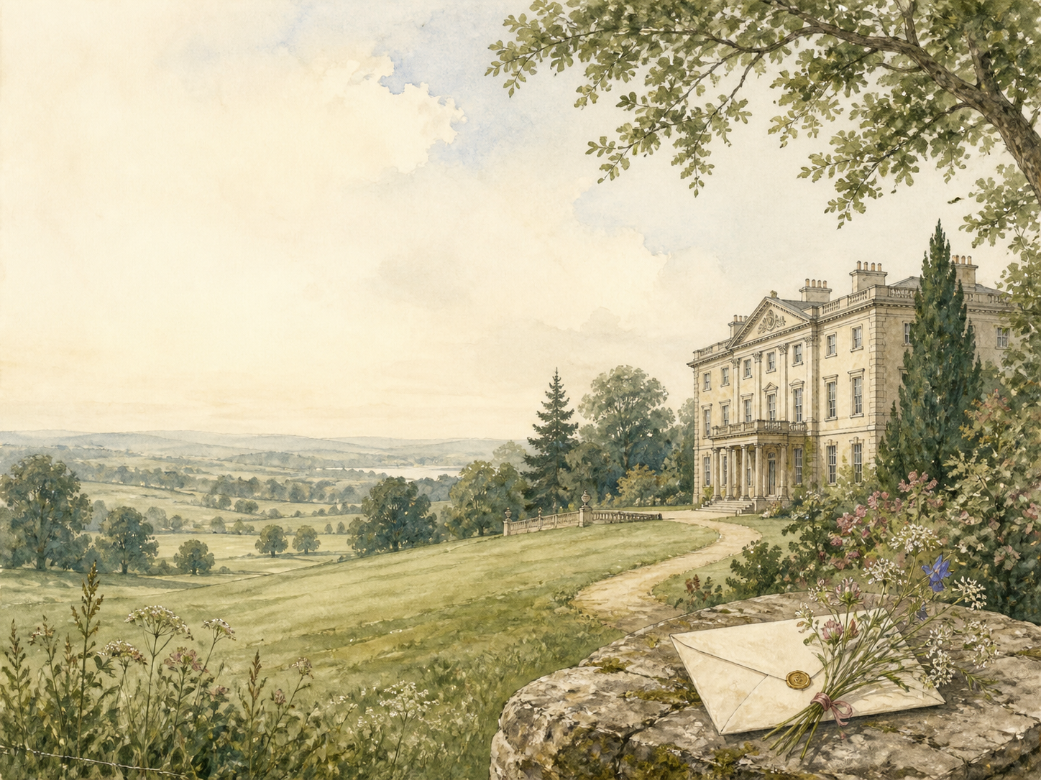
A LIVING BOOK STUDY - LEARNING BOOKLET
Name: _______________________

TASKS: DAY 1
Week 1 - Chapters 1-3: The Ball at Meryton
READ:
Mr Bingley, rich and single, rents Netherfield, delighting Mrs Bennet. At the assembly ball his proud friend Mr Darcy snubs Elizabeth Bennet.
NARRATION:
Retell the arrival of Bingley and the ball where Darcy offends Elizabeth.
EXTENSION:
Literacy: study the famous opening line. What is Austen quietly mocking?
Your response:

TASKS: DAY 2
Week 1 - Chapters 4-6: First Impressions
READ:
The families size one another up. Against his own wishes, Darcy begins to admire Elizabeth's lively wit and fine eyes.
DISCUSS:
First impressions form fast here. What does each family decide about the others?
EXTENSION:
Discuss: what is it about Elizabeth that begins to attract the proud Mr Darcy?
Your response:

TASKS: DAY 3
Week 1 - Chapters 7-9: Netherfield
READ:
Jane falls ill at Netherfield, and Elizabeth walks miles through the mud to nurse her, shocking the elegant Bingley sisters.
NARRATION:
Describe Elizabeth's muddy walk and how the Bingley sisters react.
EXTENSION:
History: research what was thought 'proper' for a young woman, and how Elizabeth bends the rules.
Your response:

TASKS: DAY 4
Week 1 - Chapters 10-12: Sparring
READ:
Elizabeth and Darcy trade sharp, clever remarks, each fascinated and annoyed by the other, before the sisters return home.
DISCUSS:
In the battle of wits between Elizabeth and Darcy, who do you think is winning?
EXTENSION:
Literacy: note how Austen reveals character mainly through dialogue.
Your response:

TASKS: DAY 5
Week 1 - Chapters 13-15: Collins and Wickham
READ:
Two new men arrive: the pompous clergyman Mr Collins, who will inherit the Bennets' home, and the charming officer Mr Wickham.
NARRATION:
Introduce Mr Collins and Mr Wickham, and the first impressions each creates.
EXTENSION:
Discuss: how do first impressions of Collins and Wickham compare with what they turn out to be?
Your response:

TASKS: DAY 6
Week 2 - Chapters 16-18: Wickham's Story
READ:
Wickham tells Elizabeth a tale that paints Darcy as cruel and unjust, and she is only too ready to believe it.
DISCUSS:
Do you believe Wickham's story about Darcy? Why is Elizabeth so quick to?
EXTENSION:
Narration: describe the Netherfield ball and the Bennet family's embarrassing moments.
Your response:

TASKS: DAY 7
Week 2 - Chapters 19-21: A Refusal
READ:
Mr Collins proposes to Elizabeth, certain she will accept; she refuses him firmly, to her mother's fury.
NARRATION:
Retell Mr Collins's proposal and Elizabeth's refusal.
EXTENSION:
PSHE: discuss Elizabeth's choice to turn down a secure but loveless marriage.
Your response:

TASKS: DAY 8
Week 2 - Chapters 22-24: Charlotte's Choice
READ:
Elizabeth's sensible friend Charlotte Lucas accepts Mr Collins herself, while Bingley leaves for London and Jane's hopes fade.
DISCUSS:
Is Charlotte wise or is she settling? What are her reasons for marrying Collins?
EXTENSION:
Maths: work out why a good marriage mattered so much to a woman's finances.
Your response:

TASKS: DAY 9
Week 2 - Chapters 25-27: To Kent
READ:
The kindly Gardiners visit, and Elizabeth sets off to stay with the newly married Charlotte in Kent.
NARRATION:
Introduce the Gardiners, and describe Elizabeth's journey to Kent.
EXTENSION:
Geography: map Elizabeth's journey from Hertfordshire to Kent.
Your response:

TASKS: DAY 10
Week 2 - Chapters 28-30: Rosings
READ:
At grand Rosings, Elizabeth meets the domineering Lady Catherine de Bourgh - and Mr Darcy appears once more.
DISCUSS:
How does Lady Catherine show the pride that comes with high rank?
EXTENSION:
Discuss: how is Lady Catherine's pride different from Darcy's?
Your response:

TASKS: DAY 11
Week 3 - Chapters 31-33: Darcy Returns
READ:
Darcy keeps seeking Elizabeth's company at Rosings, though neither he nor she quite understands his behaviour.
DISCUSS:
What is happening to Darcy? Why does he keep finding excuses to see Elizabeth?
EXTENSION:
Literacy: note the gap between what Darcy feels and what Elizabeth notices.
Your response:

TASKS: DAY 12
Week 3 - Chapters 34-36: The Proposal and the Letter
READ:
Darcy proposes proudly and is angrily refused; the next day he gives Elizabeth a letter that overturns everything she believed.
NARRATION:
Retell Darcy's first proposal and Elizabeth's furious response.
EXTENSION:
Discuss: Darcy's letter reveals the truth about Wickham and about Jane. How should it change our view?
Your response:

TASKS: DAY 13
Week 3 - Chapters 37-39: Second Thoughts
READ:
Elizabeth reads and rereads the letter, and slowly realises how badly she has misjudged both Darcy and Wickham.
DISCUSS:
What is Elizabeth learning about herself, as well as about the two men?
EXTENSION:
PSHE: discuss the courage it takes to admit you have misjudged someone.
Your response:

TASKS: DAY 14
Week 3 - Chapters 40-42: Toward Derbyshire
READ:
Elizabeth shares part of the truth with Jane, then travels north with the Gardiners.
NARRATION:
Retell how Elizabeth confides in Jane, and sets off for Derbyshire.
EXTENSION:
Geography: research the great country estates of Derbyshire, the setting for Pemberley.
Your response:

TASKS: DAY 15
Week 3 - Chapters 43-45: Pemberley
READ:
At Pemberley, Darcy's own great house, Elizabeth meets a warmer, kinder Darcy, gracious even to her humbler relations.
DISCUSS:
How does seeing Pemberley - and Darcy at home - change Elizabeth's view of him?
EXTENSION:
Art: illustrate the house and grounds of Pemberley.
Your response:

TASKS: DAY 16
Week 4 - Chapters 46-48: Scandal
READ:
News arrives that Elizabeth's youngest sister, Lydia, has run away with Wickham, threatening to disgrace the whole family.
NARRATION:
Retell how the news of Lydia's elopement reaches Elizabeth.
EXTENSION:
PSHE: discuss reputation, and how one person's choices could affect a whole family then.
Your response:

TASKS: DAY 17
Week 4 - Chapters 49-51: Patched Up
READ:
Lydia is found and quickly married to Wickham, and the couple visit, quite unashamed.
DISCUSS:
Someone has quietly paid to save the family's name. Who might it be, and why would they?
EXTENSION:
Narration: describe Lydia and Wickham's visit, and how the family receives them.
Your response:

TASKS: DAY 18
Week 4 - Chapters 52-54: The Truth About Darcy
READ:
Elizabeth discovers that it was Darcy who secretly arranged and paid for Lydia's marriage, asking for no thanks.
DISCUSS:
How does learning what Darcy did complete Elizabeth's change of heart?
EXTENSION:
Literacy: track how far Elizabeth's feelings for Darcy have travelled since the ball.
Your response:

TASKS: DAY 19
Week 4 - Chapters 55-57: Two Proposals Loom
READ:
Bingley returns and proposes to Jane; then Lady Catherine storms in to forbid Elizabeth from ever marrying Darcy.
NARRATION:
Retell Bingley's proposal, and Lady Catherine's furious visit.
EXTENSION:
Discuss: why does Lady Catherine's bullying actually help bring Elizabeth and Darcy together?
Your response:

TASKS: DAY 20
Week 4 - Chapters 58-61: Pride and Prejudice Overcome
READ:
Darcy proposes a second time, humbly, and Elizabeth joyfully accepts, as the novel closes on happy matches.
WRAP-UP:
How have both Elizabeth and Darcy grown by the end of the story?
EXTENSION:
Who had to overcome pride, and who prejudice? Trace both faults across the whole novel.
Your response:

FIRST IMPRESSIONS TRACKER
The novel was first titled 'First Impressions'. For each character, note your first impression - then, later, what they truly turn out to be.
Character | First impression | What they really are
Mr Darcy
Mr Wickham
Mr Collins
Charlotte Lucas
Lady Catherine
Mr Bingley

WHAT IS EACH MARRIAGE BASED ON?
Austen shows many kinds of marriage. For each couple, decide what their match is really built on - love, money, security, looks, or something else.
Couple | What the match is based on
Elizabeth & Darcy
Jane & Bingley
Charlotte & Collins
Lydia & Wickham
Mr & Mrs Bennet

