A FAMILY STUDY IN THE CHARLOTTE MASON TRADITION
PETER PAN
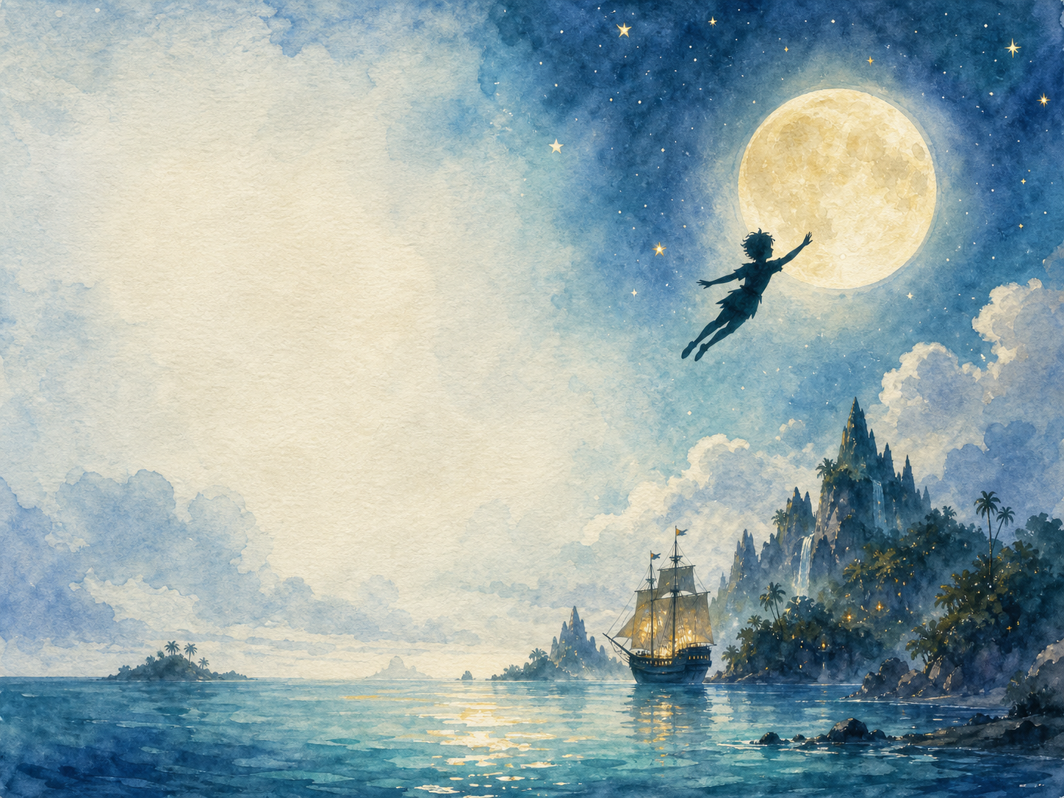
Peter and Wendy, by J.M. Barrie

A Living Book Study for mixed-age learning

Welcome. This Living Book Study of Peter Pan is written for parents teaching children of different ages side by side. Read together, talk together, and let the story do its quiet work.
In the Charlotte Mason tradition, we keep the feast wide: literature, imagination, history, art, and thoughtful conversation. Choose what fits your family, do a little at a time, and let each child respond in their own way - by telling back, drawing, building, writing, or acting.
Alongside our shared reading, a few steady habits will support progress:
- For KS2: keep grammar, punctuation and spelling ticking along - little and often (for example, CGP workbook practice).
- For KS1: follow a systematic phonics programme with daily practice, and let early reading be cheerful and successful.

How to use this plan
- Follow the suggested medium-term plan, or use the activity map to build your own route.
- Choose play stations for KS1 children from the list below (1-2 a week).
- Print the accompanying Learning Booklet for chapter-by-chapter reading and response tasks.
- Use the Independent Study slides if older children are working through the plan on their own.
- A note for parents: the book includes a dated, stereotyped portrayal of a Native American 'tribe', typical of Edwardian children's fiction. See the Year 6/KS3 Extension section below for a gentle way to open that conversation with older children.

About the Text
First published as a novel in 1911 (after beginning life as a stage play in 1904), Peter and Wendy tells the story of the Darling children, who are taught to fly by the boy who never grows up and carried off to Neverland - an island of pirates, mermaids, fairies and Lost Boys. Beneath its adventure and humour, the book is a thoughtful, sometimes melancholy meditation on childhood, imagination, and growing up.
Text used: the 1911 first edition is out of copyright for reading and study purposes, and freely available from Project Gutenberg and Standard Ebooks (see Helpful Websites, below). Note that in the UK, Great Ormond Street Hospital holds a special perpetual right to royalties from commercial performance and publication of the work itself - this applies to staging or republishing the play or novel, not to using or discussing it in family study.
Topics included: History (Edwardian England, J.M. Barrie's life), Science (light and shadow), Geography (imagining Neverland), Art (pirates, fairies, underground homes), Drama (the battle with Hook), and PSHE (growing up, family, courage).

KS1 Play-Based Learning Stations

It is important for KS1 children to continue to learn through play where possible. They can still enjoy the story with their siblings, but also continue to explore the world around them. It is also recommended that they follow a phonics scheme as they learn to read and write.
Activity | Learning Areas | Description | Resources
Shadow play | Science + Fine Motor | Use a torch to make shadow puppets on a wall; talk about how shadows are made, echoing Peter's lost shadow. | Torch, dark room, paper/card puppets
Flying and fairy dust | PE + Imaginative Play | Sprinkle glitter 'fairy dust' and pretend to fly around the room or garden; think happy thoughts to help you fly. | Safe glitter or confetti, open space
Pirate ship small world | Storytelling + Fine Motor | Build a pirate ship from a box or tray; act out a scene with toy pirates and figures. | Box/tray, toy figures, blue paper or fabric for the sea
Mermaid lagoon water play | UW + Fine Motor | Set up a water tray with toy mermaids, shells and boats; talk about the dangers and beauty of the lagoon. | Water tray, toy mermaids/shells, small boats
Build a Wendy house | DT + Construction | Build a tiny den or house from cushions, blankets or boxes, just as the Lost Boys build one for Wendy. | Cushions, blankets, boxes
Tick-tock crocodile game | PE + Listening | Play a chasing or 'beat the clock' game where one player is the ticking crocodile - stop and freeze when the ticking stops. | A ticking clock or timer, open space

Peter Pan Activity Map KS2

Literacy:
- Keep a journal as you read the book - note new words, and any moment where the narrator speaks directly to you, the reader.
- Discuss: Barrie's narrator often comments on the story as it happens. How is this different from other books you've read?
- Write a diary entry as Wendy, describing her first day in Neverland.
- Compare Peter Pan to another Edwardian fantasy story you know - what do they have in common?
- After reading the book, watch a film adaptation and compare it to the book.

History:
- Research Edwardian England (1901-1910) - what was daily life like for children when this book was written?
- Research J.M. Barrie's life and his friendship with the Llewelyn Davies family, whose sons inspired the Darling children and Peter Pan himself.
- Find out about Great Ormond Street Hospital and Barrie's gift of the book's rights to the hospital in 1929.
- Record key dates into your Book of Centuries.
Science:
- Research how shadows are made, and why a shadow always has the same shape as the object that casts it.
- Discuss: why might Barrie have chosen a lost shadow as such an important part of the story?

Geography:
- Imagine and draw a map of Neverland, based on the details in the book - the lagoon, the pirate ship, the Lost Boys' underground home.
- Trace the children's imagined flight from London - 'second star to the right and straight on till morning' - and discuss why Barrie might have given directions that don't quite make sense.

Art:
- Design your own pirate ship, or illustrate the Jolly Roger.
- Draw a cross-section of the Lost Boys' underground home.
- Illustrate Tinker Bell and discuss how such a small character can have such a big personality.

Drama:
- Act out the final battle between Peter and Captain Hook.
- Perform the scene where Peter asks the audience or reader, 'Do you believe in fairies?'

Year 6 and KS3 Extension:
- The book includes a stereotyped, dated portrayal of a Native American 'tribe'. Discuss: how are they described, and how does this compare to how such peoples would be respectfully represented today? Why is it important to notice this when reading older books?
- Discuss the theme of growing up. Why does Peter refuse to grow up, and why does Wendy eventually choose to? What does the book seem to suggest about each choice?
- Research the term 'Peter Pan syndrome', sometimes used today to describe adults who avoid responsibility. Based on the book, do you think this is a fair use of the character?
- Research J.M. Barrie's own childhood, including the early death of his brother David, and consider how this might have shaped the book's themes of childhood and loss.

Possible Medium-Term Plan (4 Weeks)

The novel has 17 chapters. This plan reads one chapter a day.

Week 1 - Chapters 1-4: Leaving Home
Day | Read | Core Task | Extension / Cross-curricular
Day 1 | Ch 1: Peter Breaks Through. | Narration: what kind of family are the Darlings? How does Barrie's narrator talk directly to the reader? | Discuss: what is unusual about how this chapter is written, compared to other stories you know?
Day 2 | Ch 2: The Shadow. | Science: how are shadows made? Discuss why a lost shadow might be a good symbol for Peter. | Art: make shadow puppets and act out this chapter.
Day 3 | Ch 3: Come Away, Come Away! | Discuss: what does Peter offer the Darling children that makes them want to leave home? | Writing: would you have gone with Peter? Explain why or why not.
Day 4 | Ch 4: The Flight. | Geography: imagine and map the route to Neverland. | Art: illustrate the flight over London and the sea.

Week 2 - Chapters 5-9: Arriving in Neverland
Day | Read | Core Task | Extension / Cross-curricular
Day 5 | Ch 5: The Island Come True. | Discuss: this chapter introduces many different groups living on Neverland. Who are they? | History/PSHE: discuss the dated, stereotyped portrayal of the 'tribe' in this chapter, and how attitudes have changed since 1911.
Day 6 | Ch 6: The Little House. | Discuss: why do the boys build Wendy a tiny house rather than just letting her live with them underground? | DT/Art: design and build a model 'Wendy house'.
Day 7 | Ch 7: The Home Under the Ground. | Art: draw a cross-section of the Lost Boys' underground home. | Discuss: what would you like and dislike about living there?
Day 8 | Ch 8: The Mermaids' Lagoon. | Narration: describe the danger and beauty of the lagoon in your own words. | Discuss: how does Barrie make the mermaids seem both beautiful and unsettling?
Day 9 | Ch 9: The Never Bird. | Discuss: what does this chapter show us about Peter's cleverness and character? | Writing: retell Peter's escape from the rock in your own words.

Week 3 - Chapters 10-13: Home, Story and Capture
Day | Read | Core Task | Extension / Cross-curricular
Day 10 | Ch 10: The Happy Home. | PSHE: why might Wendy enjoy playing 'mother' to the Lost Boys so much? What does the book suggest about family roles? | Discuss: is this a fair or old-fashioned view of a mother's role? What do you think?
Day 11 | Ch 11: Wendy's Story. | Discuss: how does Wendy's story about the Darling parents affect the Lost Boys, and why does Peter react differently to it? | Writing: write the story Wendy tells, in your own words.
Day 12 | Ch 12: The Children Are Carried Off. | Drama: act out the ambush and capture scene, building tension as you go. | Narration: retell this chapter as a newspaper report.
Day 13 | Ch 13: Do You Believe in Fairies? | Discuss: this is one of the most famous scenes in the book. Why might Barrie have written a direct appeal to the reader here? | Extension: research how this scene has been staged in the theatre, with the audience asked to clap to save Tinker Bell.

Week 4 - Chapters 14-17: Hook and the Return Home
Day | Read | Core Task | Extension / Cross-curricular
Day 14 | Ch 14: The Pirate Ship. | Art: design your own pirate ship, or illustrate the Jolly Roger. | Discuss: how does Barrie build tension as Peter sneaks aboard?
Day 15 | Ch 15: 'Hook or Me This Time'. | Drama: perform the duel between Peter and Hook. | Discuss: what makes Hook a memorable villain?
Day 16 | Ch 16: The Return Home. | Narration: how do the Darling parents react to the children's return? | Discuss: how do you think the Darling parents felt while the children were away?
Day 17 | Ch 17: When Wendy Grew Up. | Discuss: this ending is often seen as bittersweet. What does it suggest about growing up and childhood? | Wrap-up: compare Peter and Wendy's choices about growing up - who do you think made the 'right' choice, and is there a right choice at all?

Helpful Websites

- Full text (free, out of copyright for study use): Project Gutenberg - www.gutenberg.org/ebooks/16 and Standard Ebooks - standardebooks.org
- J.M. Barrie's life and the Llewelyn Davies family: Great Ormond Street Hospital - www.gosh.org/get-involved/peter-pan
- Edwardian England: Historic UK - www.historic-uk.com
- Light and shadows for children: BBC Bitesize - www.bbc.co.uk/bitesize (search 'light and shadows')

Glossary

- English Journal: a notebook where thoughts and images are kept while reading a novel. You can also use the printable booklet.
- Book of Centuries: a timeline in a book, taken from the Charlotte Mason tradition, where children add historical figures and important dates as they meet them.
- Neverland: the fictional island where Peter Pan lives, home to pirates, fairies, mermaids and the Lost Boys.
- Narrator: the voice telling a story. In Peter Pan, the narrator often speaks directly to the reader, which is an unusual technique worth noticing.

Other Living Book Studies in the Series

- Alice's Adventures in Wonderland by Lewis Carroll (Year 5-7)
- The Wind in the Willows by Kenneth Grahame
- The Secret Garden by Frances Hodgson Burnett
- Black Beauty by Anna Sewell
- A Christmas Carol by Charles Dickens (Year 7-9, GCSE extension)

