INDEPENDENT STUDY COMPANION
PETER PAN
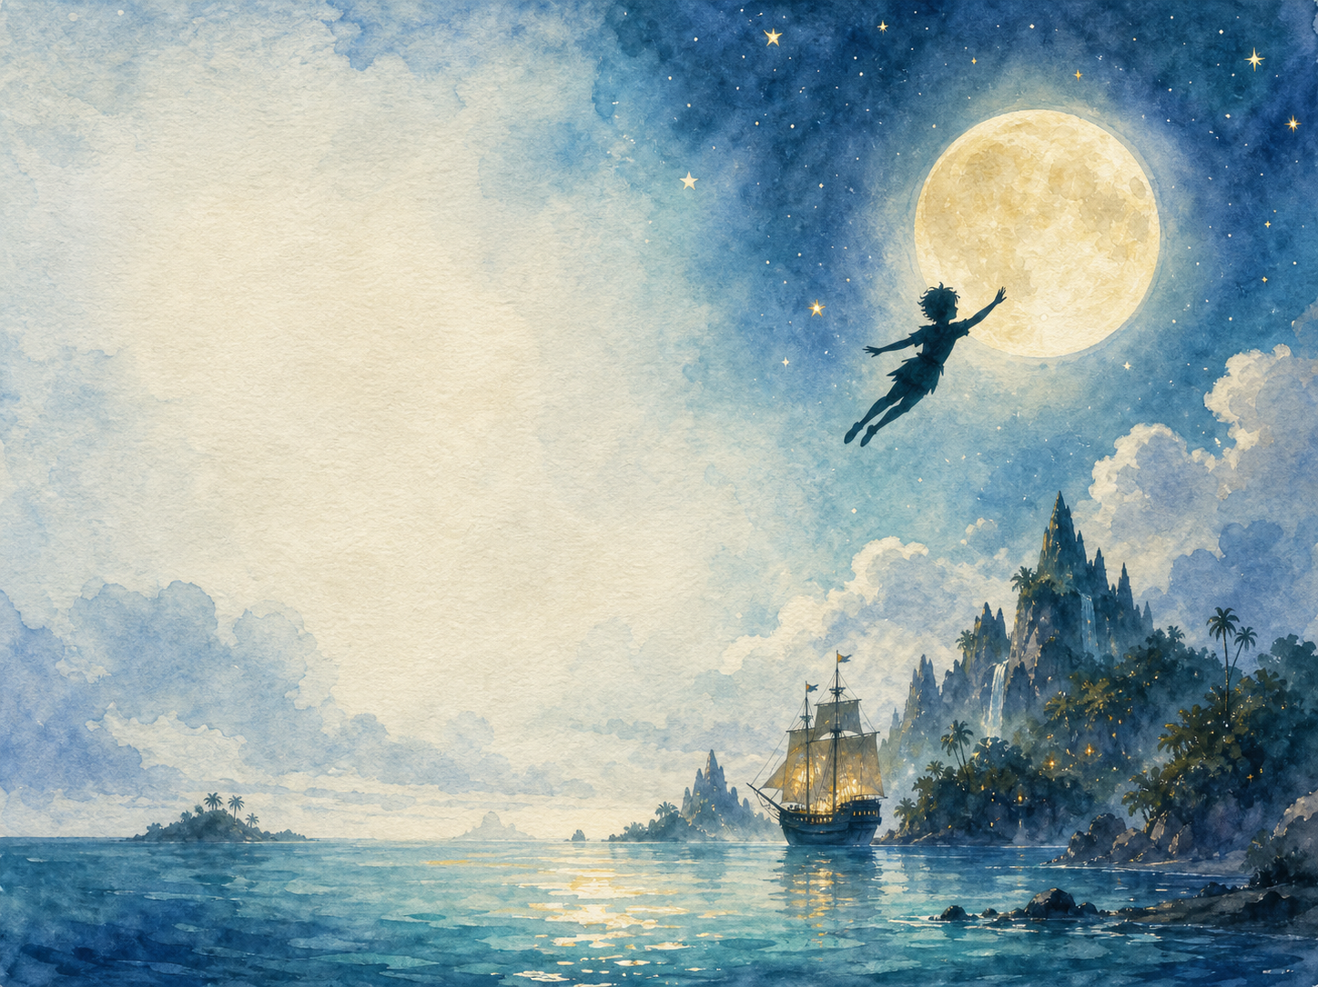
A LIVING BOOK STUDY - LEARNING BOOKLET
Name: _______________________

TASKS: DAY 1
Week 1 - Chapter 1: Peter Breaks Through
READ:
Chapter 1: introducing the Darling family, and Peter's search for his shadow.
NARRATION:
What kind of family are the Darlings? How does Barrie's narrator talk directly to the reader?
EXTENSION:
Discuss: what is unusual about how this chapter is written, compared to other stories you know?
Your response:

TASKS: DAY 2
Week 1 - Chapter 2: The Shadow
READ:
Chapter 2: Wendy sews Peter's shadow back on.
SCIENCE:
How are shadows made? Discuss why a lost shadow might be a good symbol for Peter.
EXTENSION:
Art: make shadow puppets and act out this chapter.
Your response:

TASKS: DAY 3
Week 1 - Chapter 3: Come Away, Come Away!
READ:
Chapter 3: Peter teaches the children to fly, and they set off for Neverland.
DISCUSS:
What does Peter offer the Darling children that makes them want to leave home?
EXTENSION:
Writing: would you have gone with Peter? Explain why or why not.
Your response:

TASKS: DAY 4
Week 1 - Chapter 4: The Flight
READ:
Chapter 4: the children's journey to Neverland.
GEOGRAPHY:
Imagine and map the route to Neverland.
EXTENSION:
Art: illustrate the flight over London and the sea.
Your response:

TASKS: DAY 5
Week 2 - Chapter 5: The Island Come True
READ:
Chapter 5: introducing the pirates, the 'tribe', the Lost Boys, mermaids and fairies of Neverland.
DISCUSS:
This chapter introduces many different groups living on Neverland. Who are they?
EXTENSION:
History/PSHE: discuss the dated, stereotyped portrayal of the 'tribe' in this chapter, and how attitudes have changed since 1911.
Your response:

TASKS: DAY 6
Week 2 - Chapter 6: The Little House
READ:
Chapter 6: the boys build Wendy a tiny house.
DISCUSS:
Why do the boys build Wendy a tiny house rather than just letting her live with them underground?
EXTENSION:
DT/Art: design and build a model 'Wendy house'.
Your response:

TASKS: DAY 7
Week 2 - Chapter 7: The Home Under the Ground
READ:
Chapter 7: a description of the Lost Boys' underground home.
ART:
Draw a cross-section of the Lost Boys' underground home.
EXTENSION:
Discuss: what would you like and dislike about living there?
Your response:

TASKS: DAY 8
Week 2 - Chapter 8: The Mermaids' Lagoon
READ:
Chapter 8: Wendy and the boys encounter the mermaids, and Hook attacks.
NARRATION:
Describe the danger and beauty of the lagoon in your own words.
EXTENSION:
Discuss: how does Barrie make the mermaids seem both beautiful and unsettling?
Your response:

TASKS: DAY 9
Week 2 - Chapter 9: The Never Bird
READ:
Chapter 9: Peter's clever escape using a bird's nest as a boat.
DISCUSS:
What does this chapter show us about Peter's cleverness and character?
EXTENSION:
Writing: retell Peter's escape from the rock in your own words.
Your response:

TASKS: DAY 10
Week 3 - Chapter 10: The Happy Home
READ:
Chapter 10: daily life of the Lost Boys and Wendy, their 'mother'.
PSHE:
Why might Wendy enjoy playing 'mother' to the Lost Boys so much? What does the book suggest about family roles?
EXTENSION:
Discuss: is this a fair or old-fashioned view of a mother's role? What do you think?
Your response:

TASKS: DAY 11
Week 3 - Chapter 11: Wendy's Story
READ:
Chapter 11: Wendy tells the boys a story about the Darling parents waiting for their children.
DISCUSS:
How does Wendy's story affect the Lost Boys, and why does Peter react differently to it?
EXTENSION:
Writing: write the story Wendy tells, in your own words.
Your response:

TASKS: DAY 12
Week 3 - Chapter 12: The Children Are Carried Off
READ:
Chapter 12: Hook captures the children.
DRAMA:
Act out the ambush and capture scene, building tension as you go.
EXTENSION:
Narration: retell this chapter as a newspaper report.
Your response:

TASKS: DAY 13
Week 3 - Chapter 13: Do You Believe in Fairies?
READ:
Chapter 13: Tinker Bell drinks Hook's poison to save Peter, and is saved herself by children believing in fairies.
DISCUSS:
This is one of the most famous scenes in the book. Why might Barrie have written a direct appeal to the reader here?
EXTENSION:
Extension: research how this scene has been staged in the theatre, with the audience asked to clap to save Tinker Bell.
Your response:

TASKS: DAY 14
Week 4 - Chapter 14: The Pirate Ship
READ:
Chapter 14: Peter sneaks aboard the Jolly Roger.
ART:
Design your own pirate ship, or illustrate the Jolly Roger.
EXTENSION:
Discuss: how does Barrie build tension as Peter sneaks aboard?
Your response:

TASKS: DAY 15
Week 4 - Chapter 15: 'Hook or Me This Time'
READ:
Chapter 15: the final battle between Peter and Captain Hook.
DRAMA:
Perform the duel between Peter and Hook.
EXTENSION:
Discuss: what makes Hook a memorable villain?
Your response:

TASKS: DAY 16
Week 4 - Chapter 16: The Return Home
READ:
Chapter 16: the children return to London.
NARRATION:
How do the Darling parents react to the children's return?
EXTENSION:
Discuss: how do you think the Darling parents felt while the children were away?
Your response:

TASKS: DAY 17
Week 4 - Chapter 17: When Wendy Grew Up
READ:
Chapter 17: the bittersweet ending, and Peter's return years later.
DISCUSS:
This ending is often seen as bittersweet. What does it suggest about growing up and childhood?
EXTENSION:
Wrap-up: compare Peter and Wendy's choices about growing up - who do you think made the 'right' choice, and is there a right choice at all?
Your response:

NEVERLAND MAP
Use this page to draw your own map of Neverland, labelling everywhere you meet in the story: the lagoon, the pirate ship, the Lost Boys' underground home, and anywhere else you'd like to add.

CHARACTER PROFILES

Peter Pan
Key details and your thoughts about them:

Wendy Darling
Key details and your thoughts about them:

Captain Hook
Key details and your thoughts about them:

Tinker Bell
Key details and your thoughts about them:

