A FAMILY STUDY IN THE CHARLOTTE MASON TRADITION
MACBETH
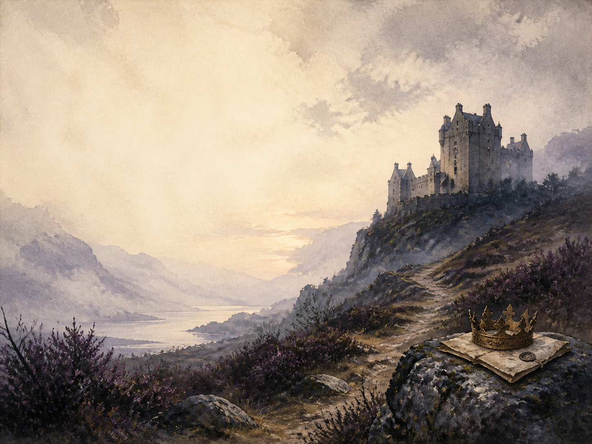
by William Shakespeare

A Living Book Study for GCSE (Years 10-11), with a Foundation Support Tier

Welcome. This Living Book Study of Macbeth is written for families working toward GCSE English Literature, with a core plan for Years 10-11, a lighter Foundation tier for students who need a gentler way in, and a Grade 9 / A-level bridge for those ready to stretch.
Macbeth is a play, meant to be heard and seen. This study keeps performance at its heart while building the exam skills GCSE rewards: close analysis of language, confident use of quotation, and awareness of context. Read the great speeches aloud, watch a production, and keep a quotation bank as you go.
A few steady habits will support progress:
- For Foundation: follow the story scene by scene, watch a film version, and focus on what happens and why.
- For GCSE core: keep a quotation bank and a themes tracker, and practise analysing HOW Shakespeare creates meaning.
- For Grade 9 / A-level bridge: weigh competing readings of the play, and write with a critical, well-supported argument.

How to use this plan
- Follow the suggested 4-week plan, which works scene by scene, then use the final day for exam-style synthesis.
- Read the great speeches aloud, and watch at least one production (for example the RSC, the Globe, or the 2015 film).
- Keep the quotation bank and themes tracker (in the Learning Booklet) filled in as you read.
- A note for parents: Macbeth is a standard GCSE text, but it is dark. It contains several murders (including a king and the on-stage killing of Macduff's young son), a great deal of blood imagery, witchcraft and the supernatural, Lady Macbeth's mental breakdown and implied suicide, and a beheading. Nothing is gratuitously graphic, but a look ahead will help you set the tone.
About the Play
Written around 1606, Macbeth is Shakespeare's shortest and bloodiest tragedy. A brave Scottish general meets three witches who prophesy that he will be king. Spurred on by his own ambition and by his wife, Macbeth murders the good King Duncan and seizes the throne - then, wracked with guilt and fear, kills again and again to keep it, until the whole country turns against him.
The play was written for a Scottish king, James I, who had just come to the English throne, and it plays to his interests: witchcraft, kingship, and his own supposed ancestor Banquo. It is a gripping study of ambition, guilt and how power can rot a good man from within.
Text used: Shakespeare's text is out of copyright and freely available from Project Gutenberg (www.gutenberg.org/ebooks/1533) and the Folger Shakespeare Library.
Topics included: History (King James I, the Divine Right of Kings, the Gunpowder Plot, witchcraft beliefs), Drama (soliloquy, staging, performance), Literacy (imagery, verse and dramatic method), RE/PSHE (ambition, guilt, conscience), Art, and Exam Skills.
Foundation Support Tier

A student who needs a gentler way in can build a firm grip on the story, characters and key moments before tackling close analysis. These activities keep the focus on understanding and performance.
Activity | Learning Areas | Description | Resources
Retell a scene | Literacy + Drama | Rewrite one scene in modern English, then perform your version. | Paper, pens
Prophecy tracker | Literacy | List each thing the witches foretell, then note how and when it comes true. | The text, paper
Design the witches | Art | Draw the three witches and the blasted heath, capturing the play's eerie mood. | Paper, pens
Perform a soliloquy | Drama | Learn and perform a short famous speech, such as the dagger or 'Out, damned spot'. | The text, a open space
Blood and hands hunt | Literacy | Find three moments where blood or hands are mentioned, and note what each one suggests. | The text, paper

GCSE (Years 10-11) Study Map

Literacy / English:
- Keep a quotation bank sorted by theme (ambition, guilt, the supernatural, kingship, appearance vs reality).
- Track the play's key images - blood, hands, darkness, sleep, clothing, and the natural order overturned.
- Study the great soliloquies ('Is this a dagger', 'Tomorrow and tomorrow') and how they reveal a mind at war with itself.
- Analyse how Shakespeare presents each main character, and how Macbeth and Lady Macbeth change places across the play.
History / Context:
- Research King James I, the Divine Right of Kings, and why murdering an anointed king was seen as an offence against God and nature.
- Research the Gunpowder Plot of 1605, fresh in the audience's minds, and the theme of treason and 'equivocation'.
- Research Jacobean beliefs about witches (James wrote a book on them), and how they shape the play's atmosphere.
- Record key dates into your Book of Centuries.
Drama:
- Read the soliloquies aloud, and stage a scene, making choices as a director.
- Compare how two productions present the witches, or the banquet ghost.
- Debate a staging question: should the ghost of Banquo be visible to the audience, or not?

RE / PSHE:
- Discuss ambition: how does 'vaulting ambition' destroy Macbeth, once he lets it rule him?
- Discuss guilt and conscience through Macbeth's visions and Lady Macbeth's sleepwalking.
- Discuss free will and fate: do the witches MAKE Macbeth act, or only tempt him?
Exam Skills:
- Learn quotations by theme, and practise unpacking a single quotation in detail (word choice, imagery, effect).
- Practise the analytical paragraph: point, evidence, analysis of method, and a link to context.
- Plan full answers to past questions, such as: 'How does Shakespeare present Macbeth as a tragic hero?'
- Practise weaving context (AO3) into analysis rather than bolting it on at the end.
Grade 9 / A-Level Bridge Extension:
- Debate whether the witches cause events or merely predict them, and what the play suggests about fate and choice.
- Analyse Macbeth as an Aristotelian tragic hero: his greatness, his fatal flaw, and his fall.
- Explore how the play presents gender, especially through Lady Macbeth's 'unsex me here'.
- Read the play as political theatre written to flatter James I, and question how comfortably it does so.

Possible Study Plan (4 Weeks)

The play has five acts. This plan works scene by scene, then ends with a day of exam-style synthesis. Read the great speeches aloud, and watch a production.

Week 1 - Act 1: Prophecy and Temptation
Day | Read (Act & Scene) | Core Task | Extension / Exam
Day 1 | Act 1 Sc 1-3. | Narration: the witches, the bleeding sergeant's report, and the prophecy to Macbeth and Banquo. | Literacy: 'Fair is foul, and foul is fair.' What does this paradox set up for the whole play?
Day 2 | Act 1 Sc 4-5. | Discuss: Lady Macbeth reads the letter and calls on spirits to 'unsex' her. What does she want, and why? | History: research the Divine Right of Kings and why killing a king was so terrible an act.
Day 3 | Act 1 Sc 6-7. | Discuss: in 'If it were done', Macbeth argues himself OUT of the murder - so how does Lady Macbeth change his mind? | Drama: perform the exchange in which Lady Macbeth taunts Macbeth's manhood.

Week 2 - Acts 2-3: Murder and Aftermath
Day | Read (Act & Scene) | Core Task | Extension / Exam
Day 4 | Act 2 Sc 1-2. | Narration: the dagger soliloquy and the murder of Duncan. | Literacy: study the dagger speech. What does it show about Macbeth's state of mind?
Day 5 | Act 2 Sc 3-4. | Discuss: the drunken Porter, the discovery of the body, and the unnatural events outside. Why the comic Porter here? | History: research 'equivocation' and its link to the Gunpowder Plot.
Day 6 | Act 3 Sc 1-3. | Narration: Macbeth fears Banquo and has him murdered, though Fleance escapes. | Discuss: how has Macbeth changed now that HE gives the orders to kill?
Day 7 | Act 3 Sc 4-6. | Narration: the banquet, where Banquo's ghost appears to Macbeth alone. | Drama: discuss whether the ghost should be visible to the audience, and why it matters.

Week 3 - Act 4: The Descent
Day | Read (Act & Scene) | Core Task | Extension / Exam
Day 8 | Act 4 Sc 1. | Narration: Macbeth returns to the witches, who show him three apparitions and their warnings. | Discuss: Macbeth hears what he WANTS to hear. How do the prophecies mislead him?
Day 9 | Act 4 Sc 2. | Narration: the murder of Lady Macduff and her children. (A distressing scene.) | PSHE: discuss how far Macbeth has fallen, now that he kills the innocent and defenceless.
Day 10 | Act 4 Sc 3. | Discuss: in England, Malcolm tests Macduff's loyalty before news of the murders arrives. | Literacy: how does this scene set 'good' kingship against Macbeth's tyranny?

Week 4 - Act 5 and Synthesis
Day | Read (Act & Scene) | Core Task | Extension / Exam
Day 11 | Act 5 Sc 1-3. | Narration: Lady Macbeth sleepwalks ('Out, damned spot'), while Macbeth grows recklessly defiant. | Discuss: how have Macbeth and Lady Macbeth swapped places since the start?
Day 12 | Act 5 Sc 4-6. | Narration: Birnam Wood moves, and Macbeth speaks 'Tomorrow, and tomorrow, and tomorrow'. | Literacy: analyse the 'Tomorrow' speech. What does Macbeth now believe life is worth?
Day 13 | Act 5 Sc 7-8. | Wrap-up: Macbeth learns the truth of the prophecies too late, and is killed by Macduff; Malcolm is crowned. | Discuss: is order truly restored at the end, or does the play leave us uneasy?
Day 14 | Whole play - exam synthesis. | Exam: plan a full answer to 'How does Shakespeare present the change in Macbeth across the play?' | Extension: 'Macbeth is more victim than villain.' How far do you agree? Argue with evidence.

Helpful Websites

- Full text (free, out of copyright): Project Gutenberg - www.gutenberg.org/ebooks/1533 and the Folger Shakespeare Library - www.folger.edu
- Shakespeare's theatre and life: Shakespeare's Globe - www.shakespearesglobe.com
- Productions and study support: Royal Shakespeare Company - www.rsc.org.uk
- King James I, witchcraft and the Gunpowder Plot: The British Library - www.bl.uk
- Exam guidance: check your own board's site (AQA, Edexcel, Eduqas, OCR) for the set question style

Glossary

- Quotation Bank: a page where you collect key lines, sorted by theme, ready for essays and exams.
- Book of Centuries: a timeline in a book, taken from the Charlotte Mason tradition, where children add historical figures and important dates as they meet them.
- Soliloquy: a speech in which a character, alone on stage, shares their thoughts aloud with the audience.
- Tragic hero: a great figure whose fatal flaw (here, ambition) brings about their own downfall.
- Divine Right of Kings: the belief that a king is chosen by God, so that killing him is a sin against God and nature.
- Equivocation: saying something deliberately ambiguous to mislead - a live issue after the Gunpowder Plot, and echoed by the witches.
- Regicide: the killing of a king - the crime at the heart of the play.

Other Living Book Studies in the Series

- Romeo and Juliet by William Shakespeare
- Animal Farm by George Orwell
- War Poetry: Wilfred Owen and Rupert Brooke
- The Strange Case of Dr Jekyll and Mr Hyde by Robert Louis Stevenson (GCSE)
- A Christmas Carol by Charles Dickens (GCSE)

