INDEPENDENT STUDY COMPANION
MACBETH
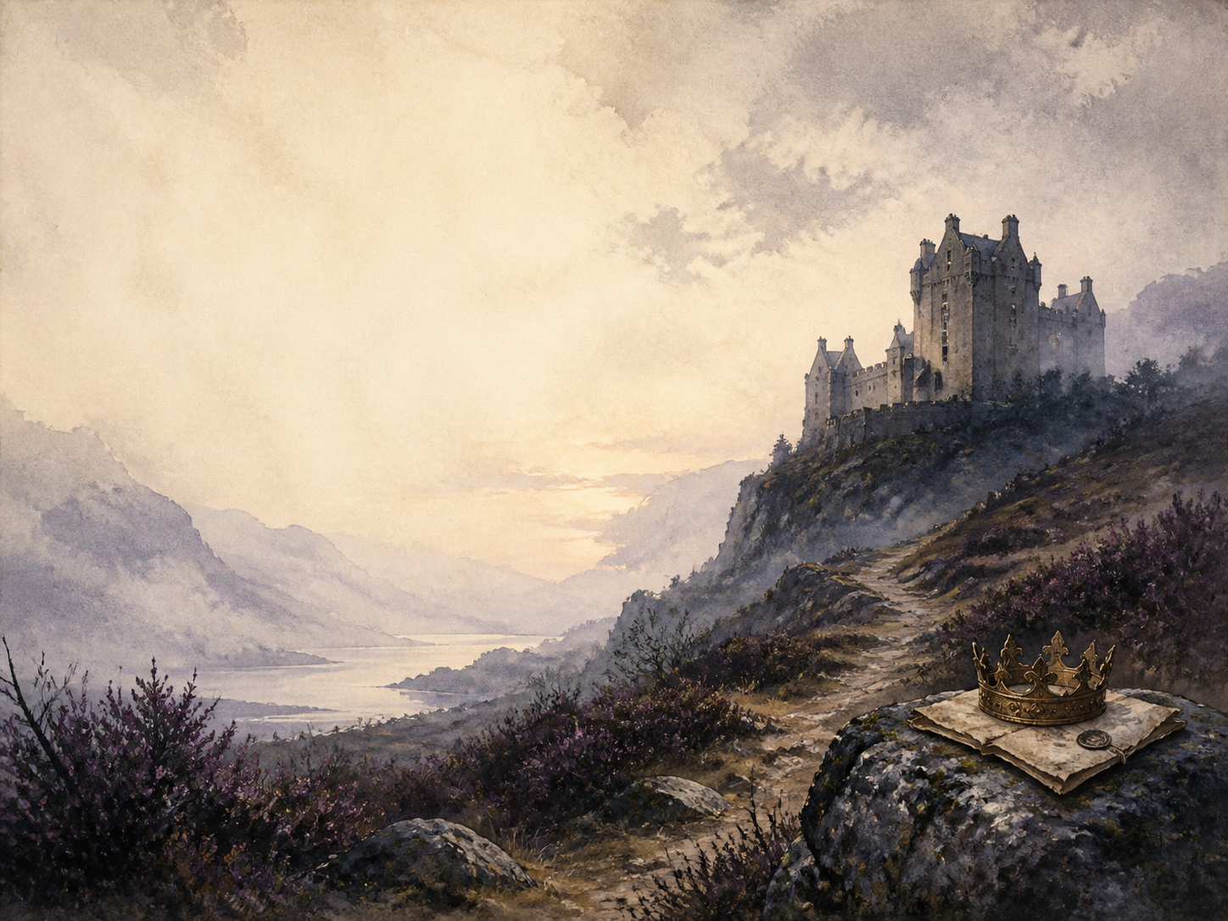
A LIVING BOOK STUDY - GCSE LEARNING BOOKLET
Name: _______________________

DAY 1: ACT 1 SCENES 1-3
READ / WATCH:
Three witches meet on a heath. After a battle, they greet Macbeth with a prophecy - that he will be Thane of Cawdor, then king - and tell Banquo his sons will be kings.
NARRATION:
Retell the prophecies given to Macbeth and to Banquo.
EXTENSION / EXAM:
'Fair is foul, and foul is fair.' What does this paradox set up for the whole play?
Your response:

DAY 2: ACT 1 SCENES 4-5
READ / WATCH:
Duncan names his son Malcolm as heir. Lady Macbeth reads Macbeth's letter and, fearing he is too kind, calls on dark spirits to 'unsex' her.
DISCUSS:
What does Lady Macbeth want, and what is she willing to become to get it?
EXTENSION / EXAM:
History: research the Divine Right of Kings, and why killing a king was seen as a sin against God and nature.
Your response:

DAY 3: ACT 1 SCENES 6-7
READ / WATCH:
Duncan arrives as an honoured guest. In a great soliloquy, Macbeth argues himself OUT of the murder - until Lady Macbeth shames him back into it.
DISCUSS:
In 'If it were done', Macbeth decides NOT to kill Duncan. How does Lady Macbeth change his mind?
EXTENSION / EXAM:
Drama: perform the exchange where Lady Macbeth taunts Macbeth's manhood.
Your response:

DAY 4: ACT 2 SCENES 1-2
READ / WATCH:
Macbeth sees a phantom dagger leading him on, and murders the sleeping Duncan; he returns horrified, unable even to say 'Amen'.
NARRATION:
Retell the dagger vision and the murder itself.
EXTENSION / EXAM:
Literacy: study the dagger soliloquy. What does it reveal about Macbeth's state of mind?
Your response:

DAY 5: ACT 2 SCENES 3-4
READ / WATCH:
A drunken Porter jokes at the gate just before Duncan's body is discovered; Macbeth kills the guards, the king's sons flee, and Macbeth is made king.
DISCUSS:
Why does Shakespeare place the comic Porter right after the murder?
EXTENSION / EXAM:
History: research 'equivocation' and its link to the Gunpowder Plot of 1605.
Your response:

DAY 6: ACT 3 SCENES 1-3
READ / WATCH:
Now king, Macbeth fears Banquo and the prophecy about his sons. He hires murderers to kill Banquo and his son Fleance - but Fleance escapes.
DISCUSS:
How has Macbeth changed, now that HE gives the orders to kill?
EXTENSION / EXAM:
Literacy: compare the Macbeth who hesitated over Duncan with the Macbeth who plots here.
Your response:

DAY 7: ACT 3 SCENES 4-6
READ / WATCH:
At a great banquet, the blood-soaked ghost of Banquo appears to Macbeth alone, and he nearly gives himself away before his horrified guests.
NARRATION:
Describe the banquet scene and Macbeth's terror at the ghost.
EXTENSION / EXAM:
Drama: should the ghost be visible to the audience, or only to Macbeth? Argue for a staging choice.
Your response:

DAY 8: ACT 4 SCENE 1
READ / WATCH:
Macbeth returns to the witches, who conjure three apparitions: beware Macduff; none 'of woman born' shall harm him; he is safe till Birnam Wood moves.
DISCUSS:
Macbeth hears what he wants to hear. How do the prophecies mislead him?
EXTENSION / EXAM:
Literacy: how does Shakespeare use double meanings to build dramatic irony here?
Your response:

DAY 9: ACT 4 SCENE 2
READ / WATCH:
On Macbeth's orders, Lady Macduff and her children are murdered in their own home. (A distressing scene.)
NARRATION:
Retell what happens to Macduff's family.
EXTENSION / EXAM:
PSHE: how far has Macbeth fallen, now that he kills the innocent and defenceless?
Your response:

DAY 10: ACT 4 SCENE 3
READ / WATCH:
In England, Malcolm tests Macduff's loyalty by pretending to be unfit to rule, before news arrives of his family's slaughter.
DISCUSS:
How does this scene set 'good' kingship against Macbeth's tyranny?
EXTENSION / EXAM:
Literacy: why does Shakespeare have Malcolm test Macduff before trusting him?
Your response:

DAY 11: ACT 5 SCENES 1-3
READ / WATCH:
Lady Macbeth sleepwalks, trying to wash imaginary blood from her hands ('Out, damned spot'), while Macbeth grows recklessly defiant behind his castle walls.
DISCUSS:
How have Macbeth and Lady Macbeth swapped places since the start of the play?
EXTENSION / EXAM:
Literacy: analyse the sleepwalking scene. Why is guilt shown through her hands and the dark?
Your response:

DAY 12: ACT 5 SCENES 4-6
READ / WATCH:
Malcolm's army cuts branches from Birnam Wood as camouflage. Told his wife is dead, Macbeth speaks his bleak 'Tomorrow, and tomorrow, and tomorrow' speech.
NARRATION:
Describe how Birnam Wood 'comes' to Dunsinane.
EXTENSION / EXAM:
Literacy: analyse the 'Tomorrow' speech. What does Macbeth now believe life is worth?
Your response:

DAY 13: ACT 5 SCENES 7-8
READ / WATCH:
Macbeth learns Macduff was not 'of woman born', and is killed by him. Malcolm is hailed as the rightful king, and order returns to Scotland.
WRAP-UP:
How do the prophecies all come true in ways Macbeth never expected?
EXTENSION / EXAM:
Discuss: is order truly restored at the end, or does the play leave us uneasy?
Your response:

DAY 14: WHOLE PLAY - EXAM SYNTHESIS
READ / WATCH:
Look back over the whole play, your quotation bank and your themes tracker, ready to write about it as a whole.
EXAM:
Plan a full answer to: 'How does Shakespeare present the change in Macbeth across the play?'
EXTENSION / EXAM:
'Macbeth is more victim than villain.' How far do you agree? Argue your case with evidence.
Your response:

QUOTATION BANK
Collect key lines here, sorted by theme, ready for exam essays. Note who speaks, when, and what method Shakespeare uses.
Theme | Quotation | Method / effect
Ambition
Guilt
The supernatural
Kingship
Appearance vs reality
Gender

THEMES TRACKER
As you read, note where each big theme appears and how it develops, so you can trace it across the whole play in the exam.
Theme | Where it appears and how it develops
Ambition
Guilt and conscience
Fate vs free will
Kingship and tyranny
The natural order overturned

