A FAMILY STUDY IN THE CHARLOTTE MASON TRADITION
KING SOLOMON'S MINES
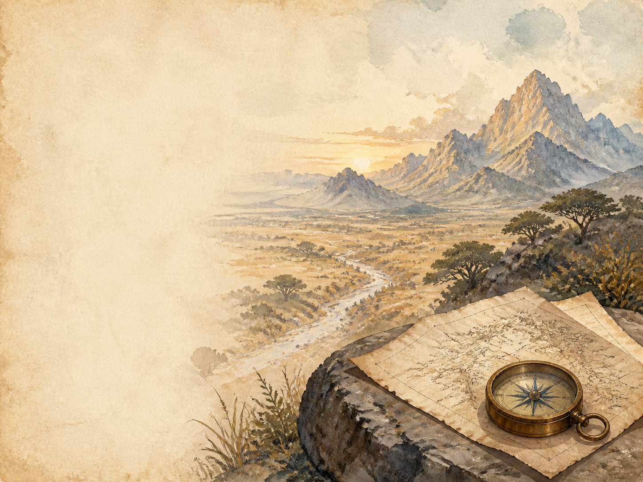
by H. Rider Haggard

A Living Book Study for KS3, with a Years 5-6 Support Tier

Welcome. This Living Book Study of King Solomon's Mines is written for families teaching children of different ages side by side, with a core plan for Years 7-9 and a lighter-touch tier for Years 5-6.
In the Charlotte Mason tradition, we keep the feast wide alongside the adventure: history, geography, science and thoughtful conversation sit next to journalling, drama and discussion. Choose what fits your family, do a little at a time, and let each child respond in their own way.
A few steady habits will support progress:
- For Years 5-6: enjoy the quest itself - the map, the desert crossing, the lost city and the treasure - and build familiarity with the story before deeper discussion.
- For Years 7-9: keep a running 'explorer's journal' as you read, and start noticing how the book pictures Africa and its peoples through the eyes of British adventurers in 1885.
- For Years 9-11: use the extension tasks to think critically about empire, race and the 'lost world' adventure genre this book helped invent.

How to use this plan
- Follow the suggested 4-week medium-term plan, or use the subject activity map to build your own route.
- Print the accompanying Learning Booklet for chapter-by-chapter reading and response tasks.
- Use the Independent Study slides if a student is working through the plan on their own.
- A note for parents: King Solomon's Mines was written in 1885, at the height of the British Empire, and it carries the attitudes of its time. The African peoples are pictured through the eyes of white adventurers, sometimes with admiration and sometimes as exotic 'others'. The original text uses a racial slur in a few places; Haggard himself later regretted this, and many modern editions remove or change it - it is worth checking your edition first. The story also contains battle violence, the sinister 'witch-hunts' led by Gagool, and the death of Foulata, a young Kukuana woman. This pack meets these themes directly rather than skipping them - see the Extension section below.

About the Text
First published in 1885, King Solomon's Mines follows the hunter Allan Quatermain, Sir Henry Curtis and Captain Good as they cross a African desert and mountains in search of a fabled diamond mine - and of Sir Henry's lost brother. It is narrated by Quatermain himself, in the plain, modest voice of an old hunter telling a tall but true-sounding tale.
The novel was a huge bestseller and effectively began the 'lost world' adventure genre - stories of explorers stumbling on hidden kingdoms - that later gave us everything from Tarzan to Indiana Jones. Allan Quatermain became the model for the rugged adventurer-hero. The book is also a document of its age: it was written by a man who had lived and worked in colonial southern Africa, and it reflects the empire's confidence and its prejudices alike.
Text used: the 1885 text is out of copyright and freely available from Project Gutenberg and Standard Ebooks (see Helpful Websites, below).
Topics included: History (the British Empire and the 'Scramble for Africa', the Zulu Kingdom, Victorian exploration), Geography (mapping the journey, deserts, southern Africa), Science (elephants and big-game, desert survival, eclipses, how diamonds form), RE/PSHE (greed, courage, loyalty, fear and superstition), Art, and Drama.
Years 5-6 Support Tier

Younger children can enjoy the treasure-hunt adventure - the secret map, the desert, the lost kingdom and the diamond mine - without needing to engage with the deeper historical and critical discussion aimed at older students.
Activity | Learning Areas | Description | Resources
Draw a treasure map | Art + Literacy | Design an old, aged treasure map like the one da Silvestra draws, with landmarks, a route and a warning. | Paper, tea/coffee to 'age' it, pens
Desert survival kit | DT + Problem Solving | List and, if you can, gather ten things you would take to cross a hot desert on foot - explain each choice. | Paper, pens, everyday objects
Elephant and big-cat facts | Science | Research African elephants: how big they are, how they live, and why they are protected today. | Books or internet access, paper
Grow a crystal | Science | Grow salt or sugar crystals in a jar over a few days, then find out how real diamonds form deep underground. | Jar, salt or sugar, water, string
Act out the eclipse | Drama + Science | Re-enact the scene where the adventurers 'command' the sun or moon to go dark - one person is the crowd, one gives the sign. | Torch, ball, a darkened room

KS3 Subject Activity Map

Literacy:
- Keep your own 'explorer's journal' as you read, in Quatermain's plain, honest style.
- Notice how Haggard uses the found map and the frame of an old hunter's memoir to make a wild tale feel believable.
- Research the 'lost world' adventure genre this novel helped begin, and list later stories and films that follow the same pattern.
- Write a newspaper report announcing the adventurers' return to England with a fortune in diamonds.
- Compare Allan Quatermain to another adventurer-hero you know from books or film.

History:
- Research the 'Scramble for Africa' - the race between European powers to colonise Africa in the late 1800s - which is the backdrop to this book.
- Research the Zulu Kingdom and the Anglo-Zulu War of 1879. Haggard lived in southern Africa, and the Kukuana warriors and regiments are closely modelled on the Zulu.
- Research H. Rider Haggard's own life as a young colonial official in Natal and the Transvaal, and how it shaped the book.
- Research Victorian exploration of the African interior - the explorers, the maps, and what was still unknown to Europeans in 1885.
- Record key dates into your Book of Centuries.

Geography:
- Map the adventurers' journey: from Durban, across the desert, over the mountains called Sheba's Breasts, and down into Kukuanaland.
- Research the deserts and grasslands of southern Africa - the real landscapes behind Haggard's invented ones.
- Find out where the world's diamonds are actually mined, including the great diamond fields of southern Africa discovered in Haggard's own lifetime.
Science:
- Research African elephants and big game - then discuss how attitudes to hunting have changed from Quatermain's day to the age of conservation.
- Research how the body copes with heat and thirst, and how people survive crossing a desert.
- Find out how a solar or lunar eclipse can be predicted in advance from tables - the trick the adventurers use to astonish the Kukuanas.
- Research how diamonds form deep underground and how they are mined and cut.

RE / PSHE:
- Discuss greed and treasure: the story is full of people who want the diamonds. Who handles that desire well, and who badly?
- Discuss fear and superstition - how Gagool uses the 'witch-hunt' to control people, and how the adventurers use the eclipse to do something similar.
- Discuss courage, loyalty and leadership, in Umbopa/Ignosi, in Infadoos, and in the doomed regiment called the Greys.

Art / Drama:
- Illustrate one of the great set-pieces: the mountains called Sheba's Breasts, the Place of Death with its seated stone kings, or the treasure chamber.
- Act out the eclipse scene, where the adventurers 'command' the sky to go dark.
- Perform the moment Umbopa reveals himself as Ignosi, the rightful king.
Years 9-11 Extension:
- King Solomon's Mines helped invent the 'lost world' genre. Research what made it so popular in 1885, and how its adventurer-hero shaped later fiction and film.
- The book both admires the Kukuanas and pictures them as exotic 'others'. Plan a response to: 'How does Haggard present Africa and its peoples, and what does this reveal about British attitudes to empire in 1885?'
- Foulata, a young Kukuana woman, and Captain Good are drawn to each other - but Haggard has her die before anything can come of it. Discuss what this choice reveals about attitudes to race and relationships at the time.
- The original text uses a racial slur that Haggard later regretted, and modern editions handle it differently. Research why publishers change historical texts, and discuss the arguments for and against doing so.

Possible Medium-Term Plan (4 Weeks)

The novel is presented here in twenty chapters. This plan reads one chapter a day.

Week 1 - Chapters 1-5: The Quest Begins
Day | Read | Core Task | Extension / Cross-curricular
Day 1 | Ch 1: I Meet Sir Henry Curtis. | Narration: introduce the three main men - Quatermain, Sir Henry and Good. What is each one like? | Discuss: why is Sir Henry so determined to find his brother?
Day 2 | Ch 2: The Legend of Solomon's Mines. | History: research the real legends of King Solomon's wealth, and why Europeans dreamed of lost African riches. | Art: draw da Silvestra's 300-year-old map, aged and stained, with its route and warning.
Day 3 | Ch 3: Umbopa Enters Our Service. | Discuss: what makes the servant Umbopa stand out from the others? | Predict: the book hints Umbopa is more than he seems. Who do you think he might really be?
Day 4 | Ch 4: An Elephant Hunt. | Science: research African elephants, and how big-game hunting was seen in Victorian times. | Discuss: how have attitudes to hunting wild animals changed between 1885 and today?
Day 5 | Ch 5: Our March into the Desert. | Geography: begin mapping the journey, from the coast out into the waterless desert. | Science: what happens to the human body without water, and how do people survive in deserts?

Week 2 - Chapters 6-10: Into Kukuanaland
Day | Read | Core Task | Extension / Cross-curricular
Day 6 | Ch 6: Water! Water!. | Narration: retell the search for water, and the moment they finally find it. | Science: research practical desert survival - shade, water, and travelling by night.
Day 7 | Ch 7: Solomon's Road. | History: research ancient roads, such as Roman roads, and who might build a great road across wild country. | Discuss: why is finding a huge, ancient road in the wilderness so strange and exciting?
Day 8 | Ch 8: We Enter Kukuanaland. | Geography: map the crossing of the mountains called Sheba's Breasts, and the land beyond. | Discuss: the Kukuanas take the adventurers for 'men from the stars'. How do the adventurers use this?
Day 9 | Ch 9: Twala the King. | Narration: describe King Twala and his court at Loo. | Discuss: what makes Twala a tyrant, and how do the people around him behave?
Day 10 | Ch 10: The Witch-Hunt. | Discuss: how does the old woman Gagool use the 'smelling out' of witches to control people through fear? | History/PSHE: research real witch-hunts in history. Why do frightened communities turn on their own?

Week 3 - Chapters 11-15: War for the Throne
Day | Read | Core Task | Extension / Cross-curricular
Day 11 | Ch 11: We Give a Sign. | Science: find out how an eclipse can be predicted in advance. How do the adventurers use this to seem powerful? | Discuss: Umbopa reveals himself as Ignosi, the rightful king. How does this change everything?
Day 12 | Ch 12: Before the Battle. | History: research the Zulu impis (regiments). Notice how closely the Kukuana army is modelled on them. | Narration: describe how the two sides prepare, and who supports Ignosi.
Day 13 | Ch 13: The Attack. | Drama: act out a moment from the battle as the fighting begins. | Discuss: how does Haggard make the battle exciting? How does he picture war?
Day 14 | Ch 14: The Last Stand of the Greys. | Narration: retell the last stand of the regiment called the Greys. | Discuss: the theme of courage and sacrifice - why does this scene stay with readers?
Day 15 | Ch 15: Good Falls Sick. | Discuss: Sir Henry faces Twala in single combat. What does this add to the story? | PSHE: Foulata nurses Good back to health. Notice the bond that begins to form between them.

Week 4 - Chapters 16-20: The Mines and Home
Day | Read | Core Task | Extension / Cross-curricular
Day 16 | Ch 16: The Place of Death. | Art: illustrate the Place of Death, with its seated stone kings around the table. | Discuss: how does Haggard build a feeling of dread in this chapter?
Day 17 | Ch 17: Solomon's Treasure Chamber. | Science: research how diamonds form underground, and how they are mined and valued. | Narration: describe the treasure chamber as the adventurers first see it.
Day 18 | Ch 18: We Abandon Hope. | Discuss: Gagool betrays them and Foulata is killed. How does greed drive the danger here? | Writing: write a diary entry as one of the adventurers, trapped in the dark with a fortune they cannot use.
Day 19 | Ch 19: Ignosi's Farewell. | Discuss: Ignosi becomes king and makes new laws, ending the witch-hunts. What kind of ruler will he be? | PSHE: what qualities make a good and fair leader? Compare Ignosi with Twala.
Day 20 | Ch 20: Found. | Wrap-up: discuss the whole book - what has the journey really been about, beyond the treasure? | Extension: look back at how the book pictures Africa and its peoples. What would you praise, and what would you question?

Helpful Websites

- Full text (free, out of copyright): Project Gutenberg - www.gutenberg.org/ebooks/2166 and Standard Ebooks - standardebooks.org
- The British Empire and the 'Scramble for Africa': The British Library - www.bl.uk and The National Archives - www.nationalarchives.gov.uk
- The Zulu Kingdom and the Anglo-Zulu War of 1879: National Army Museum - www.nam.ac.uk
- H. Rider Haggard's life: search 'H. Rider Haggard' via your library or a trusted encyclopedia
- How diamonds form: Natural History Museum - www.nhm.ac.uk
- Eclipses and how they are predicted: Royal Museums Greenwich - www.rmg.co.uk

Glossary

- Writing Journal: a notebook where thoughts and images are kept while reading a novel. You can also use the printable booklet.
- Book of Centuries: a timeline in a book, taken from the Charlotte Mason tradition, where children add historical figures and important dates as they meet them.
- The 'Scramble for Africa': the rush by European powers to claim and colonise African territory in the late 1800s - the wider history behind this adventure story.
- Lost world genre: adventure stories in which explorers discover a hidden land or kingdom. King Solomon's Mines helped begin it.
- Impi: a Zulu regiment or armed band. The Kukuana warriors in the book are modelled on the Zulu impis.
- 'Noble savage': an old and now-rejected stereotype that pictured non-European peoples as simple and naturally virtuous. It is worth spotting where the book leans on ideas like this.

Other Living Book Studies in the Series

- Robinson Crusoe by Daniel Defoe
- Treasure Island by Robert Louis Stevenson
- The Jungle Book by Rudyard Kipling
- A Christmas Carol by Charles Dickens (Year 7-9, GCSE extension)
- The Strange Case of Dr Jekyll and Mr Hyde by Robert Louis Stevenson (GCSE)

