INDEPENDENT STUDY COMPANION
KING SOLOMON'S MINES
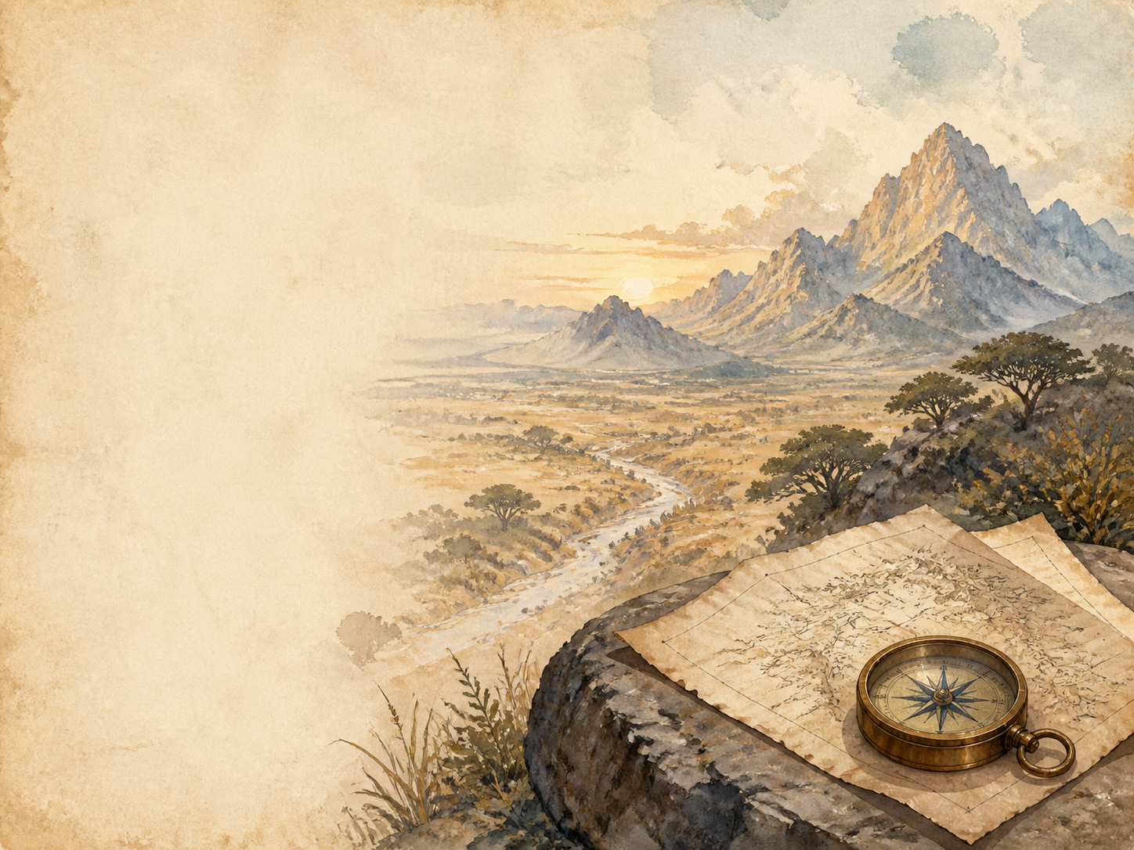
A LIVING BOOK STUDY - LEARNING BOOKLET
Name: _______________________

TASKS: DAY 1
Week 1 - Chapter 1: I Meet Sir Henry Curtis
READ:
Chapter 1: aboard a ship to Natal, the hunter Allan Quatermain meets Sir Henry Curtis and Captain Good, who are searching for Sir Henry's lost brother.
NARRATION:
Introduce the three main men. What is each one like, and how do they come to travel together?
EXTENSION:
Discuss: why is Sir Henry so determined to find his brother, whatever the danger?
Your response:

TASKS: DAY 2
Week 1 - Chapter 2: The Legend of Solomon's Mines
READ:
Chapter 2: Quatermain tells the legend of the mines and shows the map drawn in blood, 300 years earlier, by the dying Portuguese, da Silvestra.
HISTORY:
Research the real legends of King Solomon's wealth, and why Europeans dreamed of finding lost African riches.
EXTENSION:
Art: draw da Silvestra's map, aged and stained, with its route and its warning.
Your response:

TASKS: DAY 3
Week 1 - Chapter 3: Umbopa Enters Our Service
READ:
Chapter 3: a tall, dignified Zulu named Umbopa asks to join the expedition, hinting that he has his own reasons for going.
DISCUSS:
What makes Umbopa stand out from the other servants and guides?
EXTENSION:
Predict: the book hints Umbopa is more than he seems. Who do you think he might really be?
Your response:

TASKS: DAY 4
Week 1 - Chapter 4: An Elephant Hunt
READ:
Chapter 4: a dangerous elephant hunt, in which one of the party is killed.
SCIENCE:
Research African elephants, and how big-game hunting was viewed in Victorian times.
EXTENSION:
Discuss: how have attitudes to hunting wild animals changed between 1885 and today?
Your response:

TASKS: DAY 5
Week 1 - Chapter 5: Our March into the Desert
READ:
Chapter 5: the expedition leaves the last outpost and sets out across the waterless desert, following the map.
GEOGRAPHY:
Begin mapping the journey, from the coast out into the desert.
EXTENSION:
Science: what happens to the body without water, and how do people survive in deserts?
Your response:

TASKS: DAY 6
Week 2 - Chapter 6: Water! Water!
READ:
Chapter 6: almost dying of thirst, the adventurers reach the water marked on the old map.
NARRATION:
Retell the search for water, and the moment they finally find it.
EXTENSION:
Science: research practical desert survival - shade, water, and travelling in the cool of night.
Your response:

TASKS: DAY 7
Week 2 - Chapter 7: Solomon's Road
READ:
Chapter 7: the party discovers a great ancient road, built like a Roman road, leading toward the mountains.
HISTORY:
Research ancient roads, such as Roman roads. Who has the power and skill to build a great road across wild country?
EXTENSION:
Discuss: why is finding a huge, ancient road in the wilderness so strange and exciting?
Your response:

TASKS: DAY 8
Week 2 - Chapter 8: We Enter Kukuanaland
READ:
Chapter 8: the adventurers cross the freezing mountains called Sheba's Breasts and come down into the land of the Kukuana people.
GEOGRAPHY:
Map the crossing of the mountains and the fertile land beyond.
EXTENSION:
Discuss: the Kukuanas take the adventurers for 'men from the stars'. How do the adventurers use this belief?
Your response:

TASKS: DAY 9
Week 2 - Chapter 9: Twala the King
READ:
Chapter 9: the adventurers are brought before the cruel, one-eyed King Twala at his town of Loo.
NARRATION:
Describe King Twala and his court.
EXTENSION:
Discuss: what makes Twala a tyrant, and how do the people around him behave?
Your response:

TASKS: DAY 10
Week 3 - Chapter 10: The Witch-Hunt
READ:
Chapter 10: the ancient witch-finder Gagool leads a terrifying night of 'smelling out' witches, in which many are condemned.
DISCUSS:
How does Gagool use the witch-hunt to control people through fear?
EXTENSION:
History/PSHE: research real witch-hunts in history. Why do frightened communities turn on their own people?
Your response:

TASKS: DAY 11
Week 3 - Chapter 11: We Give a Sign
READ:
Chapter 11: to prove their power, the adventurers use an almanac to predict an eclipse - and Umbopa reveals who he really is.
SCIENCE:
Find out how an eclipse can be predicted in advance from tables. How do the adventurers use this to seem all-powerful?
EXTENSION:
Discuss: Umbopa reveals himself as Ignosi, the rightful king. How does this change everything?
Your response:

TASKS: DAY 12
Week 3 - Chapter 12: Before the Battle
READ:
Chapter 12: loyal regiments rally to Ignosi, and both sides prepare for civil war.
HISTORY:
Research the Zulu impis (regiments). Notice how closely the Kukuana army is modelled on them.
EXTENSION:
Narration: describe how the two sides prepare, and who chooses to support Ignosi.
Your response:

TASKS: DAY 13
Week 3 - Chapter 13: The Attack
READ:
Chapter 13: the battle for the throne begins.
DRAMA:
Act out a moment from the battle as the fighting starts.
EXTENSION:
Discuss: how does Haggard make the battle exciting? How does he picture war?
Your response:

TASKS: DAY 14
Week 3 - Chapter 14: The Last Stand of the Greys
READ:
Chapter 14: a single regiment, the Greys, holds off a whole army in a heroic, doomed last stand.
NARRATION:
Retell the last stand of the Greys.
EXTENSION:
Discuss: the theme of courage and sacrifice - why does this scene stay with readers?
Your response:

TASKS: DAY 15
Week 3 - Chapter 15: Good Falls Sick
READ:
Chapter 15: after Sir Henry meets Twala in single combat, Good falls ill and is nursed by Foulata, a young Kukuana woman the adventurers had saved.
DISCUSS:
Sir Henry faces Twala in single combat. What does this add to the story?
EXTENSION:
PSHE: notice the bond that forms between Foulata and Good. Keep it in mind for later chapters.
Your response:

TASKS: DAY 16
Week 4 - Chapter 16: The Place of Death
READ:
Chapter 16: Gagool leads the adventurers to the Place of Death, a cave where the dead kings of Kukuanaland sit turned to stone.
ART:
Illustrate the Place of Death, with its seated stone kings around the table.
EXTENSION:
Discuss: how does Haggard build a feeling of dread in this chapter?
Your response:

TASKS: DAY 17
Week 4 - Chapter 17: Solomon's Treasure Chamber
READ:
Chapter 17: Gagool opens the secret stone door to a chamber piled with diamonds, gold and ivory.
SCIENCE:
Research how diamonds form deep underground, and how they are mined and valued.
EXTENSION:
Narration: describe the treasure chamber as the adventurers first see it.
Your response:

TASKS: DAY 18
Week 4 - Chapter 18: We Abandon Hope
READ:
Chapter 18: Gagool betrays the adventurers and seals them in the treasure chamber. Foulata is killed, and the men are trapped in the dark.
DISCUSS:
Greed drives the danger in this chapter. Who pays the price, and why?
EXTENSION:
Writing: write a diary entry as one of the trapped adventurers, surrounded by a fortune you cannot use.
Your response:

TASKS: DAY 19
Week 4 - Chapter 19: Ignosi's Farewell
READ:
Chapter 19: having escaped, the adventurers say goodbye to Ignosi, now king, who promises just rule and an end to the witch-hunts.
DISCUSS:
Ignosi makes new laws as king. What kind of ruler do you think he will be?
EXTENSION:
PSHE: what qualities make a good and fair leader? Compare Ignosi with Twala.
Your response:

TASKS: DAY 20
Week 4 - Chapter 20: Found
READ:
Chapter 20: on the journey home the adventurers make one last, unexpected discovery before returning to England.
WRAP-UP:
Discuss the whole book - what has the journey really been about, beyond the treasure?
EXTENSION:
Look back at how the book pictures Africa and its peoples. What would you praise, and what would you question?
Your response:

MY EXPLORER'S JOURNAL
Keep your own journal as you read, in Quatermain's plain, honest style - note the day, what happened, and what you made of it.
Chapter | What happened | What I thought

JOURNEY MAP NOTES
Use this page to note the places the adventurers pass through: the coast, the desert, Sheba's Breasts, Kukuanaland, the mines, and home again.
Place | Chapter | What happens there

