A FAMILY STUDY IN THE CHARLOTTE MASON TRADITION
JANE EYRE
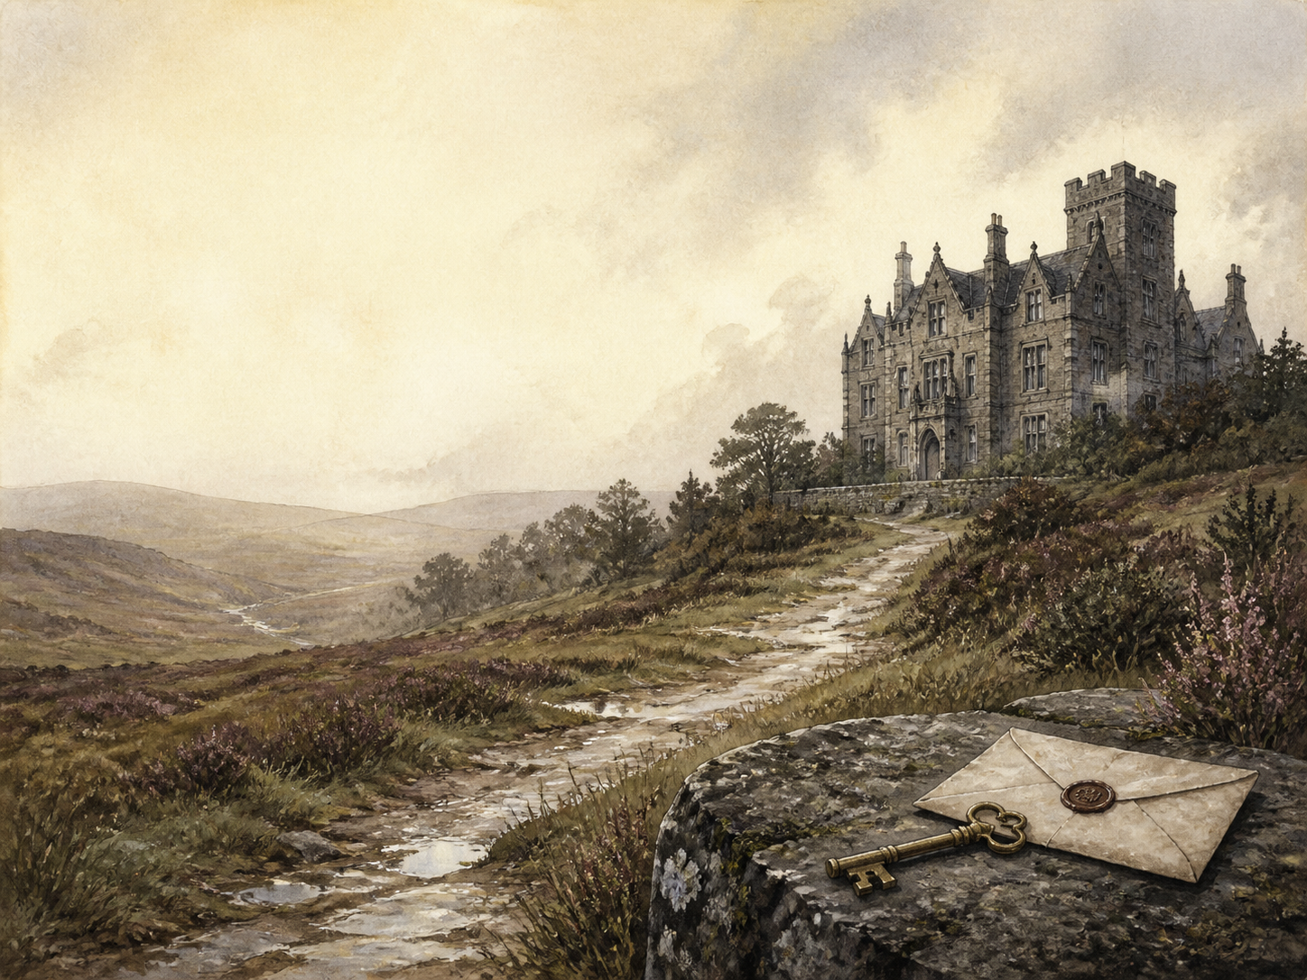
by Charlotte Bronte

A Living Book Study for Year 9 (GCSE lead-in), with a Year 8 Support Tier

Welcome. This Living Book Study of Jane Eyre is written for families teaching children of different ages side by side, with a core plan pitched at Year 9 as a lead-in to GCSE, and a lighter-touch tier for Year 8.
In the Charlotte Mason tradition, we keep the feast wide alongside the story: history, geography and searching conversation sit next to writing, drama and discussion. Choose what fits your family, do a little at a time, and let each child respond in their own way.
A few steady habits will support progress:
- For Year 8: follow Jane's journey through five homes, from cruel Gateshead to Ferndean, and enjoy the mystery of Thornfield.
- For Year 9: keep a reading journal, and start analysing how Bronte builds a strong, principled heroine, and how she uses setting and weather to mirror feeling.
- For GCSE (Years 10-11): use the extension tasks to write analytically about character, theme and context, as this is a key 19th-century novel.

How to use this plan
- Follow the suggested 4-week medium-term plan, or use the subject activity map to build your own route.
- Print the accompanying Learning Booklet for reading and response tasks.
- Use the Independent Study slides if a student is working through the plan on their own.
- A note for parents: Jane Eyre is broadly suitable for this age, but it includes the cruelty Jane suffers as a child (the terrifying 'red-room'), harsh conditions and a child's death at Lowood school, and the disturbing figure of Bertha, a woman with a severe mental illness kept locked away. Bertha is also a Creole woman from Jamaica, and the novel's treatment of her opens up important discussion about race and empire. A read-ahead will help you support these moments.

About the Text
Published in 1847 under the pen-name 'Currer Bell', Jane Eyre follows a plain, poor orphan from a loveless childhood to independence, as governess, teacher and finally wife. At Thornfield Hall she falls in love with her employer, the brooding Mr Rochester - but the house holds a terrible secret that shatters her hopes and tests everything she believes about herself.
The novel startled its first readers with a heroine who insists on her own worth, conscience and freedom. Told in Jane's own passionate first-person voice, it blends romance, Gothic mystery and a fierce argument for the dignity of women.
Text used: the 1847 text is out of copyright and freely available from Project Gutenberg and Standard Ebooks (see Helpful Websites, below).
Topics included: History (Victorian women, governesses, schools and charity, empire and slavery), Geography (Yorkshire moors and the novel's five settings), Science (Victorian ideas of illness and the mind), RE/PSHE (conscience, equality, forgiveness and independence), Art, and Drama.

Year 8 Support Tier

A younger or less confident reader can follow Jane's story and its strong sense of right and wrong without the closer literary analysis aimed at older students. These activities keep the focus on character, setting and imagination.
Activity | Learning Areas | Description | Resources
Jane's five homes | Literacy + Geography | Make a map or timeline of Jane's five homes - Gateshead, Lowood, Thornfield, Moor House and Ferndean - and what happens at each. | Paper, pens
Design Thornfield Hall | Art | Draw Thornfield Hall, including its attic and battlements, hinting at the secret it hides. | Paper, pens
A governess's day | History | Research what a Victorian governess did, and why her position was awkward - neither servant nor family. | Books or internet access
Weather and mood | Literacy | Find three places where Bronte uses weather (storms, moonlight, fire) to match Jane's feelings, and note them. | The novel, paper
Perform the red-room | Drama | Act out young Jane's terror when she is locked in the red-room - or write her thoughts as a monologue. | A open space

Year 9 Subject Activity Map

Literacy:
- Keep a reading journal, tracking how Jane holds on to her principles even when it costs her everything.
- Bronte writes in the first person and often speaks directly to the 'Reader'. Discuss the effect of this closeness.
- Study how setting and weather mirror emotion - the red-room, the split chestnut tree, the moors, fire and ice.
- Explore the Gothic elements (the attic, strange laughter, secrets) woven into a realistic story.
- Write a diary entry as Jane at a turning point - the interrupted wedding, or her flight across the moors.

History:
- Research the life of Victorian women, and why so few respectable paths were open to a poor, educated woman like Jane.
- Research charity schools like Lowood, and the real Cowan Bridge school that Bronte drew on.
- Research the wealth built on Caribbean plantations and slavery, which lies behind Rochester's first marriage to Bertha.
- Record key dates into your Book of Centuries.

Geography:
- Map the novel's five settings and the Yorkshire moorland world Bronte knew.
- Research the West Indies and Jamaica, the origin of Bertha Mason, and its place in the British Empire.

Science / The Mind:
- Research how Victorians understood mental illness, and compare it with how we understand it today, thinking about Bertha.
- Research Victorian medicine and fever, connecting it to the typhus outbreak at Lowood.

RE / PSHE:
- Discuss conscience: Jane refuses to stay with Rochester once his secret is known. Why is this so important to her?
- Discuss equality: Jane insists she is Rochester's equal in spirit, despite their difference in rank. What makes this bold for 1847?
- Discuss forgiveness and independence through Jane's dealings with the Reeds, Rochester and St John Rivers.

Art / Drama:
- Illustrate a key setting: the red-room, Thornfield in flames, or the lonely moor.
- Perform Rochester's proposal, or Jane's refusal to become his mistress.
- Design a book cover that captures Jane's strength rather than just the romance.

GCSE (Years 10-11) Extension:
- Jane Eyre is a major 19th-century novel. Plan a response to: 'How does Bronte present Jane as a strong and independent heroine?'
- Analyse how Bronte uses setting and the Gothic to shape the reader's response.
- Explore the presentation of Bertha Mason, and what later readers have made of her ('the madwoman in the attic').
- Write about the theme of equality - between men and women, and between social classes - in the novel.

Possible Medium-Term Plan (4 Weeks)

The novel has thirty-eight chapters. This plan reads about two chapters per day, grouped by Jane's five homes.

Week 1 - Chapters 1-10: Gateshead and Lowood
Day | Read | Core Task | Extension / Cross-curricular
Day 1 | Ch 1-2. | Narration: describe how the orphaned Jane is treated at Gateshead, and the terror of the red-room. | Discuss: what do we learn about Jane's spirit from how she reacts to unfairness?
Day 2 | Ch 3-4. | Discuss: Jane stands up to her aunt Reed. Is she right to, or too bold for a child of her time? | History: research charity schools and why a girl like Jane would be sent away.
Day 3 | Ch 5-6. | Narration: describe the harsh conditions at Lowood, and Jane's friendship with Helen Burns. | PSHE: Helen bears cruelty patiently; Jane wants to fight it. Whose way do you admire more?
Day 4 | Ch 7-8. | Discuss: Mr Brocklehurst humiliates Jane, but Miss Temple clears her name. How does each adult use their power? | Literacy: note how Bronte contrasts kind and cruel figures.
Day 5 | Ch 9-10. | Narration: a typhus outbreak and the death of Helen Burns; then Jane grows up and seeks a post as governess. | Discuss: how has Jane changed by the time she leaves Lowood?

Week 2 - Chapters 11-20: Thornfield Hall
Day | Read | Core Task | Extension / Cross-curricular
Day 6 | Ch 11-12. | Narration: Jane arrives at Thornfield, meets Mrs Fairfax and Adele - and a stranger on the road. | Geography: picture the moorland setting; note the strange laughter in the house.
Day 7 | Ch 13-14. | Discuss: Jane and Mr Rochester begin their sharp, teasing conversations. What draws them together? | Literacy: how does Bronte make Rochester both attractive and unsettling?
Day 8 | Ch 15-16. | Narration: a fire breaks out in Rochester's room, and Jane saves his life. Retell the night. | Discuss: what does the mysterious fire suggest about the house's secret?
Day 9 | Ch 17-18. | Discuss: the elegant Blanche Ingram arrives. How does Jane feel, and how does she hide it? | History: research the marriage market and how wealth and rank shaped Victorian matches.
Day 10 | Ch 19-20. | Narration: a disguised fortune-teller, and a mysterious night attack on the visitor Mr Mason. | Discuss: the mystery deepens. What clues is Bronte planting?

Week 3 - Chapters 21-30: Secrets and Flight
Day | Read | Core Task | Extension / Cross-curricular
Day 11 | Ch 21-22. | Discuss: Jane returns to a dying Mrs Reed. Can Jane forgive the aunt who wronged her? | PSHE: discuss forgiveness, and whether it must be earned.
Day 12 | Ch 23-24. | Narration: Rochester proposes, and Jane accepts. Retell the scene by the chestnut tree. | Literacy: the great tree is split by lightning that night. What might this foreshadow?
Day 13 | Ch 25-26. | Narration: a figure tears Jane's veil in the night, and the wedding is stopped by a shocking revelation. | Discuss: the secret of Thornfield is revealed. How does Bronte deliver the shock?
Day 14 | Ch 27-28. | Discuss: Jane refuses to stay as Rochester's mistress and flees, penniless, across the moors. Why will she not stay? | RE/PSHE: discuss conscience, and the cost of doing what one believes is right.
Day 15 | Ch 29-30. | Narration: half-dead, Jane is taken in by the Rivers family at Moor House. | Discuss: how does kindness from strangers begin to restore Jane?

Week 4 - Chapters 31-38: Moor House and Ferndean
Day | Read | Core Task | Extension / Cross-curricular
Day 16 | Ch 31-32. | Narration: Jane becomes a village schoolmistress and comes to know the cold, driven St John Rivers. | Discuss: how is St John's kind of 'goodness' different from real warmth?
Day 17 | Ch 33-34. | Narration: Jane learns she has inherited a fortune and that the Rivers are her cousins. Retell what she does with the money. | PSHE: Jane shares her inheritance equally. What does this show about her values?
Day 18 | Ch 35-36. | Discuss: St John presses Jane to marry him and go to India. Why does she refuse - and what does she hear across the moor? | Literacy: discuss the strange, almost supernatural 'call' from Rochester.
Day 19 | Ch 37-38. | Wrap-up: Jane returns to a changed Rochester at Ferndean. Why can she marry him now, as an equal at last? | Extension: 'Reader, I married him.' How has Jane won both love AND independence by the end?

Helpful Websites

- Full text (free, out of copyright): Project Gutenberg - www.gutenberg.org/ebooks/1260 and Standard Ebooks - standardebooks.org
- The Brontes and their world: The Bronte Parsonage Museum - www.bronte.org.uk
- Victorian women and the role of the governess: The British Library - www.bl.uk
- Slavery, empire and Caribbean plantations: The National Archives - www.nationalarchives.gov.uk
- The Yorkshire moors: search a trusted geography or National Park site

Glossary

- Reading Journal: a notebook where thoughts and images are kept while reading a novel. You can also use the printable booklet.
- Book of Centuries: a timeline in a book, taken from the Charlotte Mason tradition, where children add historical figures and important dates as they meet them.
- Governess: a woman employed to teach children in a private home - respectable but poorly paid, and neither servant nor family.
- Gothic: a style of writing full of gloom, secrets, wild settings and a sense of dread.
- Creole: a person of European descent born in the Caribbean; used in the novel of Bertha Mason, whose story links to plantation wealth.
- Bildungsroman: a novel that follows a character growing up and forming their values - as Jane Eyre does.

Other Living Book Studies in the Series

- Wuthering Heights by Emily Bronte
- Pride and Prejudice by Jane Austen
- The Picture of Dorian Gray by Oscar Wilde
- Romeo and Juliet by William Shakespeare
- Great Expectations by Charles Dickens

