INDEPENDENT STUDY COMPANION
JANE EYRE
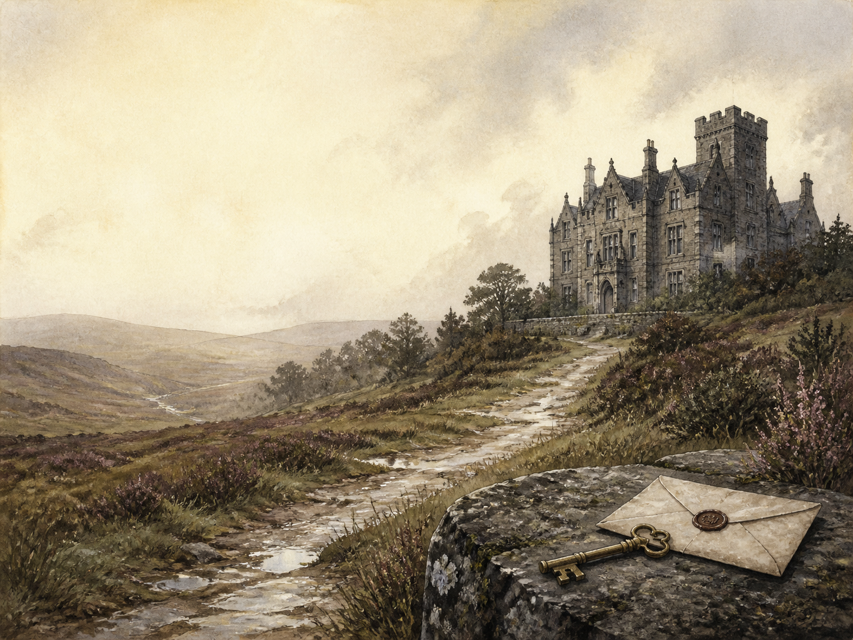
A LIVING BOOK STUDY - LEARNING BOOKLET
Name: _______________________

TASKS: DAY 1
Week 1 - Chapters 1-2: Gateshead
READ:
The orphaned Jane lives unloved with her aunt and cousins, and is punished by being locked in the frightening 'red-room'.
NARRATION:
Describe how Jane is treated at Gateshead, and the terror of the red-room.
EXTENSION:
Discuss: what do we learn about Jane's spirit from the way she reacts to unfairness?
Your response:

TASKS: DAY 2
Week 1 - Chapters 3-4: Sent Away
READ:
Jane dares to answer back to her aunt Reed, and is sent away to Lowood, a harsh charity school.
DISCUSS:
Jane stands up to her aunt. Is she right to, or too bold for a child of her time?
EXTENSION:
History: research Victorian charity schools and why a girl like Jane would be sent away.
Your response:

TASKS: DAY 3
Week 1 - Chapters 5-6: Lowood
READ:
Jane endures cold, hunger and cruelty at Lowood, but finds a true friend in the gentle, patient Helen Burns.
NARRATION:
Describe the conditions at Lowood and Jane's friendship with Helen.
EXTENSION:
PSHE: Helen bears cruelty patiently; Jane wants to fight it. Whose way do you admire more?
Your response:

TASKS: DAY 4
Week 1 - Chapters 7-8: Judged and Cleared
READ:
Mr Brocklehurst shames Jane before the whole school, but the kind Miss Temple restores her good name.
DISCUSS:
How does each adult - Brocklehurst and Miss Temple - use their power over the children?
EXTENSION:
Literacy: note how Bronte sets cruel and kind figures against each other.
Your response:

TASKS: DAY 5
Week 1 - Chapters 9-10: Loss and Growth
READ:
A typhus outbreak sweeps Lowood and Helen dies; years later, a grown-up Jane advertises for a post as a governess.
NARRATION:
Retell the loss of Helen, and how Jane comes to leave Lowood.
EXTENSION:
Discuss: how has Jane changed by the time she leaves the school?
Your response:

TASKS: DAY 6
Week 2 - Chapters 11-12: Thornfield
READ:
Jane arrives at Thornfield Hall as governess to little Adele, hears strange laughter in the house, and meets a stranger who has fallen from his horse.
NARRATION:
Describe Jane's arrival at Thornfield and her first, odd meeting with Mr Rochester.
EXTENSION:
Geography: picture the moorland setting, and note the mystery of the laughter upstairs.
Your response:

TASKS: DAY 7
Week 2 - Chapters 13-14: Sparring
READ:
Jane and the brooding Mr Rochester begin their sharp, teasing conversations.
DISCUSS:
What draws Jane and Rochester together, despite the gap in their rank?
EXTENSION:
Literacy: how does Bronte make Rochester both attractive and unsettling?
Your response:

TASKS: DAY 8
Week 2 - Chapters 15-16: Fire in the Night
READ:
A fire breaks out in Rochester's room at night, and Jane saves his life.
NARRATION:
Retell the night of the fire and how Jane acts.
EXTENSION:
Discuss: what does the mysterious fire suggest about the secret of the house?
Your response:

TASKS: DAY 9
Week 2 - Chapters 17-18: Blanche Ingram
READ:
Rochester fills the house with grand guests, including the beautiful, haughty Blanche Ingram, and Jane must watch in silence.
DISCUSS:
How does Jane feel about Blanche, and how does she hide her feelings?
EXTENSION:
History: research the Victorian 'marriage market' and how wealth and rank shaped matches.
Your response:

TASKS: DAY 10
Week 2 - Chapters 19-20: Deepening Mystery
READ:
A fortune-teller unsettles the guests, and in the night a visitor, Mr Mason, is mysteriously attacked and wounded.
NARRATION:
Retell the strange events of the fortune-teller and the night attack.
EXTENSION:
Discuss: what clues is Bronte planting about what Thornfield hides?
Your response:

TASKS: DAY 11
Week 3 - Chapters 21-22: Return to Gateshead
READ:
Jane is called back to the deathbed of her aunt Reed, and must decide how to treat the woman who wronged her.
DISCUSS:
Can Jane forgive her aunt? Should she?
EXTENSION:
PSHE: discuss forgiveness, and whether it has to be earned.
Your response:

TASKS: DAY 12
Week 3 - Chapters 23-24: The Proposal
READ:
In the garden, Rochester declares his love and proposes; Jane accepts. That night, the great chestnut tree is split by lightning.
NARRATION:
Retell the proposal scene by the chestnut tree.
EXTENSION:
Literacy: the tree is split in two that very night. What might Bronte be foreshadowing?
Your response:

TASKS: DAY 13
Week 3 - Chapters 25-26: The Wedding Stopped
READ:
A strange figure tears Jane's wedding veil in the night, and at the altar a shocking secret halts the marriage.
NARRATION:
Retell how the wedding is stopped, and the secret that comes out.
EXTENSION:
Discuss: how does Bronte build and then deliver this huge shock?
Your response:

TASKS: DAY 14
Week 3 - Chapters 27-28: Flight
READ:
Refusing to stay as Rochester's mistress, Jane flees Thornfield and wanders, penniless and starving, across the moors.
DISCUSS:
Why will Jane not stay with the man she loves, once his secret is known?
EXTENSION:
RE/PSHE: discuss conscience, and the price of doing what you believe is right.
Your response:

TASKS: DAY 15
Week 3 - Chapters 29-30: Moor House
READ:
Near death, Jane is taken in by the Rivers siblings, and slowly recovers among strangers who become friends.
NARRATION:
Describe how the Rivers family rescue and restore Jane.
EXTENSION:
Discuss: how does simple kindness begin to heal Jane after her loss?
Your response:

TASKS: DAY 16
Week 4 - Chapters 31-32: The Schoolmistress
READ:
Jane becomes a village teacher and comes to know the cold, ambitious clergyman St John Rivers.
DISCUSS:
How is St John's driven 'goodness' different from real warmth?
EXTENSION:
Literacy: compare St John with Rochester as very different kinds of man.
Your response:

TASKS: DAY 17
Week 4 - Chapters 33-34: An Inheritance
READ:
Jane learns she has inherited a fortune, and that the Rivers are her own cousins - and she shares the money equally with them.
NARRATION:
Retell what Jane discovers, and what she chooses to do with the money.
EXTENSION:
PSHE: Jane shares her inheritance equally. What does this show about her values?
Your response:

TASKS: DAY 18
Week 4 - Chapters 35-36: The Call
READ:
St John presses Jane to marry him and go to India as a missionary; as she wavers, she seems to hear Rochester calling to her across the miles.
DISCUSS:
Why does Jane refuse St John - and what does she hear that decides her?
EXTENSION:
Literacy: discuss the strange, almost supernatural 'call' from Rochester.
Your response:

TASKS: DAY 19
Week 4 - Chapters 37-38: Ferndean
READ:
Jane finds Rochester, humbled and changed, at Ferndean. Free and his equal at last, she chooses to marry him.
WRAP-UP:
Why can Jane marry Rochester now, when she could not before?
EXTENSION:
'Reader, I married him.' How has Jane won both love AND independence by the end of the novel?
Your response:

MY READING JOURNAL
Keep your own journal as you read - and track how Jane holds on to her principles, even when it costs her dearly.
Chapters | What happened | What it shows about Jane

SETTING AND MOOD
Bronte uses places and weather to mirror feeling. For each setting, note its mood and what it reflects about Jane's life at that point.
Setting | Mood / weather | What it mirrors
Gateshead (red-room)
Lowood
Thornfield
The moors
Ferndean

