A FAMILY STUDY IN THE CHARLOTTE MASON TRADITION
GREAT EXPECTATIONS
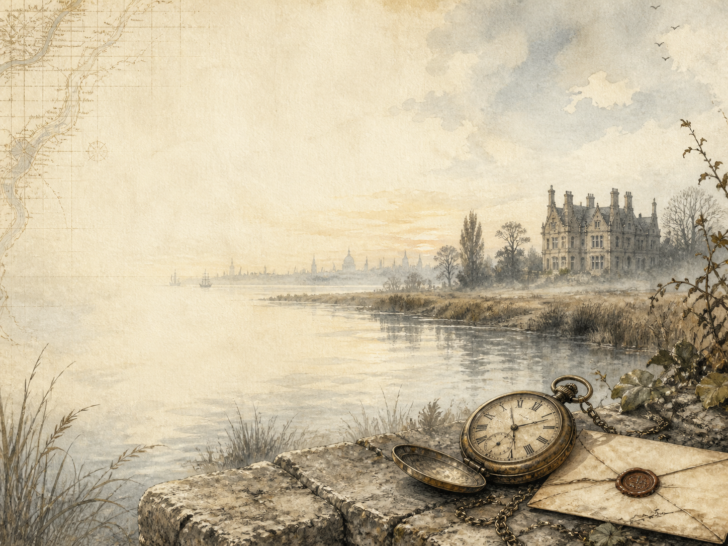
by Charles Dickens

A Living Book Study for Year 8, with a Year 7 Support Tier

Welcome. This Living Book Study of Great Expectations is written for families teaching children of different ages side by side, with a core plan pitched at Year 8 and a lighter-touch tier for Year 7.
In the Charlotte Mason tradition, we keep the feast wide alongside the story: history, geography, science and thoughtful conversation sit next to journalling, drama and discussion. Choose what fits your family, do a little at a time, and let each child respond in their own way.
A few steady habits will support progress:
- For Year 7: enjoy the story of Pip - the convict on the marshes, the strange house of Miss Havisham, and the mystery of his fortune - and build familiarity before deeper discussion.
- For Year 8: keep a running reading journal, and start tracing how Pip changes, and what Dickens is saying about class, money and what it means to be a 'gentleman'.
- For GCSE (Years 10-11): use the extension tasks to analyse Dickens' craft and themes closely, as Great Expectations is a key 19th-century novel for English Literature.

How to use this plan
- Follow the suggested 4-week medium-term plan, or use the subject activity map to build your own route.
- Print the accompanying Learning Booklet for reading and response tasks.
- Use the Independent Study slides if a student is working through the plan on their own.
- A note for parents: Great Expectations is broadly suitable for this age, but it opens with a frightening escaped convict, and includes a violent attack on a character, the unsettling figure of Miss Havisham in her decaying house, and a house fire. Themes of crime, guilt and social class run throughout. Nothing here is graphic, but a quick look ahead will help you judge the pace for your child.

About the Text
First published in weekly instalments in 1860-61, Great Expectations is told by Pip, an orphan raised 'by hand' by his harsh sister and her gentle blacksmith husband, Joe. A terrifying meeting with an escaped convict, and strange visits to the wealthy, jilted Miss Havisham and her cold ward Estella, set Pip dreaming of a grander life. When a mysterious benefactor makes him a gentleman, Pip must learn - painfully - what really makes a person worthy of respect.
Dickens wrote the novel in three 'stages' of Pip's expectations, and famously wrote two different endings. It is one of the most studied of all Victorian novels, rich in memorable characters and in sharp comment on money, class and conscience.
Text used: the 1861 text is out of copyright and freely available from Project Gutenberg and Standard Ebooks (see Helpful Websites, below).
Topics included: History (Victorian class and society, crime and punishment, transportation to Australia), Geography (the Kent marshes, London, the Thames), Science/DT (the blacksmith's forge, Victorian medicine), RE/PSHE (guilt, class, loyalty and forgiveness), Art, and Drama.
Year 7 Support Tier

A younger or less confident reader can follow Pip's story and its big moments without needing the closer literary analysis aimed at older students. These activities keep the focus on story, character and imagination.
Activity | Learning Areas | Description | Resources
Story map of Pip's journey | Literacy + Geography | Draw a map or comic strip that follows Pip from the marshes to London and back, marking the big turning points. | Paper, pens
Wanted poster | Literacy + Art | Design a 'Wanted' poster for the escaped convict from the opening chapters, with a description and reward. | Paper, pens
Miss Havisham's room | Art | Draw or model the stopped-clock room at Satis House, with the wedding feast left to rot. | Paper, craft materials
Blacksmith facts | History + DT | Find out what a village blacksmith like Joe actually did, and why the forge mattered to a Victorian village. | Books or internet access
Act the churchyard scene | Drama | Perform the opening meeting between Pip and the convict - one person plays each part. | A open space

Year 8 Subject Activity Map

Literacy:
- Keep a reading journal, tracking how Pip's feelings about Joe, Estella and himself change across the book.
- The novel first appeared as weekly instalments. Find the cliffhangers, and discuss how serial writing shapes the story.
- Dickens wrote two endings. Read about both, and decide which you prefer and why.
- Explore Dickens' symbols: the marsh mist, Satis House, the stopped clocks, hands and fire. What might each stand for?
- Write a diary entry as Pip on the night his 'great expectations' are announced.

History:
- Research the Victorian class system and how hard it was to move between classes - the heart of Pip's story.
- Research crime and punishment in Victorian Britain, including the prison 'hulks' on the marshes and transportation to Australia.
- Research what 'being a gentleman' meant in the 1800s, and how money, birth and manners fitted together.
- Record key dates into your Book of Centuries.

Geography:
- Map the world of the novel: the Kent marshes, the journey to London, and the River Thames.
- Research transportation to Australia - where convicts like Magwitch were sent, and what life there was like.
Science / DT:
- Research the work of a Victorian blacksmith and how a forge works.
- Research Victorian medicine and fever, connecting it to Pip's serious illness near the end of the book.
RE / PSHE:
- Discuss guilt and conscience: Pip feels guilty from the very first chapter. How does guilt shape his choices?
- Discuss class and snobbery: Pip grows ashamed of Joe. Was he right to? What does the book think?
- Discuss loyalty and forgiveness through Joe, Biddy and Magwitch. Who shows real goodness in this book?
Art / Drama:
- Illustrate a key setting: the misty churchyard, Satis House, or Wemmick's little 'castle'.
- Perform Pip's first meeting with Estella and Miss Havisham.
- Stage the stormy night when Magwitch returns and reveals the truth about Pip's fortune.
GCSE (Years 10-11) Extension:
- Great Expectations is a set 19th-century novel on several GCSE English Literature courses. Plan a response to: 'How does Dickens present Pip's growth from boy to man?'
- Analyse how Dickens presents Magwitch, and how our view of him is meant to change between the start and the end of the novel.
- Explore the theme of social class: how does the novel criticise the idea that money and status make a person better?
- Write about the significance of a key setting - Satis House or the marshes - as a symbol in the novel.

Possible Medium-Term Plan (4 Weeks)

The novel has fifty-nine chapters. This plan reads about three chapters per day, grouped by the turning points of the story.

Week 1 - Chapters 1-15: Childhood on the Marshes
Day | Read | Core Task | Extension / Cross-curricular
Day 1 | Ch 1-3. | Narration: describe Pip's terrifying meeting with the escaped convict in the churchyard. | Discuss: why does Pip help the convict, and how does it make him feel?
Day 2 | Ch 4-6. | Narration: retell the Christmas dinner and the arrival of the soldiers. | Discuss: the convict takes the blame for the stolen food. Why might he do this?
Day 3 | Ch 7-9. | Narration: describe Pip's first visit to Satis House, Miss Havisham and Estella. | Art: draw the stopped-clock room, with its rotting wedding feast.
Day 4 | Ch 10-12. | Discuss: Estella makes Pip feel 'common'. How does he begin to change because of her? | History: research what daily life was like for a poor Victorian family.
Day 5 | Ch 13-15. | Discuss: Pip is apprenticed to Joe but feels ashamed of the forge. Is he being fair to Joe? | Science/DT: research the work of a village blacksmith.

Week 2 - Chapters 16-30: Great Expectations
Day | Read | Core Task | Extension / Cross-curricular
Day 6 | Ch 16-18. | Narration: the lawyer Jaggers brings astonishing news. What are Pip's 'great expectations'? | Discuss: Pip assumes he knows who his secret benefactor is. Is he right to?
Day 7 | Ch 19-21. | Narration: describe Pip leaving home for London and his new life. | Geography: map Pip's journey from the marshes to the city.
Day 8 | Ch 22-24. | Discuss: Pip befriends Herbert Pocket. How is Herbert different from Pip? | History: research what it meant to 'be a gentleman' in Victorian London.
Day 9 | Ch 25-27. | Discuss: Joe visits London and Pip is embarrassed by him. What does this reveal about Pip now? | Writing: write Joe's private thoughts about the visit.
Day 10 | Ch 28-30. | Narration: Pip returns to his home town. How does he behave, and how has he changed? | Discuss: Estella reappears. What effect does she still have on Pip?

Week 3 - Chapters 31-45: London and the Benefactor
Day | Read | Core Task | Extension / Cross-curricular
Day 11 | Ch 31-33. | Discuss: Pip escorts Estella in London. What is the relationship between them? | Art: illustrate a scene of London life as Dickens describes it.
Day 12 | Ch 34-36. | Discuss: Pip and Herbert fall into debt. What does the book say about money and status? | PSHE: discuss living beyond your means, then and now.
Day 13 | Ch 37-39. | Narration: on a stormy night, the convict Magwitch returns and reveals he is Pip's secret benefactor. | Discuss: why is this such a shock to Pip? How do his 'great expectations' now look?
Day 14 | Ch 40-42. | Narration: retell Magwitch's life story and his history with his enemy, Compeyson. | History: research the prison 'hulks' and transportation to Australia.
Day 15 | Ch 43-45. | Discuss: Estella is to marry the brutish Drummle. Why might she choose him? | Discuss: Pip learns he is in danger. How does the mood of the book change?

Week 4 - Chapters 46-59: The Truth and the Reckoning
Day | Read | Core Task | Extension / Cross-curricular
Day 16 | Ch 46-48. | Narration: describe the secret plans to get Magwitch safely out of England. | Discuss: Pip's feelings for Magwitch begin to change. Why?
Day 17 | Ch 49-51. | Discuss: Miss Havisham begs Pip's forgiveness, then is caught in a fire. What has she realised? | Discuss: the secret of Estella's real parents is revealed. Why does it matter?
Day 18 | Ch 52-54. | Narration: retell the tense river journey to smuggle Magwitch away. | Drama: act out the moment Orlick lures Pip into a trap.
Day 19 | Ch 55-57. | Discuss: Magwitch is caught and dies before trial. How does Pip feel about him now? | PSHE: Joe quietly nurses Pip through his illness. What does this show about Joe?
Day 20 | Ch 58-59. | Wrap-up: Pip returns home humbled and changed. What has he finally learned about being a 'gentleman'? | Extension: read about Dickens' two endings. Which do you prefer for Pip and Estella, and why?

Helpful Websites

- Full text (free, out of copyright): Project Gutenberg - www.gutenberg.org/ebooks/1400 and Standard Ebooks - standardebooks.org
- Victorian Britain, class and society: The British Library - www.bl.uk (search 'Dickens' and 'Victorian')
- Crime, punishment and transportation: The National Archives - www.nationalarchives.gov.uk
- Charles Dickens' life and works: Charles Dickens Museum - dickensmuseum.com
- Victorian London: Museum of London - www.museumoflondon.org.uk

Glossary

- Reading Journal: a notebook where thoughts and images are kept while reading a novel. You can also use the printable booklet.
- Book of Centuries: a timeline in a book, taken from the Charlotte Mason tradition, where children add historical figures and important dates as they meet them.
- Benefactor: a person who secretly gives money or help to another - the mystery at the heart of Pip's 'great expectations'.
- Transportation: the punishment of sending convicts overseas, often to Australia, instead of imprisoning them at home.
- Hulks: old ships anchored offshore and used as floating prisons, like the one the convict escapes from.
- Serial: a story published a little at a time, in weekly or monthly parts, as this novel first was.

Other Living Book Studies in the Series

- The Adventures of Sherlock Holmes by Arthur Conan Doyle
- Frankenstein by Mary Shelley
- Dracula by Bram Stoker
- The War of the Worlds by H.G. Wells
- A Christmas Carol by Charles Dickens (Year 7-9, GCSE extension)

