INDEPENDENT STUDY COMPANION
GREAT EXPECTATIONS
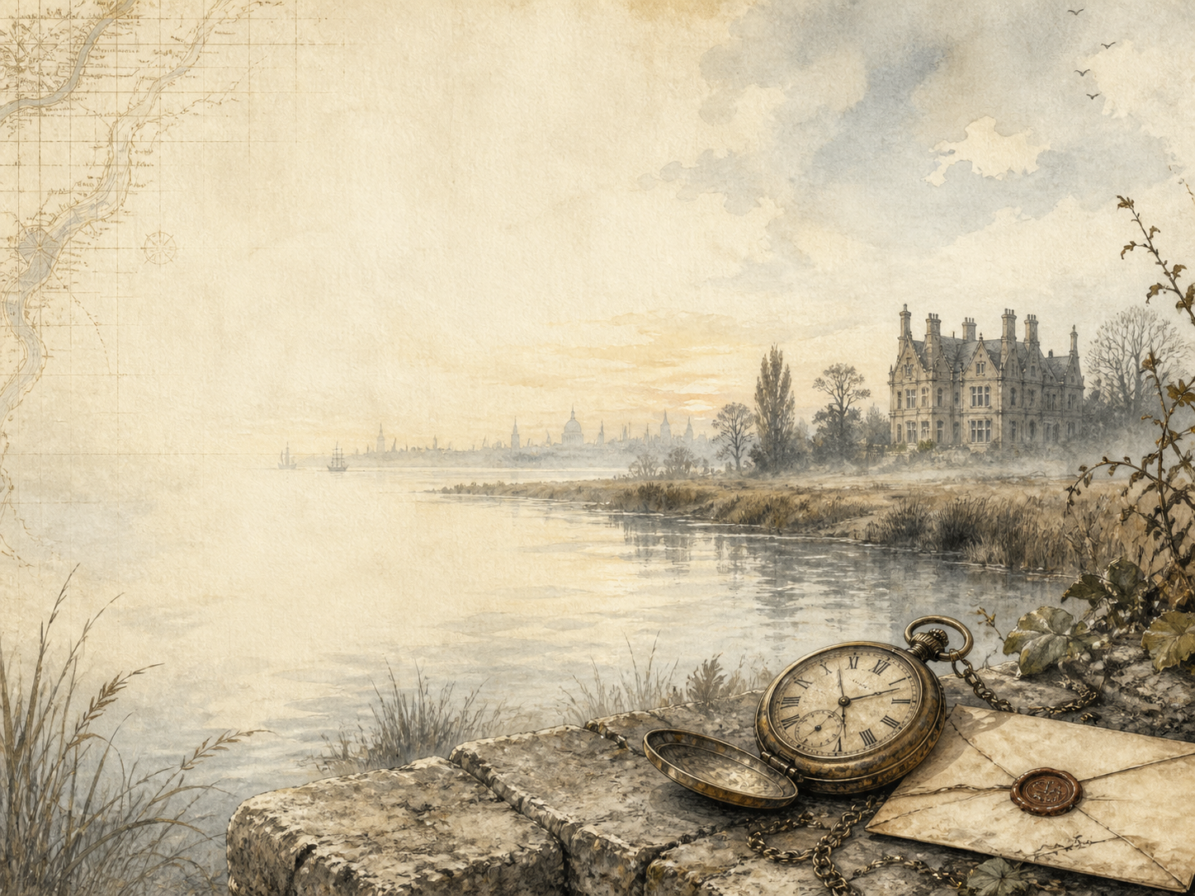
A LIVING BOOK STUDY - LEARNING BOOKLET
Name: _______________________

TASKS: DAY 1
Week 1 - Chapters 1-3: The Marshes
READ:
Pip, an orphan, meets a terrifying escaped convict in the churchyard and is forced to steal food and a file for him.
NARRATION:
Describe Pip's meeting with the convict. How does Dickens make it so frightening?
EXTENSION:
Discuss: why does Pip help the convict, and how does it make him feel afterwards?
Your response:

TASKS: DAY 2
Week 1 - Chapters 4-6: Christmas and the Soldiers
READ:
The Christmas dinner is interrupted by soldiers hunting the convicts, who are recaptured on the marshes.
NARRATION:
Retell the Christmas dinner and the arrival of the soldiers.
EXTENSION:
Discuss: the convict takes the blame for the stolen food. Why might he choose to do this?
Your response:

TASKS: DAY 3
Week 1 - Chapters 7-9: Satis House
READ:
Pip is sent to 'play' at Satis House, where he meets the strange Miss Havisham and the proud, beautiful Estella.
ART:
Draw the stopped-clock room at Satis House, with its rotting wedding feast.
EXTENSION:
Discuss: Estella makes Pip feel 'common'. Why does this affect him so deeply?
Your response:

TASKS: DAY 4
Week 1 - Chapters 10-12: A Change in Pip
READ:
Pip keeps visiting Satis House, and begins to feel ashamed of his home and his future at the forge.
DISCUSS:
How does Pip start to change because of Estella and Miss Havisham?
EXTENSION:
History: research what daily life was like for a poor Victorian family.
Your response:

TASKS: DAY 5
Week 1 - Chapters 13-15: The Forge
READ:
Pip is apprenticed to Joe the blacksmith, but instead of feeling proud, he feels trapped and discontented.
DISCUSS:
Pip is ashamed of the forge and of Joe. Is he being fair? What do you think Dickens wants us to feel?
EXTENSION:
Science/DT: research the work of a village blacksmith and how a forge works.
Your response:

TASKS: DAY 6
Week 2 - Chapters 16-18: Great Expectations
READ:
After a violent attack on Pip's sister, the lawyer Jaggers arrives with astonishing news: Pip has 'great expectations' from a secret benefactor.
NARRATION:
What are Pip's 'great expectations', and what will they allow him to become?
EXTENSION:
Discuss: Pip assumes he knows who his secret benefactor is. Is he right to jump to conclusions?
Your response:

TASKS: DAY 7
Week 2 - Chapters 19-21: To London
READ:
Pip leaves the forge - and Joe - behind and travels to London to begin his new life as a gentleman.
NARRATION:
Describe how Pip feels leaving home, and his first impressions of London.
EXTENSION:
Geography: map Pip's journey from the Kent marshes to the city.
Your response:

TASKS: DAY 8
Week 2 - Chapters 22-24: A New Life
READ:
Pip settles into London, befriends the cheerful Herbert Pocket, and learns the manners of a gentleman.
DISCUSS:
How is Herbert Pocket different from Pip? What does Pip learn from him?
EXTENSION:
History: research what it meant to 'be a gentleman' in Victorian London.
Your response:

TASKS: DAY 9
Week 2 - Chapters 25-27: Joe's Visit
READ:
Joe travels to London to visit Pip, but Pip is embarrassed by his old friend's plain manners.
DISCUSS:
What does Pip's embarrassment reveal about the person he is becoming?
EXTENSION:
Writing: write Joe's private thoughts about the visit, in his own gentle voice.
Your response:

TASKS: DAY 10
Week 2 - Chapters 28-30: Home Again
READ:
Pip returns to his home town, behaving grandly, and encounters Estella once more.
DISCUSS:
How has Pip changed since he left? How does he treat the people of his old town?
EXTENSION:
Discuss: what effect does Estella still have on Pip?
Your response:

TASKS: DAY 11
Week 3 - Chapters 31-33: London and Estella
READ:
London life continues: the theatre, Wemmick's world, and the task of escorting Estella about the city.
DISCUSS:
What is the relationship between Pip and Estella? Is it love, or something more painful?
EXTENSION:
Art: illustrate a scene of London life as Dickens describes it.
Your response:

TASKS: DAY 12
Week 3 - Chapters 34-36: Debt and Coming of Age
READ:
Pip and Herbert slide into debt as Pip comes of age at twenty-one.
DISCUSS:
What does the book say about money and status through Pip's spending?
EXTENSION:
PSHE: discuss living beyond your means - the risks then and now.
Your response:

TASKS: DAY 13
Week 3 - Chapters 37-39: The Benefactor Returns
READ:
On a stormy night, the convict Magwitch returns and reveals the shocking truth: HE is Pip's secret benefactor.
NARRATION:
Describe the stormy night and Magwitch's return. Why is it such a shock to Pip?
EXTENSION:
Discuss: how do Pip's 'great expectations' look now the truth is known?
Your response:

TASKS: DAY 14
Week 3 - Chapters 40-42: Magwitch's Story
READ:
Pip hides Magwitch and learns the story of his hard life and his enemy, Compeyson.
NARRATION:
Retell Magwitch's life story in your own words.
EXTENSION:
History: research the prison 'hulks' and transportation to Australia.
Your response:

TASKS: DAY 15
Week 3 - Chapters 43-45: Danger
READ:
Estella is to marry the brutish Bentley Drummle, and Pip learns his own life may be in danger.
DISCUSS:
Why might Estella choose to marry Drummle of all people?
EXTENSION:
Discuss: how does the mood of the book change as danger closes in?
Your response:

TASKS: DAY 16
Week 4 - Chapters 46-48: The Plan
READ:
Pip and his friends secretly plan to smuggle Magwitch out of England to safety.
NARRATION:
Describe the plan to get Magwitch away. What are the risks?
EXTENSION:
Discuss: Pip's feelings for Magwitch are changing. Why?
Your response:

TASKS: DAY 17
Week 4 - Chapters 49-51: Fire and Secrets
READ:
Miss Havisham begs Pip's forgiveness and is caught in a terrible fire; the secret of Estella's real parents comes to light.
DISCUSS:
What has Miss Havisham finally realised about what she did to Pip and Estella?
EXTENSION:
Discuss: why does the secret of Estella's real parents matter so much?
Your response:

TASKS: DAY 18
Week 4 - Chapters 52-54: The River
READ:
The tense attempt to get Magwitch away by river, and Orlick's deadly trap for Pip.
DRAMA:
Act out the moment Orlick lures Pip into the trap.
EXTENSION:
Narration: retell the river journey and how it goes wrong.
Your response:

TASKS: DAY 19
Week 4 - Chapters 55-57: Loss and Kindness
READ:
Magwitch is caught and dies before trial; Pip falls gravely ill and is nursed back to health by the faithful Joe.
DISCUSS:
How do Pip's feelings about Magwitch change by the end? What has he learned to see?
EXTENSION:
PSHE: Joe quietly nurses Pip through his illness. What does this show about true goodness?
Your response:

TASKS: DAY 20
Week 4 - Chapters 58-59: The Reckoning
READ:
Humbled and poorer, Pip returns home a changed man; years later, he meets Estella one final time.
WRAP-UP:
What has Pip finally learned about what it really means to be a 'gentleman'?
EXTENSION:
Read about Dickens' two different endings. Which do you prefer for Pip and Estella, and why?
Your response:

MY READING JOURNAL
Keep your own journal as you read - note what happens, and how your feelings about Pip change from chapter to chapter.
Chapters | What happened | What I thought of Pip

CHARACTER TRACKER
Great Expectations is full of memorable characters. Note what each one is like, and how they change.
Character | What they are like | How they change
Pip
Joe
Estella
Miss Havisham
Magwitch
Herbert

