A FAMILY STUDY IN THE CHARLOTTE MASON TRADITION
FRANKENSTEIN
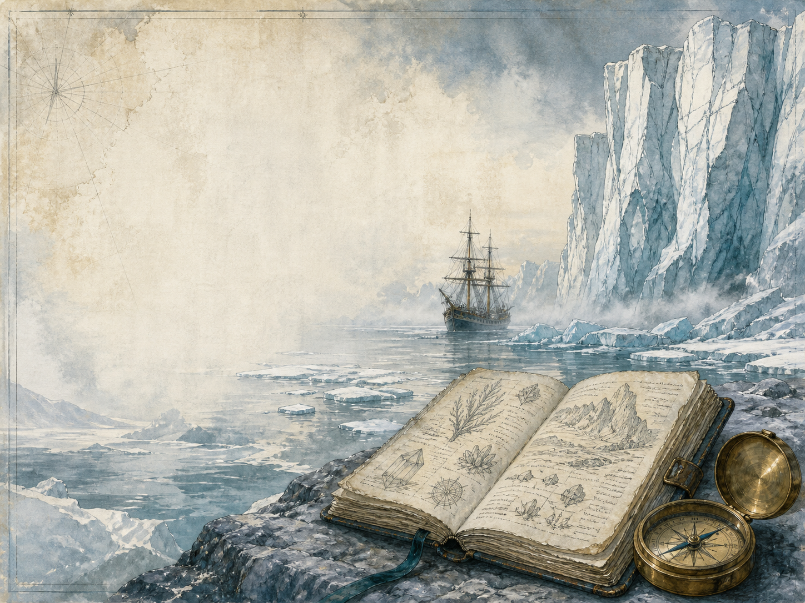
by Mary Shelley

A Living Book Study for Year 8, with a Year 7 Support Tier

Welcome. This Living Book Study of Frankenstein is written for families teaching children of different ages side by side, with a core plan pitched at Year 8 and a lighter-touch tier for Year 7.
In the Charlotte Mason tradition, we keep the feast wide alongside the story: science, history, geography and searching conversation sit next to writing, drama and discussion. Choose what fits your family, do a little at a time, and let each child respond in their own way.
A few steady habits will support progress:
- For Year 7: follow the story of the scientist and his creature, and enjoy the big questions it raises - without needing close literary analysis.
- For Year 8: keep a reading journal, and start weighing up who the real 'monster' is, and what Mary Shelley is warning us about.
- For GCSE (Years 10-11): use the extension tasks to analyse Shelley's craft, themes and context closely, as Frankenstein is a major set text.

How to use this plan
- Follow the suggested 4-week medium-term plan, or use the subject activity map to build your own route.
- Print the accompanying Learning Booklet for reading and response tasks.
- Use the Independent Study slides if a student is working through the plan on their own.
- A note for parents: Frankenstein is a serious, sometimes bleak book. A young child, William, is murdered; an innocent servant, Justine, is wrongly executed; and several more characters die. Its themes - grief, isolation, rejection and revenge - are handled thoughtfully rather than graphically, but this is emotionally weightier than an adventure story. A read-ahead will help you support your child through the darker turns.

About the Text
Published in 1818, Frankenstein was written by Mary Shelley when she was still a teenager, after a ghost-story challenge one wet summer by Lake Geneva. The young scientist Victor Frankenstein discovers how to give life to lifeless matter - but recoils in horror from the creature he makes. Abandoned and shunned for his looks, the creature turns from gentle longing to terrible revenge, and creator and creation destroy each other.
Often called the first true science-fiction novel, Frankenstein asks questions that feel more urgent than ever: how far should science go, and who is responsible for what we create? Its full title, 'The Modern Prometheus', points back to the Greek myth of the man who stole fire from the gods.
Text used: the 1818 text is out of copyright and freely available from Project Gutenberg and Standard Ebooks (see Helpful Websites, below).
Topics included: Science (electricity, galvanism and the ethics of discovery), History (the Romantic age, the science of 1818, the Prometheus myth), Geography (Geneva, the Alps, the Arctic), RE/PSHE (responsibility, prejudice, loneliness and revenge), Art, and Drama.
Year 7 Support Tier

A younger or less confident reader can follow the story and its big 'what if' questions without the closer literary analysis aimed at older students. These activities keep the focus on ideas, science and imagination.
Activity | Learning Areas | Description | Resources
Design the creature | Art | Draw the creature from Mary Shelley's own description - NOT the green, bolt-necked film version. | Paper, pens
Storyboard the creation | Art + Literacy | Draw a short comic strip of the night the creature comes to life. | Paper, pens
Static electricity | Science | Try safe static experiments (balloons, hair, small papers) and find out what electricity is. | Balloons, wool, small paper scraps
The year without a summer | History + Science | Research 1816, the cold, dark summer - caused by a volcano - when Mary Shelley wrote the book. | Books or internet access
Monster or not? debate | Drama + PSHE | Hold a short debate: is the creature a monster, or a victim? Take a side and argue it. | Nothing needed

Year 8 Subject Activity Map

Literacy:
- Notice the 'frame' structure: Walton's letters wrap around Victor's story, which wraps around the creature's story. Why tell it this way?
- Explore the Gothic genre - ruined ice, storms, graveyards, dread - and find examples in the book.
- Keep asking the book's central question: who is the real 'monster' here, and does your answer change?
- Write the creature's diary for the days it spends secretly watching the cottagers.
Science:
- Research 'galvanism' - the 1800s experiments with electricity that seemed to make dead muscles twitch - and how it inspired the book.
- Debate the ethics of science: 'just because we can do something, does it mean we should?'
- Connect the book to modern debates - artificial intelligence, cloning, gene editing, transplants. What would Mary Shelley make of them?

History:
- Research Mary Shelley's life, and the famous wet summer of 1816 by Lake Geneva where the story was born.
- Research the Romantic movement in art and writing, and its fascination with nature, feeling and the sublime.
- Research the Greek myth of Prometheus, who stole fire from the gods - the book's other title is 'The Modern Prometheus'.
- Record key dates into your Book of Centuries.

Geography:
- Map the settings: Geneva, the Alps and Mont Blanc, the Orkney Islands, and the frozen Arctic.
- Research why the Alps and the Arctic suit the book's mood so well.
RE / PSHE:
- Discuss responsibility: Victor creates life, then abandons it. What did he owe his creation?
- Discuss prejudice: the creature is judged and rejected for its looks alone. How does this shape who it becomes?
- Discuss loneliness and revenge: how does being cast out turn the creature from gentle to violent?
Art / Drama:
- Illustrate a key scene: the creation, the meeting on the glacier, or the final Arctic pursuit.
- Act out the confrontation where the creature demands that Victor make him a companion.
- Design a book cover that captures the story's real mood, not the Hollywood cliche.
GCSE (Years 10-11) Extension:
- Frankenstein is a major GCSE and A-level set text. Plan a response to: 'How does Shelley make the reader feel sympathy for the creature?'
- Analyse the theme of dangerous ambition, and how Victor's story warns against it.
- Explore the 'nature versus nurture' question: is the creature born evil, or made evil by rejection?
- Write about how Shelley uses the frame narrative and setting to shape our response.

Possible Medium-Term Plan (4 Weeks)

This plan works through Walton's opening letters and the twenty-four chapters, grouped by the turns of the story.

Week 1 - Letters + Chapters 1-5: Ambition and Creation
Day | Read | Core Task | Extension / Cross-curricular
Day 1 | Walton's Letters 1-4. | Narration: who is Robert Walton, and who does he rescue from the ice? | Discuss: how does the 'frame' of Walton's letters draw us into the story?
Day 2 | Ch 1-2. | Narration: describe Victor's happy childhood in Geneva and his early love of old science. | History: research the Romantic age and its fascination with nature and feeling.
Day 3 | Ch 3-4. | Discuss: at university, Victor becomes obsessed with the secret of life. Is his ambition admirable, dangerous, or both? | Science: research 'galvanism' and the 1800s experiments with electricity.
Day 4 | Ch 5. | Narration: the creature comes to life - and Victor flees in horror. Describe the scene. | Discuss: Victor abandons his creation at the moment of its 'birth'. What did he owe it?

Week 2 - Chapters 6-10: Consequences
Day | Read | Core Task | Extension / Cross-curricular
Day 5 | Ch 6-7. | Narration: Victor recovers, then learns his young brother William has been murdered. | Discuss: how does dread begin to gather around Victor's secret?
Day 6 | Ch 8. | Discuss: the innocent servant Justine is wrongly accused and executed. Why does Victor stay silent? | PSHE: discuss injustice, and the courage it takes to speak up.
Day 7 | Ch 9-10. | Narration: in the mountains, Victor finally meets the creature face to face. | Art: illustrate the meeting on the glacier, high in the Alps.

Week 3 - Chapters 11-16: The Creature's Story
Day | Read | Core Task | Extension / Cross-curricular
Day 8 | Ch 11-12. | Narration: the creature tells of its first confusing days, and of secretly watching a poor family. | Discuss: how does the creature's own voice change how we feel about it?
Day 9 | Ch 13-14. | Discuss: the creature teaches itself to speak and read by watching the cottagers. What does it long for? | Literacy: write a diary entry as the creature, watching the family it loves from hiding.
Day 10 | Ch 15-16. | Discuss: rejected in horror by everyone it meets, the creature turns to rage. Who is to blame? | PSHE: discuss how rejection and loneliness can change a person.

Week 4 - Chapters 17-24: The Bargain and the Chase
Day | Read | Core Task | Extension / Cross-curricular
Day 11 | Ch 17-18. | Discuss: the creature demands a companion of its own. Should Victor agree? | Geography: map Victor's journey across Europe to England and Scotland.
Day 12 | Ch 19-20. | Narration: Victor destroys the half-made second creature. What does the creature vow in revenge? | Discuss: was Victor right to break his promise, whatever the cost?
Day 13 | Ch 21-22. | Narration: retell the deaths and the trial that follow, and Victor's marriage to Elizabeth. | Discuss: the creature warned, 'I will be with you on your wedding-night'. Trace the dread this builds.
Day 14 | Ch 23-24. | Wrap-up: the pursuit ends in the Arctic, where Victor dies and the creature grieves. Who do you pity most? | Extension: 'The real monster is the maker, not the made.' How far do you agree?

Helpful Websites

- Full text (free, out of copyright): Project Gutenberg - www.gutenberg.org/ebooks/84 and Standard Ebooks - standardebooks.org
- Mary Shelley and the writing of Frankenstein: The British Library - www.bl.uk
- The science behind the story (galvanism, electricity): Science Museum - www.sciencemuseum.org.uk
- The Romantic movement: search a trusted encyclopedia or gallery site
- The 1816 'year without a summer': search a trusted science or history site

Glossary

- Reading Journal: a notebook where thoughts and images are kept while reading a novel. You can also use the printable booklet.
- Book of Centuries: a timeline in a book, taken from the Charlotte Mason tradition, where children add historical figures and important dates as they meet them.
- Frame narrative: a story told inside another story - here, Walton's letters frame Victor's tale, which frames the creature's.
- Galvanism: the early-1800s idea that electricity could stir life in dead tissue, which helped inspire the novel.
- Gothic: a style of writing full of gloom, dread, wild landscapes and the supernatural.
- Prometheus: the figure from Greek myth who stole fire from the gods for humankind - echoed in the book's second title.

Other Living Book Studies in the Series

- Great Expectations by Charles Dickens
- The Adventures of Sherlock Holmes by Arthur Conan Doyle
- Dracula by Bram Stoker
- The War of the Worlds by H.G. Wells
- The Strange Case of Dr Jekyll and Mr Hyde by Robert Louis Stevenson (GCSE)

