INDEPENDENT STUDY COMPANION
FRANKENSTEIN
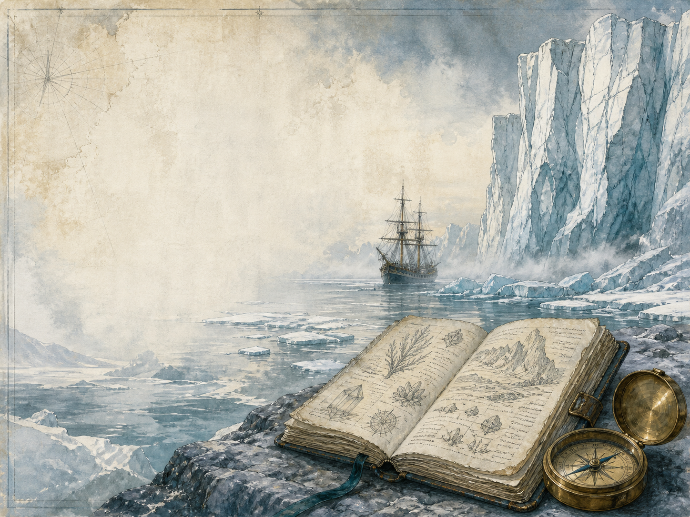
A LIVING BOOK STUDY - LEARNING BOOKLET
Name: _______________________

TASKS: DAY 1
Week 1 - Walton's Letters 1-4
READ:
On an expedition to the Arctic, Captain Walton writes home to his sister - and rescues a dying man, Victor Frankenstein, who begins to tell his story.
NARRATION:
Who is Robert Walton, and who does he pull from the ice?
EXTENSION:
Discuss: how does starting with Walton's letters draw us into the story?
Your response:

TASKS: DAY 2
Week 1 - Chapters 1-2
READ:
Victor describes his warm childhood in Geneva, his beloved Elizabeth, and his early passion for old books of science.
NARRATION:
Describe Victor's happy early life and what first fires his curiosity.
EXTENSION:
History: research the Romantic age and its love of nature and strong feeling.
Your response:

TASKS: DAY 3
Week 1 - Chapters 3-4
READ:
At university in Ingolstadt, Victor throws himself into modern science and secretly discovers how to give life to lifeless matter.
DISCUSS:
Is Victor's ambition admirable, dangerous, or both?
EXTENSION:
Science: research 'galvanism' and the 1800s experiments with electricity that inspired the book.
Your response:

TASKS: DAY 4
Week 1 - Chapter 5
READ:
The creature stirs into life - and Victor, horrified by what he has made, runs from the room and falls ill.
NARRATION:
Describe the night the creature comes to life, and Victor's reaction.
EXTENSION:
Discuss: Victor abandons his creation at the moment of its 'birth'. What did he owe it?
Your response:

TASKS: DAY 5
Week 2 - Chapters 6-7
READ:
Nursed back to health by his friend Clerval, Victor learns that his little brother William has been murdered, and hurries home.
NARRATION:
Retell how Victor recovers, and the dreadful news that reaches him.
EXTENSION:
Discuss: how does dread begin to gather around Victor's secret?
Your response:

TASKS: DAY 6
Week 2 - Chapter 8
READ:
The gentle servant Justine is accused of William's murder on false evidence, and is executed - while Victor stays silent.
DISCUSS:
Why does Victor say nothing to save Justine? What would you have done?
EXTENSION:
PSHE: discuss injustice, and the courage it takes to speak up for the truth.
Your response:

TASKS: DAY 7
Week 2 - Chapters 9-10
READ:
Crushed by guilt, Victor goes into the mountains, where the creature finds him and demands to be heard.
NARRATION:
Describe the meeting between Victor and the creature high on the glacier.
EXTENSION:
Art: illustrate the confrontation on the ice, among the Alps.
Your response:

TASKS: DAY 8
Week 3 - Chapters 11-12
READ:
The creature tells its own story: its confusing first days, and the poor cottage family it secretly watches and comes to love.
NARRATION:
Retell the creature's earliest days in its own words.
EXTENSION:
Discuss: how does hearing the creature's own voice change how you feel about it?
Your response:

TASKS: DAY 9
Week 3 - Chapters 13-14
READ:
By watching the family, the creature teaches itself to speak and read, and aches for friendship and a place to belong.
DISCUSS:
What does the creature most long for, and why can it not have it?
EXTENSION:
Literacy: write a diary entry as the creature, watching the family it loves from its hiding place.
Your response:

TASKS: DAY 10
Week 3 - Chapters 15-16
READ:
When the creature finally reveals itself, it is met with horror and violence, and its gentleness curdles into rage.
DISCUSS:
The creature is rejected for its looks alone. Who is to blame for what it becomes?
EXTENSION:
PSHE: discuss how rejection and loneliness can change a person.
Your response:

TASKS: DAY 11
Week 4 - Chapters 17-18
READ:
The creature demands that Victor make it a companion, and a reluctant Victor travels across Europe to begin.
DISCUSS:
Should Victor agree to make a second creature? Weigh up both sides.
EXTENSION:
Geography: map Victor's journey across Europe to England and Scotland.
Your response:

TASKS: DAY 12
Week 4 - Chapters 19-20
READ:
Fearing the consequences, Victor destroys the half-finished second creature - and the creature swears a terrible revenge.
NARRATION:
What does the creature vow when Victor breaks his promise?
EXTENSION:
Discuss: was Victor right to destroy the second creature, whatever the cost?
Your response:

TASKS: DAY 13
Week 4 - Chapters 21-22
READ:
The creature's revenge begins to fall on those Victor loves, even as he marries Elizabeth.
NARRATION:
Retell the losses that follow, and trace the dread of the creature's warning.
EXTENSION:
Discuss: 'I will be with you on your wedding-night.' How does Shelley build suspense from this line?
Your response:

TASKS: DAY 14
Week 4 - Chapters 23-24
READ:
The pursuit ends where it began, in the frozen Arctic, where Victor dies and the grieving creature vanishes into the ice.
WRAP-UP:
By the end, who do you pity most - Victor, the creature, or someone else?
EXTENSION:
'The real monster is the maker, not the made.' How far do you agree?
Your response:

MY READING JOURNAL
Keep your own journal as you read - and keep asking the book's big question: who is the real 'monster' here?
Chapters | What happened | Who seems the 'monster' now?

SHOULD SCIENCE ALWAYS GO FURTHER?
Frankenstein asks whether everything that CAN be done SHOULD be done. Note arguments on both sides, using the book and the modern world (AI, cloning, gene editing).
Reasons to press on | Reasons for caution

