A FAMILY STUDY IN THE CHARLOTTE MASON TRADITION
DRACULA
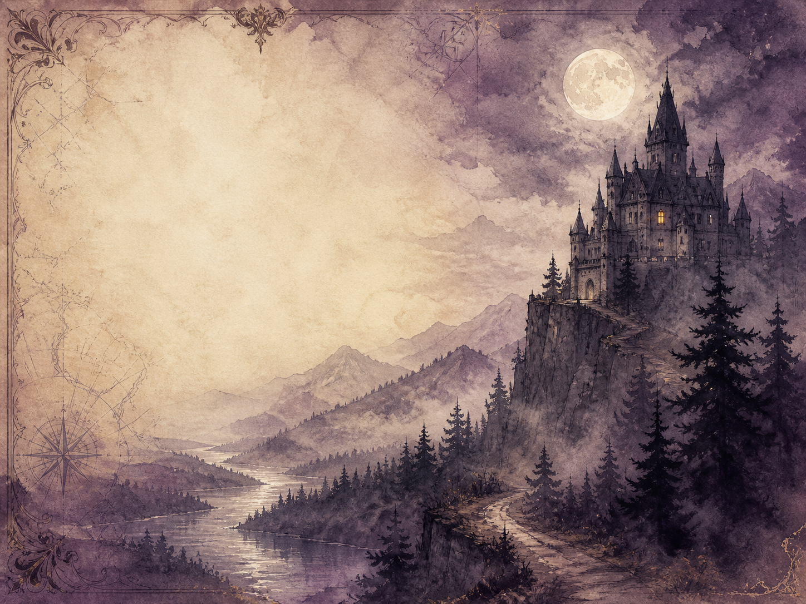
by Bram Stoker

A Living Book Study for Year 8, with a Year 7 Support Tier

Welcome. This Living Book Study of Dracula is written for families teaching children of different ages side by side, with a core plan pitched at Year 8 and a lighter-touch tier for Year 7.
In the Charlotte Mason tradition, we keep the feast wide alongside the chills: history, geography, science and thoughtful conversation sit next to writing, drama and discussion. Choose what fits your family, do a little at a time, and let each child respond in their own way.
A few steady habits will support progress:
- For Year 7: enjoy the atmosphere and the chase - the castle, the ship, the hunt for the Count - and keep track of the story through its many letters and diaries.
- For Year 8: keep a reading journal, and start noticing how Stoker builds fear, and what Victorian readers were really afraid of.
- For GCSE (Years 10-11): use the extension tasks to analyse Gothic conventions, structure and context, as Dracula is a rich example of the horror genre.

How to use this plan
- Follow the suggested 4-week medium-term plan, or use the subject activity map to build your own route.
- Print the accompanying Learning Booklet for reading and response tasks.
- Use the Independent Study slides if a student is working through the plan on their own.
- A note for parents: Dracula is a genuine horror novel and the most intense book in this set. It contains frightening, tense scenes, blood-drinking, several deaths, and a disturbing sequence in which the friends destroy an 'un-dead' character with a stake. Woven through the vampire attacks are strong undertones of seduction that reflect Victorian anxieties. The horror is atmospheric rather than gory, but please read ahead and decide whether it suits your child now, or is better saved for a little later.

About the Text
Published in 1897, Dracula is told entirely through documents - diary entries, letters, newspaper cuttings, ships' logs and even phonograph recordings. A young solicitor, Jonathan Harker, travels to Transylvania to help the mysterious Count Dracula buy property in England, and discovers he is a prisoner of an ancient evil. When Dracula reaches England, a small band of friends, led by the wise Professor Van Helsing, must uncover what he is and hunt him back to his castle.
Dracula did not invent the vampire, but it fixed the modern image of one, and has never been out of print. It is also a window into the fears of its time - of outsiders, of disease, of the clash between old superstition and new science, all set against a Britain proud of its telegraphs, typewriters and railways.
Text used: the 1897 text is out of copyright and freely available from Project Gutenberg and Standard Ebooks (see Helpful Websites, below).
Topics included: History (late-Victorian fears, Vlad the Impaler and Transylvania, new technology), Geography (the Carpathians, Whitby, London, the route back across Europe), Science (Victorian medicine and blood transfusion, bats, hypnosis), RE/PSHE (good and evil, courage, teamwork, faith and superstition), Art, and Drama.
Year 7 Support Tier

A younger or less confident reader can enjoy the atmosphere and the adventure of the hunt without the closer literary analysis aimed at older students. These activities lean into setting, folklore and imagination.
Activity | Learning Areas | Description | Resources
Design Castle Dracula | Art | Draw the Count's castle in the Carpathian mountains, perched high above the forest. | Paper, pens
Vampire folklore | History + Research | Find out about vampire legends from around the world, and how they differ from Stoker's Count. | Books or internet access
Map the journey | Geography | Draw a map tracing Harker's journey to Transylvania, and the Count's journey to England. | Paper, atlas or map
The ship's last log | Literacy | Write the final log entry of the doomed ship that carries Dracula to Whitby. | Paper, pens
Fact or superstition? | Science | Sort vampire 'defences' - garlic, crosses, sunlight - and find the real facts about bats and blood. | Books or internet access

Year 8 Subject Activity Map

Literacy:
- The whole book is told through documents - diaries, letters, cuttings, phonograph records. Discuss what this 'collage' adds, and what it hides.
- With so many narrators, we only ever see part of the truth. Track how suspense is built by what each character does NOT know.
- Explore the Gothic genre: ruined castles, storms, the un-dead, blood and dread. Collect examples from the text.
- Write a new document for the story - a telegram, a newspaper report, or a diary entry from a minor character.

History:
- Research late-Victorian Britain and its fears: of foreign 'invasion', of disease, and of a changing world.
- Research Vlad the Impaler and the real Transylvania, and how Stoker borrowed their names and legends.
- Notice the up-to-date technology in the book (typewriter, phonograph, telegraph, blood transfusion). Why set an ancient evil against modern gadgets?
- Record key dates into your Book of Centuries.

Geography:
- Map the Carpathian Mountains and Transylvania, where the story begins.
- Research Whitby, the real Yorkshire town where Dracula comes ashore, and its clifftop abbey.
- Trace the final chase back across Europe, up the Danube, toward the Count's castle.
Science:
- Research Victorian medicine and blood transfusion - and why it was so dangerous before blood groups were understood.
- Research bats: which ones really feed on blood, and how far the myths are from the facts.
- Van Helsing uses hypnotism to track the Count. Research what hypnosis really is, and what it is not.
RE / PSHE:
- Discuss good and evil, and how the friends' courage and faith are set against Dracula's power.
- Discuss teamwork: the hunters succeed by pooling their documents and skills. What makes them effective together?
- Discuss how the book treats its two main women, Mina and Lucy. What does it praise, and what feels dated now?
Art / Drama:
- Illustrate a great set-piece: Castle Dracula, the storm-wrecked ship at Whitby, or the hunt in the vaults.
- Act out Harker's growing realisation that he is a prisoner in the castle.
- Design a poster or book cover that captures the novel's dread without spoiling the ending.
GCSE (Years 10-11) Extension:
- Dracula is a key Gothic text. Plan a response to: 'How does Stoker create fear and suspense?'
- Analyse how the documentary (epistolary) structure shapes the reader's experience.
- Explore the novel's context: what late-Victorian anxieties does the Count seem to embody?
- Write about the presentation of women in the novel, comparing Mina and Lucy.

Possible Medium-Term Plan (4 Weeks)

The novel has twenty-seven chapters. This plan groups them by the movement of the story, from the castle to the final chase.

Week 1 - Chapters 1-6: Castle Dracula
Day | Read | Core Task | Extension / Cross-curricular
Day 1 | Ch 1-2. | Narration: describe Harker's journey to Transylvania and his first meeting with the Count. | Discuss: what small details warn us that something is wrong, before Harker sees it?
Day 2 | Ch 3-4. | Narration: Harker realises he is a prisoner. Retell his growing horror and his daring escape attempt. | Art: illustrate Castle Dracula, high in the mountains.
Day 3 | Ch 5-6. | Discuss: the story shifts to Mina, Lucy and Dr Seward through their letters. How does Stoker weave the documents together? | Geography: research Whitby, the real town where the story now moves.

Week 2 - Chapters 7-12: The Ship and the Sickness
Day | Read | Core Task | Extension / Cross-curricular
Day 4 | Ch 7-8. | Narration: a storm drives a ship ashore at Whitby with a dead crew. Retell the ship's log and what follows. | Literacy: discuss why the captain's log makes the arrival so eerie.
Day 5 | Ch 9-10. | Discuss: Lucy falls mysteriously ill, and Professor Van Helsing is called in. What baffles the doctors? | Science: research Victorian blood transfusion and why it was so risky.
Day 6 | Ch 11-12. | Narration: retell the escaped wolf, the shocks that follow, and Lucy's death. | Discuss: how does Stoker keep us dreading what is coming?

Week 3 - Chapters 13-18: The Un-Dead
Day | Read | Core Task | Extension / Cross-curricular
Day 7 | Ch 13-14. | Discuss: after Lucy's funeral, children are harmed by a 'bloofer lady'. What does Van Helsing suspect? | PSHE: discuss how hard it is to believe something that seems impossible.
Day 8 | Ch 15-16. | Narration: the friends confront the truth about Lucy and act to free her soul. (A dark, tense sequence.) | Discuss: why does Stoker make this scene so difficult and solemn?
Day 9 | Ch 17-18. | Narration: the band of hunters unites and learns of Dracula's boxes of earth. Retell their plan. | History: research the technology the hunters use to organise themselves.

Week 4 - Chapters 19-27: The Pursuit of the Count
Day | Read | Core Task | Extension / Cross-curricular
Day 10 | Ch 19-20. | Narration: the hunters track and sterilise Dracula's hiding-places. Describe the strange prisoner Renfield. | Discuss: how does the hunt shift the balance of fear?
Day 11 | Ch 21-22. | Discuss: Dracula strikes back and marks Mina. How do the friends respond? | PSHE: discuss courage and hope in the face of dread.
Day 12 | Ch 23-24. | Narration: the Count flees for home by sea, and the hunters use Mina's strange link to track him. | Geography: map the route of the chase back across Europe.
Day 13 | Ch 25-26. | Discuss: the race across the Carpathians toward the castle. How does Stoker build the tension to its peak? | Science: research what hypnosis really is, and how Van Helsing uses it here.
Day 14 | Ch 27. | Wrap-up: the final confrontation and its cost. Was the ending satisfying? Who paid the price? | Extension: what were Victorian readers really afraid of, and how does Dracula give shape to those fears?

Helpful Websites

- Full text (free, out of copyright): Project Gutenberg - www.gutenberg.org/ebooks/345 and Standard Ebooks - standardebooks.org
- Bram Stoker and the Gothic novel: The British Library - www.bl.uk (search 'Gothic' and 'Dracula')
- Whitby and its abbey: English Heritage - www.english-heritage.org.uk
- Vlad the Impaler and Transylvania: search a trusted encyclopedia
- The science of bats: Bat Conservation Trust - www.bats.org.uk

Glossary

- Reading Journal: a notebook where thoughts and images are kept while reading a novel. You can also use the printable booklet.
- Book of Centuries: a timeline in a book, taken from the Charlotte Mason tradition, where children add historical figures and important dates as they meet them.
- Epistolary novel: a story told through documents - letters, diaries, cuttings and records - as Dracula is.
- Gothic: a style of writing full of gloom, ruined places, dread and the supernatural.
- Un-dead: Stoker's word for a vampire - a body that has died but does not rest.
- Transfusion: moving blood from one person into another; new and dangerous in Victorian medicine.

Other Living Book Studies in the Series

- Great Expectations by Charles Dickens
- The Adventures of Sherlock Holmes by Arthur Conan Doyle
- Frankenstein by Mary Shelley
- The War of the Worlds by H.G. Wells
- The Strange Case of Dr Jekyll and Mr Hyde by Robert Louis Stevenson (GCSE)

