INDEPENDENT STUDY COMPANION
DRACULA
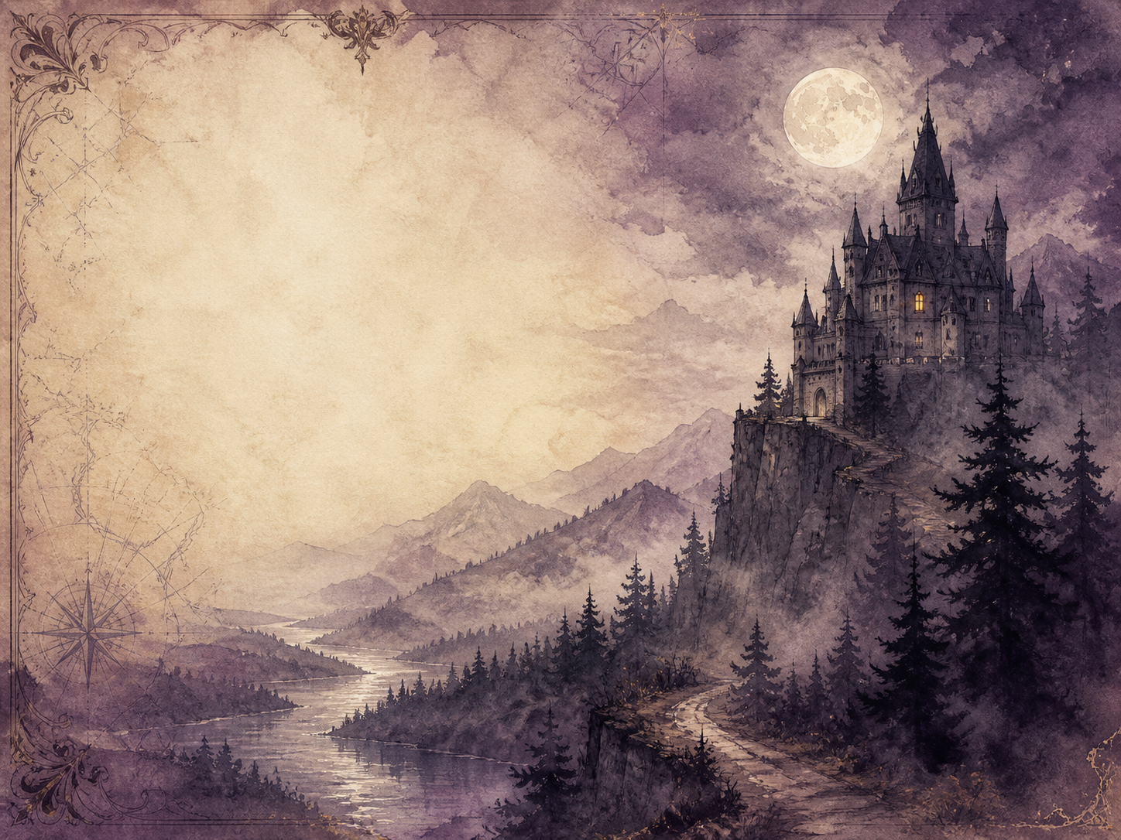
A LIVING BOOK STUDY - LEARNING BOOKLET
Name: _______________________

TASKS: DAY 1
Week 1 - Chapters 1-2: Into the Mountains
READ:
The solicitor Jonathan Harker journeys deep into Transylvania to help Count Dracula buy a house in England, and reaches the Count's strange castle.
NARRATION:
Describe Harker's journey and his first meeting with the Count.
EXTENSION:
Discuss: what small, uneasy details warn us that something is wrong, before Harker admits it to himself?
Your response:

TASKS: DAY 2
Week 1 - Chapters 3-4: A Prisoner
READ:
Harker realises he is trapped in the castle with something inhuman, and makes a desperate attempt to escape.
NARRATION:
Retell Harker's growing horror and his daring escape attempt.
EXTENSION:
Art: illustrate Castle Dracula, perched high in the Carpathian mountains.
Your response:

TASKS: DAY 3
Week 1 - Chapters 5-6: England
READ:
The story shifts to England, told through the letters and diaries of Mina, Lucy and Dr Seward, as an unseen danger draws near.
DISCUSS:
How does Stoker weave together letters and diaries from different people to tell one story?
EXTENSION:
Geography: research Whitby, the real Yorkshire town where the story now moves.
Your response:

TASKS: DAY 4
Week 2 - Chapters 7-8: The Ship
READ:
A violent storm drives a ship ashore at Whitby, its crew gone and its captain dead at the wheel - and Lucy begins to sleepwalk.
NARRATION:
Retell the ship's last log and the eerie events that follow at Whitby.
EXTENSION:
Literacy: discuss why telling this through the captain's log makes it so chilling.
Your response:

TASKS: DAY 5
Week 2 - Chapters 9-10: The Illness
READ:
Lucy falls mysteriously ill, losing blood no one can explain, and the wise Professor Van Helsing is called from Amsterdam.
DISCUSS:
What baffles the doctors about Lucy's illness?
EXTENSION:
Science: research Victorian blood transfusion, and why it was so dangerous before blood groups were understood.
Your response:

TASKS: DAY 6
Week 2 - Chapters 11-12: Loss
READ:
Despite everything the friends try, and after further shocks, Lucy dies.
NARRATION:
Retell the events leading to Lucy's death.
EXTENSION:
Discuss: how does Stoker keep the reader dreading what is coming next?
Your response:

TASKS: DAY 7
Week 3 - Chapters 13-14: The Bloofer Lady
READ:
After Lucy's funeral, small children are found harmed by a mysterious 'bloofer lady', and Van Helsing begins to fear the impossible.
DISCUSS:
What does Van Helsing suspect, and why is it so hard for the others to believe him?
EXTENSION:
PSHE: discuss how difficult it can be to accept a truth that seems impossible.
Your response:

TASKS: DAY 8
Week 3 - Chapters 15-16: The Un-Dead
READ:
The friends face the terrible truth about Lucy and act, solemnly, to set her soul at rest. (A dark and tense sequence.)
DISCUSS:
Why does Stoker make this scene so solemn and difficult, rather than exciting?
EXTENSION:
Literacy: how do the different narrators' voices add weight to this moment?
Your response:

TASKS: DAY 9
Week 3 - Chapters 17-18: The Hunters Unite
READ:
The friends pool their diaries and letters, and Van Helsing teaches them what they face and how the Count can be beaten.
NARRATION:
Retell how the band of hunters comes together and forms its plan.
EXTENSION:
History: research the up-to-date technology the hunters use - typewriter, telegraph, phonograph.
Your response:

TASKS: DAY 10
Week 4 - Chapters 19-20: The Hunt Begins
READ:
The hunters track down and spoil Dracula's hidden boxes of earth, and puzzle over the strange prisoner Renfield.
NARRATION:
Describe how the hunters turn the Count's own hiding-places against him.
EXTENSION:
Discuss: how does going on the attack change the mood of the book?
Your response:

TASKS: DAY 11
Week 4 - Chapters 21-22: Mina in Danger
READ:
Dracula strikes back and marks Mina as his own, and the friends rally around her.
DISCUSS:
How do the friends respond when Mina is put in danger?
EXTENSION:
PSHE: discuss finding courage and hope in the face of dread.
Your response:

TASKS: DAY 12
Week 4 - Chapters 23-24: The Count Flees
READ:
Cornered, Dracula escapes by sea for his homeland, and the hunters use Mina's strange link to him to give chase.
NARRATION:
Retell how the hunters pick up the Count's trail as he flees England.
EXTENSION:
Geography: map the route of the chase back across Europe toward Transylvania.
Your response:

TASKS: DAY 13
Week 4 - Chapters 25-26: The Race
READ:
The friends race across Europe and up into the Carpathians, closing in on the Count before he can reach his castle.
DISCUSS:
How does Stoker wind the tension tighter and tighter as the chase nears its end?
EXTENSION:
Science: research what hypnosis really is, and how Van Helsing uses it to track the Count.
Your response:

TASKS: DAY 14
Week 4 - Chapter 27: The Reckoning
READ:
The pursuit ends in a final confrontation near the castle walls, at a heavy cost to the hunters.
WRAP-UP:
Was the ending satisfying? Who paid the price, and was it worth it?
EXTENSION:
What were Victorian readers really afraid of, and how does Dracula give those fears a shape?
Your response:

MY READING JOURNAL
The story is told through many documents. Keep your own journal of what each one reveals - and what the characters still do not know.
Chapters | What we learn | What they still don't know

HOW STOKER BUILDS FEAR
Dracula is a masterclass in suspense. Collect the tricks Stoker uses to frighten the reader, with an example of each from the book.
Technique (e.g. weather, silence, delay) | Example from the book

