A FAMILY STUDY IN THE CHARLOTTE MASON TRADITION
BLACK BEAUTY
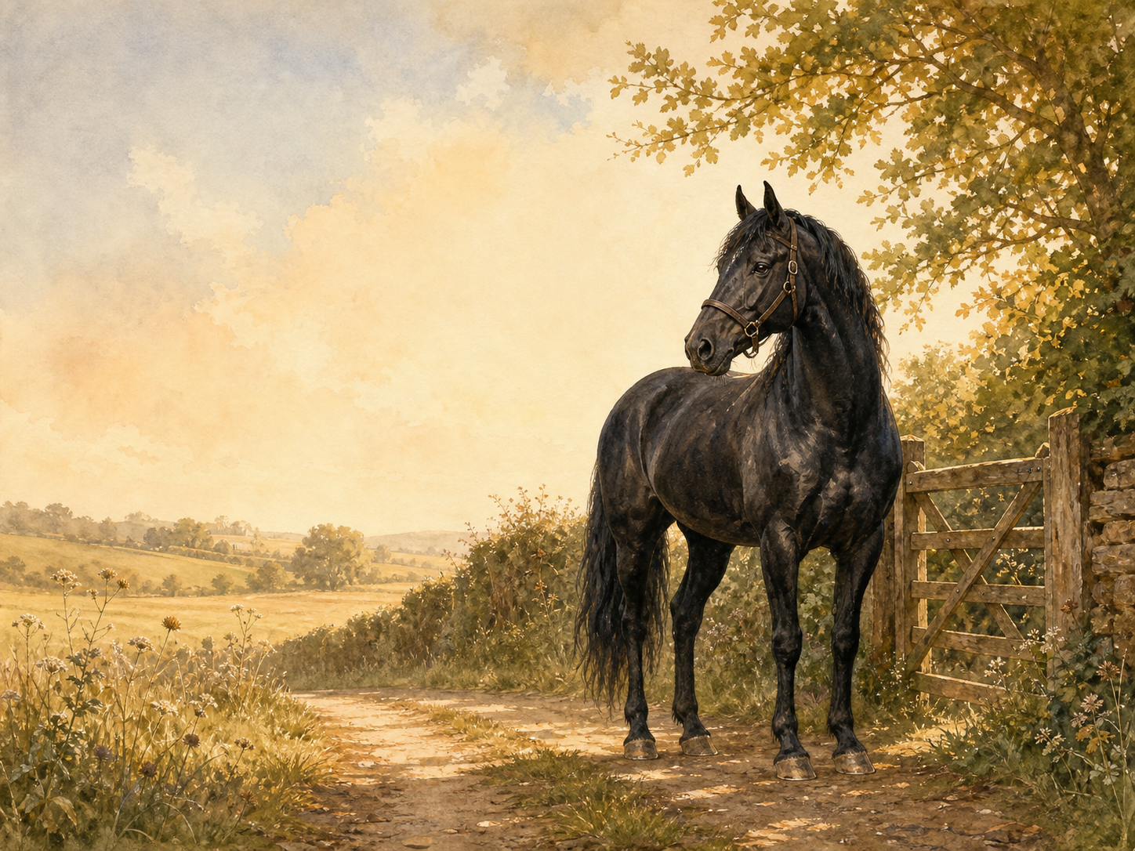
by Anna Sewell

A Living Book Study for mixed-age learning

Welcome. This Living Book Study of Black Beauty is written for parents teaching children of different ages side by side. Read together, talk together, and let the story do its quiet work.
In the Charlotte Mason tradition, we keep the feast wide: literature, nature, history, art, and thoughtful conversation. Choose what fits your family, do a little at a time, and let each child respond in their own way - by telling back, drawing, building, writing, or acting.
Alongside our shared reading, a few steady habits will support progress:
- For KS2: keep grammar, punctuation and spelling ticking along - little and often (for example, CGP workbook practice).
- For KS1: follow a systematic phonics programme with daily practice, and let early reading be cheerful and successful.

How to use this plan
- Follow the suggested medium-term plan, or use the activity map to build your own route.
- Choose play stations for KS1 children from the list below (1-2 a week).
- Print the accompanying Learning Booklet for chapter-by-chapter reading and response tasks.
- Use the Independent Study slides if older children are working through the plan on their own.
- The book is narrated by a horse and deals honestly with cruelty and hardship, though nothing is described graphically. It ends happily.

About the Text
First published in 1877, Black Beauty is narrated by a horse, telling the story of his own life from a well-loved foal at Birtwick Park, through harder years pulling cabs and carts under careless owners, to a peaceful retirement. Anna Sewell wrote the book in the last years of her life, in poor health herself, explicitly to encourage kindness towards horses - and it went on to change public attitudes and even the law around how working horses were treated.
Text used: the 1877 first edition is out of copyright and freely available from Project Gutenberg and Standard Ebooks (see Helpful Websites, below).
Topics included: History (Victorian working horses, the RSPCA, Anna Sewell's life), Science/Nature (horse care, anatomy and behaviour), Geography (mapping Black Beauty's many homes), Art (tack and harness, campaign posters), and PSHE (kindness, empathy, and the 'Golden Rule').

KS1 Play-Based Learning Stations

It is important for KS1 children to continue to learn through play where possible. They can still enjoy the story with their siblings, but also continue to explore the world around them. It is also recommended that they follow a phonics scheme as they learn to read and write.
Activity | Learning Areas | Description | Resources
Horse and cart small world | Storytelling + Fine Motor | Set up toy horses, carts and stables; retell Black Beauty moving between his different homes. | Toy horses, small carts/blocks, tuff tray
Grooming station | Fine Motor + PSED | Brush and care for a toy or soft-toy horse with a real brush; talk about gentle hands and kindness. | Soft toy horse, soft brush, ribbons
Stable building | DT + Construction | Build a stable from blocks, cardboard or a large box; make it warm, dry and comfortable. | Building blocks/boxes, straw or shredded paper
Horseshoe match-up | Maths + Fine Motor | Match magnetic or card horseshoes by size or pattern; count and sort them. | Toy/card horseshoes, sorting trays
Kind hands role-play | PSED | Practise gentle handling with a soft toy animal - stroking, offering 'food', talking softly - and discuss why animals need kind, calm treatment. | Soft toy animal, play food
Weather and horses | UW + Discussion | Look outside and talk about what a horse would need in today's weather - shelter, water, a blanket. Draw or act it out. | Outdoor space, paper for drawing

Black Beauty Activity Map KS2

Literacy:
- Keep a journal as you read the book - note new words, and how Black Beauty describes his different owners.
- Discuss: why might Anna Sewell have chosen to tell this story in the horse's own voice, rather than a human character's?
- Write a short persuasive leaflet against a cruelty you've read about in the book - just as the whole novel was itself a piece of campaigning writing.
- Compare the 'voices' of two different characters - for example John Manly's kindness and Reuben Smith's carelessness.
- After reading the book, watch a film adaptation and compare it to the book.

History:
- Research Victorian working horses - carriage horses, cab horses, farm horses - and how differently each was expected to work.
- Research the bearing rein (also called a check rein), a real device described in the book, and why Anna Sewell campaigned against it.
- Find out about the RSPCA (founded 1824) and how books like Black Beauty helped change attitudes to animal welfare.
- Research Anna Sewell's own life - unable to walk easily herself, she depended on horse-drawn transport, and wrote the book while seriously ill.
- Record key dates into your Book of Centuries.
Science / Nature:
- Research horse anatomy and care: hooves, teeth, feeding and grooming.
- Research how horses communicate - through ears, tail, and body language - and compare this to what Black Beauty 'tells' us in the book.
- Compare the different roles working horses had (carriage, cab, farm, war) and the different equipment or 'tack' each needed.

Geography:
- Map Black Beauty's many homes across the book - Birtwick Park, Earlshall, London, and his final farm - as a 'horse's journey' map.
- Research Victorian London's cab trade, and the streets a working cab horse like Black Beauty might have walked each day.

Art:
- Draw and label a diagram of horse tack, including the bearing rein described in the book.
- Design a 'Be Kind to Animals' poster in the spirit of the book's message.
PSHE:
- Discuss the 'Golden Rule' as Jerry Barker describes it in the book - what does it mean, and how does it apply beyond horses?
- Discuss: how does telling the story from an animal's point of view change how a reader feels about kindness and cruelty?

Year 6 and KS3 Extension:
- Research how Black Beauty influenced real animal welfare law - public reaction to the book is credited with helping end the fashion for the bearing rein.
- Black Beauty is one of the first popular 'animal autobiography' novels. Compare its use of an animal narrator to a more modern example, such as War Horse by Michael Morpurgo.
- Discuss: the book was written as deliberate campaigning literature. Is it still an effective piece of persuasive writing today, or do some parts feel dated?
- Research the working conditions of Victorian cab drivers themselves, such as Jerry Barker's family - how does the book link the treatment of horses to the treatment of poor working people?

Possible Medium-Term Plan (4 Weeks)

The novel has 49 short chapters across four parts: Part I (Birtwick Park), Part II (Earlshall), Part III (London cab life), Part IV (the last home). This plan groups them into sixteen reading days, with a wrap-up response day at the end.

Week 1 - Part I: Birtwick Park (Chapters 1-10)
Day | Read | Core Task | Extension / Cross-curricular
Day 1 | Ch 1-3: My Early Home / The Hunt / My Breaking In. | Narration: what values does Black Beauty's mother teach him? Discuss the hunt - how does Sewell use it to show danger and loss? | Nature: research how young horses are trained and 'broken in' today, and how attitudes have changed.
Day 2 | Ch 4-6: Birtwick Park / A Fair Start / Liberty. | Discuss: what makes Birtwick Park a genuinely good home for a horse? | Art: draw Black Beauty's stable at Birtwick Park.
Day 3 | Ch 7-8: Ginger / Ginger's Story Continued. | Narration: what has made Ginger bad-tempered? How has her early treatment shaped her? | Discuss: can unkindness explain bad behaviour, in horses or in people?
Day 4 | Ch 9-10: Merrylegs / A Talk in the Orchard. | Compare the three horses - Black Beauty, Ginger and Merrylegs - in a table: personality, history, and how they're treated. | Discuss: which horse would you most like to have known?

Week 2 - Part I continued (Chapters 11-21)
Day | Read | Core Task | Extension / Cross-curricular
Day 5 | Ch 11-13: Plain Speaking / A Stormy Day / The Devil's Trade Mark. | Discuss: what is John Manly's 'plain speaking' about? What does he think of the bearing rein? | History: research the bearing/check rein, and why Anna Sewell campaigned against it.
Day 6 | Ch 14-16: James Howard / The Old Hostler / The Fire. | Narration: how does Sewell build tension in The Fire? | Discuss: what do James and John's actions in the fire show about courage?
Day 7 | Ch 17-19: John Manly's Talk / Going for the Doctor / Only Ignorance. | Discuss: Black Beauty risks his life for the doctor. What does the book suggest about a horse's loyalty and intelligence? | Writing: write the scene from the doctor's point of view.
Day 8 | Ch 20-21: Joe Green / The Parting. | Discuss: why does Squire Gordon's family have to sell the horses? | Writing: write Black Beauty's feelings on leaving Birtwick Park for good.

Week 3 - Parts II and III begin (Chapters 22-35)
Day | Read | Core Task | Extension / Cross-curricular
Day 9 | Ch 22-24: Earlshall / A Strike for Liberty / The Lady Anne. | Discuss: how does life change for Black Beauty and Ginger at Earlshall? | Discuss: what does Ginger's 'strike' against the bearing rein show us about her?
Day 10 | Ch 25-27: Reuben Smith / How It Ended / Ruined and Going Downhill. | Narration: what happens to Black Beauty because of Reuben Smith's carelessness? | Discuss: how can a horse be 'ruined' through no fault of his own?
Day 11 | Ch 28-31: A Job Horse and His Drivers / Cockneys / A Thief / A Humbug. | Discuss: Black Beauty is passed between different owners in this section. What different kinds of bad or careless treatment does he meet? | Geography: research Victorian horse fairs, where horses like Black Beauty were bought and sold.
Day 12 | Ch 32-35: A Horse Fair / A London Cab Horse / An Old War Horse / Jerry Barker. | History: research Victorian London cab life. | Narration: what makes Jerry Barker different from Black Beauty's other owners so far?

Week 4 - Part III concludes and Part IV (Chapters 36-49)
Day | Read | Core Task | Extension / Cross-curricular
Day 13 | Ch 36-39: The Sunday Cab / The Golden Rule / Dolly and a Real Gentleman / Seedy Sam. | Discuss: what does 'The Golden Rule' suggest about how people should treat each other, not just horses? | Discuss: what does Seedy Sam's story add to the book's message about poverty and hardship?
Day 14 | Ch 40-43: Poor Ginger / The Butcher / The Election / A Friend in Need. | Narration: how does Black Beauty feel meeting Ginger again? What has happened to her? | PSHE: discuss how the book links kindness to horses with kindness to people.
Day 15 | Ch 44-45: Old Captain and His Successor / Jerry's New Year. | Discuss: how has Jerry Barker's family fared across the book? | Writing: write a short diary entry as Black Beauty on New Year's Day.
Day 16 | Ch 46-49: Jakes and the Lady / Hard Times / Farmer Thoroughgood and His Grandson Willie / My Last Home. | Narration: trace Black Beauty's final journey to a happy retirement. | Discuss: why do you think Anna Sewell chose to end the book this way?
Day 17 | Response day - no new reading. | Write your own 'Kindness Code' - five rules for treating animals well, inspired by the book. | Wrap-up: compare how Black Beauty is treated across all four parts of the book, from Birtwick Park to My Last Home.

Helpful Websites

- Full text (free, out of copyright): Project Gutenberg - www.gutenberg.org/ebooks/271 and Standard Ebooks - standardebooks.org
- RSPCA history: RSPCA - www.rspca.org.uk/whatwedo/aboutus/history
- Victorian working horses and London cab trade: The Victorian Web - www.victorianweb.org
- Horse care and welfare for children: World Horse Welfare - www.worldhorsewelfare.org
- Anna Sewell's life: search 'Anna Sewell biography' via your library or a trusted encyclopedia

Glossary

- English Journal: a notebook where thoughts and images are kept while reading a novel. You can also use the printable booklet.
- Book of Centuries: a timeline in a book, taken from the Charlotte Mason tradition, where children add historical figures and important dates as they meet them.
- Bearing rein (check rein): a strap once used to force a carriage horse's head unnaturally high - criticised throughout the book as cruel and exhausting.
- Tack: the equipment used on a horse, such as saddles, bridles and reins.

Other Living Book Studies in the Series

- Alice's Adventures in Wonderland by Lewis Carroll (Year 5-7)
- The Wind in the Willows by Kenneth Grahame
- The Secret Garden by Frances Hodgson Burnett
- A Christmas Carol by Charles Dickens (Year 7-9, GCSE extension)
- The Strange Case of Dr Jekyll and Mr Hyde by Robert Louis Stevenson (GCSE)

