INDEPENDENT STUDY COMPANION
BLACK BEAUTY
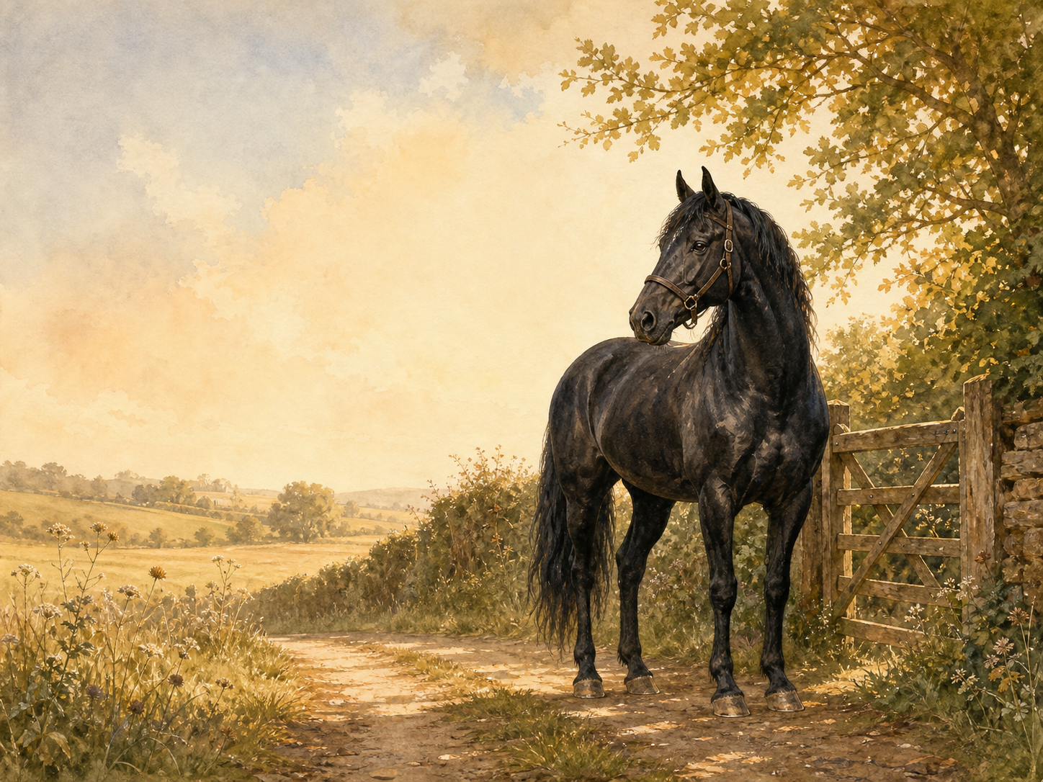
A LIVING BOOK STUDY - LEARNING BOOKLET
Name: _______________________

TASKS: DAY 1
Week 1 - Chapters 1-3
READ:
Chapter 1: My Early Home, Chapter 2: The Hunt, and Chapter 3: My Breaking In.
NARRATION:
What values does Black Beauty's mother teach him? Discuss the hunt - how does Sewell use it to show danger and loss?
EXTENSION:
Nature: research how young horses are trained today, and how attitudes to 'breaking in' have changed.
Your response:

TASKS: DAY 2
Week 1 - Chapters 4-6
READ:
Chapter 4: Birtwick Park, Chapter 5: A Fair Start, and Chapter 6: Liberty.
DISCUSS:
What makes Birtwick Park a genuinely good home for a horse?
EXTENSION:
Art: draw Black Beauty's stable at Birtwick Park.
Your response:

TASKS: DAY 3
Week 1 - Chapters 7-8
READ:
Chapter 7: Ginger, and Chapter 8: Ginger's Story Continued.
NARRATION:
What has made Ginger bad-tempered? How has her early treatment shaped her?
EXTENSION:
Discuss: can unkindness explain bad behaviour, in horses or in people?
Your response:

TASKS: DAY 4
Week 1 - Chapters 9-10
READ:
Chapter 9: Merrylegs, and Chapter 10: A Talk in the Orchard.
COMPARE:
Compare the three horses - Black Beauty, Ginger and Merrylegs - in a table: personality, history, and how they're treated.
EXTENSION:
Discuss: which horse would you most like to have known?
Your response:

TASKS: DAY 5
Week 2 - Chapters 11-13
READ:
Chapter 11: Plain Speaking, Chapter 12: A Stormy Day, and Chapter 13: The Devil's Trade Mark.
DISCUSS:
What is John Manly's 'plain speaking' about? What does he think of the bearing rein?
EXTENSION:
History: research the bearing/check rein, and why Anna Sewell campaigned against it.
Your response:

TASKS: DAY 6
Week 2 - Chapters 14-16
READ:
Chapter 14: James Howard, Chapter 15: The Old Hostler, and Chapter 16: The Fire.
NARRATION:
How does Sewell build tension in The Fire?
EXTENSION:
Discuss: what do James and John's actions in the fire show about courage?
Your response:

TASKS: DAY 7
Week 2 - Chapters 17-19
READ:
Chapter 17: John Manly's Talk, Chapter 18: Going for the Doctor, and Chapter 19: Only Ignorance.
DISCUSS:
Black Beauty risks his life for the doctor. What does the book suggest about a horse's loyalty and intelligence?
EXTENSION:
Writing: write the scene from the doctor's point of view.
Your response:

TASKS: DAY 8
Week 2 - Chapters 20-21
READ:
Chapter 20: Joe Green, and Chapter 21: The Parting.
DISCUSS:
Why does Squire Gordon's family have to sell the horses?
EXTENSION:
Writing: write Black Beauty's feelings on leaving Birtwick Park for good.
Your response:

TASKS: DAY 9
Week 3 - Chapters 22-24
READ:
Chapter 22: Earlshall, Chapter 23: A Strike for Liberty, and Chapter 24: The Lady Anne, or a Runaway Horse.
DISCUSS:
How does life change for Black Beauty and Ginger at Earlshall? What does Ginger's 'strike' against the bearing rein show us about her?
Your response:

TASKS: DAY 10
Week 3 - Chapters 25-27
READ:
Chapter 25: Reuben Smith, Chapter 26: How It Ended, and Chapter 27: Ruined and Going Downhill.
NARRATION:
What happens to Black Beauty because of Reuben Smith's carelessness?
EXTENSION:
Discuss: how can a horse be 'ruined' through no fault of his own?
Your response:

TASKS: DAY 11
Week 3 - Chapters 28-31
READ:
Chapter 28: A Job Horse and His Drivers, Chapter 29: Cockneys, Chapter 30: A Thief, and Chapter 31: A Humbug.
DISCUSS:
Black Beauty is passed between different owners in this section. What different kinds of bad or careless treatment does he meet?
EXTENSION:
Geography: research Victorian horse fairs, where horses like Black Beauty were bought and sold.
Your response:

TASKS: DAY 12
Week 3 - Chapters 32-35
READ:
Chapter 32: A Horse Fair, Chapter 33: A London Cab Horse, Chapter 34: An Old War Horse, and Chapter 35: Jerry Barker.
HISTORY:
Research Victorian London cab life.
EXTENSION:
Narration: what makes Jerry Barker different from Black Beauty's other owners so far?
Your response:

TASKS: DAY 13
Week 4 - Chapters 36-39
READ:
Chapter 36: The Sunday Cab, Chapter 37: The Golden Rule, Chapter 38: Dolly and a Real Gentleman, and Chapter 39: Seedy Sam.
DISCUSS:
What does 'The Golden Rule' suggest about how people should treat each other, not just horses?
EXTENSION:
Discuss: what does Seedy Sam's story add to the book's message about poverty and hardship?
Your response:

TASKS: DAY 14
Week 4 - Chapters 40-43
READ:
Chapter 40: Poor Ginger, Chapter 41: The Butcher, Chapter 42: The Election, and Chapter 43: A Friend in Need.
NARRATION:
How does Black Beauty feel meeting Ginger again? What has happened to her?
EXTENSION:
PSHE: discuss how the book links kindness to horses with kindness to people.
Your response:

TASKS: DAY 15
Week 4 - Chapters 44-45
READ:
Chapter 44: Old Captain and His Successor, and Chapter 45: Jerry's New Year.
DISCUSS:
How has Jerry Barker's family fared across the book?
EXTENSION:
Writing: write a short diary entry as Black Beauty on New Year's Day.
Your response:

TASKS: DAY 16
Week 4 - Chapters 46-49
READ:
Chapter 46: Jakes and the Lady, Chapter 47: Hard Times, Chapter 48: Farmer Thoroughgood and His Grandson Willie, and Chapter 49: My Last Home.
NARRATION:
Trace Black Beauty's final journey to a happy retirement.
EXTENSION:
Discuss: why do you think Anna Sewell chose to end the book this way?
Your response:

TASKS: DAY 17
Week 4 - Response Day
READ:
No new reading - review the whole book.
WRITING OPPORTUNITY:
Write your own 'Kindness Code' - five rules for treating animals well, inspired by the book.
EXTENSION:
Wrap-up: compare how Black Beauty is treated across all four parts of the book, from Birtwick Park to My Last Home.
Your response:

BLACK BEAUTY'S HOMES
As you read, track each home Black Beauty lives in, who owns him, and how he is treated there.
Home | Owner(s) | How he is treated | Chapters

HORSE CARE FACT FILE
Hooves

Teeth

Feeding

Grooming

Fun facts

