A FAMILY STUDY IN THE CHARLOTTE MASON TRADITION
ANIMAL FARM
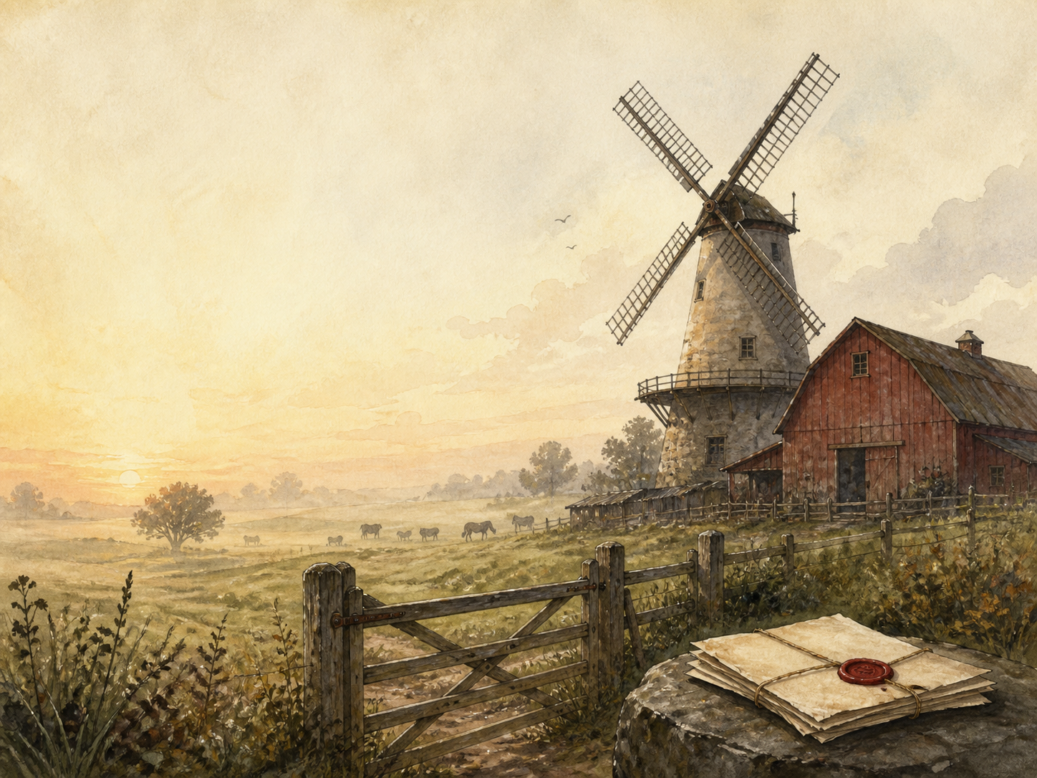
by George Orwell

A Living Book Study for GCSE (Years 10-11), with a Foundation Support Tier

Welcome. This Living Book Study of Animal Farm is written for families working toward GCSE-level English skills, with a core plan for Years 10-11, a lighter Foundation tier, and a Grade 9 / A-level bridge for those ready to stretch.
Animal Farm is short but deep. It is not on most GCSE set-text lists, but it is one of the best books there is for building the exact skills exams reward: reading a story as an allegory, spotting how writers use satire and propaganda, and weaving in historical context. It pairs especially well with a study of the Russian Revolution.
A few steady habits will support progress:
- For Foundation: enjoy the story of the animals' revolution and follow how their bright hopes are slowly betrayed.
- For GCSE core: read the book as an allegory, matching characters and events to real history, and analyse how Orwell uses satire and propaganda.
- For Grade 9 / A-level bridge: weigh what Orwell is really attacking - not revolution itself, but its betrayal - and connect it to his other writing.

How to use this plan
- Follow the suggested 2-week plan, reading one short chapter a day.
- Keep the allegory tracker (in the Learning Booklet) filled in, matching each character and event to its real-world parallel.
- Print the accompanying Learning Booklet for reading and response tasks; use the Independent Study slides for solo work.
- A note for parents: Animal Farm is a political fable and, though told through farm animals, it is dark. It shows a violent revolution, forced 'confessions' and executions (animals torn apart by dogs), and the death of the loyal horse Boxer, who is sold to the slaughterhouse - an upsetting moment for many readers. The violence stands for real historical events rather than being graphic, but a read-ahead will help.

About the Text
Published in 1945, Animal Farm is George Orwell's short, savage fable about a revolution that goes wrong. The mistreated animals of Manor Farm rise up, drive out their drunken master, and set out to run the farm themselves on the principle that 'all animals are equal'. But the clever pigs slowly take charge, twist the rules, and end up as cruel as the humans they replaced - until 'some animals are more equal than others'.
Orwell, a democratic socialist, wrote it as a direct attack on Stalin's Soviet Union and the way the ideals of the 1917 Russian Revolution had been betrayed. Almost every character and event mirrors real history, which makes it a superb book for learning to read allegory and satire.
Text used: Animal Farm entered the public domain in the UK and much of the Commonwealth in 2021 (70 years after Orwell's death) and can be read free from sources such as Faded Page (Canada) and Project Gutenberg Australia. Note that it remains under copyright in the United States until 2041, so US readers should use a purchased or library copy.
Topics included: History (the Russian Revolution and the Soviet Union), Politics (power, propaganda and how the powerless are controlled), Literacy (allegory, satire and language), PSHE (ideals and their betrayal), Art, and Exam Skills.
Foundation Support Tier

A student who needs a gentler way in can enjoy the fable and grasp its message before tackling the historical allegory in detail. These activities keep the focus on the story and its ideas.
Activity | Learning Areas | Description | Resources
The Seven Commandments | Literacy | Copy out the Seven Commandments, then track every time the pigs secretly change one. | The text, paper
Match the characters | History | Make matching cards linking each animal to the real person or group it stands for. | Card, pens
Propaganda poster | Art | Design a poster the pigs might use to keep the other animals obedient and hopeful. | Paper, pens
Write an anthem | Literacy + Music | Write your own verse of 'Beasts of England', the animals' stirring revolutionary song. | Paper, pens
Squealer's spin | Literacy | Take a bad event from the book and rewrite it as cheerful 'good news', the way Squealer would. | Paper, pens

GCSE (Years 10-11) Study Map

Literacy / English:
- Read the book as an allegory: a simple story standing for something larger and real.
- Study Orwell's satire - how he uses a farmyard fable to mock and expose real politics.
- Track the propaganda: the changing commandments, the sheep's chants, and Squealer's twisting of the truth.
- Analyse how Orwell's plain, clear style makes the horror land all the harder.
History / Context:
- Research the Russian Revolution of 1917 and the rise of the Soviet Union under Stalin.
- Match the allegory: Old Major (Marx/Lenin), Napoleon (Stalin), Snowball (Trotsky), Mr Jones (the Tsar), Boxer (the workers), the dogs (the secret police).
- Research real propaganda, show trials and the rewriting of history under totalitarian regimes.
- Record key dates into your Book of Centuries.
Politics / PSHE:
- Discuss how power corrupts: the pigs begin as liberators and end as tyrants.
- Discuss how the powerless are controlled - by fear (the dogs), by lies (Squealer), and by rewriting the past.
- Discuss why a revolution built on fine ideals can end up betraying them.
Exam Skills:
- Practise analysing HOW Orwell creates meaning - his word choice, irony and symbols.
- Practise weaving historical context into your analysis, rather than adding it as an afterthought.
- Plan a 'big idea' essay, such as: 'How does Orwell present the abuse of power in Animal Farm?'
Grade 9 / A-Level Bridge Extension:
- Orwell was a socialist who hated tyranny. Discuss whether the book attacks revolution itself, or only its betrayal.
- Read Orwell's essay 'Politics and the English Language' and connect it to Squealer's twisting of words.
- Compare Animal Farm with Orwell's later novel 1984 as two studies of totalitarian power.
- Discuss why the fable still speaks to regimes far beyond the Soviet Union.

Possible Study Plan (2 Weeks)

The book has ten short chapters. This plan reads one a day, pairing each with the real history it mirrors.

Week 1 - Revolution
Day | Read | Core Task | History / Extension
Day 1 | Chapter 1. | Narration: old Major shares his dream and teaches the animals the song 'Beasts of England'. | History: research the ideas of Marx and Lenin that inspired the Russian Revolution.
Day 2 | Chapter 2. | Narration: Major dies, the pigs shape his ideas into 'Animalism', and the animals drive out Mr Jones. The Seven Commandments are painted up. | History: research the 1917 Revolution and the overthrow of the Tsar.
Day 3 | Chapter 3. | Discuss: the animals work hard for a fine harvest - but the pigs quietly keep the milk and apples for themselves. | PSHE: this is the first small betrayal. Why does no one stop it?
Day 4 | Chapter 4. | Narration: at the Battle of the Cowshed, Jones and his neighbours try to retake the farm and are beaten off. | History: research the Russian Civil War and foreign attempts to crush the revolution.
Day 5 | Chapter 5. | Narration: Mollie runs away; Snowball and Napoleon clash over the windmill; Napoleon's dogs drive Snowball off the farm. | History: research the power struggle between Trotsky and Stalin.

Week 2 - Betrayal
Day | Read | Core Task | History / Extension
Day 6 | Chapter 6. | Narration: the animals toil on the windmill; Napoleon begins trading with humans, and the commandments start to change. | History: research Stalin's Five-Year Plans and the drive to industrialise.
Day 7 | Chapter 7. | Narration: hunger, fear, and a wave of forced 'confessions' and executions carried out by the dogs. | History: research the Great Purge and the Soviet show trials.
Day 8 | Chapter 8. | Narration: the Battle of the Windmill against Frederick, and Napoleon's growing cult and cruelty. | History: research the German invasion of the USSR and the cult of Stalin.
Day 9 | Chapter 9. | Narration: times grow hard; the loyal horse Boxer collapses and is sold to the knacker, though told he is going to hospital. | PSHE: Boxer stands for the loyal workers. Why is his fate the book's cruellest moment?
Day 10 | Chapter 10. | Wrap-up: years later the pigs walk on two legs and feast with humans; the animals can no longer tell pig from man. | Extension: 'All animals are equal, but some are more equal than others.' How does the whole book build to this line?

Helpful Websites

- Full text (free where out of copyright): Faded Page - www.fadedpage.com and Project Gutenberg Australia - gutenberg.net.au (UK/Commonwealth readers; US readers should use a purchased or library copy)
- George Orwell's life and work: The Orwell Foundation - www.orwellfoundation.com
- The Russian Revolution and the Soviet Union: The British Library - www.bl.uk
- Propaganda and how it works: Imperial War Museums - www.iwm.org.uk
- Exam guidance: check your own board's site for essay and analysis expectations

Glossary

- Allegory: a story in which characters and events stand for something larger and real - here, the Russian Revolution.
- Book of Centuries: a timeline in a book, taken from the Charlotte Mason tradition, where children add historical figures and important dates as they meet them.
- Satire: writing that uses humour, irony and exaggeration to expose and criticise, especially in politics.
- Propaganda: information, often twisted or one-sided, spread to make people believe or support something.
- Totalitarian: describing a government that demands total control over its people and allows no opposition.
- Fable: a short story, often with animals, that teaches a lesson or makes a point.

Other Living Book Studies in the Series

- Macbeth by William Shakespeare
- Romeo and Juliet by William Shakespeare
- War Poetry: Wilfred Owen and Rupert Brooke
- The Strange Case of Dr Jekyll and Mr Hyde by Robert Louis Stevenson (GCSE)
- A Christmas Carol by Charles Dickens (GCSE)

