INDEPENDENT STUDY COMPANION
ANIMAL FARM
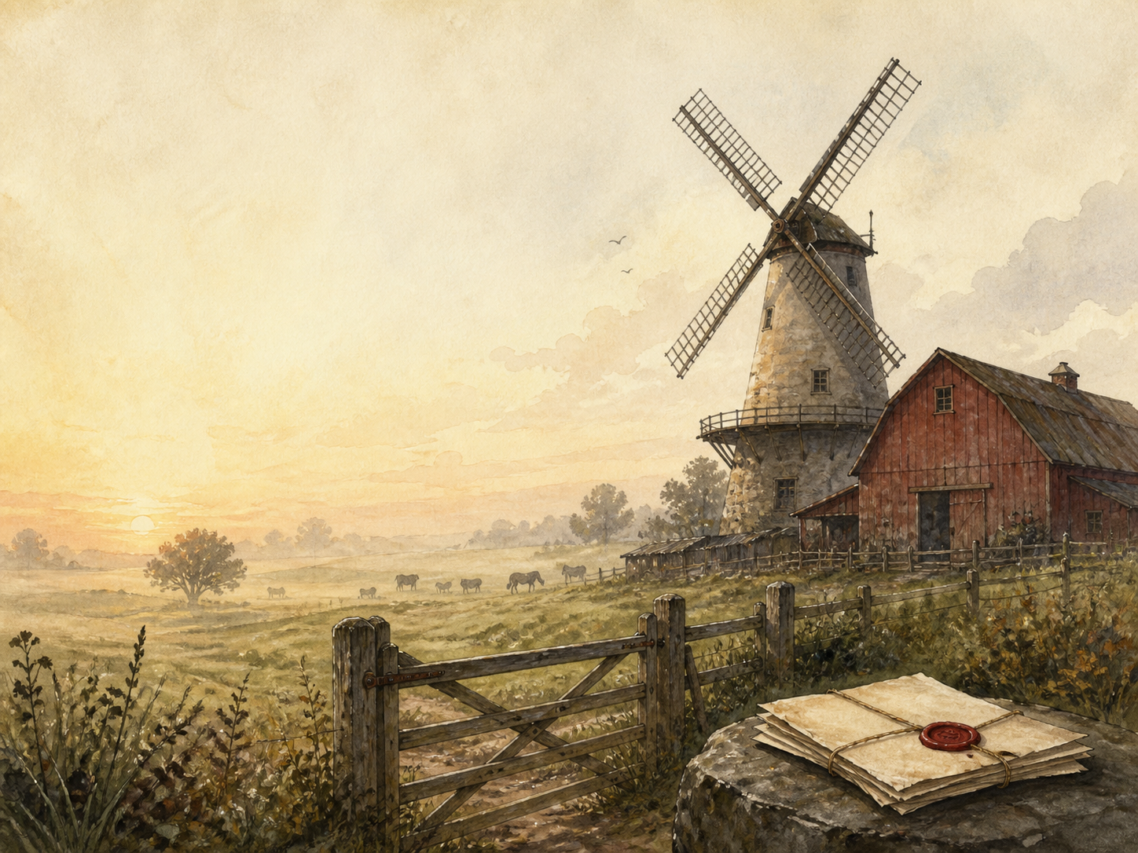
A LIVING BOOK STUDY - GCSE LEARNING BOOKLET
Name: _______________________

ALLEGORY TRACKER - FILL IN AS YOU READ
Nearly every character and event stands for something real. Fill this in as you meet them - it is the key to the whole book.
In the book | What it stands for in real history
Mr Jones
Old Major
Napoleon
Snowball
Squealer
Boxer
The dogs
The sheep
Moses the raven
The windmill
The Battle of the Cowshed

DAY 1: CHAPTER 1
READ:
Old Major, a wise old boar, gathers the animals to share his dream of a world without cruel humans, and teaches them the rousing song 'Beasts of England'.
NARRATION:
What is old Major's vision, and how do the animals respond to it?
HISTORY / EXTENSION:
Research the ideas of Marx and Lenin that inspired the Russian Revolution.
Your response:

DAY 2: CHAPTER 2
READ:
Old Major dies. The pigs turn his ideas into 'Animalism', and when the drunken Mr Jones neglects them, the animals rebel and drive him out. They paint up the Seven Commandments.
NARRATION:
Retell the rebellion, and list the Seven Commandments.
HISTORY / EXTENSION:
Research the 1917 Russian Revolution and the overthrow of the Tsar.
Your response:

DAY 3: CHAPTER 3
READ:
The animals bring in a fine harvest by working together - but the pigs quietly keep the milk and the windfall apples for themselves.
DISCUSS:
This is the first small betrayal. How do the pigs justify it, and why does no one object?
HISTORY / EXTENSION:
PSHE: discuss how small unfairnesses, unchallenged, can grow into big ones.
Your response:

DAY 4: CHAPTER 4
READ:
News of the rebellion spreads. At the Battle of the Cowshed, Mr Jones and neighbouring farmers try to retake the farm and are driven off.
NARRATION:
Retell the Battle of the Cowshed and how the animals win.
HISTORY / EXTENSION:
Research the Russian Civil War and foreign attempts to crush the young revolution.
Your response:

DAY 5: CHAPTER 5
READ:
Mollie flees to an easier life. Snowball and Napoleon quarrel over the plan to build a windmill - until Napoleon's secretly-raised dogs chase Snowball off the farm.
DISCUSS:
How does Napoleon seize power, and how is it different from winning an argument?
HISTORY / EXTENSION:
Research the power struggle between Trotsky and Stalin after Lenin's death.
Your response:

DAY 6: CHAPTER 6
READ:
The animals labour on the windmill. Napoleon begins trading with humans, and when animals object, the commandments seem mysteriously to have changed.
DISCUSS:
How does Squealer explain away each broken rule? Why do the animals believe him?
HISTORY / EXTENSION:
Research Stalin's Five-Year Plans and the harsh drive to industrialise the USSR.
Your response:

DAY 7: CHAPTER 7
READ:
Winter brings hunger. Napoleon forces animals to 'confess' to crimes, and has them killed by the dogs before the whole farm. 'Beasts of England' is banned.
NARRATION:
Retell the confessions and executions. How is this the opposite of everything the rebellion promised?
HISTORY / EXTENSION:
Research the Great Purge and the Soviet show trials of the 1930s.
Your response:

DAY 8: CHAPTER 8
READ:
After the Battle of the Windmill against the cheating farmer Frederick, Napoleon's cult grows: he is showered with titles, honours and praise.
DISCUSS:
How is Napoleon turned into a god-like leader? What is the effect on the other animals?
HISTORY / EXTENSION:
Research the German invasion of the USSR, and the 'cult of personality' around Stalin.
Your response:

DAY 9: CHAPTER 9
READ:
Life grows harder for everyone but the pigs. When the loyal horse Boxer collapses, he is sold to the knacker for slaughter - while the animals are told he was taken to hospital.
DISCUSS:
Boxer stands for the loyal working class. Why is his fate the book's cruellest and most important moment?
HISTORY / EXTENSION:
PSHE: discuss how the ones who work hardest and trust most are often the most betrayed.
Your response:

DAY 10: CHAPTER 10
READ:
Years pass. The pigs learn to walk on two legs and dine with human farmers. The animals, looking from pig to man, can no longer tell which is which.
WRAP-UP:
The last commandment reads: 'All animals are equal, but some are more equal than others.' How does the whole book build to this line?
HISTORY / EXTENSION:
Extension: what is Orwell's final warning about revolutions and power?
Your response:

HOW THE COMMANDMENTS CHANGE
The pigs slowly rewrite the Seven Commandments to excuse themselves. Track each change and what it lets the pigs get away with.
Original commandment | How it is changed - and why

