A FAMILY STUDY IN THE CHARLOTTE MASON TRADITION
A CHRISTMAS CAROL
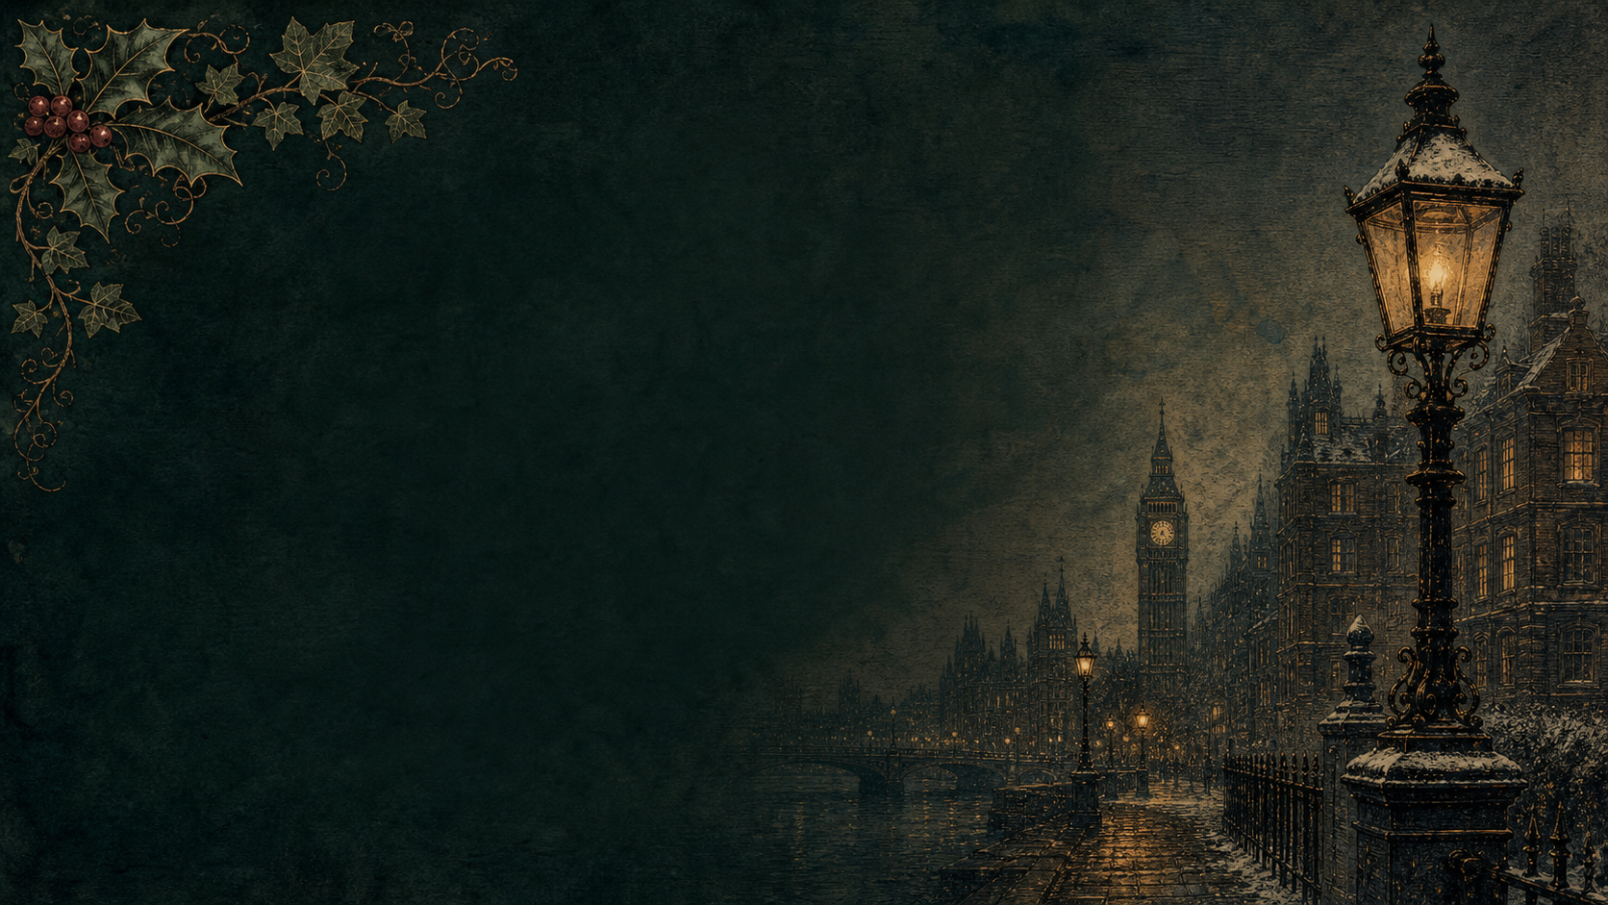
by Charles Dickens

A Living Book Study for KS2-KS3, with GCSE Extension

Welcome. This Living Book Study of A Christmas Carol is written for families teaching children of different ages side by side, with a core plan for Years 7-9 (KS3), a lighter-touch tier for Years 5-6, and a GCSE-style extension for Years 10-11.
In the Charlotte Mason tradition, we keep the feast wide: literature, history, art, geography, drama and thoughtful conversation. Choose what fits your family, do a little at a time, and let each child respond in their own way - by telling back, drawing, discussing, or writing.
Alongside the shared reading, a few steady habits will support progress:
- For Years 5-6: keep grammar, punctuation and spelling ticking along - little and often.
- For Years 7-9: build a quotation bank as you read - short, memorable lines you can explain and use in writing.
- For Years 10-11: practise timed, exam-style responses using the GCSE extension prompts.

How to use this plan
- Follow the suggested 4-week medium-term plan, or dip into the subject activity map to build your own route.
- Choose activities to match the ages in your family - not every task needs doing by everyone.
- Print the accompanying Learning Booklet for day-by-day reading and response tasks.
- Use the Independent Study slides if children are working through the plan on their own.

About the Text
First published in 1843, A Christmas Carol tells the story of Ebenezer Scrooge, a miserly London businessman visited on Christmas Eve by the ghost of his former partner Jacob Marley, and then by three spirits - of Christmas Past, Present and Yet to Come. Written in five short chapters Dickens called 'staves', it is one of the most widely read works in the English language, and remains a touchstone for later GCSE study of Dickens, Victorian social history, and literary techniques such as allegory and pathos.
Text used: the 1843 first edition is out of copyright and freely available from Project Gutenberg and Standard Ebooks (see Helpful Websites, below). Any modern edition with the original five staves will work equally well.
Topics included: History (Victorian London, poverty and the Poor Law, Dickens' childhood), Geography (mapping the novel's London), Art (Victorian illustration), Drama (reading aloud, performance), and GCSE-level literary analysis (structure, allegory, characterisation).

Years 5-6 Support Tier

Younger children can follow the same story through a simplified retelling or an abridged/illustrated edition, joining in with family read-aloud sessions and the activities below rather than the full GCSE-level tasks.
Activity | Learning Areas | Description | Resources
Ghost of Christmas Past box | Art + Storytelling | Make a shoebox scene of one memory the Ghost of Christmas Past shows Scrooge (his school, or Fezziwig's party). | Shoebox, craft materials, scissors, glue
Cratchit Christmas dinner | DT + Maths | Plan and (if possible) help cook a small version of the Cratchits' Christmas dinner; talk about sharing a little among many. | Simple recipe, kitchen access, plates
Chains of the past | Art + PSHE | Make a paper chain; on each link write or draw something Scrooge could do to be kinder, echoing Marley's chain of regrets. | Paper strips, glue/stapler, pens
Victorian Christmas cards | Art + History | Look at early Victorian Christmas card designs, then design your own in that style. | Card, colouring materials, pictures of Victorian cards
“God bless us, every one” banner | Art + Literacy | Letter and decorate Tiny Tim's famous line as a banner for the room. | Paper/card, pens, string

KS3 / GCSE Subject Activity Map

Literacy:
- Keep a reading journal: after each stave, note new/unusual words and one quotation worth remembering.
- Rewrite the opening paragraph (“Marley was dead: to begin with...”) in modern-day language.
- Watch a film adaptation (e.g. The Muppet Christmas Carol, or the 2009 animated version) and compare it to the book.
- Track how Scrooge changes across the five staves - find one quotation per stave that shows his state of mind.
- Write a sixth stave: what happens to Scrooge the following Christmas?

History:
- Research the Poor Law and workhouses in Victorian England - why does Scrooge mention them to the charity collectors?
- Find out about Charles Dickens' own childhood, including his father's imprisonment for debt and his time working in a blacking factory. How might this have shaped the novel?
- Research how the Victorians popularised the modern Christmas: cards, crackers, trees (Prince Albert), and carols.
- Record key dates (Dickens' life, publication of the novel, Victoria's reign) in your Book of Centuries.

Geography:
- Plot the London locations mentioned in the novel (Cornhill, St Paul's, the Royal Exchange) on a map of London.
- Map the wider journey of the Ghost of Christmas Present - a lighthouse at sea, a coal mine, a ship - and discuss who is celebrating Christmas in each place.

Art:
- Look at John Leech's original 1843 illustrations for the novel. Choose a scene and create your own illustration in a similar style.
- Storyboard the three spirits - Past, Present and Yet to Come - showing how Dickens makes each one look and feel different.
- Design a Victorian-style Christmas card influenced by a scene from the book.

Drama / Performance:
- Read Scrooge and Marley's conversation aloud as a two-person scene.
- Act out the Cratchits' Christmas dinner, or Scrooge's visit to Fred's party at the end of the book.
- Perform Scrooge's transformation as a short monologue - from 'Bah! Humbug!' to 'I am as merry as a schoolboy!'

GCSE Extension:
- Build a quotation bank: 6-8 key quotations with a note on technique (metaphor, allegory, symbolism) and effect.
- Practise essay planning: 'How does Dickens use the character of Scrooge to explore ideas about redemption?'
- Analyse the allegorical figures of Ignorance and Want in Stave 3 - what is Dickens' warning to his Victorian readers?
- Compare A Christmas Carol to another Dickens-adjacent GCSE text you may study later, such as Jekyll and Hyde, focusing on how both use a transformation/duality structure.

Possible Medium-Term Plan (4 Weeks)

Staves: 1 Marley's Ghost | 2 The First of the Three Spirits | 3 The Second of the Three Spirits | 4 The Last of the Spirits | 5 The End of It

Week 1 - Stave 1: Marley's Ghost
Day | Read | Core Task | Extension / Cross-curricular
Day 1 | Read from the opening to Scrooge's counting-house, his nephew Fred, and the charity collectors. | Narration: How does Dickens describe Scrooge? Find three adjectives or images from the extended 'squeezing, wrenching, grasping' description. | History: Research Victorian counting-houses and clerks - compare to Bob Cratchit's working conditions.
Day 2 | Read Marley's Ghost's visitation. | Narration: Describe Marley's ghost using the five senses. What does the chain represent? | Extension: Why might Christmas Eve have been a popular time for Victorian ghost stories?
Day 3 | Response day. | Writing: 'I wear the chain I forged in life.' Explain this line in your own words - what has Marley done to deserve his fate? | GCSE Extension: Analyse the chain as a symbol. Plan a short response to: 'How does Dickens present Marley as a warning to Scrooge?'

Week 2 - Stave 2 and start of Stave 3
Day | Read | Core Task | Extension / Cross-curricular
Day 4 | Read the Ghost of Christmas Past: Scrooge's school days and Fezziwig's party. | Narration: Contrast young Scrooge with the Scrooge we meet in Stave 1. | Art: Illustrate Fezziwig's Christmas party.
Day 5 | Read the story of Belle and the broken engagement. | Writing: Write a diary entry as young Scrooge, or as Belle, on the day the engagement ends. | Discuss: What does Scrooge choose instead of love? Why?
Day 6 | Response day. | History: Research Dickens' own childhood (his father's debt, the blacking factory). Record key dates in your Book of Centuries. | Discuss: How might Dickens' own life have shaped this stave?
Day 7 | Read the opening of Stave 3: the Ghost of Christmas Present and the Cratchits' Christmas dinner. | Narration: What does 'God bless us, every one!' tell us about Tiny Tim? | PSHE: Discuss family, poverty and joy - can you be happy with very little?
Day 8 | Read Fred's party and the wider journey (miners, lighthouse keepers, sailors). | Geography: Map the places visited by the Ghost of Christmas Present. | Discuss: Why does Dickens show Christmas being celebrated in so many different places?

Week 3 - Ignorance and Want, and Stave 4
Day | Read | Core Task | Extension / Cross-curricular
Day 9 | Read the appearance of Ignorance and Want beneath the Ghost's robes. | GCSE Extension: 'This boy is Ignorance. This girl is Want. Beware them both...' Plan a response to: How does Dickens use allegory here to comment on Victorian society? | Discuss: Why might this be the most important passage in the whole book?
Day 10 | Read the arrival of the Ghost of Christmas Yet to Come, and the businessmen discussing a death. | Narration: How does Dickens make this spirit feel more frightening than the other two? | Discuss: Structure - why does a story about change often build to its darkest moment before the end?
Day 11 | Read the Cratchits mourning Tiny Tim, and Scrooge finding his own grave. | Writing: Write Scrooge's internal monologue as he kneels at his graveside. | Discuss: What does Scrooge finally promise the spirit?
Day 12 | Response day. | Compare the three spirits in a table: what each looks like, what it shows Scrooge, and what he learns from it. | Art: Storyboard the three spirits side by side.

Week 4 - Stave 5 and wrap-up
Day | Read | Core Task | Extension / Cross-curricular
Day 13 | Read Scrooge waking on Christmas morning, sending the turkey, and meeting the charity collector again. | Narration: 'I am as merry as a schoolboy!' - find evidence that Scrooge has changed. | Drama: Read this scene aloud as a performance.
Day 14 | Read the ending, including Scrooge's visit to Fred's for Christmas dinner. | Discuss: Has Scrooge really changed for good? What tells you this isn't a temporary fright? | Writing: Write the final paragraph of a modern retelling, ending on your own version of 'God bless us, every one!'
Day 15 | Wrap-up and extension. | Watch a film adaptation and discuss similarities and differences. | GCSE Extension: Full practice question - 'Dickens presents Scrooge as a character who changes. Write about how Dickens presents this change, and why it might matter to a Victorian reader.' Plan and write a timed response using your quotation bank.

Helpful Websites

- Full text (free, out of copyright): Project Gutenberg - www.gutenberg.org/ebooks/46 and Standard Ebooks - standardebooks.org
- Original 1843 John Leech illustrations: British Library - www.bl.uk (search 'A Christmas Carol illustrations')
- Victorian Christmas traditions: Historic UK - www.historic-uk.com/CultureUK/A-Victorian-Christmas/
- Dickens' life and the blacking factory: Charles Dickens Museum - www.dickensmuseum.com
- GCSE-style analysis practice: search current exam board English Literature resources for 'A Christmas Carol'

Glossary

- English Journal: a notebook where thoughts, quotations and images are kept while reading a novel. Use the printable Learning Booklet, or a plain notebook.
- Book of Centuries: a timeline book, in the Charlotte Mason tradition, where children record historical figures and dates as they meet them.
- Stave: Dickens' word for a chapter in A Christmas Carol - a musical term, fitting a book about carols.
- Allegory: a story or image where characters or events represent a wider idea - as with Ignorance and Want in Stave 3.

Other Living Book Studies in the Series

- Alice's Adventures in Wonderland by Lewis Carroll (Year 5-7)
- The Wind in the Willows by Kenneth Grahame
- The Jungle Book by Rudyard Kipling
- Treasure Island by Robert Louis Stevenson
- The Strange Case of Dr Jekyll and Mr Hyde by Robert Louis Stevenson (GCSE)

