INDEPENDENT STUDY COMPANION
A CHRISTMAS CAROL
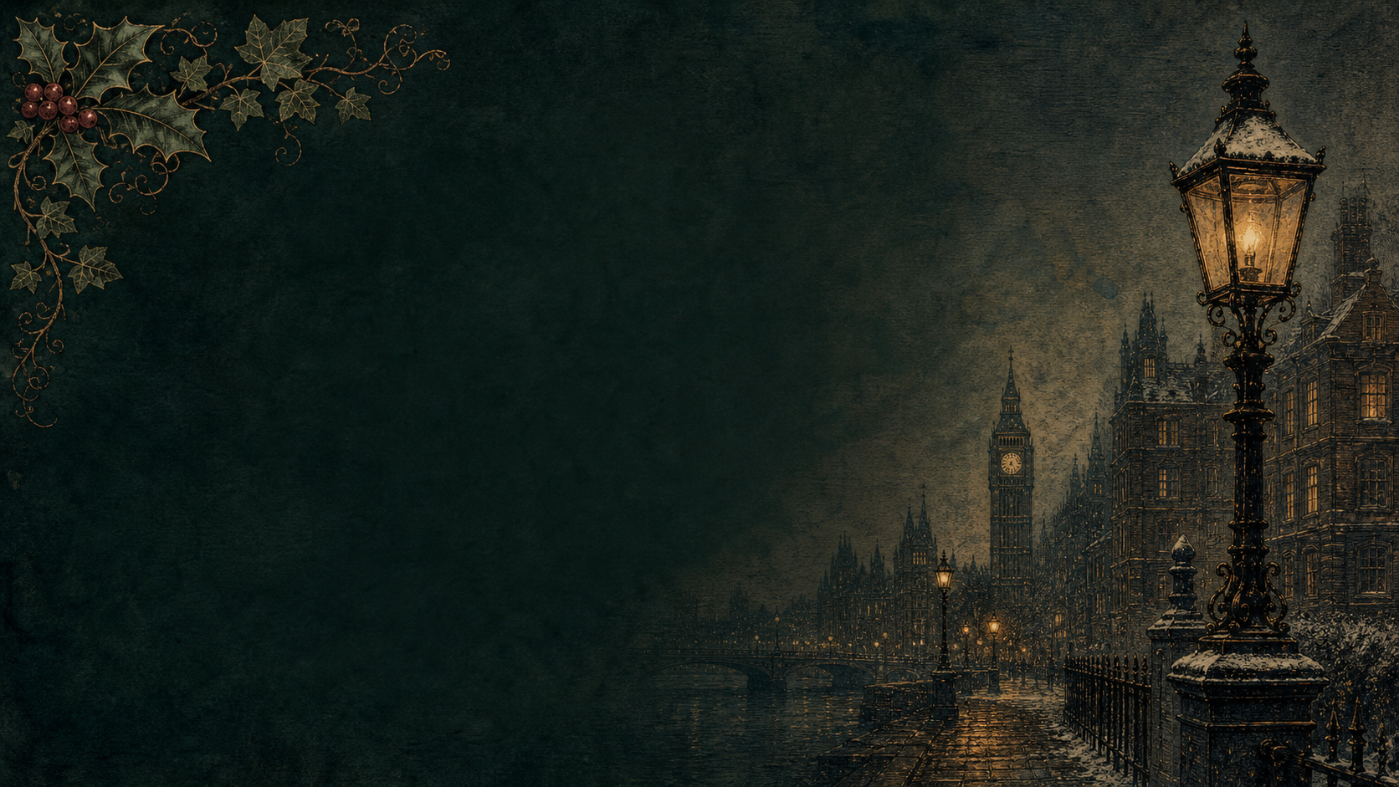
A LIVING BOOK STUDY - LEARNING BOOKLET
Name: _______________________

TASKS: DAY 1
Week 1 - Stave 1: Marley's Ghost
READ:
The opening of the book, up to Scrooge meeting his nephew Fred and the two charity collectors at the counting-house.
NARRATION:
How does Dickens describe Scrooge? Find three words or images from the description of him as 'a squeezing, wrenching, grasping...' man.
EXTENSION:
History: find out about Victorian counting-houses and clerks. How is Bob Cratchit's working day different from an office worker's today?
Your response:

TASKS: DAY 2
Week 1 - Stave 1: Marley's Ghost
READ:
Marley's Ghost's visitation to Scrooge.
NARRATION:
Describe Marley's ghost using your senses - what does Scrooge see, hear, and feel? What does the chain represent?
EXTENSION:
Why might Christmas Eve have been a popular night for telling ghost stories in Victorian times?
Your response:

TASKS: DAY 3
Week 1 - Stave 1: Marley's Ghost
READ:
Re-read Marley's warning to Scrooge.
WRITING OPPORTUNITY:
'I wear the chain I forged in life.' Explain this line in your own words. What has Marley done in his life to deserve this fate?
GCSE EXTENSION:
Analyse the chain as a symbol. Plan a short response to: 'How does Dickens present Marley as a warning to Scrooge?'
Your response:

TASKS: DAY 4
Week 2 - Stave 2: The First of the Three Spirits
READ:
The Ghost of Christmas Past takes Scrooge to his old school, and to Fezziwig's Christmas party.
NARRATION:
Contrast young Scrooge with the Scrooge we met in Stave 1. What has changed?
EXTENSION:
Art: illustrate Fezziwig's Christmas party.
Your response:

TASKS: DAY 5
Week 2 - Stave 2: The First of the Three Spirits
READ:
The story of Belle, and the end of her engagement to Scrooge.
WRITING OPPORTUNITY:
Write a diary entry as young Scrooge, or as Belle, on the day the engagement ends.
EXTENSION:
Discuss: what does Scrooge choose instead of love? Why do you think he makes that choice?
Your response:

TASKS: DAY 6
Week 2
READ:
Re-read the opening of Stave 1, where Scrooge turns away the charity collectors.
HISTORY TASK:
Research Charles Dickens' own childhood: his father's imprisonment for debt, and his time working in a blacking factory. Record key dates in your Book of Centuries.
EXTENSION:
Discuss: how might Dickens' own life have shaped this stave?
Your response:

TASKS: DAY 7
Week 2 - Stave 3: The Second of the Three Spirits
READ:
The arrival of the Ghost of Christmas Present, and the Cratchits' Christmas dinner.
NARRATION:
What does Tiny Tim's line 'God bless us, every one!' tell us about him and his family?
EXTENSION:
PSHE: discuss family, poverty and joy. Can a family be happy with very little money?
Your response:

TASKS: DAY 8
Week 2 - Stave 3: The Second of the Three Spirits
READ:
Fred's Christmas party, and the Ghost's journey to a lighthouse, a coal mine, and a ship at sea.
GEOGRAPHY TASK:
Map the places visited by the Ghost of Christmas Present in this section.
EXTENSION:
Discuss: why does Dickens show Christmas being celebrated in so many different places at once?
Your response:

TASKS: DAY 9
Week 3
READ:
The appearance of Ignorance and Want beneath the Ghost's robes.
DISCUSS:
'This boy is Ignorance. This girl is Want. Beware them both...' Why might this be the most important passage in the whole book?
GCSE EXTENSION:
Plan a response to: 'How does Dickens use allegory here to comment on Victorian society?'
Your response:

TASKS: DAY 10
Week 3 - Stave 4: The Last of the Spirits
READ:
The arrival of the Ghost of Christmas Yet to Come, and the businessmen discussing a death.
NARRATION:
How does Dickens make this spirit feel more frightening than the other two?
EXTENSION:
Discuss: why does a story about change often build to its darkest moment before the ending?
Your response:

TASKS: DAY 11
Week 3 - Stave 4: The Last of the Spirits
READ:
The Cratchits mourning Tiny Tim, and Scrooge finding his own neglected grave.
WRITING OPPORTUNITY:
Write Scrooge's internal monologue as he kneels at his graveside.
EXTENSION:
Discuss: what does Scrooge finally promise the spirit?
Your response:

TASKS: DAY 12
Week 3
READ:
Response day - no new reading.
COMPARE THE THREE SPIRITS:
Draw a table with three columns, one for each spirit. For each, note: what it looks like, what it shows Scrooge, and what he learns from it.
EXTENSION:
Art: storyboard the three spirits side by side.
Your response:

TASKS: DAY 13
Week 4 - Stave 5: The End of It
READ:
Scrooge waking on Christmas morning, sending the turkey, and meeting the charity collector again.
NARRATION:
'I am as merry as a schoolboy!' Find evidence in this stave that Scrooge has changed.
EXTENSION:
Drama: read this scene aloud as a performance.
Your response:

TASKS: DAY 14
Week 4 - Stave 5: The End of It
READ:
The ending, including Scrooge's visit to Fred's for Christmas dinner.
DISCUSS:
Has Scrooge really changed for good? What tells you this isn't a temporary fright?
WRITING OPPORTUNITY:
Write the final paragraph of a modern retelling, ending on your own version of 'God bless us, every one!'
Your response:

TASKS: DAY 15
Week 4 - Wrap-up
READ:
No new reading - watch a film adaptation instead, if you can.
DISCUSS:
Compare the film to the book. What is similar? What is different, and why might a filmmaker make those changes?
GCSE EXTENSION:
Full practice question: 'Dickens presents Scrooge as a character who changes. Write about how Dickens presents this change, and why it might matter to a Victorian reader.' Plan and write a timed response using your quotation bank.
Your response:

QUOTATION BANK
Collect 6-8 key quotations as you read. For each, note the stave, the technique Dickens uses, and the effect it creates.
Quotation | Stave | Technique | Effect

VICTORIAN CHRISTMAS FACT FILE

Christmas cards

Christmas trees

Carols

Christmas dinner

Fun facts

